***Audio_mac***

By – [Maccuchi Macusubhi](https://maheshp2002.github.io/)

[](https://twitter.com/Mahesh____P) [](https://www.linkedin.com/feed/?trk=homepage-basic_google-one-tap-submit) [](https://www.instagram.com/m_a_c_dev_il/?r=nametag) [](https://wa.me/916238079095)

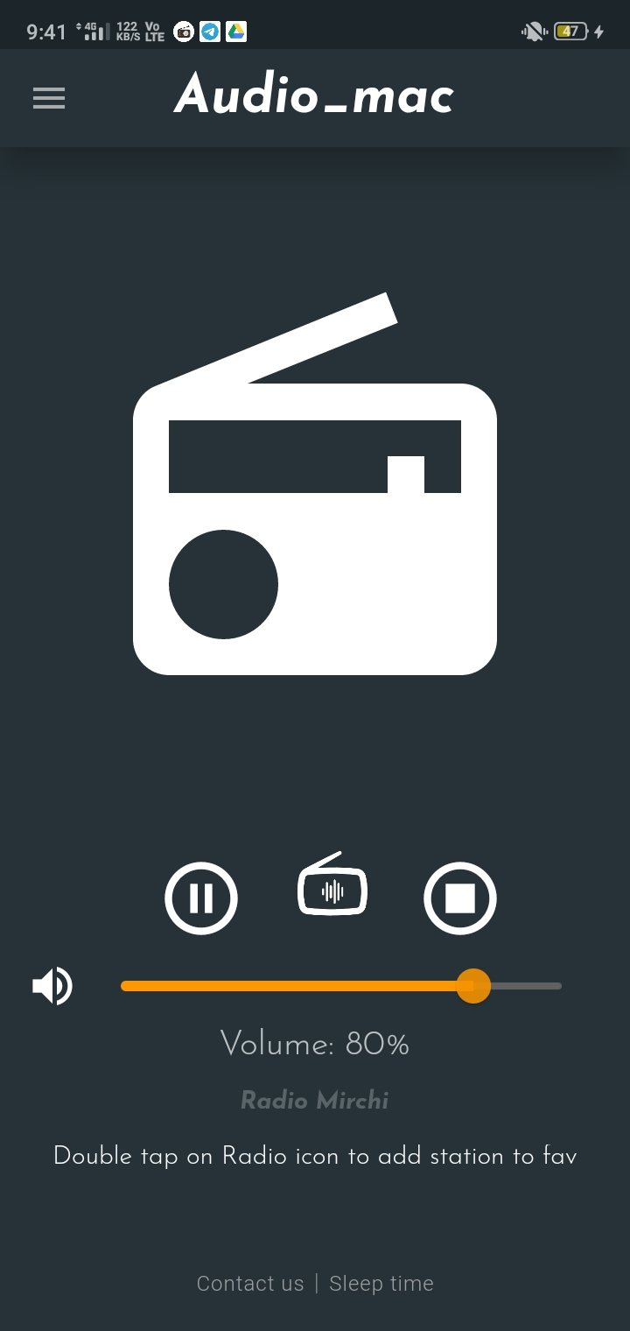 **Click on** **icon to play or pause FM. Or click on play icon in notification bar**

**Click on**  **icon to stop. Or click on play icon in notification bar**

**Click on** **icon to change FM station.**

**Double tap on the radio image to add station to favourites. (Note:- in order to add a station to favourites, you need to be signed in with your email account. If you don’t have an you can create one).**

CHOOSE OTHER STATION

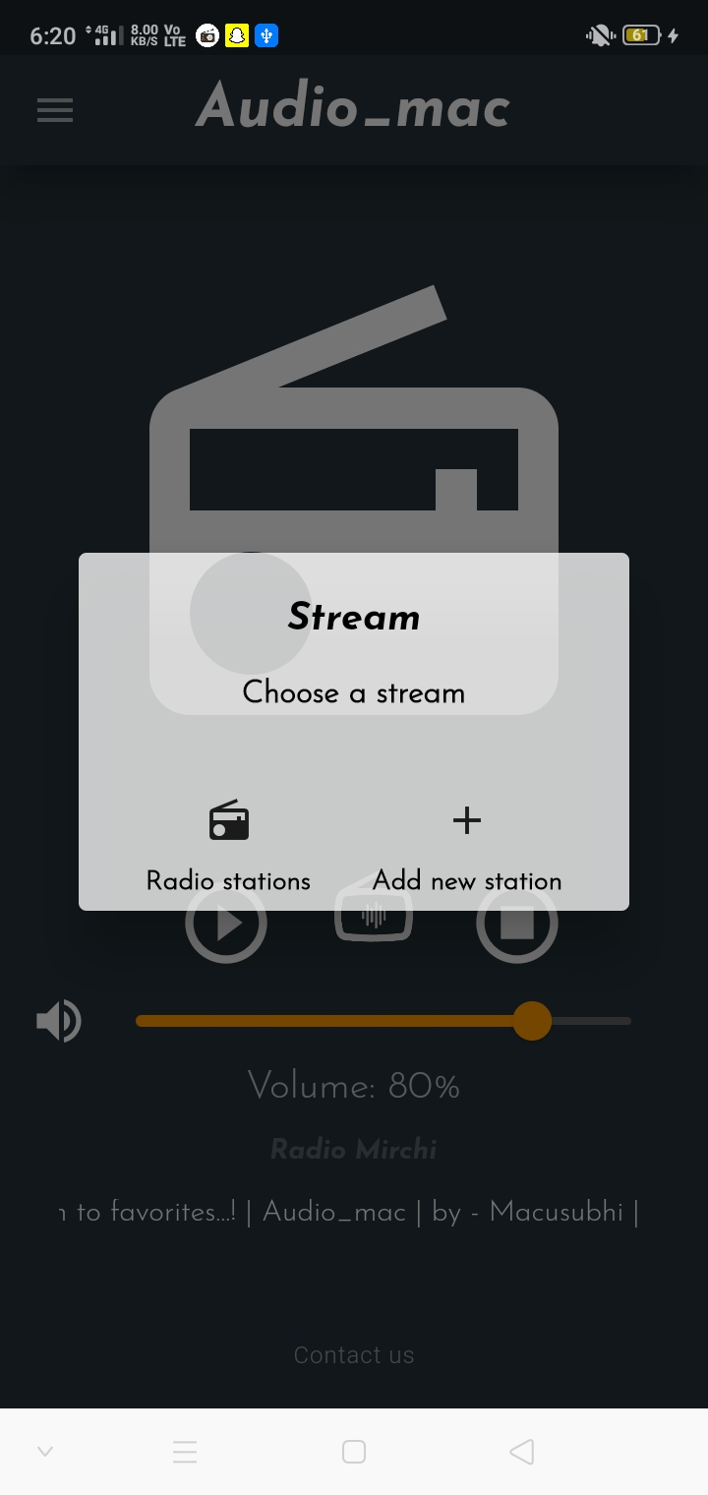

**Click on “Radio stations” button to choose FM stations available within the app.**

**Click on “Add new station” to play FM station using streaming URL.**

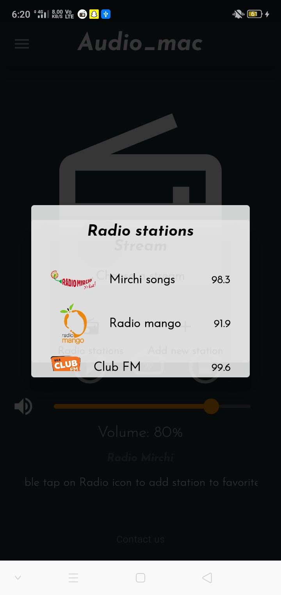 **Here just click on your favourite FM radio station, it will start playing that station. (Note:- some times it may take some time to load. Please wait or change station).**

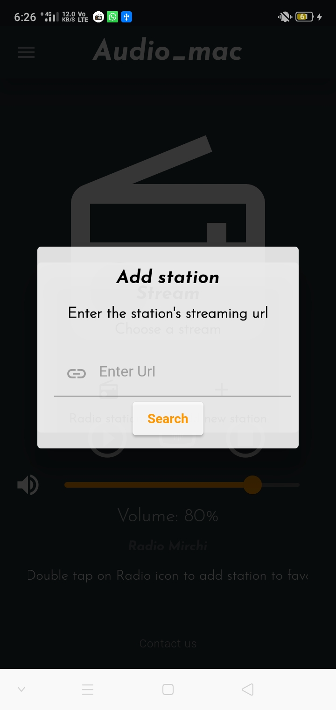

**Here you can enter any audio streaming URL, and can hear that station/audio.**

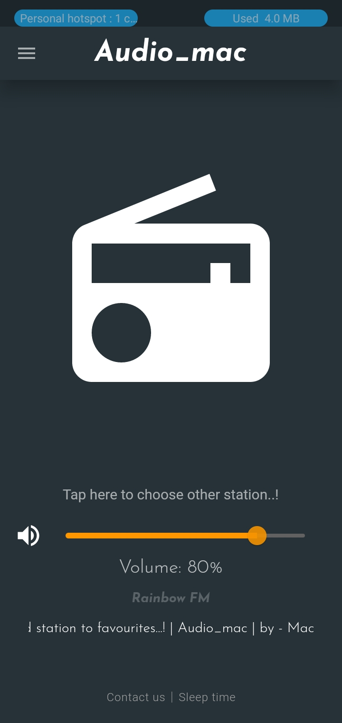

**You can also change the station by taping on the “Loading” text / “Tap here to choose other station..!”**

**text to change the FM station.**



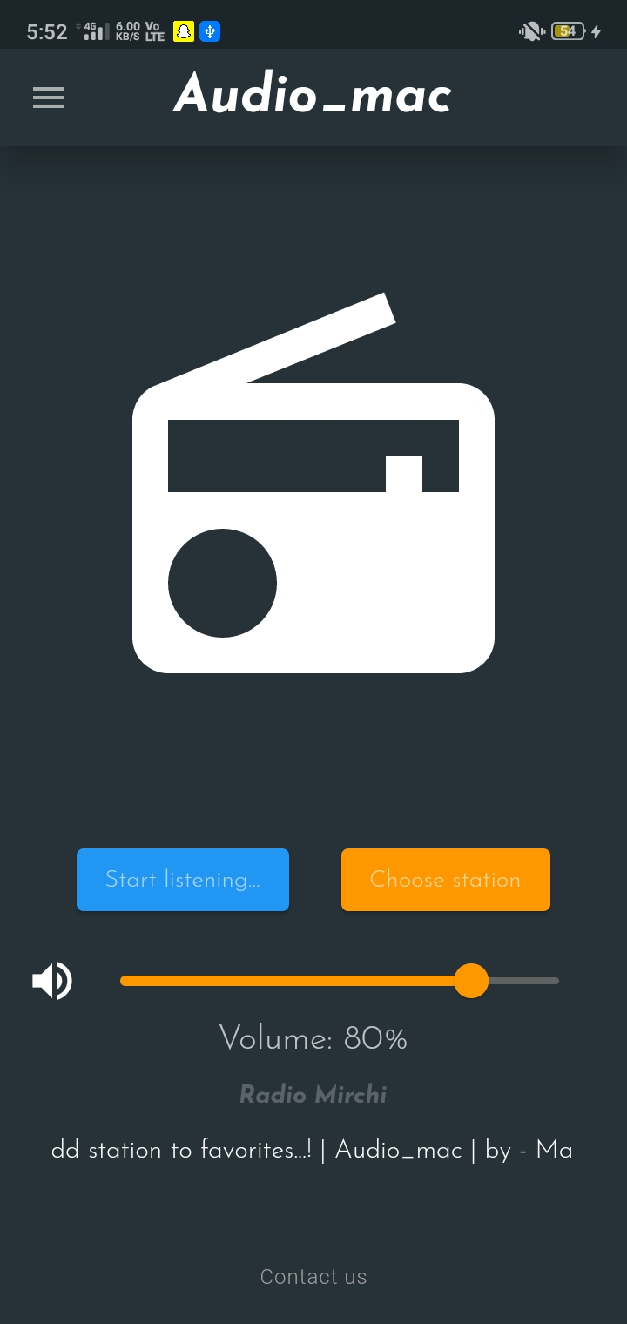

**Here you can either choose a radio station/can click on start listening button to start listening to the app default radio station (which is radio mirchi).**

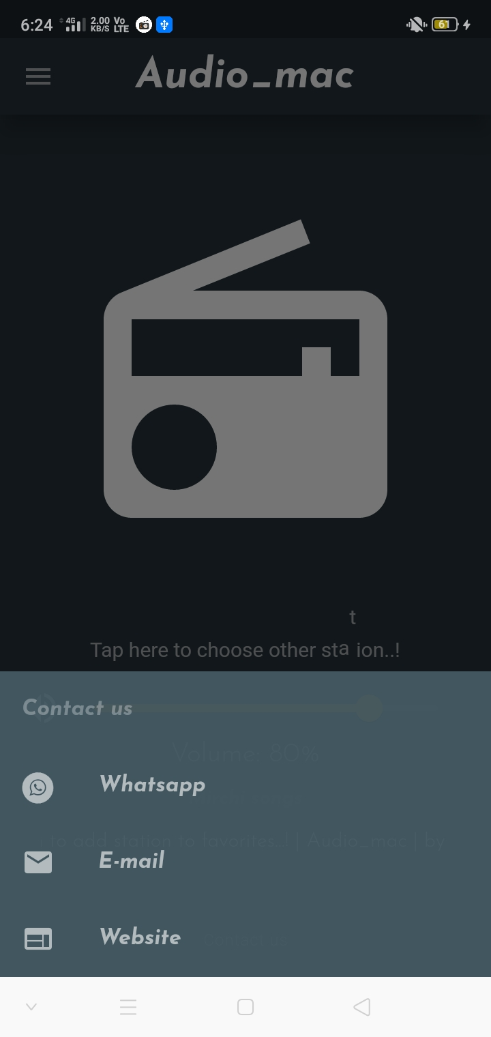



**If you find any issue with the app you can contact us by clicking on the “Contact us” text in bottom of home page.**

**You can contact us via whatsapp or email or can visit our website.**

**R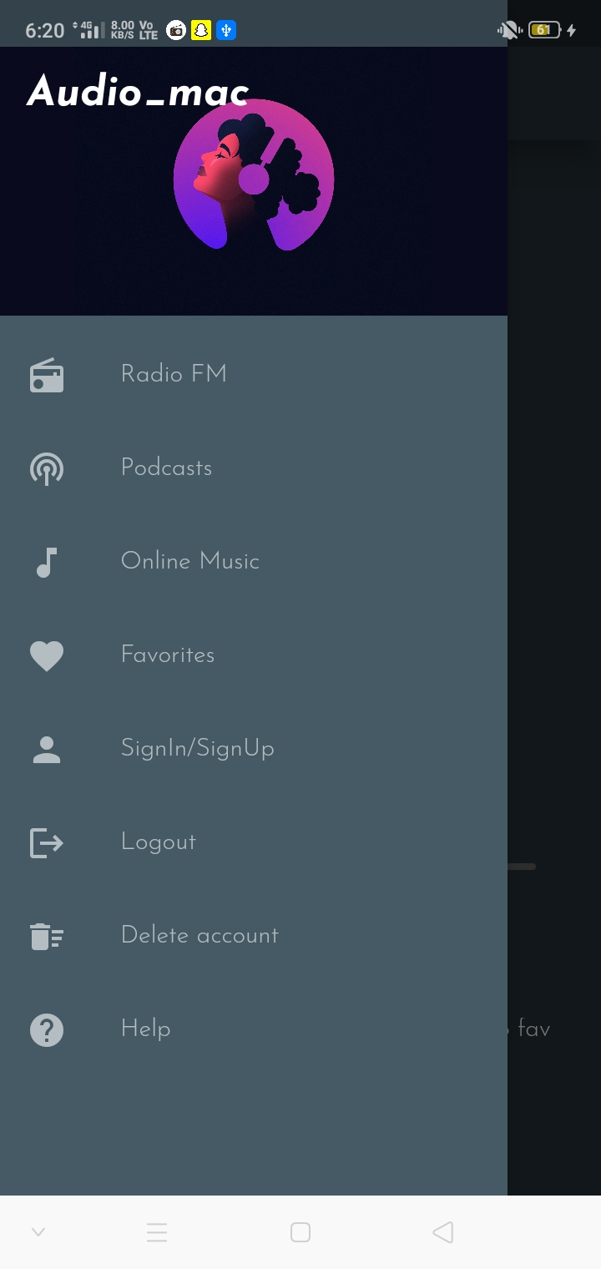EMOVING ITEM FROM FAVOURITE**

**Logout from account.**

**Delete user Account.**

**Home Screen.**

**Online podcasts.**

**Online music.**

**Favourite stations.**

**Sign in/Sign-up email**

**Help page.**

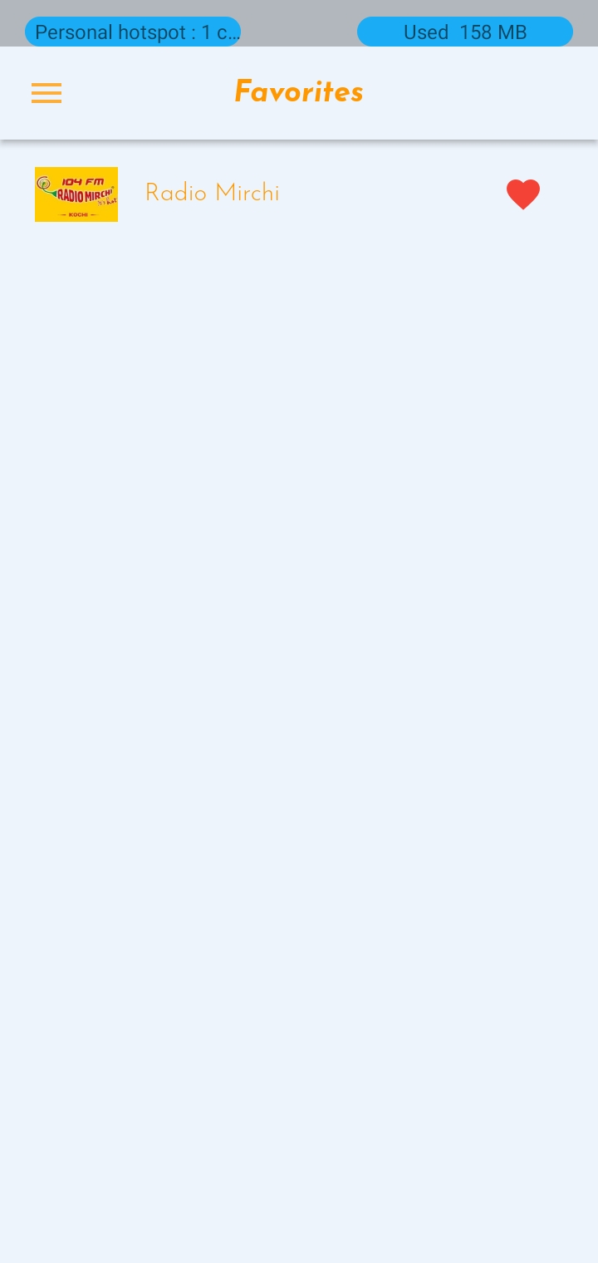

**By tapping on this icon you can remove a station from favourites.**

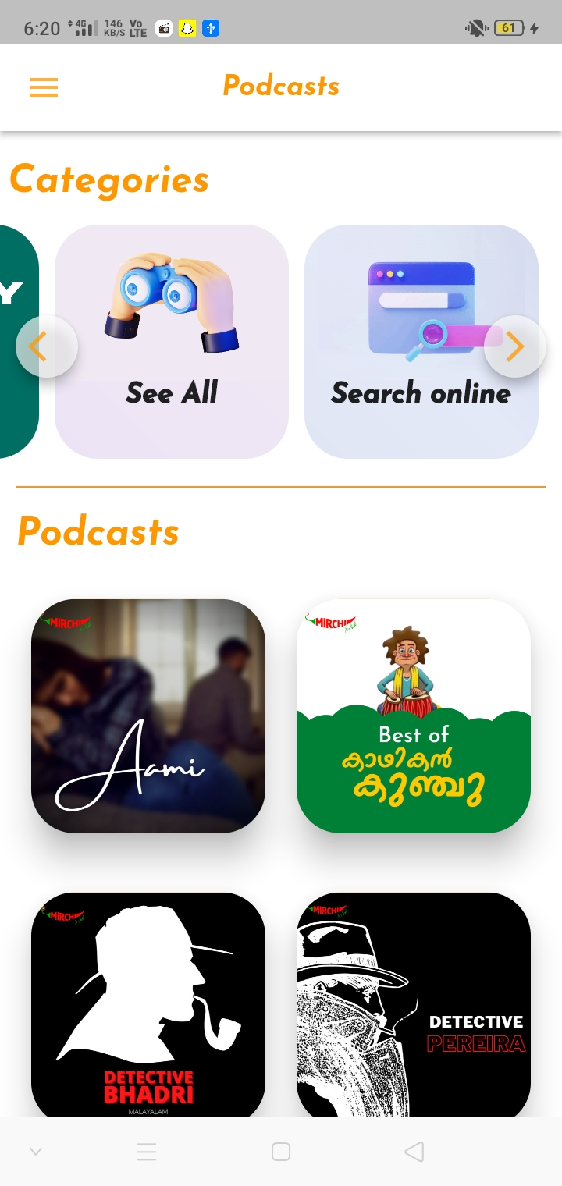

**By tapping on search online you can hear all mirchi podcasts in “Mirchi plus”.**



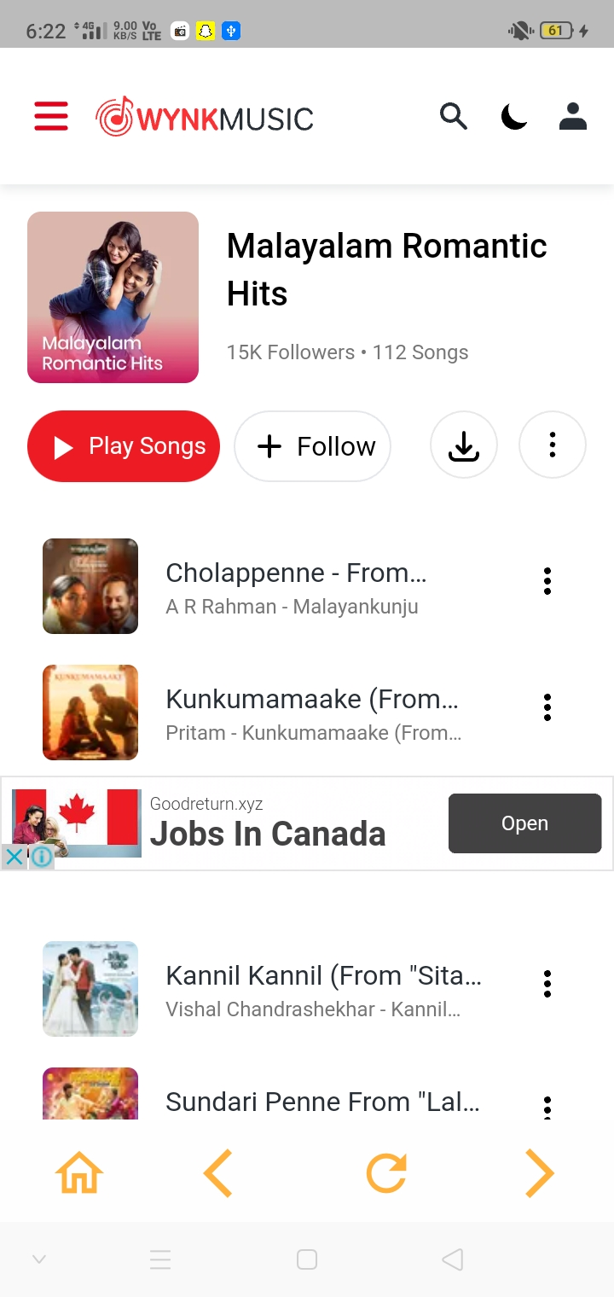



**The button is used to go back to the “Search” page.**

**The button is used to go backward in webpage.**

**The button is used to go forward in webpage.**

**The button is used to reload the webpage.**







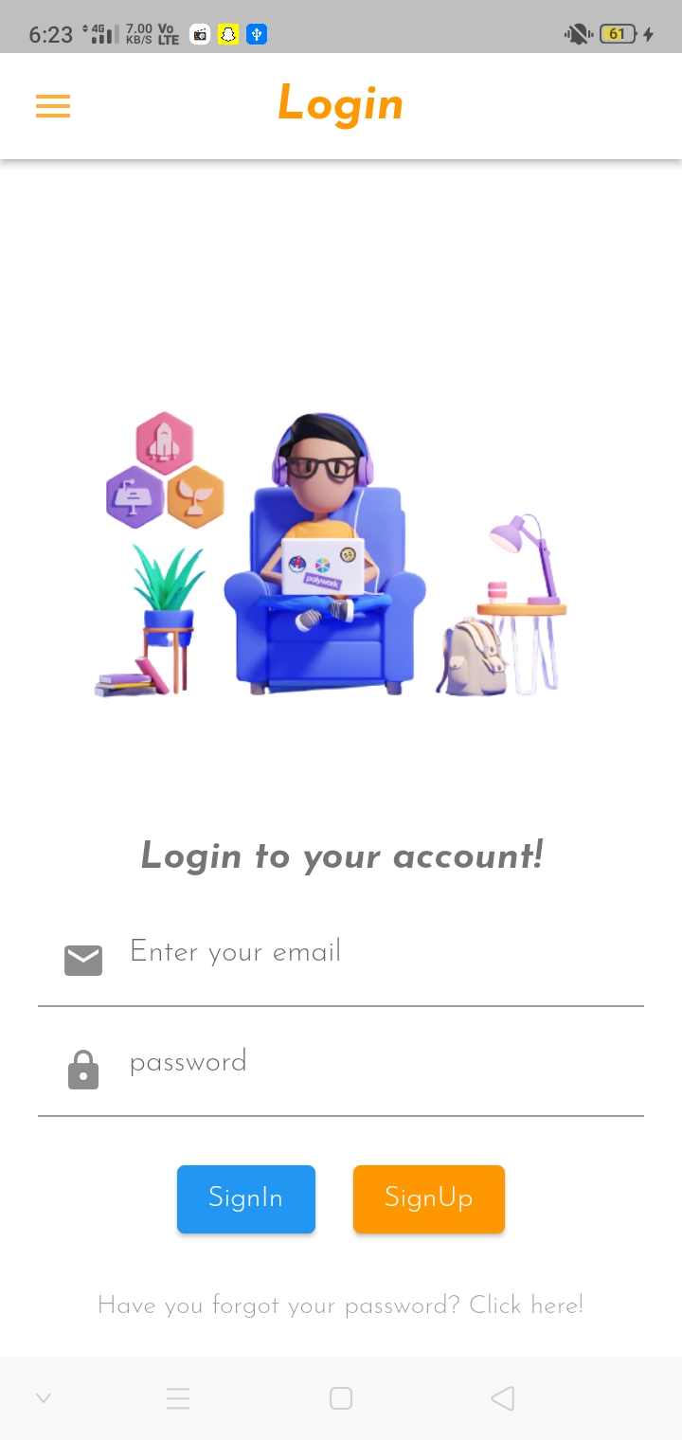

**In this page you can either sign-in to your existing “Audio_mac” account or can create a new “Audio_mac” account. (Note:- an account is required in order to add a station to favourite).**





**By Tapping on this text you can reset your password.(Note:- reset password mail can be found in spam section of your e-mail)**



* **If you find any bug or issue, please contact me.**
* **(Note:- you’ll have to provide details about the bug, so that i can fix it and provide you a better update).**