Report
Of
C++ PROGRAMMING

Submitted
To
School of Computer Science and Engineering
IILM University, Greater Noida, U.P.

In partial fulfilment of the requirement of degree of
B.Tech CSE


By
Roll Number of Student: 2410030765
Name of Student: MAHESH PATHLAVATH
Batch: 2026-27

2026-27

CANDIDATE'S DECLARATION
I, Mahesh Pathlavath, do hereby declare that the internship report titled “C++ Programming” has been completed by me to fulfil the requirement for the award of the degree of Bachelor of Technology in CSE. All the references have been quoted and I have not taken as such any material from any other source. I affirm to you that this report is my own and has not been submitted to any other institute for any degree/diploma requirement and further I shall be solely responsible for any kind of copyright violation in this regard.

Signature
Student Name: Mahesh Pathlavath
Roll No.: 2410030765

ACKNOWLEDGEMENT
I am using this opportunity to express my gratitude to everyone who supported me throughout the Internship Program. I am thankful for their aspiring guidance, invaluably constructive criticism and friendly advice during this work. I am sincerely grateful to them for sharing their truthful and illuminating views on a number of issues related to this work.
I express my gratitude to my parents for their blessings.

Signature
Student Name: Mahesh Pathlavath
Roll No.: 2410030765

INTERNSHIP COMPLETION CERTIFICATE
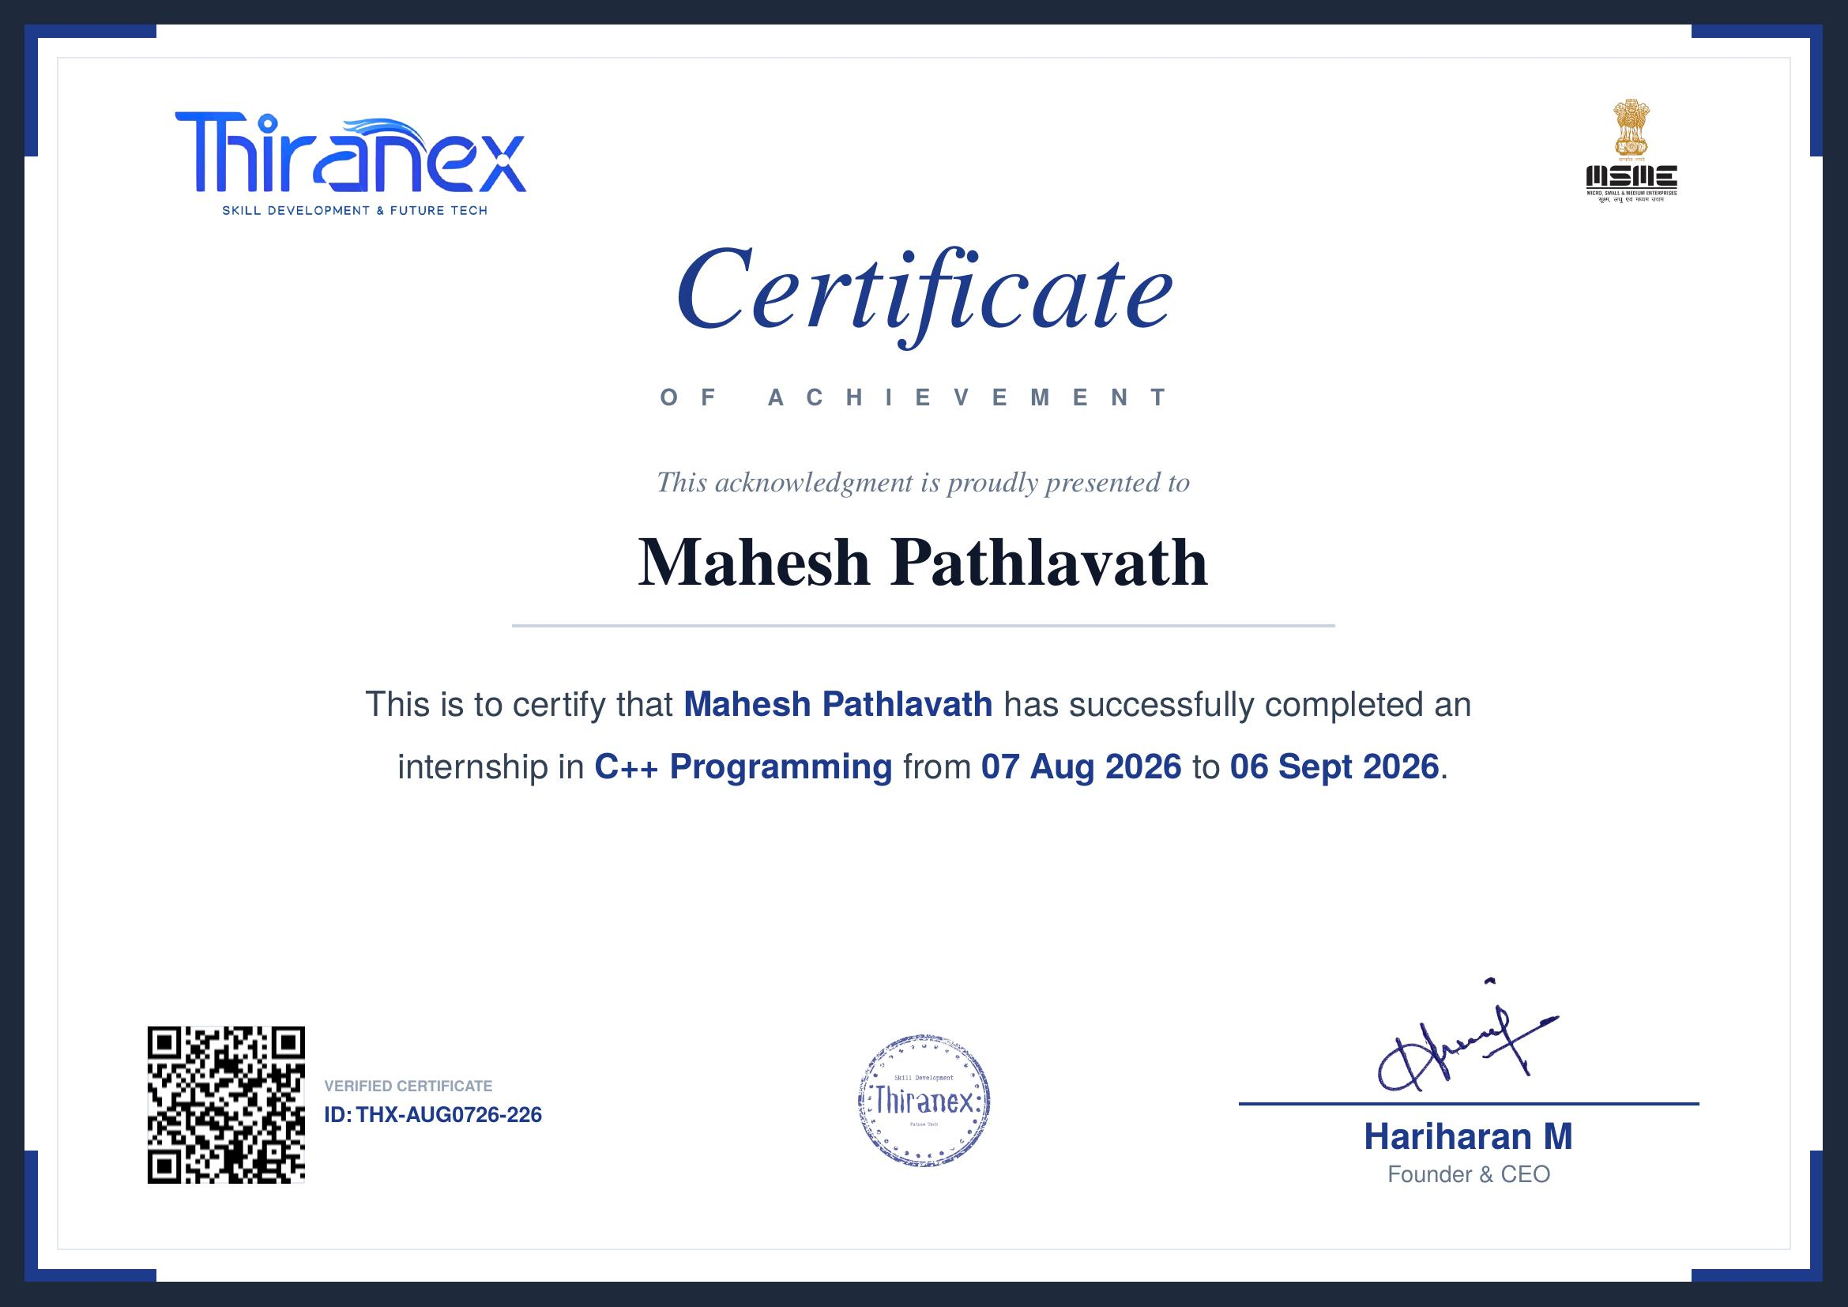

TABLE OF CONTENTS
Chapter No. | Chapter Name | Page Nos.
 | Cover Page | ----
1. | Candidate's Declaration | i
2. | Acknowledgment | ii
3. | Internship Completion Certificate | iii
4. | Project Description  4.1 Introduction  4.2 Organization Profile  4.3 Problem Statement  4.4 Project Objectives  4.5 Scope of the Project  4.6 Technologies and Tools Used  4.7 System Architecture  4.8 Methodology  4.9 Expected Outcomes  4.10 Certificates of Completion | 1
5. | Bibliography/References | 8

Chapter 4: Project Description
4.1 Introduction
This report presents a summary of the one-month internship undertaken in C++ Programming at Thiranex, a skill development and future technology organization, from 07 August 2026 to 06 September 2026. The internship provided practical, hands-on exposure to the C++ programming language, reinforcing core programming concepts and introducing industry-relevant coding practices. As part of the internship, a representative console-based application, a Student Result Management System, was designed and implemented in C++ to apply the concepts learned during the training.
4.2 Organization Profile
Thiranex is a skill development and future technology-focused organization that offers structured internship and training programs aimed at building strong technical foundations among students and early-career learners. Its programs are designed to bridge the gap between academic learning and industry expectations through practical, project-based training in areas such as programming, software development, and emerging technologies.
4.3 Problem Statement
Many students possess theoretical knowledge of programming languages but lack practical, hands-on experience in applying these concepts to build functional applications. There was a need for a structured, guided environment in which fundamental and object-oriented C++ concepts could be practiced through real coding exercises and a small end-to-end application, thereby strengthening both problem-solving ability and coding proficiency.
4.4 Project Objectives
- To strengthen fundamental and advanced concepts of C++ programming.
- To gain hands-on experience in writing, debugging, and optimizing C++ code.
- To apply object-oriented programming (OOP) principles in a practical application.
- To design and implement a simple, functional console-based system using C++.
- To build a foundation for further learning in software development and data structures.
4.5 Scope of the Project
The scope of the work carried out during the internship was limited to console-based application development using standard C++. It covered core language fundamentals, object-oriented design, file handling for basic data persistence, and elementary use of the Standard Template Library (STL). The scope did not extend to graphical user interfaces, networking, or database connectivity, as the focus was on strengthening core programming fundamentals within the internship duration.
4.6 Technologies and Tools Used
- Programming Language: C++ (C++11/14 standard)
- Compiler/IDE: GNU G++ Compiler / Code::Blocks / Visual Studio Code
- Concepts Applied: OOP (classes, inheritance, polymorphism), STL, file handling
- Version Control (if applicable): Git/GitHub for tracking code changes
- Operating System: Windows
4.7 System Architecture
The representative application developed during the internship, the Student Result Management System, follows a simple modular, layered console architecture consisting of the following components:
- Input/Output Layer: Handles interaction with the user through the console menu.
- Business Logic Layer: Classes encapsulating student records, marks calculation, and grading logic using OOP principles.
- Data Storage Layer: File handling module that reads from and writes student records to a data file for persistence between runs.
This layered structure keeps the input handling, processing logic, and data storage separate, making the program easier to understand, test, and extend.
4.8 Methodology
The internship followed a structured, progressive learning methodology:
- Week 1: Learning C++ fundamentals - syntax, data types, control structures, and functions.
- Week 2: Object-oriented programming - classes, objects, inheritance, and polymorphism.
- Week 3: Arrays, strings, pointers, dynamic memory management, and an introduction to STL.
- Week 4: Design and development of the Student Result Management System, integrating OOP concepts and file handling, followed by testing and debugging.
4.9 Expected Outcomes
- A working console-based application demonstrating core C++ and OOP concepts.
- Improved proficiency in writing clean, efficient, and well-structured C++ code.
- Enhanced logical thinking, debugging ability, and problem-solving skills.
- A stronger foundation for future coursework and projects involving data structures and software development.
4.10 Certificates of Completion and Other Communication Mail Proof
The certificate of successful completion of the internship, issued by Thiranex (Certificate ID: THX-AUG0726-226, signed by Mr. Hariharan M, Founder & CEO), has been attached in Chapter 3 of this report.
Chapter 5: Bibliography/References
1. Deitel, P., & Deitel, H. (2016). C++ How to Program (10th ed.). Pearson Education.
2. Stroustrup, B. (2013). The C++ Programming Language (4th ed.). Addison-Wesley.
3. cplusplus.com. C++ Language Reference. Retrieved 2026, from https://cplusplus.com
4. Thiranex. (2026). Internship Completion Certificate, Certificate ID: THX-AUG0726-226.

