Report
Of
CLOUD VIRTUAL INTERNSHIP

Submitted
To
School of Computer Science and Engineering
IILM University, Greater Noida, U.P.

In partial fulfilment of the requirement of degree of
B.Tech CSE


By
Roll Number of Student: 2410030765
Name of Student: MAHESH PATHLAVATH
Section: 3CSE19
Batch: 2026-27

2026-27

CANDIDATE'S DECLARATION
I, Mahesh Pathlavath, do hereby declare that the internship report titled “Cloud Virtual Internship” has been completed by me to fulfil the requirement for the award of the degree of Bachelor of Technology in CSE. All the references have been quoted and I have not taken as such any material from any other source. I affirm to you that this report is my own and has not been submitted to any other institute for any degree/diploma requirement and further I shall be solely responsible for any kind of copyright violation in this regard.

Signature
Student Name: Mahesh Pathlavath
Roll No.: 2410030765

ACKNOWLEDGEMENT
I am using this opportunity to express my gratitude to everyone who supported me throughout the Internship Program. I am thankful for their aspiring guidance, invaluably constructive criticism and friendly advice during this work. I am sincerely grateful to them for sharing their truthful and illuminating views on a number of issues related to this work.
I express my gratitude to my parents for their blessings.

Signature
Student Name: Mahesh Pathlavath
Roll No.: 2410030765

INTERNSHIP COMPLETION CERTIFICATE
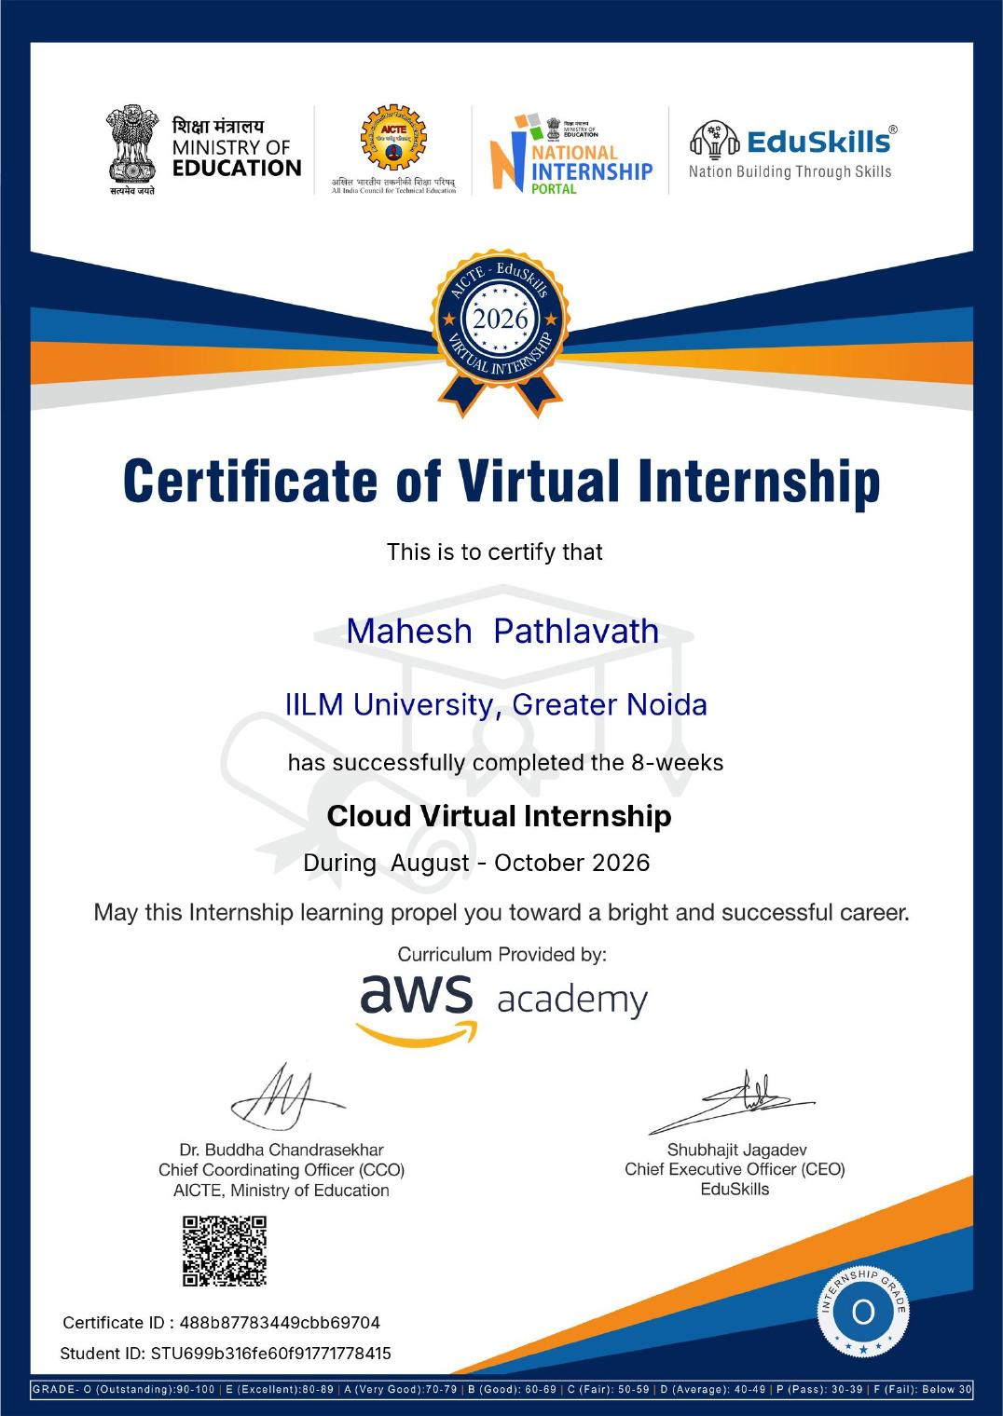

TABLE OF CONTENTS
Chapter No. | Chapter Name | Page Nos.
 | Cover Page | ----
1. | Candidate's Declaration | i
2. | Acknowledgment | ii
3. | Internship Completion Certificate | iii
4. | Project Description  4.1 Introduction  4.2 Organization Profile  4.3 Problem Statement  4.4 Project Objectives  4.5 Scope of the Project  4.6 Technologies and Tools Used  4.7 System Architecture  4.8 Methodology  4.9 Expected Outcomes  4.10 Certificates of Completion | 1
5. | Bibliography/References | 8

Chapter 4: Project Description
4.1 Introduction
This report presents a summary of the 8-week Cloud Virtual Internship undertaken during August - October 2026. The internship was offered by EduSkills in collaboration with AICTE, Ministry of Education, through the National Internship Portal, with curriculum provided by AWS Academy. It gave practical exposure to cloud computing fundamentals and Amazon Web Services (AWS), covering core concepts such as compute, storage, networking, security and cloud economics. The internship was completed successfully with an Outstanding (O) grade.
4.2 Organization Profile
EduSkills is a not-for-profit organization working with the All India Council for Technical Education (AICTE), Ministry of Education, Government of India, to build industry-ready skills among students under the vision "Nation Building Through Skills". It runs virtual internship programs in emerging technologies such as cloud computing, artificial intelligence and cybersecurity, delivered in partnership with industry leaders. The Cloud Virtual Internship uses the AWS Academy curriculum provided by Amazon Web Services.
4.3 Problem Statement
Many students have theoretical knowledge of computing but little practical exposure to cloud platforms, which are now central to modern software development and IT operations. There was a need for a structured, guided program in which cloud concepts and AWS services could be learned in an organized way, thereby bridging the gap between academic learning and industry expectations.
4.4 Project Objectives
- To understand the fundamental concepts, models and benefits of cloud computing.
- To gain familiarity with core AWS services for compute, storage, database and networking.
- To understand cloud security, identity management and the shared responsibility model.
- To learn the basics of cloud architecture, scalability, availability and cost management.
- To build a foundation for further learning and certification in cloud technologies.
4.5 Scope of the Project
The scope of the internship was limited to foundational cloud computing concepts and core AWS services as covered in the AWS Academy curriculum. It included cloud models, basic AWS architecture, security fundamentals and pricing. The scope did not extend to advanced production-grade architectures, large-scale deployments or specialised areas such as machine learning operations, as the focus was on building a strong conceptual base within the internship duration.
4.6 Technologies and Tools Used
- Cloud Platform: Amazon Web Services (AWS)
- Curriculum: AWS Academy (Cloud Foundations)
- Core Services Studied: Compute (EC2), Storage (S3), Databases (RDS), Networking (VPC), Identity and Access Management (IAM)
- Program Delivery: AICTE-EduSkills Virtual Internship via the National Internship Portal
- Access: Web browser and AWS Management Console on Windows
4.7 System Architecture
The cloud architecture studied during the internship follows a layered AWS model consisting of the following components:
- Compute Layer: Virtual servers and scalable compute resources used to run applications, such as Amazon EC2.
- Storage and Database Layer: Object storage, block storage and managed databases used to store and manage data, such as Amazon S3 and Amazon RDS.
- Networking and Security Layer: Virtual private networks, subnets, and identity and access controls that protect and connect resources, such as Amazon VPC and IAM.
This layered structure separates compute, data and security concerns, making cloud solutions easier to understand, scale and secure.
4.8 Methodology
The 8-week internship followed a structured, progressive learning methodology:
- Weeks 1-2: Introduction to cloud computing, cloud service and deployment models, and the AWS global infrastructure.
- Weeks 3-4: Core AWS services - compute, storage and databases.
- Weeks 5-6: Networking, security, identity management and the shared responsibility model.
- Weeks 7-8: Cloud architecture, scalability, high availability, pricing and cost optimization, followed by assessment.
4.9 Expected Outcomes
- A clear understanding of cloud computing concepts and the AWS ecosystem.
- Familiarity with core AWS services and their practical use cases.
- Improved awareness of cloud security, scalability and cost management.
- A stronger foundation for future cloud certifications, coursework and projects.
4.10 Certificates of Completion and Other Communication Mail Proof
The certificate of successful completion of the internship, issued by EduSkills in association with AICTE, Ministry of Education (Certificate ID: 488b87783449cbb69704; Student ID: STU699b316fe60f91771778415; Internship Grade: O - Outstanding; signed by Dr. Buddha Chandrasekhar, Chief Coordinating Officer, AICTE, and Shubhajit Jagadev, Chief Executive Officer, EduSkills), has been attached in Chapter 3 of this report.
Chapter 5: Bibliography/References
1. Amazon Web Services. (2026). AWS Academy Cloud Foundations Curriculum. Amazon Web Services, Inc.
2. Amazon Web Services. AWS Documentation. Retrieved 2026, from https://docs.aws.amazon.com
3. EduSkills Foundation. (2026). AICTE-EduSkills Virtual Internship Program.
4. EduSkills. (2026). Cloud Virtual Internship Certificate, Certificate ID: 488b87783449cbb69704.

