# Employee CURD Assignment:

1. Use angular 10 for assignment
2. Create CURD application for employee, based on UI shown in below Visual Designs
   1. UI should be similar to given screens only
3. Employee Data should be maintained in json file
   1. All operations like Employees listing, employee add, delete, edit and deactivate should be done using same json file

Landing Page: Login Page

User should be able to login from login screen shown as below

Email ID: [admin@persistent.com](mailto:admin@persistent.com)

Password: BookingAdmin

Add validations for below scenarios

1. Empty username or password
2. Incorrect username or password
3. Incorrect Email address format
4. Show above validation message in red text above *Login Button*

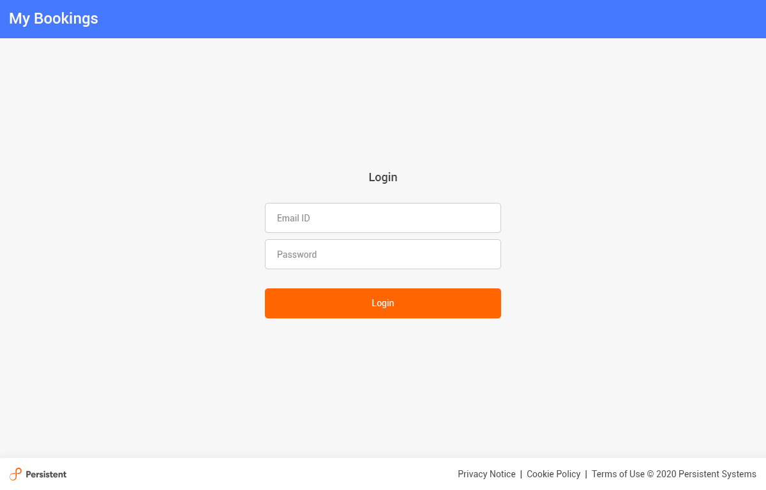

After successful login, User will land to Employees Listing Page, shown as below:

This is screen when there is no employee data

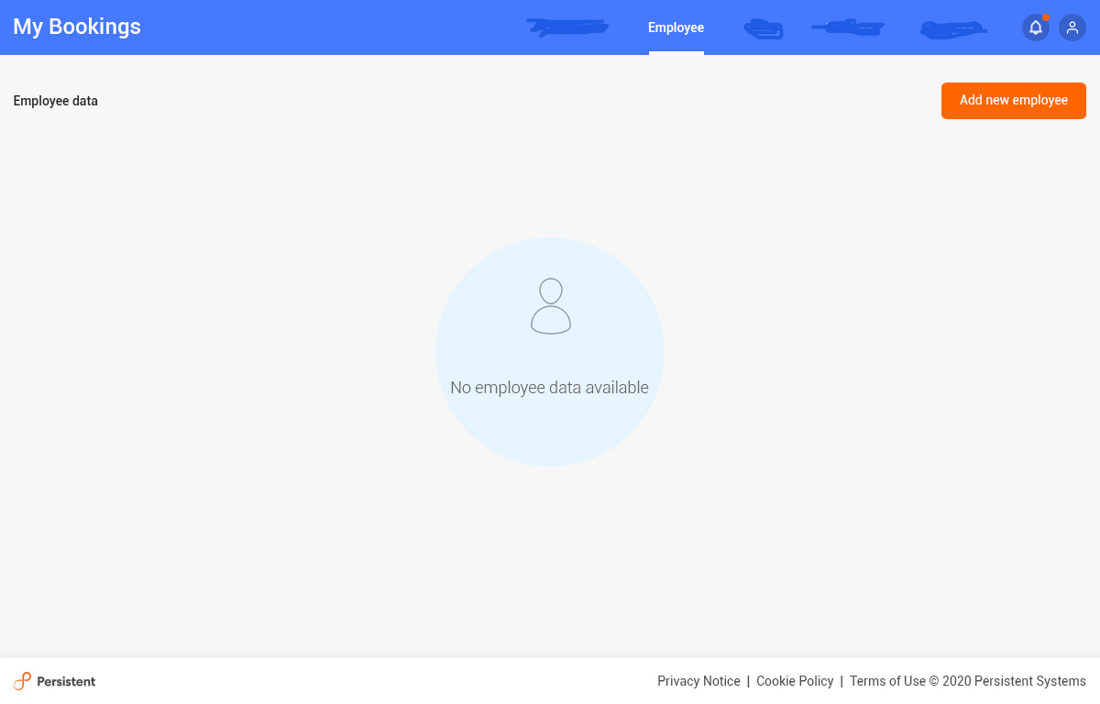

On click of *Add New Employee,* pop up to add new employee data will occur shown as below:

* Mandatory fields are
  + First name, last name, ID, Gender, Grade
  + Other fields are: ODC/Non OCD, BU, Project
* Add validation for mandatory fields
* ID should be number only
* Only empty spaces should not be allowed as value to any of fields
* After each operation finish (e.g add employee), show relevant message using snackbar and revert to home page

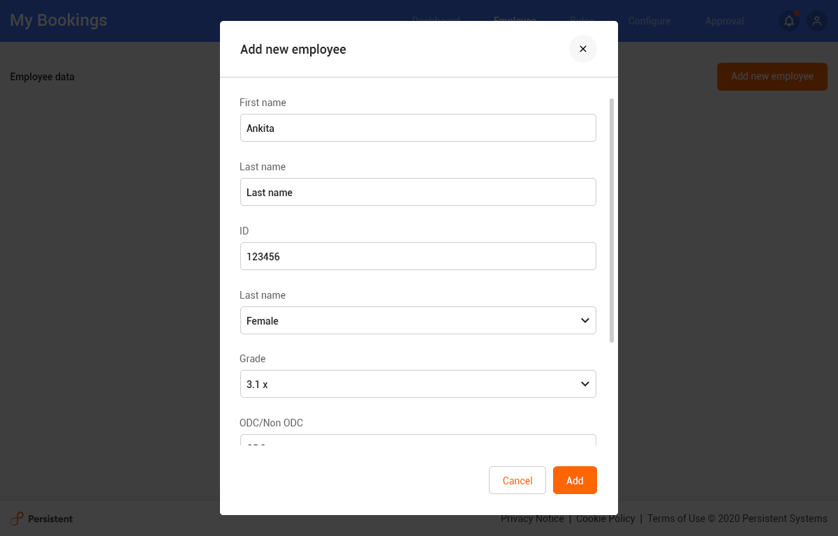

Once employee get added, it is listed as below:

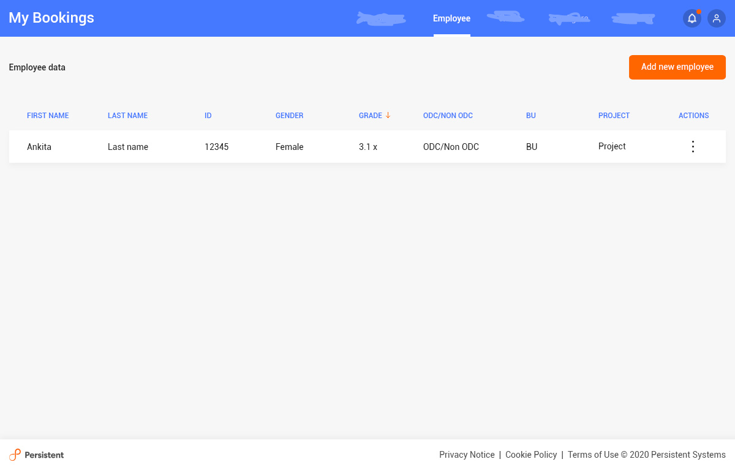

On clicking on *Actions (kebab Menu Icon) ,* It should show below options

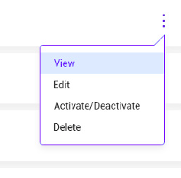

On click of Edit, similar popup like Add Employee will open with prefilled data of selected employee. On click of Edit Employee button, record should be edited and redirect back to listing page. Selected employee record should be updated in list without page refresh.

On Click of Delete button, show confirmation pop up as below

On click of *Yes*, record will be deleted, on click of *No* go back to listing page

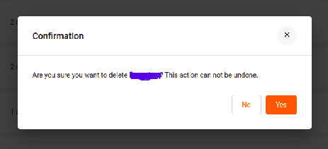

Activate/De-activate Button: <To be added>

View: Ignore *View* Button as of now.

Pagination needs to be added on Employee listing page, like below

