#Company_Logo#

**Generate .Net Documentation For**

**App_Name**

Display all the XML comments in a well formatted

HTML page using Sandcastle

Company_Name

Date_Create

# Introduction

**This document gives step by step instructions on how to generate code documentation for the generated application through a third-party tool called SandCastle Help File Builder. The SandCastle generated documentation page is not available by default and a developer has to enable XML comments and build the project in the SandCastle tool to access the help.**

# About SandCastle

**The SandCastle Help File Builder is a standalone GUI program to build the help file using XML output. Its licensed under the ‘Microsoft Public License (Ms-PL). For more information, please visit:** <https://github.com/EWSoftware/SHFB>

# Tools Required

* Visual Studio 2017 (Minimum Community Edition)
* Sandcastle Installer
* Sandcastle Help File Builder
* 7-Zip or WinRAR

# Summary

The following steps are required to create a HTML page with the documentation:

1. Download the generated application code from Turanto
2. Generate XML output file
3. Build the project in SandCastle Help File Builder
4. View the documentation

# Step 1: Download Code

To download the source code of the application:

1. Go to create.turanto.com
2. Enter your credentials in the login page. If you do not have credentials, please contact your system administrator so that an account can be created for you.

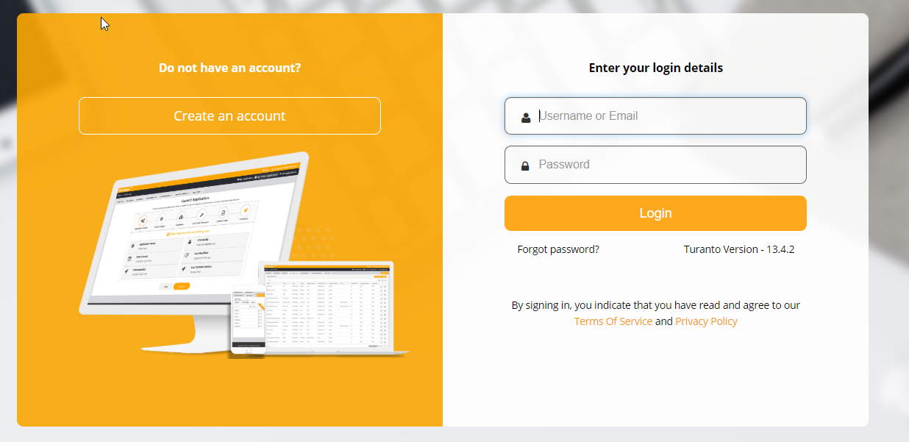

Figure : Login page for create.turanto.com

1. After you login, you will be re-directed to a list of all applications created by you. Use the Search options to search for the application name you wish to generate the documentation for or find the app in the list shown.
   1. If the application was not created by you, please contact the system administrator
2. Once you locate the application, click on the dropdown arrow on the right side and select ‘Download’

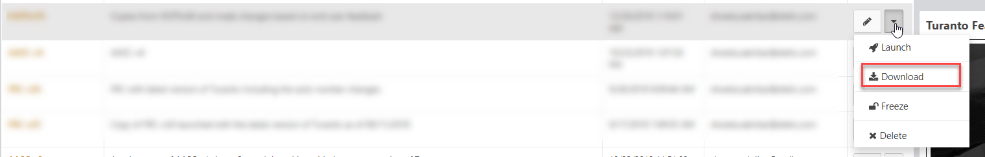

Figure : Option to download application in Turanto

1. Click on the ‘Download Code’ option in the ‘Full Web Application Code Package’

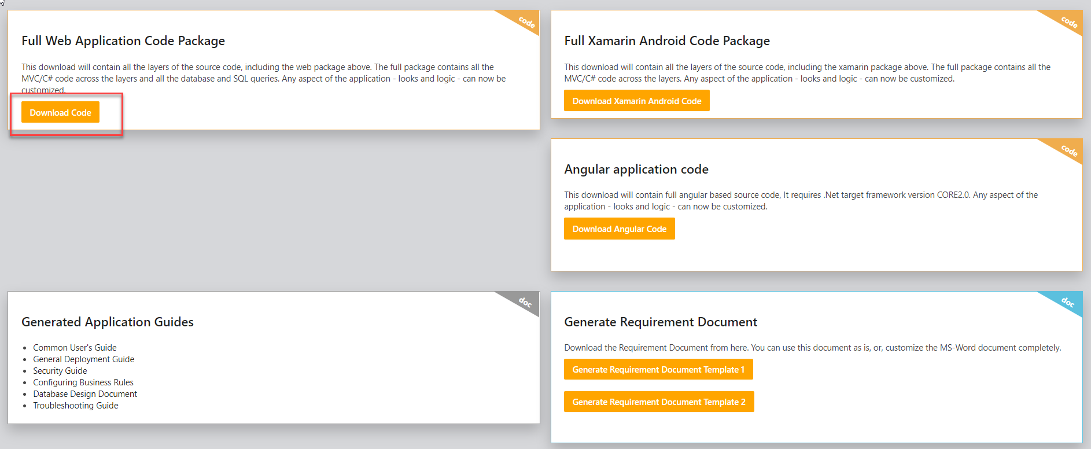

Figure 3: Download button for the generated application source code

1. The code will take a couple of minutes to download and you should see a [YourApplicationName].rar file downloaded.
2. Un-zip the downloaded code folder. You should see the following directory structure

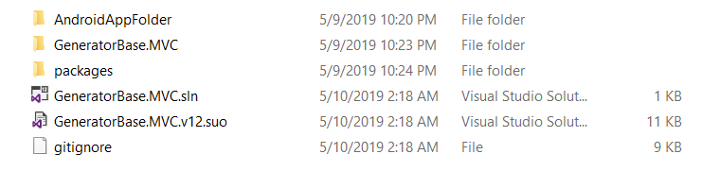

Figure 4: Directory Structure for the downloaded code

1. Open the ‘GeneratorBase.MVC.sln’ VS solution file

# Step 2: Generate XML Output

After the code has been downloaded, follow the steps below to generate the XML output:

1. Open the solution in Visual Studio and right-click on the project & go into options.

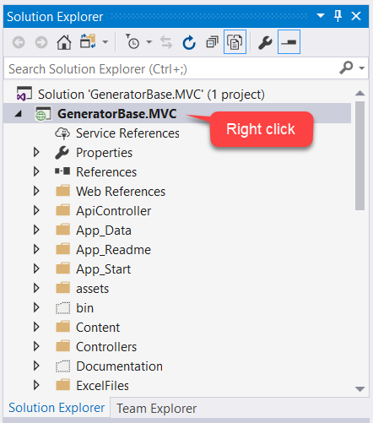 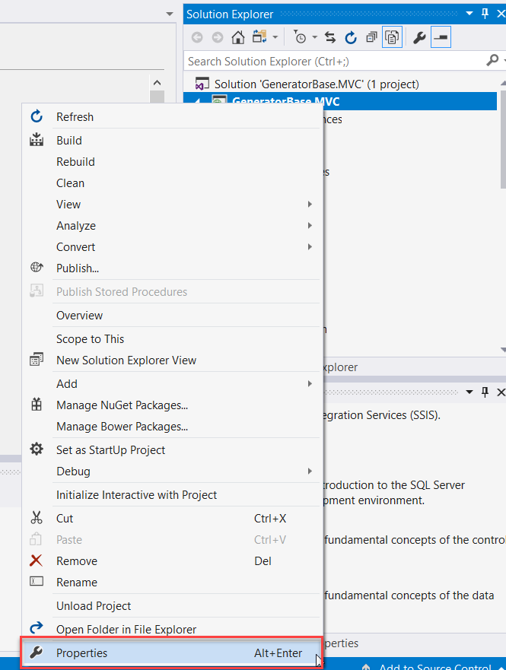

1. Go inside the ‘Build’ properties and check the box that says generate xml documentation. Leave it at the default of /bin location

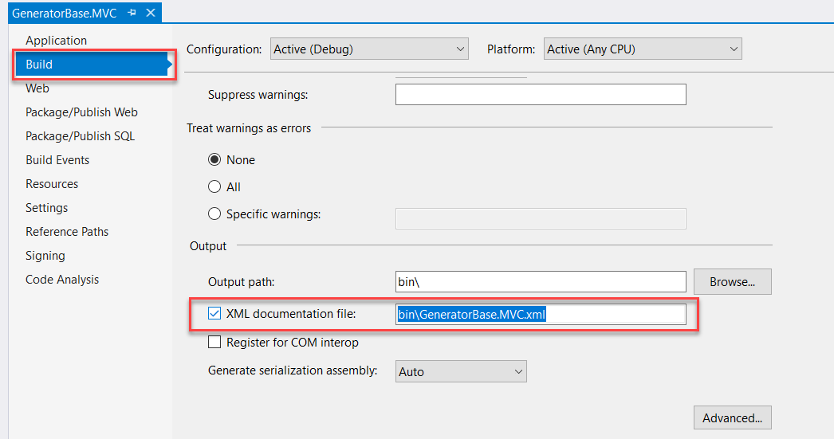

Figure 5: Enable XML output

1. After making this change, go into the ‘Build’ option in VS and Build the project. Please keep in mind that this build can sometimes take a long time.

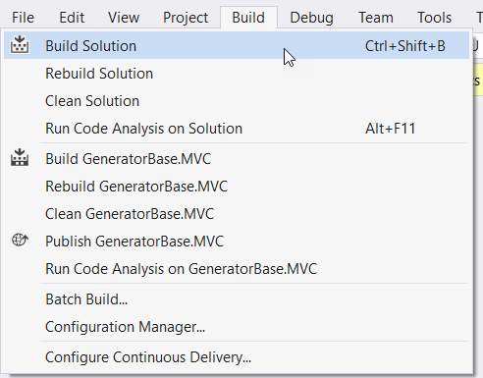

Figure 6: Build the solution

1. You should see the XML documentation file in the \GeneratorBase.MVC\bin\GeneratorBase.MVC.xml in your downloaded code once the build is successfully completed.

# Step 3: Use SandCastle Help File Builder

The following sections describe how to use the tool SandCastle to present the XML documentation in an easy to navigate HTML page.

## Installation Instructions

The complete instructions to download Sandcastle as well as the system requirements can be found below:

<http://ewsoftware.github.io/SHFB/html/8c0c97d0-c968-4c15-9fe9-e8f3a443c50a.htm>

The following is an overview of the steps:

1. Visit here to find the latest installer for SandCastle: <https://github.com/EWSoftware/SHFB/releases>
2. Download the Installer .zip folder

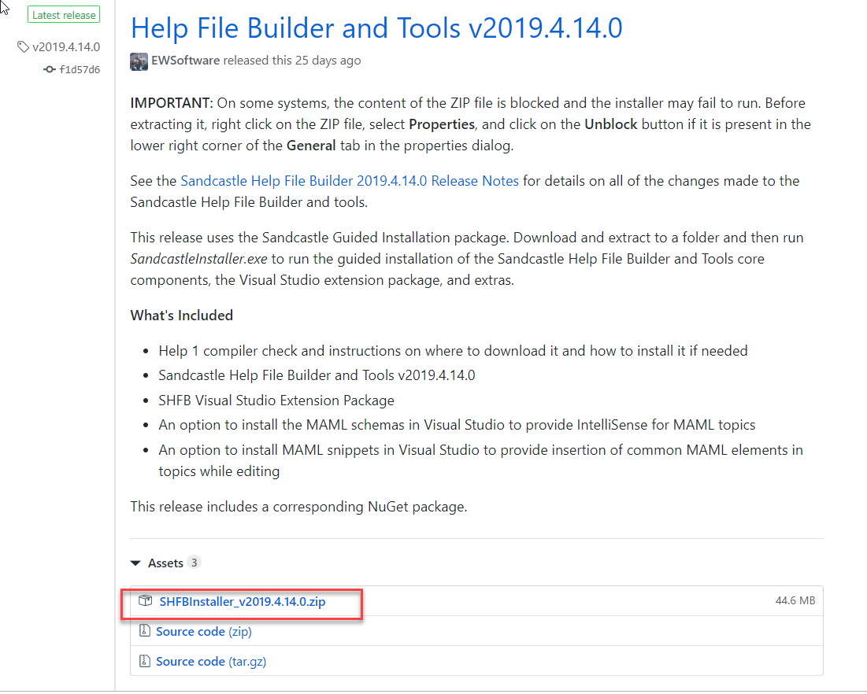

Figure 7: Example Screen for SandCastle Installation

1. Use 7-Zip or WinRAR to unzip the installer
2. Run the Installer executable file

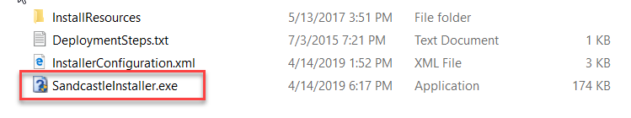

Figure 8: SandCastle Installer File

1. Follow the SandCastle Wizard to install SandCastle Help File Builder and Tools:

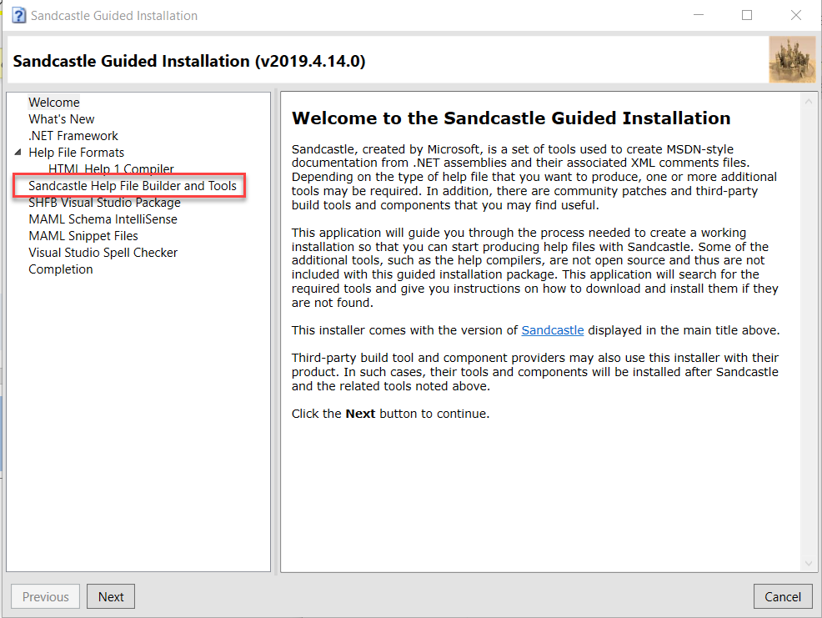

Figure 9: SandCastle Installation Wizard

* 1. All other components besides SHFB like the following are NOT required for Turanto Generated Application Documentation.
     1. HTML Help 1 Compiler
     2. SHFB Visual Studio Package
     3. MAML Schema IntelliSense
     4. MAML Snippet Files
     5. Visual Studio Spell Checker

## Build The Documentation

1. Open the recently downloaded Sandcastle Help File Builder on your machine.
   * Search for ‘SandCastle Help File Builder GUI’ on your computer if you are unable to locate it

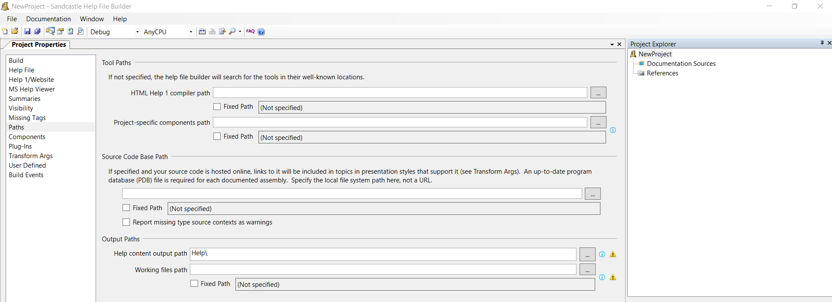

Figure 10: SandCastle GUI

1. On the project explorer tab on the right side, right click on the ‘Documentation Sources’ and select ‘Add Documentation Source’

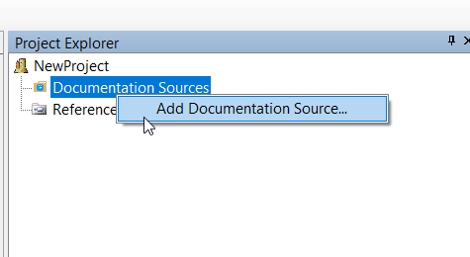

Figure 11: Add new documentation source

1. In the pop up to add new documentation source, navigate to ‘\GeneratorBase.MVC\bin’ in your downloaded code and select ‘GeneratorBase.MVC.dll’
2. You will see that the .dll and the .xml files are attached automatically

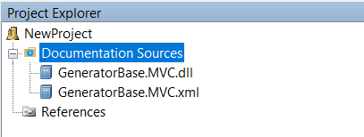

Figure 12: Select the sources for documentation

1. Go inside ‘Path’ and set up the Output path to be /Documentation

**Please Note: The tool automatically erases everything in the directory that you pick as the output path for the documentation every time the project is build. Ensure that you either use this default Documentation folder or create an empty folder. Make sure to backup all your work.**

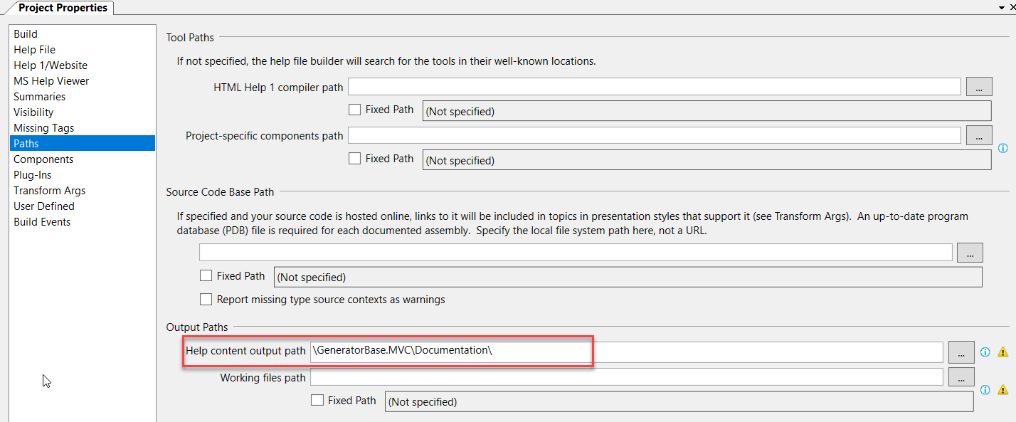

Figure 13: Set output path for the documentation

1. Go inside the Build option on the tool bar and click on ‘Build Documentation’

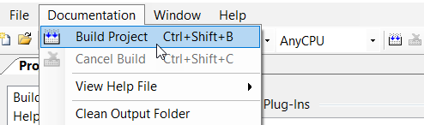

Figure 14: Build the documentation project

1. Go to the ‘Build output’ window to see if the tool ran successfully

# Step 4: View the Documentation

1. Browse to the output path directory located here ../GeneratorBase.MVC/Documentation
   1. If you changed the ‘Output Path’ to point to another directory go there
2. Click on index.html to open the .NET documentation

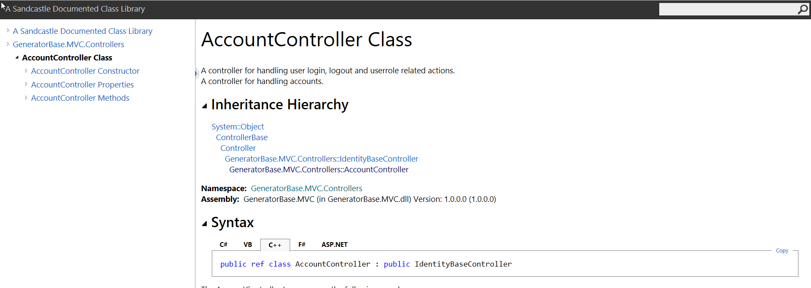

Figure 15: Sample SandCastle generated documentation page

1. Re-deploy this code from your local machine to the servers to access this documentation in the live system OR you can also deploy just the /Documentation folder.
2. This SandCastle generated documentation output URL can be found in the ‘Admin’ section of your application under the ‘Developer Tools’ group

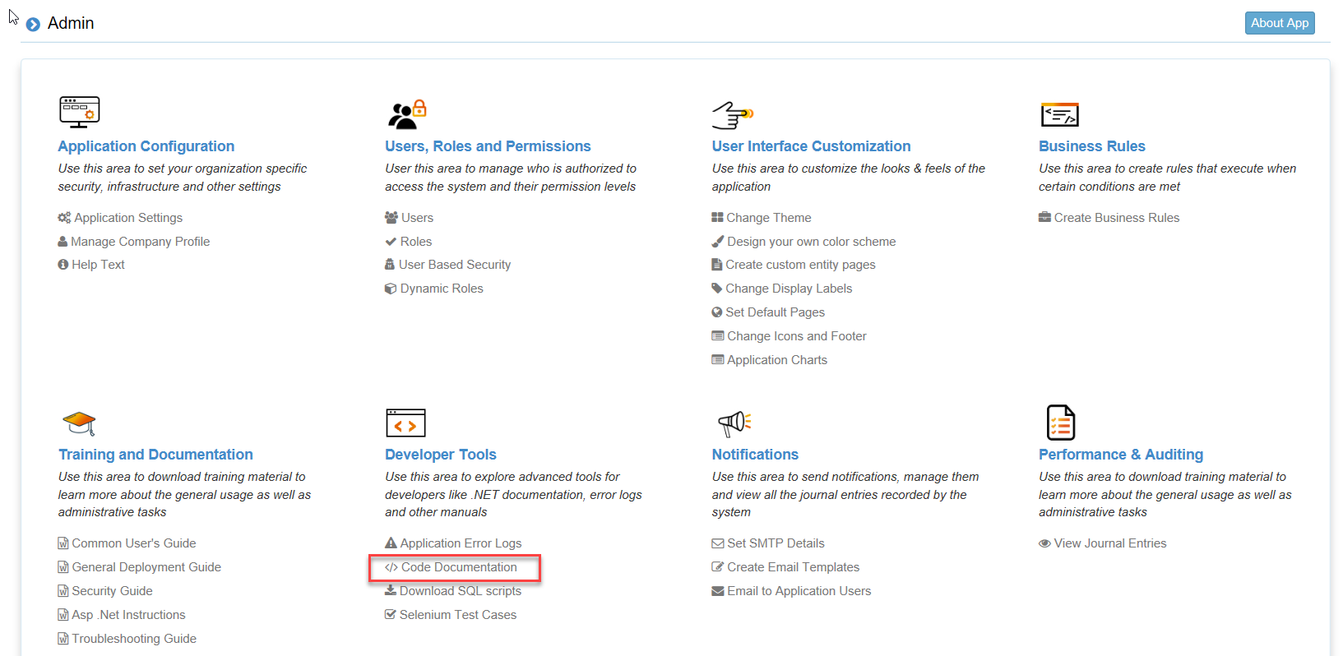

Figure 16: Link to the SandCastle Generated Documentation in the Admin Section

# Commonly Encountered Problems

## Missing Tags

If you see a lot of warnings due to missing <summary> tags you can suppress the messages by un-checking the warning messages for different tags by going to the ‘Missing Tags’ tab:

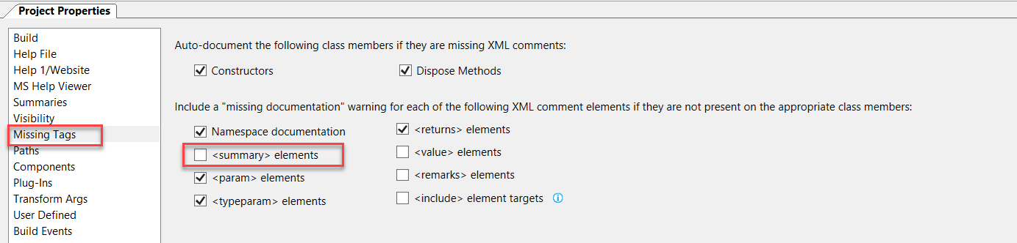

Figure 17: Suppress warnings for tags

## Build Error Due to Assemblies

If you see any Build errors due to Newtonsoft.JSON assembly, in the ‘Project Properties’ window go inside the ‘Plug-Ins’ option. Then go to the Assembly Binding Redirection and then the ‘Ignore If Unresolved’ tab. Add ‘Newtonsoft.Json’ and Click ‘Ok’

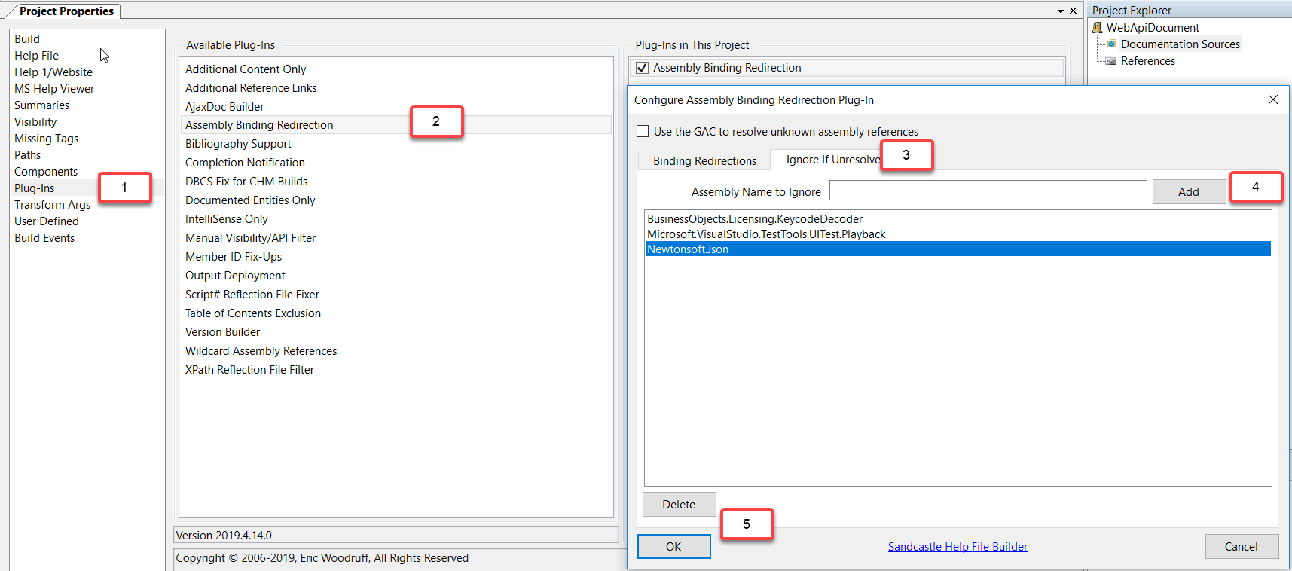

Figure 18: Ignore Unresolved assembly errors

# Point Of Contact

If you have any questions or concerns, please contact Company_Name at Company_Email