Azure Function Deployment on Azure Cloud

1. Create Azure SQL Database

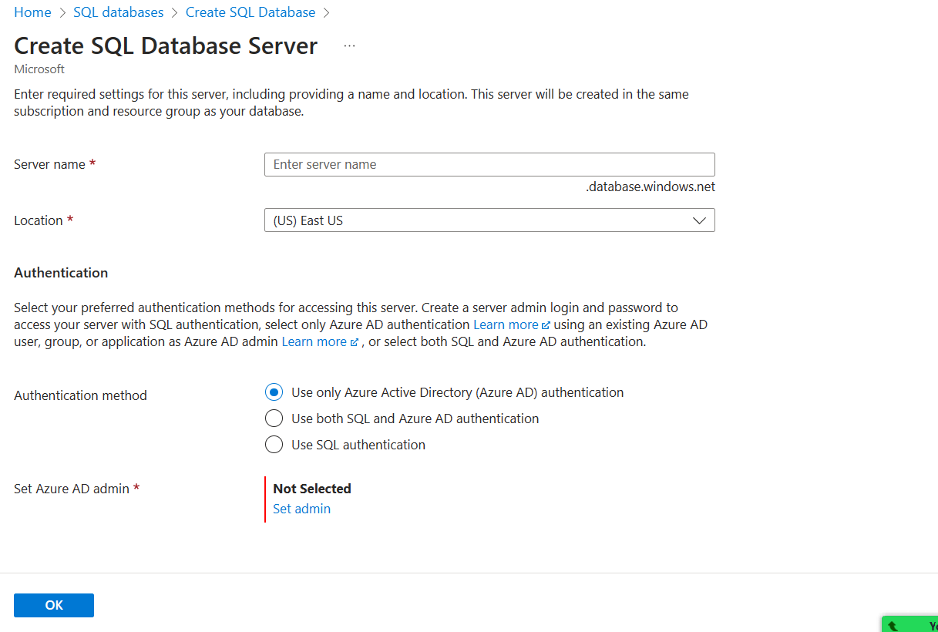

Make sure that u select SQL Authentication, make sure that the password is String password

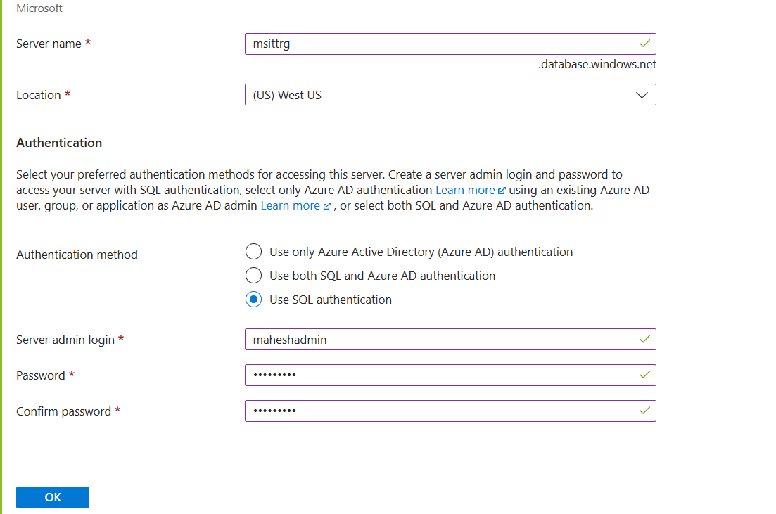

DB Costing

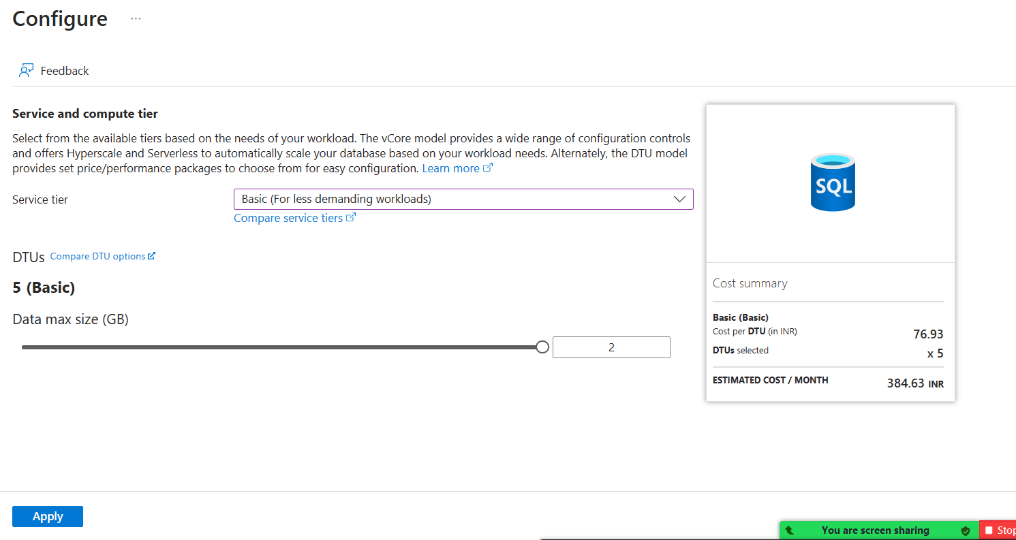

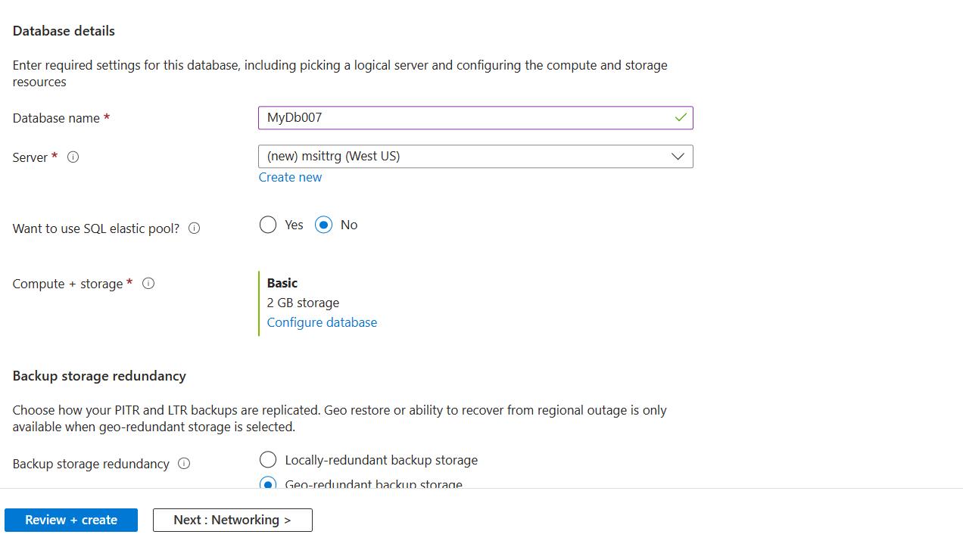

Click on Server name to set access ruels

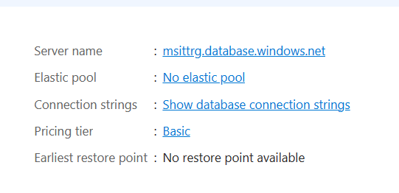

Click on Network Settings

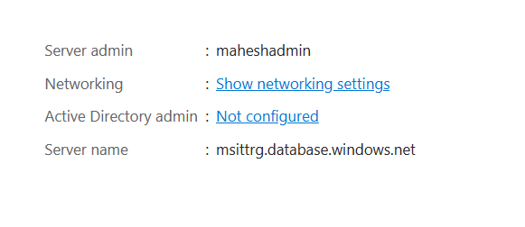

Add the Client IP and make sure that the DB is accessible from Azure Resources

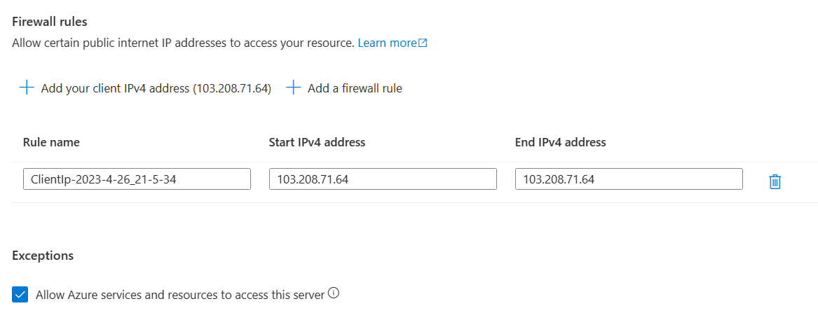

Copy the COnnstring string and connect to the Azure SQL from local Sql Server Management Studio

