CHAPTER-2 Requirement Analysis

2.1 Requirement Analysis
- ADMIN
  - Login
  - Add HR/Employee Details/Project Manager
  - View HR/Employee Details/Project Manager
  - Edit Profiles
  - of HR/Employee Details/Project Manager
- HR
  - Login
  - View Employee Details
  - Keep Track of Employee Attendance
  - Manages Leave of Employees
  - Keep Track of Employee Performance
  - Time-Sheet
  - Manages Salary of Employees
  - Manages Recruitment of Intern
- PROJECT MANAGERS
  - Login
  - Keep Track of Team Members
  - View Project Detail
  - Notify About Meetings
  - Submit Project
  - Analyse Work Done by HR
- EMPLOYEE
  - Login
  - Keep track of own attendance
  - Apply for Leave applications
  - Keep track of work done

2.2 Project Model

Iterative Waterfall Model :
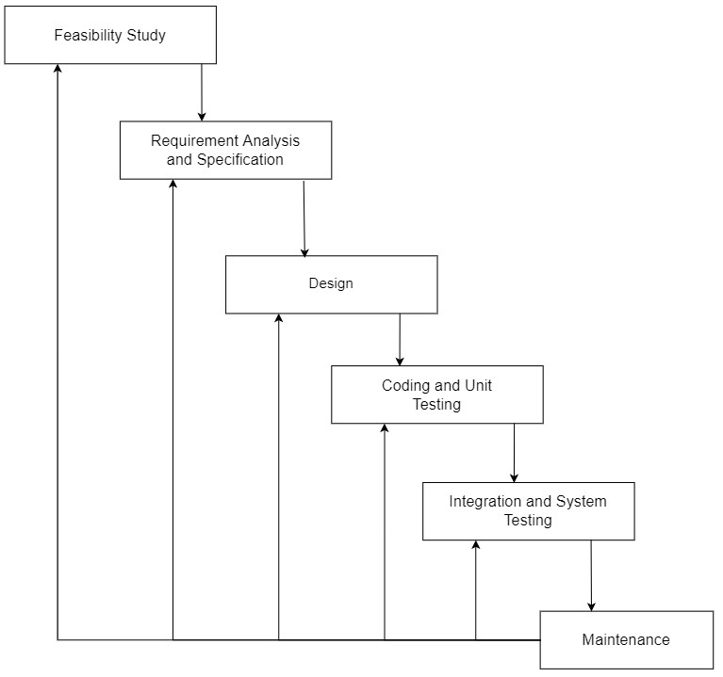[Figure 3: Iterative Waterfall Model]

- In this iterative model. Iterative process starts with a simple implementation of a small set of the software requirements and iteratively enhances the evolving versions until the complete system is implemented and ready to be deployed.
- An iterative life cycle model does not attempt to start with a full specification of requirements.
- Instead, development begins by specifying and implementing just part of the software, which is then reviewed to identify further requirements.
- This process is then repeated, producing a new version of the software at the end of each iteration of the model.
- When errors are detected at some later phase, these feedback paths allow correcting errors committed by programmers during some phase.
- The feedback paths allow the phase to be reworked in which error are committed and these changes are reflected in the later phase.
- But there is no feedback path to the stage – feasibility study, because once a project has been taken, does not give up the project easily.
- It is good to detect errors in the same phase in which they are committed. It reduces the effort and time required to correct the errors.

Advantages of Iterative Waterfall Model:
- Feedback Path:
In the iterative waterfall model feedback path from one phase to its preceding phase allows correcting the errors that are committed and these changes are reflected in the later phases.
- Simple:
Iterative waterfall model is very simple to understand and use. That’s why it is one of the most widely used software development models.
- Cost Effective:
It is highly cost-effective to change the plan or requirements in the model.
Moreover, it is best suited for agile organization.

2.3 Scheduled Representation
- Generalized project scheduling tools and technique can be applied with little modification to software projects.
- Program evolution and review techniques (PERT) and critical path method (CPM) are two project scheduling method that can be applied to software development. Both techniques are driven by information already developed in earlier project planning activities:
- Estimate of effort.
- A decomposition of the product function.
- The selection of appropriate task set.
- Decomposition of tasks.

[Table 1: Scheduled Representation]
ACTIVITIES | START DATE | FINISH DATE
Requirement Analysis
System Analysis
System Design
System Coding
Testing and Integration

2.4 Feasibility Study
Feasibility studies aim to objectively and rationally uncover the strengths and weaknesses of an existing business or proposed venture, opportunities and threats present in the environment, the resources required to carry through, and ultimately the prospects for success. In its simplest terms, the two criteria to judge feasibility are cost required and value to be attained.
A well-designed feasibility study should provide a historical background of the business or project, a description of the product or service, accounting statements, details of the operations and management, marketing research and policies, financial data, legal requirements and tax obligations. Generally, feasibility studies precede technical development and project implementation.
A feasibility study evaluates the project's potential for success; therefore, perceived objectivity is an important factor in the credibility of the study for potential investors and lending institutions. It must therefore be conducted with an objective, unbiased approach to provide information upon which decisions can be based.
- Economic Feasibility
The purpose of the economic feasibility assessment is to determine the positive economic benefits to the organization that the proposed system will provide. It includes quantification and identification of all the benefits expected. This assessment typically involves a cost/ benefits analysis.

- Technical Feasibility
The technical feasibility assessment is focused on gaining an understanding of the present technical resources of the organization and their applicability to the expected needs of the proposed system. It is an evaluation of the hardware and software and how it meets the need of the proposed system.

- Schedule Feasibility
A project will fail if it takes too long to be completed before it is useful. Typically, this means estimating how long the system will take to develop, and if it can be completed in a given time period using some methods like payback period. Schedule feasibility is a measure of how reasonable the project timetable is. Some projects are initiated with specific deadlines. It is necessary to determine whether the deadlines are mandatory or desirable.

