 

INSTITUTE FOR ADVANCED COMPUTING AND

SOFTWARE DEVELOPMENT AKURDI, PUNE

Documentation On

**“E-Barber Shop”**

PG-DAC FEB 2020

*Submitted By:*

**Group No: 53**

**Mahesh Wale 1159**

**Sanket Awasarkar 1014**

**Manojay kulkarni 1155**

**Prashant Karhale Mr. Milind Arjun Centre Coordinator Project Guide**

# Table of Contents

1. Introduction 4
   1. Document Purpose 4
   2. Problem Statement 5
   3. Product Scope 5
   4. Aim & Objectives 5
2. Overall Description 6
   1. Product Perspective 6
   2. Benefits of E-Barber Shop 6
   3. User and Characteristics 7
   4. Operating Environment 8
   5. Design and Implementation Constraints 9
3. Requirements Specification 9
   1. External Interface Requirements 9
4. System Diagram 11
   1. Activity Diagram 12
   2. Data Flow Diagram 14
   3. Use Case Diagram 17
   4. Class Diagram 18
   5. ER Diagram 19
5. Table Structure 20
   1. Shops 20
   2. Services 20
   3. Slots 20
   4. Users 21
   5. Appointments 21
   6. Appoint_Services 21
   7. Appoints_Slots 21
6. Conclusion 22
   1. Future Scope 22
7. References 23

**List of Figures**

Figure 1 Admin Activity Diagram 11

Figure 2 Shop Owner Activity Diagram 12

Figure 3 Customer Activity Diagram 13

Figure 4 Level 0 Data Flow Diagram 14

Figure 5 Level 1 Data Flow Diagram 14

Figure 6 Level 2 Data Flow Diagram for Admin 15

Figure 7 Level 2 Data Flow Diagram for Shop Owner 15

Figure 8 Level 2 Data Flow Diagram for Customer 16

Figure 9 Use Case Diagram 17

Figure 10 Class Diagram 18

Figure 11 ER Diagram 19

# 1. Introduction

Generally, to use the Barber Shop services the customer has to go to Barber shop and wait in queue for the Barber appointment in shop. There is no automated system for doing all the things that generally happens in society, so that we members come to know what is happening in society. The E-Barber Shop System allows customer to register and login. After that customer can select the location after selecting the location he can select shop he prefer. He can select the services that he wants from that shop. He can also select multiple services after that he can select the time slot as he prefer and book the appointment. The shop owner can view the list of appointment. The system has brought the customer and Barber Shop owner on one platform and decrease the communication gap between them.

## Document Purpose

The advancement in Information Technology and internet penetration has greatly enhanced various business processes and communication between Barber shop owners and their customers. This E-Barber Shop System is developed to provide the following services:

* + 1. Enhance Business Processes:

To be able to use internet technology to project to the global world instead of limiting their services to their local domain alone, thus increase their return on investment (ROI).

* + 1. Online Society Management:

Customer can select the location from drop box. After selecting the location he can select particular shop. He can select the services that he wants. He can also select multiple services after that he can select the time slot as he prefer and book the appointment.

## Problem Statement

Existing system to use the Barber Shop services the customer has to go to Barber shop and wait in queue for the barber appointment in shop. Its customers do not have a proper way to make an appointment other than making a call or visit the Salon premise. Salon owner, employees and customers need to keep reminders on their mobiles over appointments. Salon owner and her employees maintain a diary to note down the appointment details. Service details of the salon are written on papers which always leading for misplacements. Hence this system is proposed to overcome the flaws of the existing system and now customer can book the Barber Shop appointment online and also shop owner can add, update and view the services and also can view the list of appointments.

## Product Scope

This project traverses a lot of areas ranging from business concept to computing field, and required to perform several researches to be able to achieve the project objectives. The area covers include:

* This includes study on how the daily Barber shop appointment process involved

and opportunity that exist for improvement..

* J2EE Technology used for the development of the application.
* General customers as well as the shop owner will be able to use the system effectively.
* Web-platform means that the system will be available for access 24/7 24/7 except when there is a temporary server issue which is expected to be minimal..

## Aims & Objectives

Specific goals are: -

* To produce a web-based system that allows the customer to book Barber Shop appointment online.
* Shop owner can view the list of appointments of customer and also can add, update and delete the services.
* To fill the communication gap between customer and shop owner.

# Overall Description

## Product Perspective:

2.1.1 Existing system function:

Existing system to use the Barber Shop services the customer has to go to Barber shop and wait in queue for the barber appointment in shop. Its customers do not have a proper way to make an appointment other than making a call or visit the Salon premise. Salon owner, employees and customers need to keep reminders on their mobiles over appointments. Salon owner and her employees maintain a diary to note down the appointment details. Service details of the salon are written on papers which always leading for misplacements.

* + - **III. PROPOSED SYSTEM**
    1. Product functionality:

E-Barber Shop System provides the features for admin, shop owner and customer. It includes several functionalities describes as below:

* + - 1. *Admin Management:*

It provides facility to add, update, delete and view the shops. We can view their details and also update the shop details.

* + - 1. *Shop Owner Management:*

The shop owner can view the list of appointment. He can add, update and delete the services. He can add time slots. Shop owner can change the status of shop that shop is on/off for that day.

*Booking the appointment:*

Customer can select the location from drop box. After selecting the location he can select particular shop. He can select the services that he wants. He can also select multiple services after that he can select the time slot as he prefer and book the appointment.

## Benefits of E-Barber Shop

* This E-Barber Shop system is fully functional and flexible.
* It is very easy to use.
* This system helps customer to book appointment at barber shop.
* It saves lot of time of customer.
* It increases the efficiency of the management at offering quality services to the customers.

## Users and Characteristics:

* + 1. Admin:
       - Admin can login to the system.
       - View the list of all the register shops.
       - Add new shop.
       - Delete shop.
       - Update shop details.
    2. Customer:
       - Customer can login to the system.
       - Select the location of shop.
       - Can view list of shops at that location.
       - Can select the shop.
       - From selected shop can select multiple services.
       - After selecting services he can time slot.
       - Can book the appointment.
    3. Shop Owner:
       - Shop owner can login to the system.
       - View appointment list.
       - Add new services.
       - Update services.
       - Delete the services.
       - Add time slot.
       - Delete time slot.
       - Change the status of shop is on/off.

## Operating Environment:

* + 1. Server Side:

**Processor:** Intel Dual Core

**HDD:** Minimum 500GB Disk Space

**RAM:** Minimum 2GB **OS:** Windows 8.1 **Database:** MySQL.

Client Side (minimum requirement):

**Processor:** Intel Dual Core

**HDD:** Minimum 80GB Disk Space

**RAM:** Minimum 1GB

**OS:** Windows 7.

## Design and Implementation Constraints:

* The application will use Spring MVC, JavaScript, CSS Bootstrap as main web technologies.
* HTTP and FTP protocols are used as communication protocols. FTP is used to upload the web application in live domain and the client can access it via HTTP protocol.
* Several types of validations make this web application a secured one and SQL Injections can also be prevented.
* Since E-Barber Shop System is a web-based application, internet connection must be established.
* The E-Barber Shop System will be used on PCs and will function via internet or intranet in any web browser.

# Specific Requirement

## External Interface Requirements:

* + 1. User Interfaces:
* All the users will see the same page when they enter in this website. This page asks the users a username and a password.
* After being authenticated by correct username and password, user will be redirect to their corresponding profile where they can do various activities.
* The user interface will be simple and consistence, using terminology commonly understood by intended users of the system. The system will have simple interface, consistence with standard interface, to eliminate need for user training of infrequent users.
  + 1. Hardware Interfaces:
* No extra hardware interfaces are needed.
* The system will use the standard hardware and data communication resources.
* This includes, but not limited to, general network connection at the server/hosting site, network server and network management tools.
  + 1. Application Interfaces:

**OS:** Windows 7, Linux

**Web Browser:**

The system is a web-based application; clients need a modern web browser such as Mozilla Firebox, Internet Explorer, Opera, and Chrome. The computer must have an Internet connection in order to be able to access the system.

* + 1. Communications Interfaces:
* This system uses communication resources which includes but not limited to, HTTP protocol for communication with the web browser and web server and TCP/IP network protocol with HTTP protocol.
* This application will communicate with the database that holds all the booking information. Users can contact with server side through HTTP protocol by means of a function that is called HTTP Service. This function allows the application to use the data retrieved by server to fulfil the request fired by the user.

# System Design

# 1.Admin activity

## 

**Figure 1: Admin Activity Diagram**

## 

**Figure 2: Shop Owner Activity Diagram**

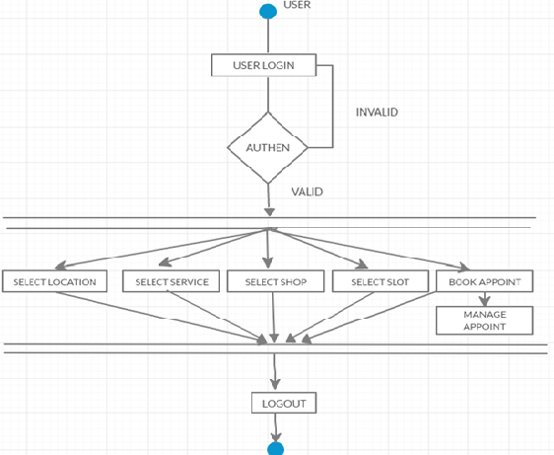

**Figure 4: Customer Activity Diagram**

## Data Flow Diagram



**Figure 4: Level 0 Data Flow Diagram**

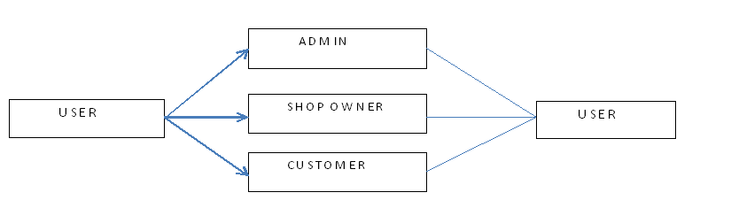

**Figure 5: Level 1 Data Flow Diagram**

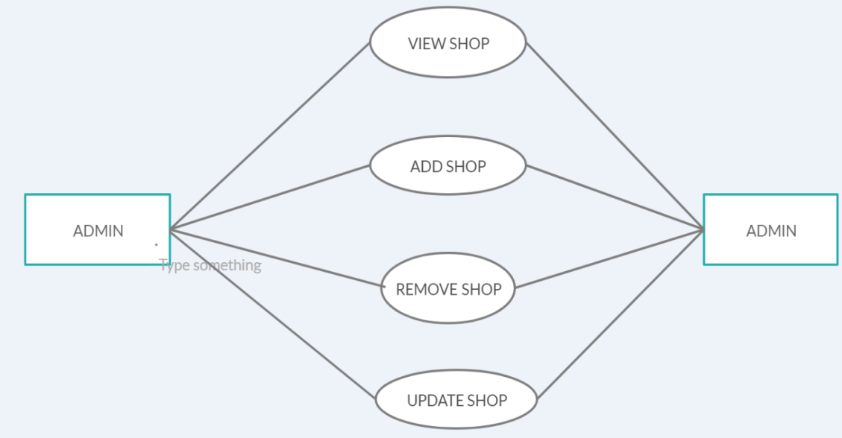

**Figure 6: Level 2 Data Flow Diagram for Admin**

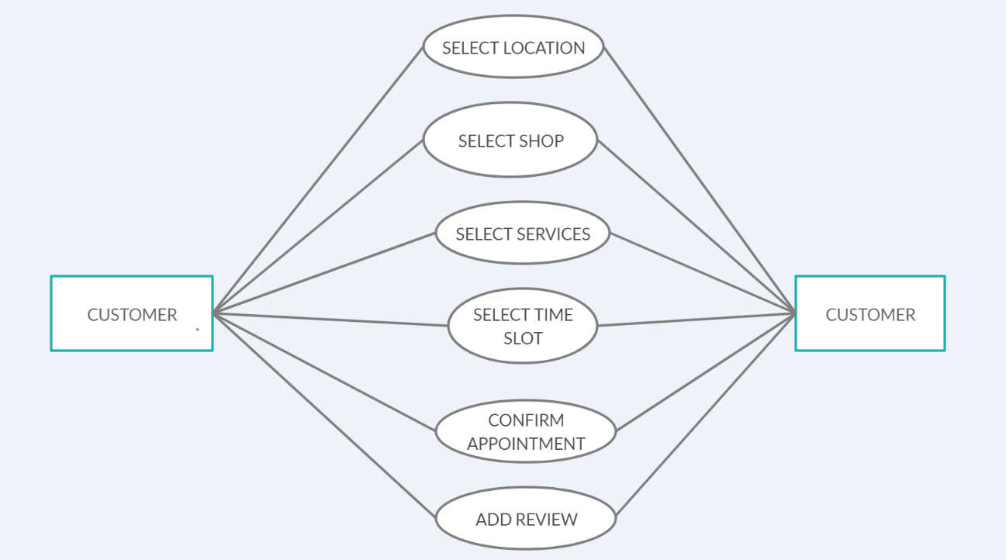

**Figure 7: Level 2 Data Flow Diagram for Customer**

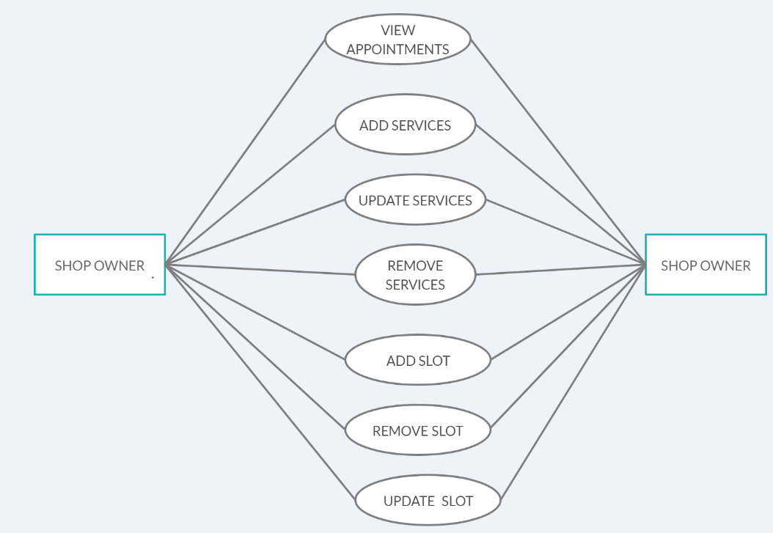

**Figure 8: Level 2 Data Flow Diagram for Shop Owner**

## Use Case Diagram

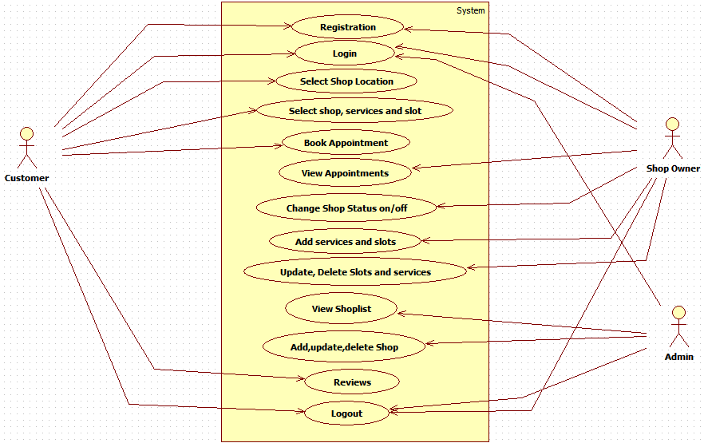

**Figure 10: Use Case Diagram**

## 

## Class Diagram

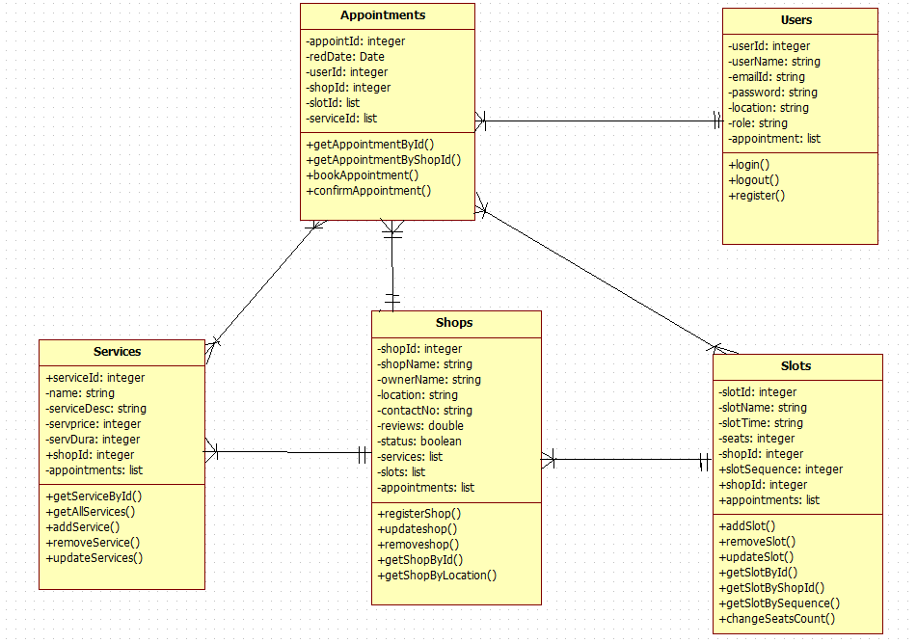

**Figure 9: Class Diagram**

## 

## ER Diagram

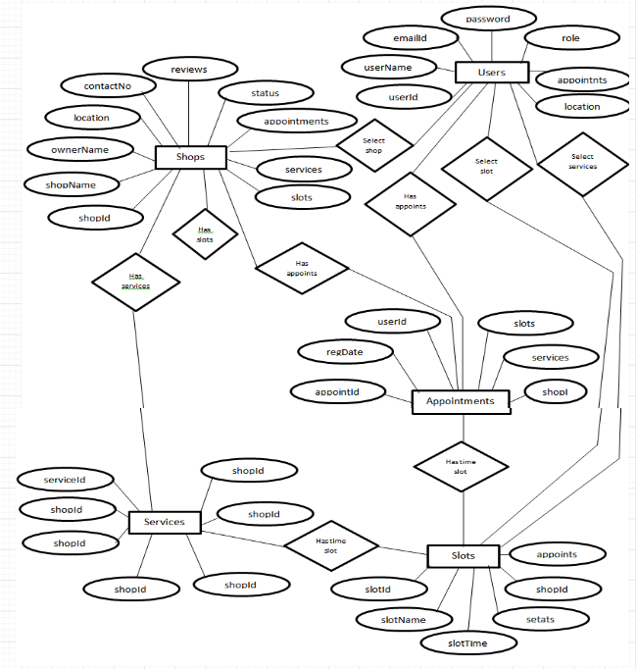

**Figure 11: ER Diagram**

# Table Structure

## SHOP:

|  |  |  |  |  |  |
| --- | --- | --- | --- | --- | --- |
| Field | Type | Null | Key | Default | Extra |
| shopId | number(11) | NO | PRI | NULL | Auto_increment |
| shopName | varchar2(30) | NO |  | NULL |  |
| ownerName | varchar2(30) | NO | UNI | NULL |  |
| location | varchar2(30) | NO |  | NULL |  |
| contactNumber | number(10) | NO |  | NULL |  |
| status | boolean | NO |  | NULL |  |
| reviews | number(10) | NO |  | NULL |  |

## SERVICES :

|  |  |  |  |  |  |
| --- | --- | --- | --- | --- | --- |
| Field | Type | Null | Key | Default | Extra |
| serviceId | number(11) | NO | PRI | NULL | Auto_increment |
| serviceName | varchar2(50) | NO |  | NULL |  |
| servDesc | varchar2(100) | YES |  | NULL |  |
| ServiceTime | number(10) |  |  | NULL |  |
| servicePrice | number(10) |  |  | NULL |  |
| shopId | number(10) |  | FKEY | NULL |  |

## SLOTS:

|  |  |  |  |  |  |
| --- | --- | --- | --- | --- | --- |
| Field | Type | Null | Key | Default | Extra |
| slotId | number(11) | NO | PRI | NULL | Auto_increment |
| slotName | varchar2(100) | YES |  | NULL |  |
| slotTime | varchar2(100) | NO | UNI | NULL |  |
| chaireAvalable | number(10) | NO |  | NULL |  |
| shopId | number(10) | NO | FKEY | NULL |  |
| slotSequence | number(10) | NO |  | NULL |  |

## 

## USERS:

|  |  |  |  |  |  |
| --- | --- | --- | --- | --- | --- |
| Field | Type | Null | Key | Default | Extra |
| userId | number(11) | NO | PRI | NULL | Auto_increment |
| userName | varchar2(20) | NO |  | NULL |  |
| emailId | varchar2(30) | NO | UNI | NULL |  |
| password | number(10) | NO |  | NULL |  |
| location | varchar2(30) |  |  | NULL |  |
| role | Varchar2(10) |  |  | NULL |  |

## Appointments:

|  |  |  |  |  |  |
| --- | --- | --- | --- | --- | --- |
| Field | Type | Null | Key | Default | Extra |
| appointId | number(11) | NO | PRI | NULL | Auto_increment |
| regDate | Date | NO |  | NULL |  |
| shopId | number(10) |  | FKEY | NULL |  |
| userId | number(10) |  | FKEY | NULL |  |

## appoints_services:

|  |  |  |  |  |  |
| --- | --- | --- | --- | --- | --- |
| Field | Type | Null | Key | Default | Extra |
| appointId | number(11) | NO |  | NULL |  |
| serviceId | number(11) | NO |  | NULL |  |

## appoints_slots:

|  |  |  |  |  |  |
| --- | --- | --- | --- | --- | --- |
| Field | Type | Null | Key | Default | Extra |
| appointId | number(11) | NO |  | NULL |  |
| slotsId | number(11) | NO |  | NULL |  |

**Conclusion**

E-Barber Shop system is responsible for providing best services, flexible time slot and daily services and time changes with the affordable prices on specified. This approach also offers an added advantage that customers can select a specified time slot of the day for the appointments of shop. The application provides facility to add/remove/slot and services items at shop. It also provides facility where customers can mention their queries/complaints in reviews.

.

# Future Scope

This project can be enhanced further by adding other categories and Services. The software is flexible enough to be modified and implemented as per future requirements. Message and Email alerts for various happenings can be added to the system so that users do not miss the updates and happenings of the system.

# 7 References

[1]. Kirti Bhandge, Tejas Shinde, Dheeraj Ingale, Neeraj Solanki, Reshma Totare,”A Proposed System for Touchpad Based Barber shop System Using Android Application”, International Journal of Advanced Research in Computer Science Technology (IJARCST 2015).

[2]. Varsha Chavan, Priya Jadhav,Snehal Korade,Priyanka Teli, ”Implementing Customizable Online Barber shop System Using Web Based Application”, International Journal of Innovative Science, Engineering Technology(IJISET) 2015.

**ONLINE REFERENCE**

1. [www.salonist.in/](http://www.salonist.in/)
2. <https://docs.oracle.com/javase/tutorial/>