

  
Synopsys Presents Inno Champ Contest

**Theme of The Contest : SMART, SECURE, EVERYTHING**

***Innovative ideas to create Cleaner and Healthier Planet; To detect, prevent and fight Corona pandemic***

|  |
| --- |
| Maheshwaran.p |
| Government college of technology  coimbatore |

# CONFIDENTIAL INFORMATION

The information contained in this presentation is the confidential and proprietary information of Synopsys. You are not permitted to disseminate or use any of the information provided to you in this presentation outside of Synopsys without prior written authorization.

# IMPORTANT NOTICE

In the event information in this presentation reflects Synopsys future plans, such plans are as of the date of this presentation and are subject to change. Synopsys is not obligated to update this presentation or develop the products with the features and functionality discussed in this presentation. Additionally, Synopsys services and products may only be offered and purchased pursuant to an authorized quote and purchase order or a mutually agreed upon written contract with Synopsys.

## Participant Details

|  |  |
| --- | --- |
| **Title** | **Specify Details** |
| Name of the participant | Maheshwaran.p |
| Specify your Engg Degree | BE-CSE 3rd year |
| Specify Category | Inno Champ Male |
| Name of the Engineering College and City |  |
| **Theme of The Contest :** SMART, SECURE, EVERYTHING | |
| **Focus of the presentation** : **Innovative ideas to create Cleaner and Healthier Planet, To detect, prevent and fight Corona pandemic** | |
| **Technology to be explored in the proposed solution :** AI/ML OR Cloud OR IoT OR Semiconductors OR Combination of any of these technologies | |
| **Application of the proposed solution to be in the Domain of :** Automation and Robotics, Health and Wellness, Energy and Environment | |
| **Criteria for Evaluation of the Presentation :** Complexity of the problem statement, Subject Knowledge/Domain/Technology, Potential Business Opportunity, Novelty of the Idea , Mention of earlier Publications(if any) | |
| **Important Points to Note :** Fill in the details in Slide 3,4. Limit to Maximum 4-5 slides Including slide # 3,4. Font size Calibri 10, Presentation to reach Synopsys Team by **28 October 2020** | |

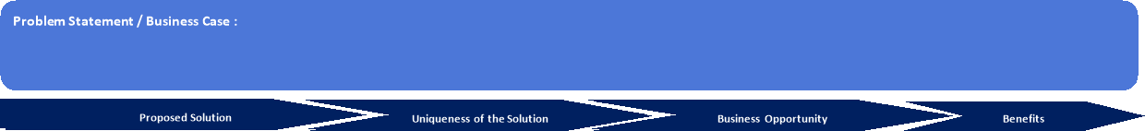

|  |  |  |  |  |  |  |
| --- | --- | --- | --- | --- | --- | --- |
| **Scope :**  **Application/Use Case  :To give awareness by  correct information to the correct people.**  **For Example: consider , whenever people want  to go outside they need  to   use our platform and our platform wants Bluetooth access.**  **Now , I am going to the temple with this platform . whenever I am getting very close to person ,this platform warns me with sound notification .here distance will be calculated by Bluetooth strength.**  **Bluetooth strength ∝1/distance.**  **Distance is  indirectly proportional to the Bluetooth strength.**  **If it perceives high strength, it starts indicating me  to keep social distance  and stores the detail [ user id /device ID of this platform] of the person who stands near to me .This data will refresh every 14 days. In this manner we can keep track of every person who crossed me or who came near by me .After this traveling , if my covid19 test result was positive we can sent this message to stored users id/device ID  in my device and can create awareness as " you went too near to a covid patient ,so  make sure as negative! to ignore your negativity!".** |  | **Any references :**  **Its completely new idea.**  **Mention Prior Publications of this Idea / Solution (If applicable) :** |  | **Potential Business Opportunity :In chinna , everyone needs to wear location tracking band to trace people to reduce the spread of the  Covid19.Our platform (App) being  software is  less expensive than hardware (band).so we  can  release this platform in these kind of countries as a subscription soft service .otherwise we can gain by admob.** | Reduce  the spreading opportunity of virus by tracing last 14 days details[ visited people ] of covid patient.Benifits for the end user:can  prevent from covid by taking immediate action(test) | **For End User**:  **Compared to existing solutions :** |

**Tools and Technology Proposed for the Solution :**

Explanation of the Proposed Solution

Wireframe / Schematic Diagram / Innovation Effort

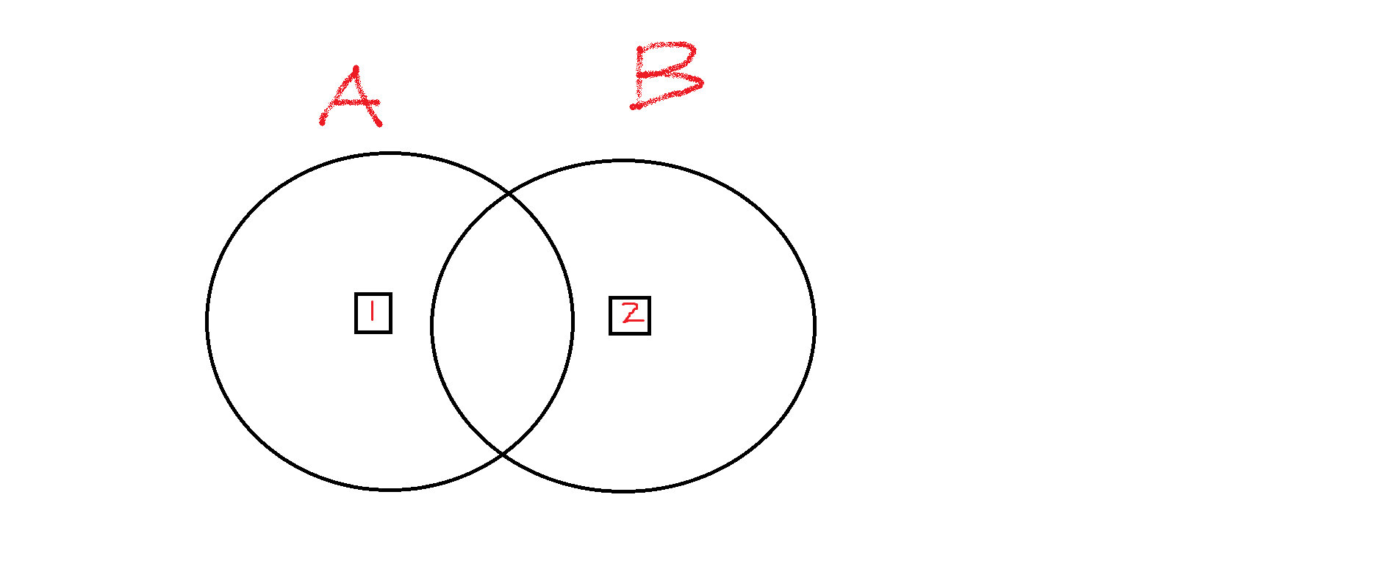

## Explanation of the Proposed Solution

Wireframe / Schematic Diagram /Innovation Effort

Here , A is the Bluetooth region of person1 and B is the Bluetooth region of person2.If the Bluetooth strength is high ,we need to store user id(unique) of person 2 into person 1's device and  person 1's user id into person 2  for 14 days.

 Synopsys Confidential Information © 2020 Synopsys, Inc. 1z