Phase 1 (Rank 106)
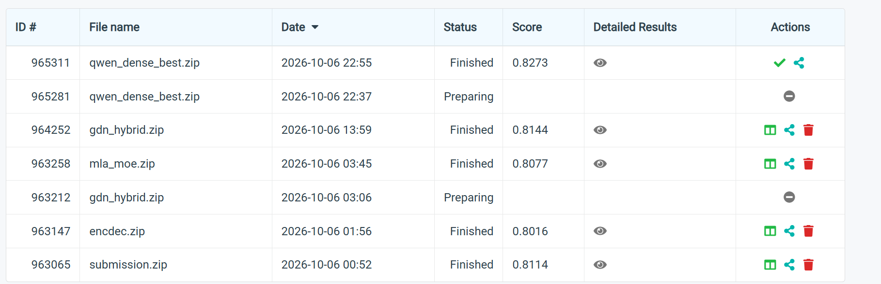
Phase 2 (Rank 113)
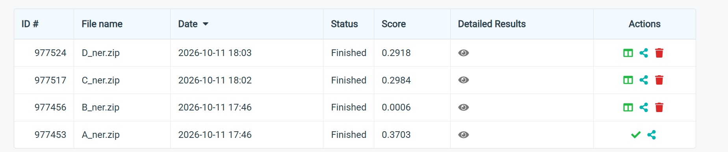
Phase 3 (Rank 50)
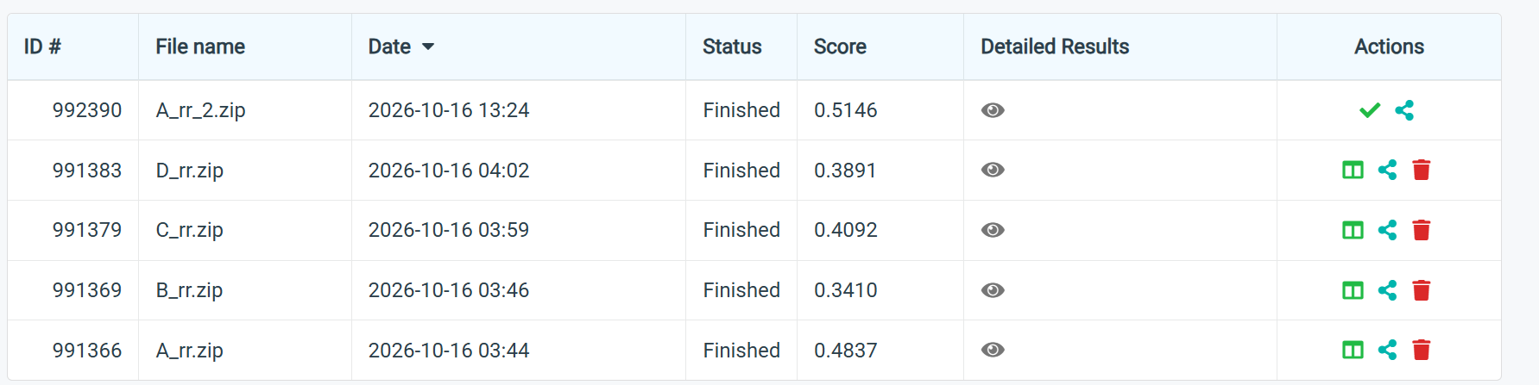
Phase 4 (Rank 22)
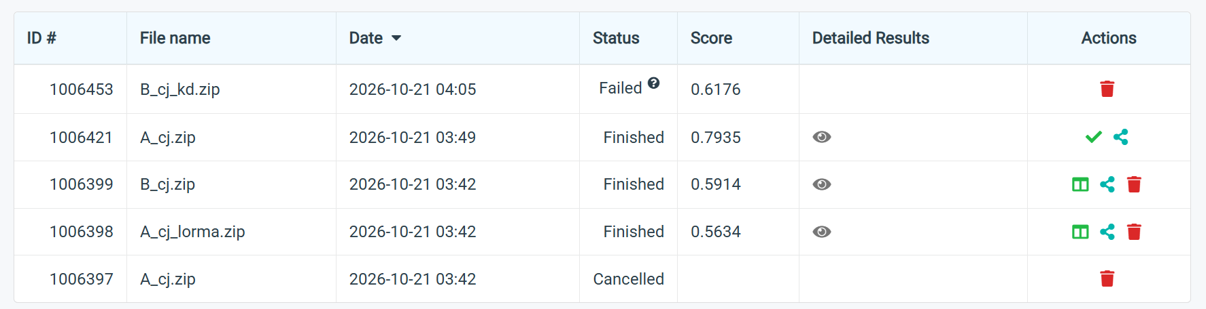

Phase 5 (Rank 92)
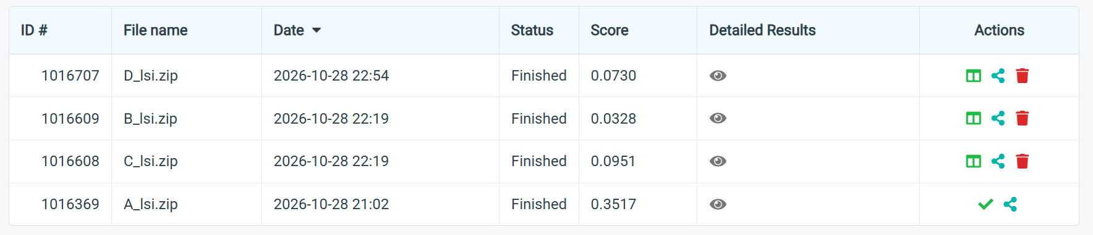
Phase 6 (Rank 119)
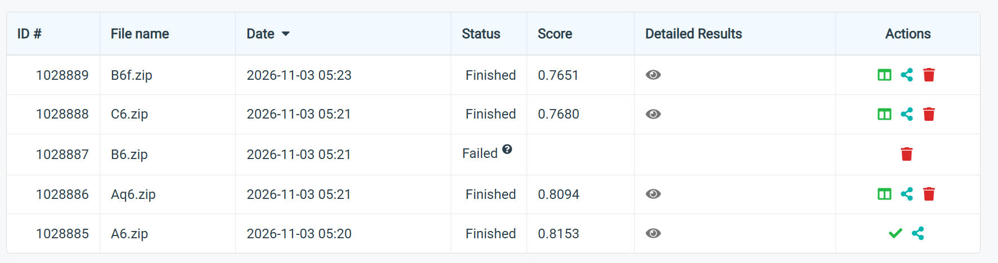
Phase 7 (Rank 126)


