**1 INTRODUCTION:**

1.1 Overview :

The air transport system generally includes airports, ATC system, and airlines.This course will provide you with an overview of the air transportation system and illustrate the interdependence among its components.

1.2 Purpose:

Air transport allows people from different countries to cross international boundaries and travel other countries for personal, business, medical, and tourism purposes.

**2 PROBLEM DEFINITION & DESIGN THINKING:**

2.1 Empathy map

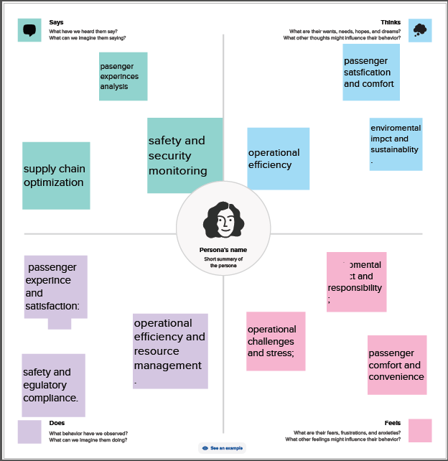

2.2 Ideation & Brainstorming Map

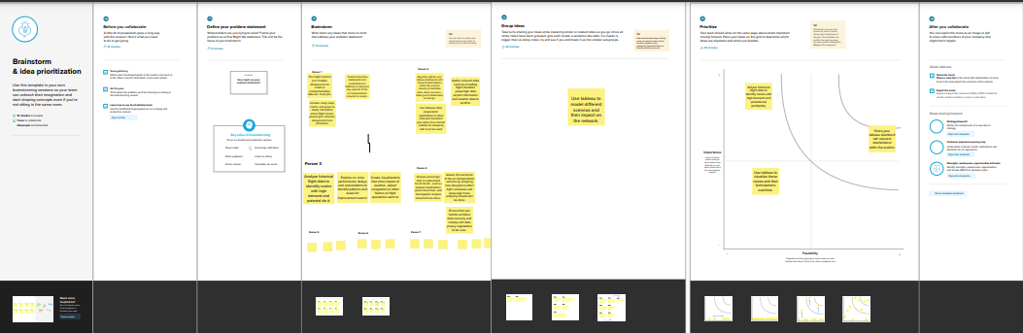

3 RESULT:

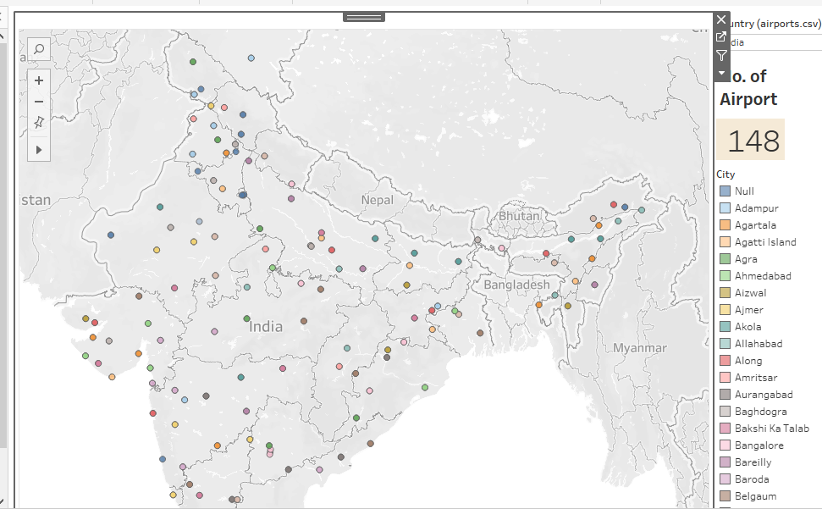

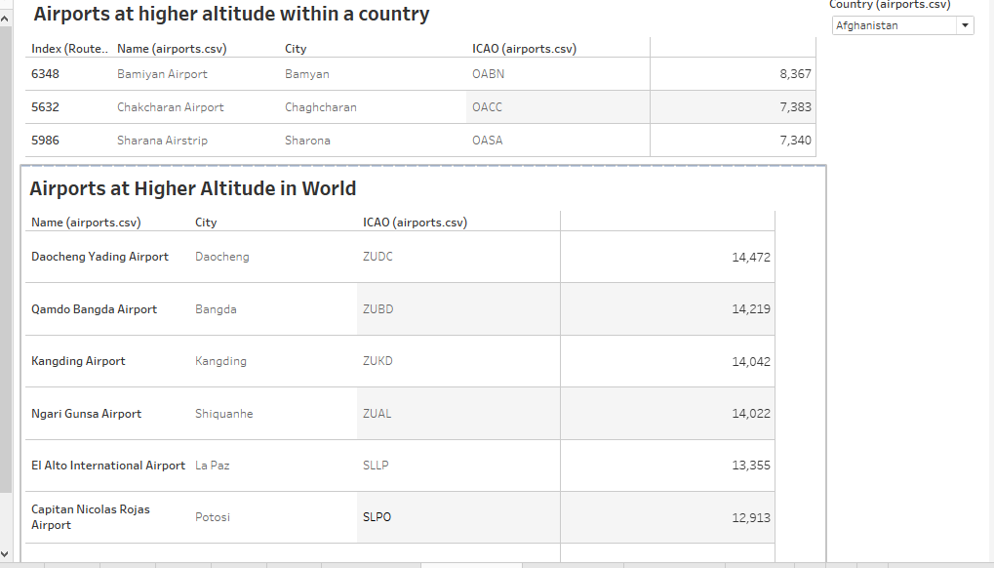

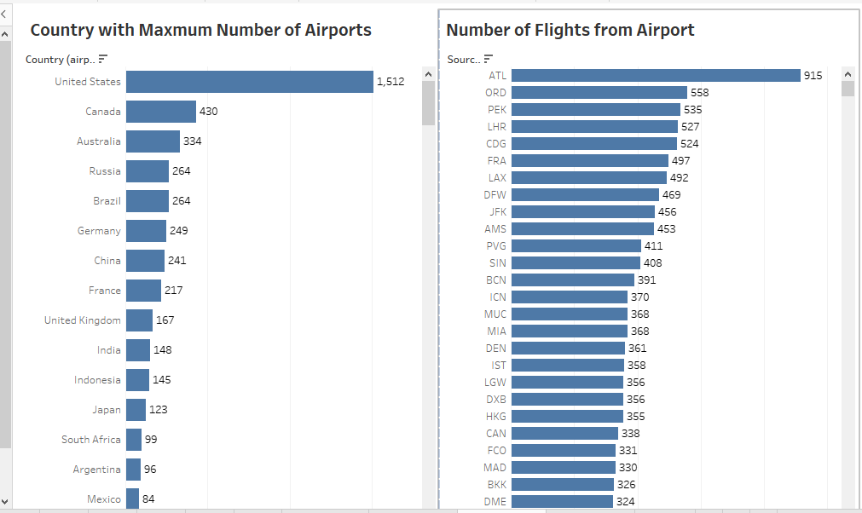

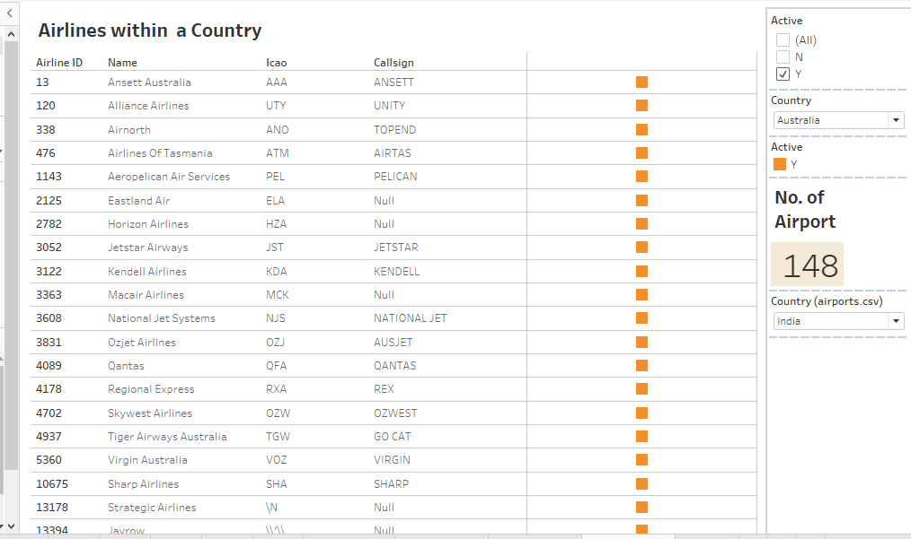

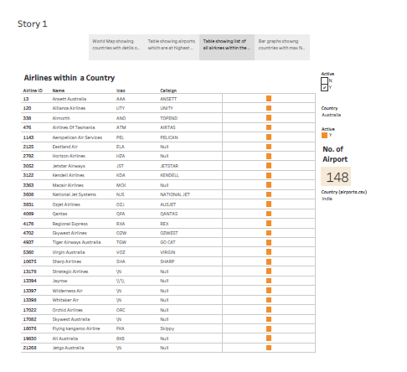

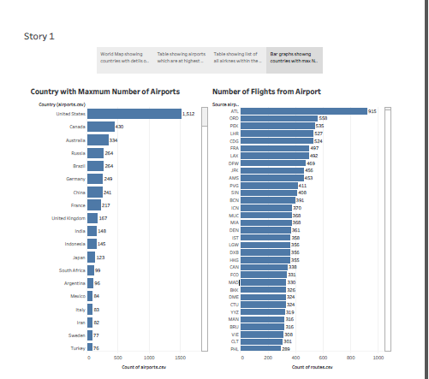

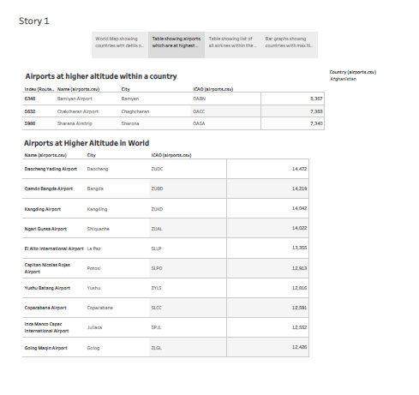

4 ADVANTAGES &DISADVANTAGES:

Advantages:

Transportation at high speeds.

Aviation is crucial in defence to more easily protect any nation from attackers.

Physical barriers like land borders water, or mountains do not limit their speed.

It offers a secure environment for the transport of expensive products.

Disadvantages:

More costly than other modes of transportation.

Unsuitable for cheap, large items as transport costs may exceed the cost of the items.

To fly or operate any aircraft, skill is required.

More prone to accidents than other modes.

5 APPLICATION:

Generates economic growth, provides jobs, increases revenues from taxes, and fosters the conservation of protected areas.

A critically infrastructure with high impact on mobility, trade and economy.

Speed, reliability in terms of cargo security, lack of access limitations to remote locations.

Business and leisure travel, the delivery of time-sensitive goods, and emergency response and rescue missions.

6 CONCULSION:

The air transport industry is not only a vital engine of global socio-economic growth but is also of vital importance as a catalyst for economic development in most countries and for many regions within each country .

The air transport industry needs not only to be financially sound to be effective as an economic catalyst for growth but also to be environmentally responsible.

Its arises not only from its ability to facilitate the movement of people but also its ability to expedite the movement of goods.

7 FUTURE SCOPE:

Robotics, artificial intelligence, the internet of things, unmanned aircraft systems and the push for hybrid and electric airplanes.

The future of the aviation industry in India is likely to see continued growth and expansion.

8 APPENDIX:

https://benex.com

https://d3.harvard.education.com