**Project Synopsis: FF No** **180**

**Project Title: Fracture Detection from Mobile-Captured X-rays**

**Introduction:**

Fractures are one of the most common orthopedic conditions requiring timely detection. In hospitals and rural healthcare centers, X-ray films are often photographed using mobile devices to share with doctors. However, these images are prone to issues such as **low contrast, noise, reflections, blur, and perspective distortions**, making fracture identification difficult.

Manual diagnosis by radiologists can be slow and error-prone in resource-constrained areas. Therefore, there is a strong need for an **automated system** that can preprocess mobile-captured X-ray images and apply **machine learning/deep learning algorithms** to detect fractures accurately and efficiently. This project focuses on building such a system to aid medical professionals and patients by providing fast, reliable, and accessible diagnostic support.

**Literature Survey:**

**Table 1. Literature Survey of existing literature**

|  |  |  |  |  |  |
| --- | --- | --- | --- | --- | --- |
| **Sr.**  **No** | **Paper Title** | **Objectives claimed by**  **authors in their paper** | **Methodologies used** | **Outcomes**  **(from result &**  **Discussion)** | **Gap Identified**  **(Generally from Conclusion & Future**  **scope)** |
| 1. | A Modified VGG19-Based Framework for Accurate and Interpretable Real-Time Bone Fracture Detection (2025) | To build an interpretable, real-time fracture detection model | Modified VGG-19 CNN, CLAHE, Otsu thresholding, Canny edge detection, Grad-CAM visualization | The system achieved 99.78% accuracy and AUC of 1.0, with inference time <0.5 seconds, making it both accurate and practical | Tested on clean X-rays, lacks evaluation on mobile-captured noisy images |
| 2. | Lightweight G-YOLOv11: Advancing Efficient Fracture Detection in Pediatric Wrist X-rays (2024) | To design a lightweight and efficient detection model for pediatric fractures | YOLOv11 with Ghost Convolutions for reduced computation | Achieved mAP@0.5 of 0.535 with inference speed of 2.4 ms, reducing model size by 68.7% compared to YOLOv11l | Limited accuracy; not validated on non-clinical or mobile-captured images |
| 3. | Pediatric Wrist Fracture Detection Using Feature Context Excitation Modules in X-ray Images (2024) | To improve fracture detection accuracy by enhancing feature representation using attention mechanisms | YOLOv8 integrated with SE (Squeeze-Excitation), Global Context, Gather-Excite, and Gaussian Context Transformer modules | |  | | --- | |  |  |  | | --- | | Best variant (YOLOv8 + SE-M3) improved mAP@50 to 67.07%, outperforming standard YOLOv8 | | The model improves context-awareness but still struggles with blurred and low-quality X-rays, typical of mobile captures |
| 4 | YOLOv8-ResCBAM: YOLOv8 Based on an Effective Attention Module for Pediatric Wrist Fracture Detection (2024) | To increase detection accuracy for pediatric wrist fractures using attention-enhanced YOLO | Integration of ResBlock and Convolutional Block Attention Module (CBAM) into YOLOv8 architecture | Achieved mAP@50 of 65.8%, an improvement over baseline YOLOv8 (63.6%) | Despite improvement, the accuracy remains moderate; not optimized for uncontrolled conditions such as glare, noise, or perspective issues in mobile-captured X-rays |
| 5 | Novel Transfer Learning Based Bone Fracture Detection Using Radiographic Images (MobLG-Net) (2025) | To build a lightweight transfer learning-based fracture detection system using a hybrid of deep and classical ML methods | MobileNet for feature extraction combined with LightGBM and Logistic Regression for classification | Achieved 99% accuracy in cross-validation, demonstrating high reliability | The approach is lightweight and mobile-suitable, but tested only on clinical-quality images; mobile-captured noisy X-rays not considered |
| 6 | Enhancing Diagnosis: Ensemble Deep-Learning Model for Fracture Detection Using X-ray Images (2024) | To enhance diagnostic accuracy by combining multiple deep learning models through an ensemble framework | Ensemble of MobileNetV2, VGG16, InceptionV3, and ResNet50. Preprocessing steps included histogram equalization and global average pooling | Reported accuracy of 92.96%, recall of 91.62%, and F1-score of 92.14% for humerus fracture detection | Ensemble approach improves performance but is computationally heavy, making it less suitable for mobile and real-time environments |
| 7 | Weakly Supervised Learning Based Bone Abnormality Detection from Musculoskeletal X-rays (2024) | To develop a detection system capable of recognizing bone abnormalities with minimal annotation effort, reducing dependency on fully labeled data | Employed weakly supervised learning techniques on musculoskeletal X-ray images to learn abnormality patterns without extensive ground truth | Demonstrated promising detection capability even with limited annotation, showing feasibility of reducing labeling burden | May lack precision in localization; needs evaluation on diverse image qualities, particularly mobile-captured X-rays |
| 8 | A Real-time Human Bone Fracture Detection and Classification from Multi-modal Images Using Deep Learning Technique (2024) | To build a real-time, multi-modal fracture detection and classification system for clinical use | Combined X-ray and MRI data using deep learning (e.g., YOLOv8) for fracture detection and classification tasks | Achieved high detection and classification accuracy in real-time across multiple modalities | Multi-modal setup increases complexity; applicability to single-mode, especially mobile-captured X-rays, is untested |
| 9 | FractureSpot: YOLO-Powered X-Ray Detection System (2025) | To compare multiple YOLO variants in terms of accuracy and efficiency for fracture detection | Implemented and evaluated YOLOv5x6, YOLOv5s6, YOLOv8n, and YOLOv9n on Roboflow’s Bone Fracture Detection dataset | Provided comparative metrics (precision, recall, mAP) across different YOLO versions, helping identify optimal variant for detection tasks | Evaluated on curated dataset; performance in noisy, mobile-captured settings remains untested |
| 10 | Real-Time Bone Fracture Detection Using MobileNetV2 and Explainable AI for Clinical Integration (2025) | To create a real-time, lightweight, interpretable fracture detection model deployable in clinical environments | Used MobileNetV2 CNN with Grad-CAM explainability, trained on elbow X-rays (normal, hairline, displaced); deployed via Docker + Flask web interface | Achieved accuracy of 89.26%, precision 91.52%, F1 score 89.04%, with minimal false negatives in real-time web deployment | Tested on clinical X-rays only; needs testing on mobile-captured images and extended to other bone types |

**Gaps Identified:**

The primary goal of this project is to design and implement an AI-based system that can accurately detect bone fractures from mobile-captured X-ray images. The specific goals are:

* To enable fast and reliable fracture detection without requiring high-quality, clinical-grade X-rays.
* To improve image quality of mobile-captured X-rays using preprocessing techniques (noise reduction, contrast enhancement, perspective correction).
* To develop a robust deep learning model capable of identifying fractures even under noisy, blurred, or distorted conditions.
* To provide a lightweight, mobile-compatible system that can be deployed in rural and resource-limited healthcare settings.
* To enhance diagnostic support for doctors by highlighting suspected fracture regions (explainable AI).
* To contribute towards accessible healthcare solutions, ensuring early and affordable fracture detection for patients.

**Objectives framed based on Gaps**

1. To design an image preprocessing pipeline that enhances mobile-captured X-ray quality by applying denoising, contrast enhancement, and perspective correction techniques.
2. To develop and train deep learning models (CNN, MobileNet, YOLO-based architectures) for robust fracture detection across varied bone types.
3. To evaluate model performance using standard metrics such as accuracy, precision, recall, F1-score, and AUC, ensuring reliable detection under noisy/low-quality input conditions.
4. To implement explainable AI methods (e.g., Grad-CAM) for highlighting fracture regions, thereby increasing interpretability and trust for medical practitioners.
5. To build a lightweight and mobile-compatible system for real-time detection, deployable as a mobile app or web-based interface for use in rural and resource-limited settings.
6. To validate the system in real-world conditions by testing it on mobile-captured X-rays (beyond clean, clinical datasets).

**Problem Statement:**

Bone fractures are among the most frequent injuries requiring rapid and accurate diagnosis. Conventional diagnosis relies on radiologists interpreting high-quality digital X-rays. However, in many rural and resource-constrained areas, X-ray films are often photographed using mobile devices and shared with doctors. These mobile-captured X-ray images suffer from several challenges, including low contrast, noise, blur, uneven lighting, glare, and perspective distortion, which significantly reduce diagnostic reliability.

Existing deep learning models for fracture detection have shown excellent performance on clean, clinical-grade datasets, but their accuracy drops drastically when applied to real-world, mobile-captured images. This gap limits their deployment in practical healthcare settings, especially where professional radiology facilities are not available.

Thus, there is a pressing need to develop a robust, lightweight, and mobile-compatible AI system that can preprocess mobile-captured X-rays and detect fractures with high accuracy. Such a system would improve accessibility, enable faster preliminary diagnosis, and support medical professionals in making better clinical decisions.

**Software Requirements:**

**Programming Languages & Frameworks:**

* Python – for deep learning model development, preprocessing pipeline, and integration.
* TensorFlow / PyTorch – for building and training CNN, MobileNet, and YOLO-based models.
* OpenCV & scikit-image – for image preprocessing (denoising, contrast enhancement, perspective correction).
* Flask / Django – for web-based deployment of the fracture detection system.
* Android Studio / React Native (optional) – if mobile application interface is developed.

**AI/ML Libraries & Tools:**

* Keras – for rapid prototyping of deep learning models.
* YOLOv8/YOLOv11 frameworks – for fracture localization.
* Grad-CAM libraries – for explainable AI visualization.
* scikit-learn – for evaluation metrics and classical ML (if hybrid methods used).

**Databases & Storage:**

* SQLite / MySQL / MongoDB – for storing patient records, test results, and images.
* Google Drive / AWS S3 / Firebase (optional) – for cloud storage and dataset handling.

**Version Control & Collaboration:**

* Git / GitHub – for version control and collaborative development.
* Jupyter Notebook / Google Colab – for experimentation and model training.

**Operating System:**

* Windows 10

1. **Algorithms**
2. **Image Preprocessing Algorithm –** Enhances mobile-captured X-rays by applying noise reduction (Gaussian/Bilateral filtering), contrast enhancement (Histogram Equalization/CLAHE), and perspective correction for clearer analysis.
3. **CNN/Transfer Learning Classification Algorithm –** Uses deep learning models (MobileNetV2, ResNet, EfficientNet) to classify X-rays as Fractured or Normal.
4. **YOLO-based Object Detection Algorithm –** Detects and localizes fracture regions in X-ray images using YOLOv8/YOLOv11 architectures.
5. **Grad-CAM Explainability Algorithm –** Generates visual heatmaps to highlight regions that influenced the model’s fracture prediction, improving interpretability.
6. **Quality Assessment Algorithm –** Automatically checks image quality (blur, glare, skew, low brightness) and prompts user to re-capture if input is unsuitable.
7. **Deployment & Reporting Algorithm –** Integrates the trained model into a lightweight mobile/web application, producing fracture detection results and overlays for doctors/patients.
8. **Architecture Diagram**

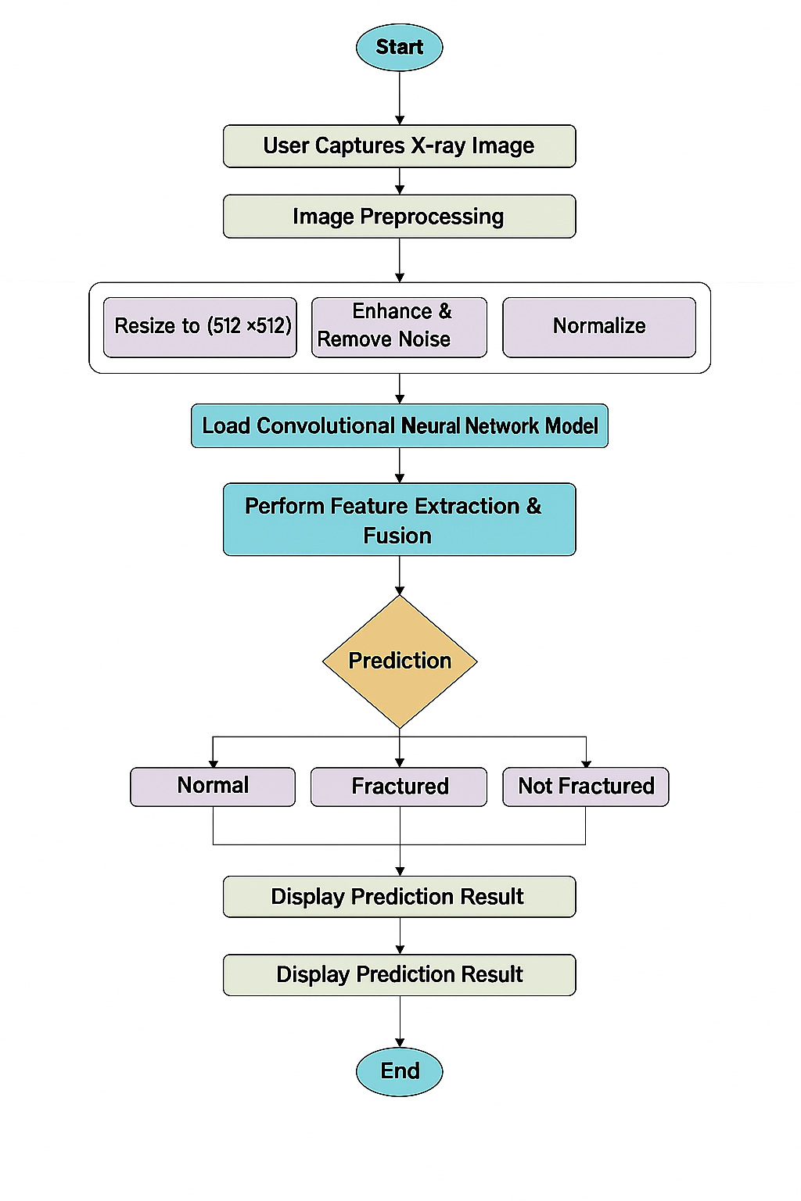

**Fig 1: Fracture Detection from Mobile-Captured X-rays**

**Expected Outcomes:**

1. **Preprocessed X-ray Images** – Mobile-captured X-rays enhanced through denoising, contrast adjustment, and perspective correction for improved clarity.
2. **Accurate Fracture Classification** – Automatic identification of X-rays as *Fractured* or *Normal* with high accuracy, precision, recall, and AUC scores.
3. **Fracture Localization** – Visualization of suspected fracture regions using bounding boxes (YOLO) or heatmaps (Grad-CAM).
4. **Explainable AI Results** – Grad-CAM overlays highlighting decision-making areas to support doctors’ trust and interpretation.
5. **Mobile-Compatible Deployment** – Lightweight system deployable on mobile or web platforms, capable of real-time or near real-time inference.
6. **Diagnostic Report Generation** – Summarized output showing fracture status, confidence score, and visual highlights, which can be shared with doctors/patients.
7. **Improved Accessibility** – A cost-effective tool that enables rural or resource-limited healthcare centers to access reliable fracture detection.

**References:**

1. A. S. Kumar, R. Gupta, & P. Sharma. (2025). A modified VGG19-based framework for accurate and interpretable real-time bone fracture detection. *arXiv preprint*, arXiv:2508.03739.
2. M. Alenezi, T. Alqahtani, & H. Khan. (2024). Lightweight G-YOLOv11: Advancing efficient fracture detection in pediatric wrist X-rays. *arXiv preprint*, arXiv:2501.00647.
3. Y. Zhang, L. Chen, & S. Wang. (2024). Pediatric wrist fracture detection using feature context excitation modules in X-ray images. *arXiv preprint*, arXiv:2410.01031.
4. J. Li, Z. Zhao, & Q. Wu. (2024). YOLOv8-ResCBAM: YOLOv8 based on an effective attention module for pediatric wrist fracture detection. *arXiv preprint*, arXiv:2409.18826.
5. H. Das, R. Prasad, & M. Kumar. (2025). Novel transfer learning based bone fracture detection using radiographic images (MobLG-Net). *BMC Medical Imaging*, 25(1), 12.
6. S. Roy, K. N. Patel, & A. Banerjee. (2024). Enhancing diagnosis: Ensemble deep-learning model for fracture detection using X-ray images. *Clinical Radiology*, 79(11), 926–934.
7. K. Sharma, V. Kumar, & P. Singh. (2024). Weakly supervised learning based bone abnormality detection from musculoskeletal X-rays. *Multimedia Tools and Applications*, 83, 45121–45140.
8. F. Alam, S. Hussain, & M. Khan. (2024). A real-time human bone fracture detection and classification from multi-modal images using deep learning technique. *Applied Intelligence*, 54, 22112–22130.
9. A. K. Yadav, P. Mishra, & R. Singh. (2025). FractureSpot: YOLO-powered X-ray detection system. *International Journal for Research in Applied Science & Engineering Technology (IJRASET)*, 13(2), 1125–1134.
10. M. Iqbal, S. Ahmed, & R. N. Khan. (2025). Real-time bone fracture detection using MobileNetV2 and explainable AI for clinical integration. *Journal of Advanced Science, Technology and Trends (JASTT)*, 4(1), 55–67.