**Part II**

**REPORT 4:**

**1. Evaluation of 1 hidden layer neural network in the notebook -**

**For 1 hidden layer: ( 256 (hidden layer),10(output layer)) :**

Epoch 1/500

100000/100000 [==============================] - 13s 131us/step - loss: 3.3261 - accuracy: 0.6069 - val_loss: 1.4429 - val_accuracy: 0.6845

Epoch 500/500

100000/100000 [==============================] - 11s 112us/step - loss: 0.7310 - accuracy: 0.8095 - val_loss: 29.9248 - val_accuracy: 0.6868

--- Training time 5752.9015691280365 seconds ---

**Testing accuracy 0.68684**

--- Test run time 0.4433915615081787 seconds ---

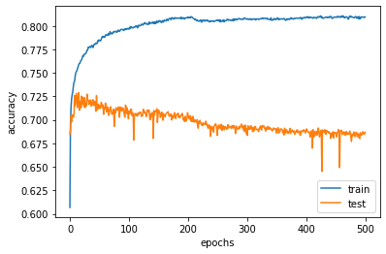

**For 2 hidden layers(256 (hidden layer 1),10(hidden layer 2), 10(output layer)):**

Train on 100000 samples, validate on 25000 samples

Epoch 1/500

100000/100000 [==============================] - 8s 84us/step - loss: 2.3372 - accuracy: 0.1420 - val_loss: 2.0926 - val_accuracy: 0.2012

Epoch 500/500

100000/100000 [==============================] - 13s 134us/step - loss: 2.1442 - accuracy: 0.2141 - val_loss: 6.2376 - val_accuracy: 0.2122

--- Training time 6039.723716259003 seconds ---

**Testing accuracy 0.21224**

--- Test run time 1.151582956314087 seconds ---

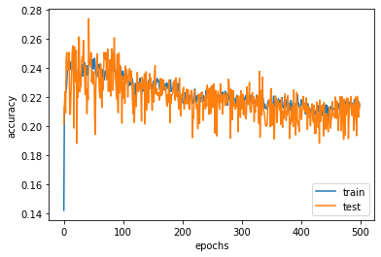

**For 2 hidden layers(256 (hidden layer 1),64(hidden layer 2), 10(output layer))**

Epoch 1/500

100000/100000 [==============================] - 6s 63us/step - loss: 11.2246 - accuracy: 0.3024 - val_loss: 10.4171 - val_accuracy: 0.3531

Epoch 500/500

100000/100000 [==============================] - 7s 69us/step - loss: 5.2914 - accuracy: 0.6716 - val_loss: 5.4133 - val_accuracy: 0.6641

--- Training time 3323.7027037143707 seconds ---

**Testing accuracy 0.66408**

--- Test run time 1.0352692604064941 seconds ---

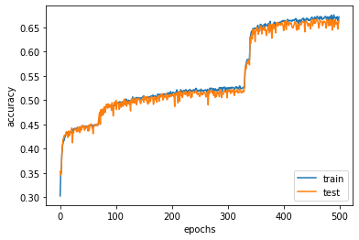

|  |  |
| --- | --- |
| **For 2 hidden layers(256,10)** | **For 2 hidden layers(256,64)** |
| Testing accuracy **0.21224** | Testing accuracy **0.66408** |
| --- Run time 6039.723 seconds --- | --- Run time 3323.702 seconds -- |

**For 3 hidden layers (256 (hidden layer 1),10(hidden layer 2), 10(hidden layer 3), 10(output layer)):**

Train on 100000 samples, validate on 25000 samples

Epoch 1/500

100000/100000 [==============================] - 6s 64us/step - loss: 14.4042 - accuracy: 0.1058 - val_loss: 13.3768 - val_accuracy: 0.1666

100000/100000 [==============================] - 6s 59us/step - loss: 2.1707 - accuracy: 0.2048 - val_loss: 2.2194 - val_accuracy: 0.2104

--- Training time 3094.117511987686 seconds ---

**Testing accuracy 0.21036**

--- Test run time 0.5574488639831543 seconds ---

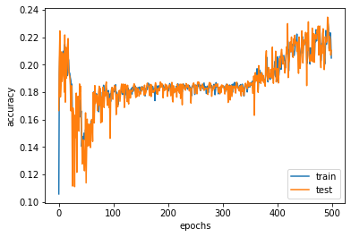

**For 3 hidden layers(256 (hidden layer 1),32(hidden layer 2), 10(hidden layer 3), 10(output layer)):**

Train on 100000 samples, validate on 25000 samples

Epoch 1/500

100000/100000 [==============================] - 6s 64us/step - loss: 10.4358 - accuracy: 0.3493 - val_loss: 9.8104 - val_accuracy: 0.3897

Epoch 500/500

100000/100000 [==============================] - 7s 67us/step - loss: 7.4223 - accuracy: 0.5394 - val_loss: 7.6011 - val_accuracy: 0.5283

--- Training time 3138.4407527446747 seconds ---

**Testing accuracy 0.52828**

--- Test run time 0.5929369926452637 seconds ---

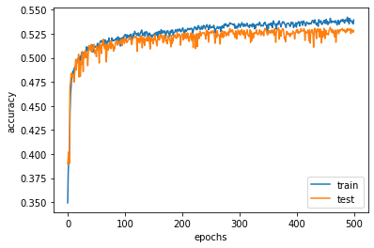

|  |  |
| --- | --- |
| **For 3 hidden layers(256, 10, 10)** | **For 3 hidden layers(256, 32, 10)** |
| Testing accuracy **0.21036** | Testing accuracy  **0.52828** |
| --- Run time 3094.117 seconds --- | --- Run time 3138.440 seconds -- |

**For 5 hidden layers (256 (hidden layer 1),128(hidden layer 2), 64(hidden layer 2), 128(hidden layer 3), 64(hidden layer 4), 32(hidden layer 5) and 10(output layer)):**

Train on 100000 samples, validate on 25000 samples

Epoch 1/500

100000/100000 [==============================] - 7s 67us/step - loss: 2.3637 - accuracy: 0.2220 - val_loss: 2.0562 - val_accuracy: 0.2399

Epoch 500/500

100000/100000 [==============================] - 7s 74us/step - loss: 2.0225 - accuracy: 0.3158 - val_loss: 2.0331 - val_accuracy: 0.3161

--- Training time 3606.651248216629 seconds ---

**Testing accuracy 0.09224**

--- Test run time 0.5552670955657959 seconds ---

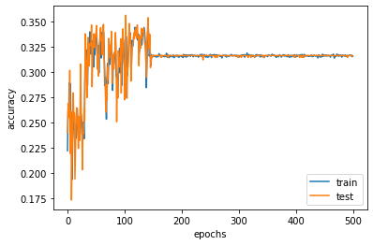

**For 5 hidden layers(256 (hidden layer 1),10(hidden layer 2), 10(hidden layer 2), 10(hidden layer 3), 10(hidden layer 4), 10(hidden layer 5) and 10(output layer)):**

Epoch 500/500

100000/100000 [==============================] - 7s 71us/step - loss: 1.6006 - accuracy: 0.4514 - val_loss: 1.8042 - val_accuracy: 0.3797

--- Training time 3524.50181388855 seconds ---

**Testing accuracy 0.37972**

--- Test run time 0.8004767894744873 seconds ---

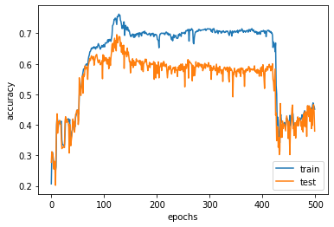

|  |  |
| --- | --- |
| **For 5 hidden layers(256, 128, 64, 32, 16)** | **For 5 hidden layers(256, 10, 10, 10, 10)** |
| Testing accuracy **0.09224** | Testing accuracy  **0.37972** |
| --- Run time 3606.651 seconds --- | --- Run time 3524.501 seconds -- |

**Observation:** Accuracy of the neural network is strongly dependent on the number of neurons given in each layer which can be seen from the above 2 layer, 3 layer and 5 layer runs.

|  |  |  |  |
| --- | --- | --- | --- |
| **1 hidden layer**  **( 256 (hidden layer),10(output layer))** | **2 hidden layers**  **(256 (hidden layer 1),10(hidden layer 2), 10(output layer)):** | **3 hidden layers**  **(256 (hidden layer 1),10(hidden layer 2), 10(hidden layer 3), 10(output layer)):** | **5 hidden layers**  **(256 (hidden layer 1),10(hidden layer 2), 10(hidden layer 2), 10(hidden layer 3), 10(hidden layer 4), 10(hidden layer 5) and 10(output layer))** |
| Testing accuracy 0.68684 | Testing accuracy 0.21224 | Testing accuracy 0.21036 | Testing accuracy 0.37972 |
| Run time 5752.901 seconds | Run time 6039.723 seconds | Run time 3094.11 seconds | Run time 3524.501 seconds |
| As the number of hidden layers is increasing, we could observe that the accuracy on test data is fluctuating. | | | |

**3. Using the resize images() function to reduce the resolution of the images to (20 × 20), (15 × 15), (10 × 10) and (5 × 5). Using the 2 hidden layer architecture, compare the performance at different resolutions, including the original (28 × 28) resolution, both in terms of test accuracy and time.**

**For 2 hidden layers (256 (hidden layer 1),64(hidden layer 2), 10(output layer))**

**For 5X5:**

Train on 100000 samples, validate on 25000 samples

Epoch 1/500

100000/100000 [==============================] - 3s 34us/step - loss: 2.4995 - accuracy: 0.3777 - val_loss: 1.6103 - val_accuracy: 0.4593

Epoch 500/500

100000/100000 [==============================] - 4s 37us/step - loss: 2.5721 - accuracy: 0.5232 - val_loss: 2.7570 - val_accuracy: 0.4758

-- Training time 1804.995157957077 seconds ---

**Testing accuracy 0.47584**

--- Test run time 0.2517099380493164 seconds ---

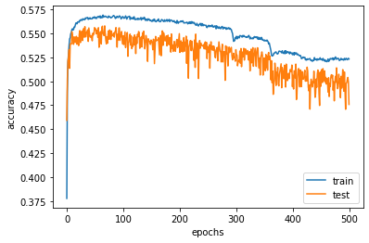

**For 10X10:**

Train on 100000 samples, validate on 25000 samples

Epoch 1/500

100000/100000 [==============================] - 4s 40us/step - loss: 9.5189 - accuracy: 0.3914 - val_loss: 7.9602 - val_accuracy: 0.4821

Epoch 500/500

100000/100000 [==============================] - 4s 39us/step - loss: 2.8507 - accuracy: 0.5397 - val_loss: 3.0966 - val_accuracy: 0.5487

--- Training time 2143.9146728515625 seconds ---

**Testing accuracy 0.54872**

--- Test run time 0.45835185050964355 seconds ---

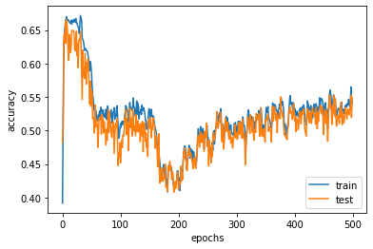

**For 15X15:**

Epoch 1/500

100000/100000 [==============================] - 5s 48us/step - loss: 10.1042 - accuracy: 0.3695 - val_loss: 9.2935 - val_accuracy: 0.4210

Epoch 500/500

100000/100000 [==============================] - 5s 49us/step - loss: 6.2367 - accuracy: 0.6129 - val_loss: 6.4942 - val_accuracy: 0.5968

--- Training time 2435.1182730197906 seconds ---

**Testing accuracy 0.59684**

--- Test run time 0.7004239559173584 seconds ---

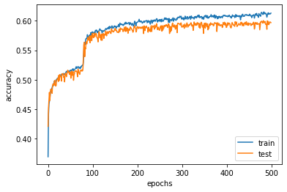

**For 20X20:**

rain on 100000 samples, validate on 25000 samples

Epoch 1/500

100000/100000 [==============================] - 5s 54us/step - loss: 11.9237 - accuracy: 0.2577 - val_loss: 11.5433 - val_accuracy: 0.2824

Epoch 500/500

100000/100000 [==============================] - 5s 48us/step - loss: 7.0339 - accuracy: 0.5634 - val_loss: 7.2705 - val_accuracy: 0.5488

--- Training time 2607.388431787491 seconds ---

**Testing accuracy 0.54884**

--- Test run time 0.6049740314483643 seconds ---

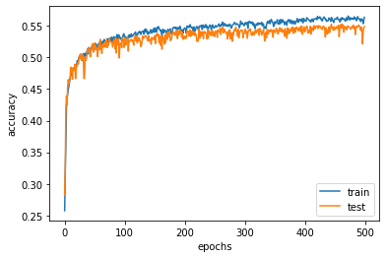

**Using the 2 hidden layer architecture comparing the performances at different resolutions:**

|  |  |  |  |  |  |
| --- | --- | --- | --- | --- | --- |
|  | **(28 × 28)** | **(20 × 20)** | **(15 × 15)** | **(10 × 10)** | **(5 × 5)** |
| **Test accuracy** | 0.66408 | 0.54884 | 0.59684 | 0.54872 | 0.47584 |
| **Run time** | 3323.702 | 2607.388 | 2435.118 | 2143.914 | 1804.995 |
| **As the resolution of the picture decreases, the run time decreases.** | | | | | |