1. What is your Backend Roles & Responsibility?
2. When we get API-Functional-spec[Swagger-Document] document from the development team, we go through all the End-points understand the Functionality.
3. Involved in Understanding JSON schema [JSON Structure & Mandatory & non mandatory fields] for all endpoints.
4. Write positive & Negative API Test scenario for every End points.
5. Execute them manually using Postman.
6. Get the latest RestAssured framework from the Github.
7. Involved in CRUD Operation.
8. Involved in performing Complex post operation using POJO Class/JSON File.
9. Involved in HTTP Request creation.
10. Involved in HTTP Response Validation.
11. Involved in Complex response validation using JSON Path.
12. Good Knowledge on All type of Authentication.
13. Used all type of Parameter in API.
14. Involved in E-2-E workflow Automation using Request Chaining.
15. Used BDD to perform CRUD Operation.
16. Good Knowledge of Status Code.
17. Can you write few API URL, which u used in your Previous Project?

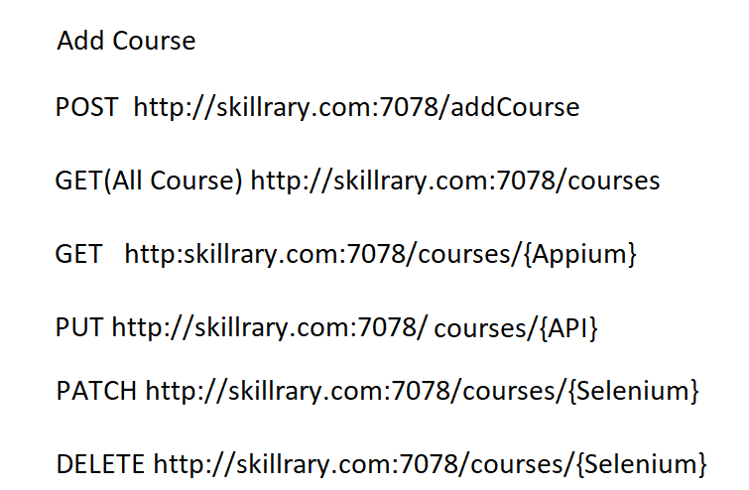

1. How Many API Test cases you wrote in your previous Project?

Module-1🡪 6 API’s 🡪 140 Test Cases

Module-1 + Module-2 🡪 250 Test Cases

1. Can you write one POST Request body in your Previous Project?
2. Can you write one complex GET Response in your Previous Project?
3. What was not Automatable in your Previous API Testing?
4. Adhoc testing Test cases
5. Compatibility Testing
6. Usability Testing