1. Regression Prediction

SOLUTION:

Commands Used:

install.packages("ISLR")
library(ISLR)
attach(Carseats)
lm.fit = lm(Sales ~ CompPrice + Income + Advertising + Price + Age, data=Carseats )
summary(lm.fit)
predict(lm.fit, data.frame(CompPrice=c(120,95,135),Income=c(45,67,85),Advertising=c(2.1,5.3,5.8),Price=c(110,100,127),Age=c(37,56,61)), interval="confidence")
predict(lm.fit, data.frame(CompPrice=c(120,95,135),Income=c(45,67,85),Advertising=c(2.1,5.3,5.8),Price=c(110,100,127),Age=c(37,56,61)), interval="prediction")

Fill in the missing sales predictions in the following table

CompPrice | Income | Advertising | Price | Age | Sales Predicted
120 | 45 | 2.1 | 110 | 37 | 7.397435
95 | 67 | 5.3 | 100 | 56 | 5.826792
135 | 85 | 5.8 | 127 | 61 | 7.160397

2 a. Create a factor variable called highmpg within the Auto data set. The variable should have the value TRUE for autos with a mpg of greater than 30 and a value of FALSE otherwise. Show your code.

Solution:
Code used
install.packages(“ISLR”)
library(ISLR)
attach(Auto)
?Auto
highmpg=ifelse(mpg>30, "TRUE", "FALSE")
Auto=data.frame(Auto, highmpg)

2 b. Build a decision tree model that can be used to predict whether an auto has a high mpg based on data other than the numeric mpg. The name variable can be safely excluded from the model as it has too many levels and won’t provide any predictive value, being unique to each row. Show your code, as well as a plot of the decision tree (with text), and also supply the % of values that were misclassified by the model.

Solution:
Commands used :
install.packages("tree")
library(tree)
tree.Auto=tree(highmpg~.-name-mpg,Auto)
summary(tree.Auto)
plot(tree.Auto)
text(tree.Auto,pretty=0)

Output on console:

Classification tree:
tree(formula = highmpg ~ cylinders + displacement + horsepower +
weight + acceleration + year + origin, data = Auto)
Variables actually used in tree construction:
[1] "horsepower" "year" "origin" "weight" "displacement"
Number of terminal nodes: 13
Residual mean deviance: 0.2311 = 87.59 / 379
Misclassification error rate: 0.05867 = 23 / 392

Plot Obtained: Below

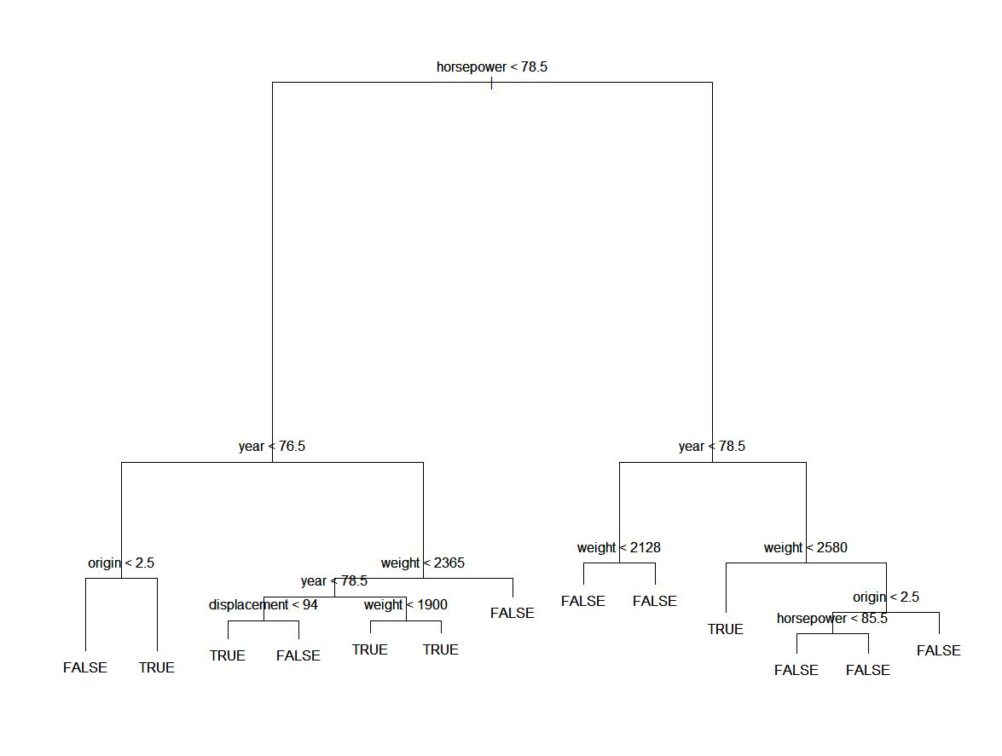

Problem C: Based on the model you built, what 3-4 variables seem to be most important in determining whether an auto has a high mpg? List the variables.

Solution: Horsepower, Year, Origin, Weight

Problem D: Set a seed using your 8-digitVillanova number (available in Novasis, among other places). Break the Auto data into training and test data sets using random sampling. Let the training data set be 67% of the records and the test data set be the remaining 33%. Train a new model on the training data, and then test the predictions of the new model against your test data. Show your code (including your Villanova number), as well as a table that compares the predicted test values with the actuals. State what % of the test data was misclassified.

Solution:
Commands Used:
set.seed(01642259)
train=sample(1:nrow(Auto), nrow(Auto) * .67)
Auto.test = Auto[-train,]
highmpg.test=highmpg[-train]
tree.autohighmpg = tree(highmpg~.-mpg-name,Auto, subset = train)
tree.pred=predict(tree.autohighmpg, Auto.test, type="class")
table(tree.pred, highmpg.test)

Output on console:

highmpg.test
tree.pred FALSE TRUE
FALSE 99 6
TRUE 7 18
Percent of data misclassified= 6+7/130 =0.1=0.1*100=10%

Problem E: Determine whether your tree should be pruned. Use cross-validation to determine the ideal size of your tree. Show your code, along with the output that tells you how large your tree should be. Add a few sentences that explain how large your tree should ideally be and how you know that this is the best size.

Solution:
Commands Used:
cv.autohighmpg = cv.tree(tree.autohighmpg, FUN=prune.misclass)
names(cv.autohighmpg)
cv.autohighmpg
plot(cv.autohighmpg$size,cv.autohighmpg$dev,type="b)
plot(cv.autohighmpg$k,cv.autohighmpg$dev,type="b")
plot(cv.autohighmpg)

Output on Console:
[1] "size" "dev" "k" "method"
$size
[1] 10 5 4 3 2 1
$dev
[1] 33 33 28 24 38 61

$k
[1] -Inf 0 1 5 13 21

$method
[1] "misclass"

attr(,"class")
[1] "prune" "tree.sequence"

Plots Obtained
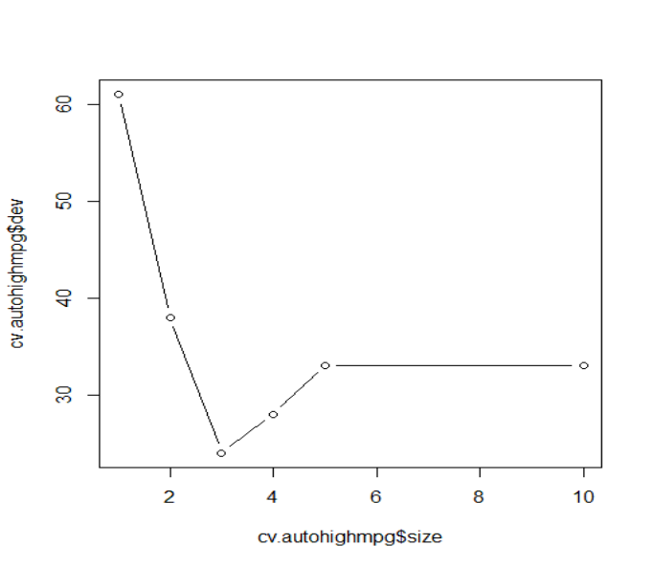

Mininmum deviance is 24. So best size is the size corresponding to this deviance which is 3.

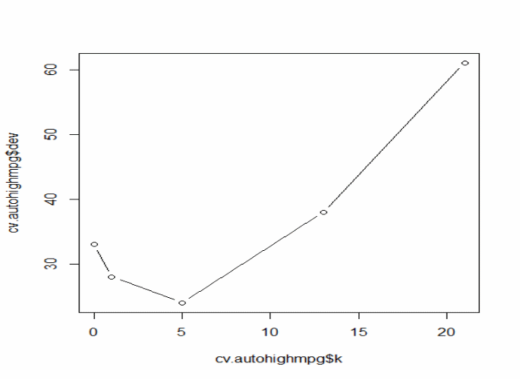

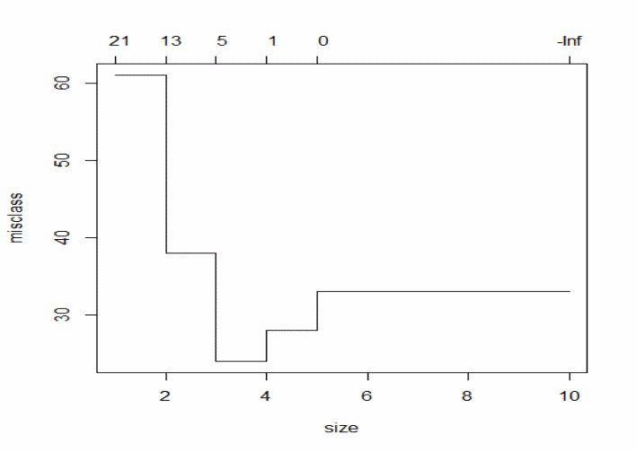

In the above plot, the lower X axis is the number of terminal nodes and the upper X axis is the number of folds (# of pieces the data is split) in the cross validation.
It shows how the misclassification error varies against these. So, this plot is very useful in determining the optimal number of terminal nodes at which the decision tree should be pruned.
In the above plot, 3 and 5 the two options (# terminal nodes) at which you want to prune the data.
Ideally, it is best keep the tree as simple as possible (lesser number of nodes) and the misclassification error as low as possible.
Given a choice of number of terminal nodes between 3 - 5, 3 terminal nodes should be the first choice.

f) Create a pruned version of your tree based on the ideal size you determined in the previous step. Use this pruned version to make predictions for your test data set. Show your code, as well as a table that compares the predicted test values with the actuals. State what % of the test data was misclassified. Explain whether or not the pruning improved your predictive accuracy.

Solution:

Commands Used
prune.auto=prune.misclass(tree.autohighmpg,best=3)
prune.predict = predict(prune.auto, Auto.test, type="class")
table(prune.predict, highmpg.test)
highmpg.test
prune.predict FALSE TRUE
FALSE 103 9
TRUE 2 16

% of the test data was misclassified= 9+2/130
=0.085
=8.5 %

Yes % of the test data was misclassified decreases from 10 % to 8.5% after Pruning. So pruning improved the predictive accuracy.

g) Try to improve your results using either bagging or a random forest. State which alternative you are using. Show your code, as well as your OOB error rate. Note again that name should not be part of your analysis.

Solution: install.packages("randomForest")
library(randomForest)
set.seed(01642259)
rf.Auto=randomForest(highmpg~. -mpg-name, data=Auto, subset = train, importance=TRUE)
rf.Auto

Call:
randomForest(formula = highmpg ~ . - mpg - name, data = Auto, importance = TRUE, subset = train)
Type of random forest: classification
Number of trees: 500
No. of variables tried at each split: 2

OOB estimate of error rate: 8.02%
Confusion matrix:
FALSE TRUE class.error
FALSE 196 8 0.03921569
TRUE 13 45 0.22413793

importance(rf.Auto)
TRUE Mean DecreaseAccuracy Mean DecreaseGini
cylinders 5.521281 5.603101 7.79734 3.044625
displacement 9.137109 18.107183 18.36833 15.238174
horsepower 11.845740 18.484905 22.12942 19.699102
weight 11.464012 22.215984 23.43002 18.658696
acceleration 9.904066 7.468129 12.53212 8.686559
year 21.618763 36.802977 37.77017 18.371809
origin 9.404817 16.764425 17.14757 5.879648

varImpPlot(rf.Auto)

2h)

Solution 3. P(H|E) = P(E|H) * P(H)/ P(E)
Where P(H|E)= Probability of Hypothesis given some evidence
P(E|H)= Probability of evidence given some Hypothesis
P(H)=Probability of hypothesis
P(E)=Probability of Evidence

probability that person
laptop will fail within warrenty period. = Probability that a * probability that
Given that person belongs to sales person belongs to sales someone laptop will
department department. Given that there fail within warranty
laptop fail within warranty period
period
/ probability of being from sales department

= 25*5/10 = 12.5%

