1 a) Create an R data frame set based on the full contents of the HR.Employees table in Oracle XE

install.packages("RODBC")
library(RODBC)
myconn <-odbcConnect("test", uid="nidhi", pwd="nidhi")
empdat <- sqlFetch(myconn, "HR.EMPLOYEES")
table_data <- sqlQuery(myconn, "SELECT * FROM HR.EMPLOYEES")
summary(table_data)

Output:
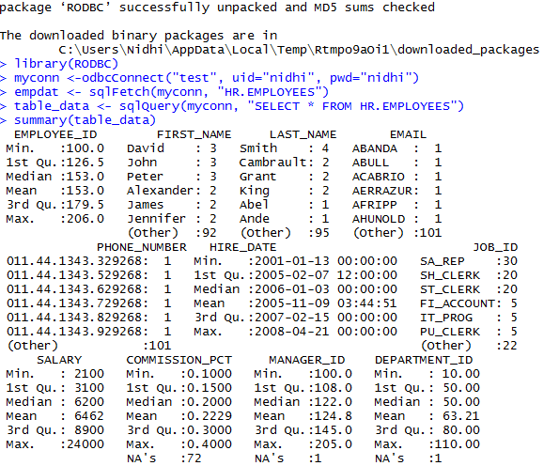

b) Use R to update all employees with the last name of TAYLOR to the last name of SMITH
Commands Used
empdat <- sqlFetch(myconn, "HR.EMPLOYEES")
empdat_copy <- empdat
empdat_copy$LAST_NAME[empdat_copy$LAST_NAME=="Taylor"] <- "Smith"

c) Then, use R to determine the average salary of employees with the last name SMITH, using the data frame you updated in the previous step

Commands Used
mean(empdat_copy$SALARY[empdat_copy$LAST_NAME=="Smith"])

Output:
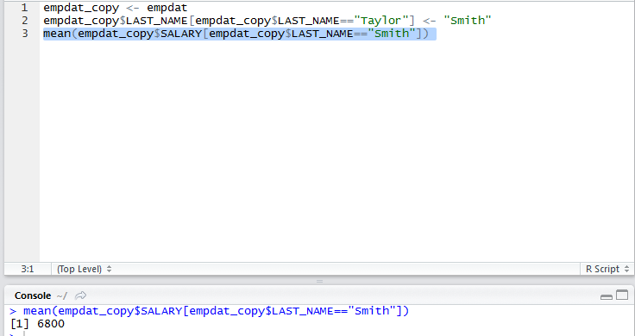

2 a) How much does being a private school raise the out of state tuition costs? (Consider only those two variables in your analysis.) Is the effect statistically significant?

Commands used for linear Regression Analysis:

install.packages("ISLR")
library(ISLR)

attach(College)
mydat = data.frame(Private, Outstate)
lm.fit = lm(data = mydat, formula=Outstate ~ Private)
summary(lm.fit)
lm(formula = Outstate ~ Private, data = mydat)
plot(Private, Outstate)
abline(lm.fit)
lm_coef <- round(coef(lm.fit), 3)
mtext(bquote(Outstate == .(lm_coef[2])*Private + .(lm_coef[1])),
+ adj=1, padj=0) # display equation

Output on console:
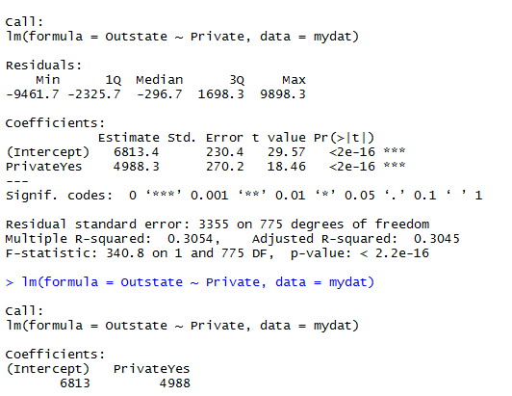

Plot Obtained:
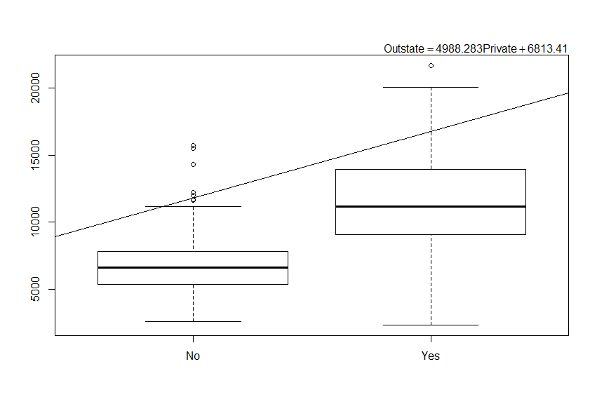
The median of Out of state tuition for Private schools is approximately 12,000 where as the median of Out of state tuition for non-Private schools is approximately 7000. So Private Schools raised the out of state tuition fee by approximately 5000.

P-value – tells us the likelihood that a variable has a real relationship to what is being measured (measure of statistical significance). P-values range from 0 to 1 – lower values mean that relationship is more likely to be real. P-values of 0.05 and 0.01 usually considered important thresholds. As P-value < 2.2 e-16, therefore the effect is statistically significant.

2.b. Create a column that calculates the acceptance rate as follows:
College$AcceptRate <- College$Accept/College$Apps
Do private colleges have a higher or lower acceptance rate than public colleges? (Consider only those two variables in your analysis.) Is the effect statistically significant?

Command used:
install.packages("ISLR")
library(ISLR)
attach(College)
College$AcceptRate <- College$Accept/College$Apps
CollegeDat <- data.frame(Private, College$AcceptRate)
lm.fit = lm(data=CollegeDat, formula=College$AcceptRate ~ Private)
summary(lm.fit)
plot(Private, College$AcceptRate)
abline(lm.fit)
lm_coef <- round(coef(lm.fit), 3)
mtext(bquote(College$AcceptRate == .(lm_coef[2])*Private + .(lm_coef[1])), adj=1, padj=0) # display equation

Output on console:

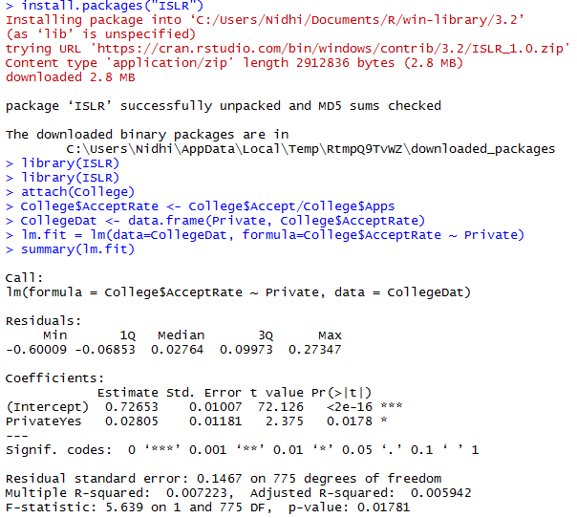

Plot Obtained:
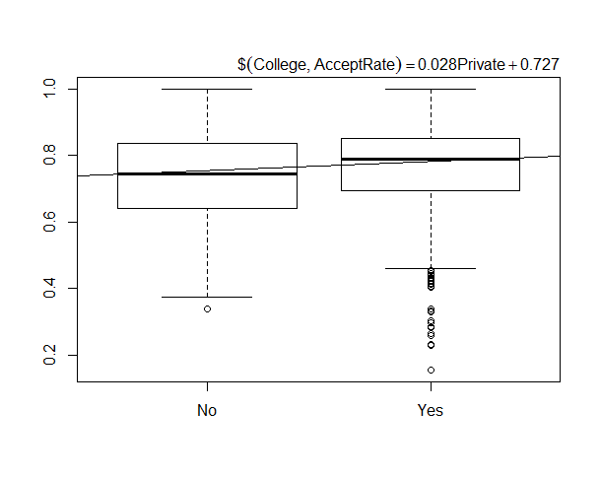
Median value for acceptance rate of private colleges is approximately 0.8 where as Median value for acceptance rate of private colleges is approximately 0.75. So private collges have higher acceptance rate compared to public colleges. As P-value is 0.01, the effect is statistically Significant.

2c. Build a model that predicts out of state tuition based on the percent of alumni who donate (perc.alumni), instructional expenditure per student (Expend), and graduation rate (Grad.rate). Do those three variables account for at least 70% of the variation in out of state tuition?

Commands Used:
install.packages("ISLR")
library(ISLR)
lm.CollegeMulti = lm(Outstate~perc.alumni+Expend+Grad.Rate,data=College)
summary(lm.CollegeMulti)
predict(lm.CollegeMulti, data.frame(perc.alumni=c(10,20,30,40,60),Expend=c(8000,700,8500,6000,12000),Grad.Rate=c(55,75,65,44,89)), interval="confidence")
predict(lm.CollegeMulti, data.frame(perc.alumni=c(10,20,30,40,60),Expend=c(8000,700,8500,6000,12000),Grad.Rate=c(55,75,65,44,89)), interval="prediction")

Output On Console:
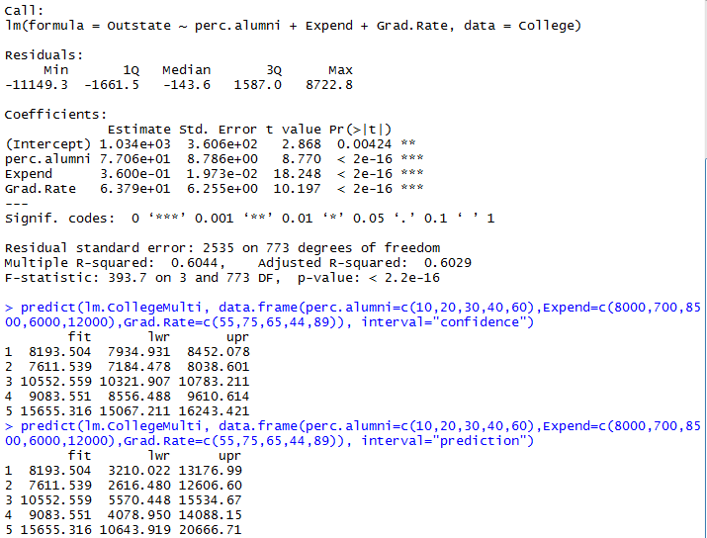

We assess a regression model using R2 statistic. It Tells us proportion of the variability in Y that can be explained by X Value between 0 and 1. Higher values mean that the model is more predictive. “Good” value relative to domain. Usually want to look at “Adjusted R2” which penalizes more complex models and small sample sizes.
As R squared value is 0.6044, so it accounts for 60% Variation.

