PROJECT DOCUMENTATION
Social Media Website
A Cloud-Deployed Social Media Web Application on AWS
Prepared by
MAHESWRAY MEENA K

Table of Contents

1. Introduction
This project is a lightweight, Instagram-style social media website that allows registered users to create posts, upload images, like posts, and comment on them. The objective of this project was to design, build, and deploy a complete two-tier web application on Amazon Web Services (AWS) using a production-style architecture that includes high availability, load balancing, auto scaling, and network isolation between public and private layers.
This document describes the cloud infrastructure that was provisioned, the overall system architecture, the application features, the underlying database design, and screenshots demonstrating the working application.

2. Project Objectives
- Design a scalable and fault-tolerant AWS architecture for a two-tier web application.
- Separate the frontend and backend layers into independent tiers, each with its own Auto Scaling Group.
- Use an Application Load Balancer to distribute incoming traffic across multiple instances.
- Secure the infrastructure using dedicated Security Groups for each layer.
- Enable private backend instances to access the internet securely through a NAT Gateway.
- Build a functional social media website to demonstrate the deployed infrastructure.

3. System Architecture Overview
The application follows a two-tier architecture deployed inside a custom Virtual Private Cloud (VPC). The frontend tier serves the web client and is placed behind an internet-facing Application Load Balancer, while the backend tier hosts the application/API layer and communicates with the database. Public subnets host internet-facing resources, and private subnets host the backend layer, isolating it from direct internet access.

3.1 High-Level Traffic Flow
- A user accesses the application through the Load Balancer DNS name over HTTP.
- The Application Load Balancer forwards the request to a healthy Frontend EC2 instance using the Frontend Target Group.
- The Frontend instance communicates with the Backend layer, which is reached through the Backend Target Group.
- Backend instances process the request and read/write data to the MySQL database.
- Backend instances in the private subnet use the NAT Gateway for any required outbound internet access (such as package updates), while inbound internet access is not permitted.
- Auto Scaling Groups continuously monitor instance health and maintain the desired number of running instances for both tiers.

4. AWS Infrastructure Components
The table below summarizes the AWS resources provisioned for this project.
Component | Details
VPC | Custom Virtual Private Cloud with public and private subnets
Internet Gateway | Attached to the VPC to allow internet access for public subnet resources
NAT Gateway | Deployed in the public subnet to allow private subnet (backend) instances outbound internet access
Route Tables | Separate route tables for public subnet (routed via Internet Gateway) and private subnet (routed via NAT Gateway)
Security Groups | 5 Security Groups configured to control inbound/outbound traffic for each layer
Application Load Balancer | Internet-facing load balancer distributing traffic to the frontend tier
Target Groups | Separate target groups for the frontend and backend tiers used for health checks and routing
Launch Templates | Templates defining the AMI, instance type, and configuration for frontend and backend instances
Auto Scaling Groups | Auto Scaling Groups for the frontend and backend tiers, maintaining 2 running instances each
EC2 Instances | 2 Frontend instances and 2 Backend instances
Database | MySQL relational database storing users, posts, comments, and likes

4.1 Security Groups
Five Security Groups were configured to enforce the principle of least privilege across the different layers of the architecture:
Security Group | Purpose
ALB Security Group | Allows inbound HTTP traffic (port 80) from the internet and forwards it to the frontend instances
Frontend Security Group | Allows inbound traffic only from the ALB Security Group and permits outbound traffic to the backend tier
Backend Security Group | Allows inbound traffic only from the Frontend Security Group on the application port
Database Security Group | Allows inbound traffic only from the Backend Security Group on the MySQL port (3306)
Management/Bastion Security Group | Restricts SSH access to the instances for administration and troubleshooting

4.2 Compute and Scaling
- Frontend Auto Scaling Group: launches frontend EC2 instances from a Launch Template and registers them with the Frontend Target Group behind the Load Balancer.
- Backend Auto Scaling Group: launches backend EC2 instances from a Launch Template and registers them with the Backend Target Group.
- Both Auto Scaling Groups are currently configured to run 2 instances each, providing redundancy in case an instance becomes unhealthy.

4.3 Networking
- Public Route Table: routes 0.0.0.0/0 traffic to the Internet Gateway, used by the public subnet hosting the Load Balancer and NAT Gateway.
- Private Route Table: routes 0.0.0.0/0 traffic to the NAT Gateway, used by the private subnet hosting the backend instances.
- This design ensures the backend and database layers are not directly reachable from the public internet.

5. Application Overview
The social media website is the demo application deployed on top of the above infrastructure. It is a simple Instagram-style social platform where users can register, log in, create text or image posts, like posts, and comment on them.

5.1 Key Features
- User Registration and Login with encrypted password storage.
- Create a post with text and/or an image.
- Like and unlike posts, with a live like counter.
- View the list of users who liked a specific post.
- Comment on posts, with all comments displayed in chronological order.
- Session-based authentication with a Logout option.

6. Database Design
The application uses a relational MySQL database consisting of four tables: users, posts, comments, and likes. The schema below reflects the structure used by the application.

6.1 users Table
Column | Description
id | Primary key, unique user identifier
username | Unique username chosen during registration
password | Encrypted password hash (scrypt algorithm)
created_at | Timestamp when the account was created

6.2 posts Table
Column | Description
id | Primary key, unique post identifier
user_id | Foreign key referencing the author in the users table
content | Text content of the post
created_at | Timestamp when the post was created
media_url | Path to an uploaded image, if any
media_type | Type of media attached to the post (e.g. image)

6.3 comments Table
Column | Description
id | Primary key, unique comment identifier
post_id | Foreign key referencing the related post
user_id | Foreign key referencing the commenting user
content | Text content of the comment
created_at | Timestamp when the comment was created

6.4 likes Table
Column | Description
id | Primary key, unique like identifier
post_id | Foreign key referencing the liked post
user_id | Foreign key referencing the user who liked the post
created_at | Timestamp when the like was recorded
The relationships between the tables are as follows: each post belongs to one user, each comment belongs to one post and one user, and each like record links one user to one post. This structure allows efficient retrieval of a post along with its likes and comments.

7. Application Walkthrough
This section presents screenshots of the deployed application, accessed through the Load Balancer's public DNS name.

7.1 Login Page
Users can log in to their existing account using their username and password.
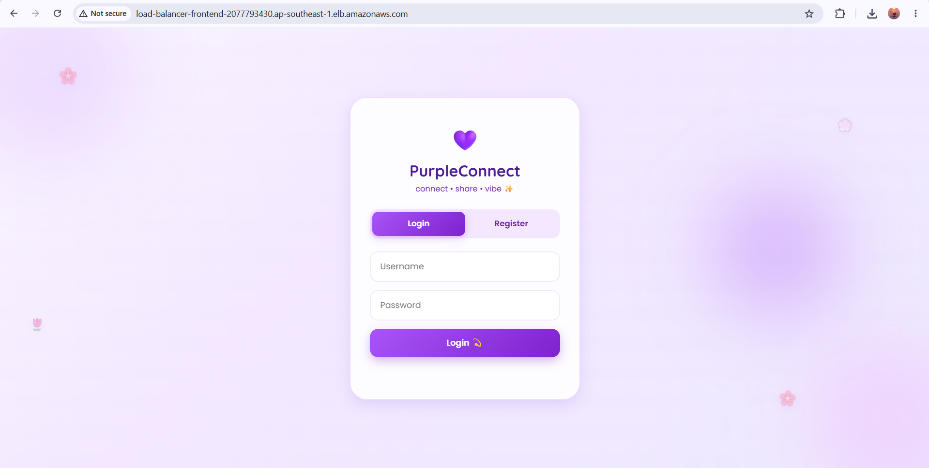
Figure 1: Login page of the social media website

7.2 Registration Page
New users can create an account by choosing a unique username and password.
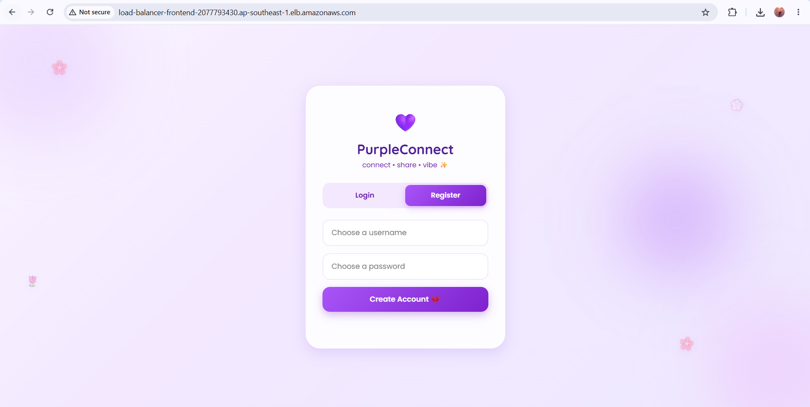
Figure 2: Registration page of the social media website

7.3 News Feed
Once logged in, users see the news feed where they can create a new post and view posts from other users, along with like and comment counts.
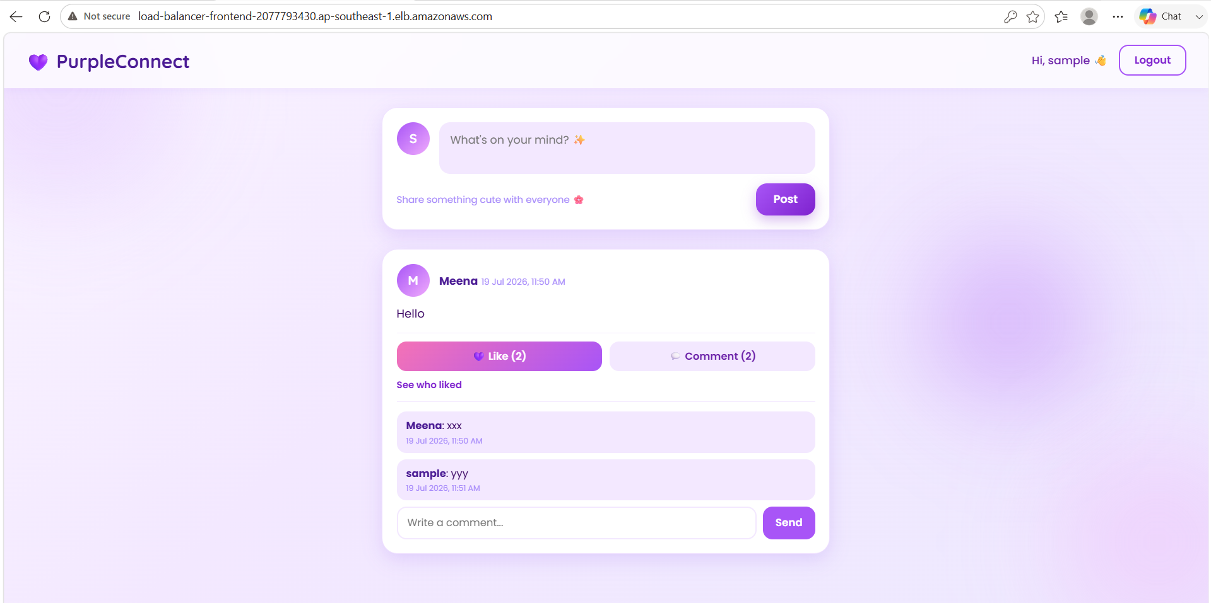
Figure 3: News feed showing a post with likes and comments

7.4 Creating a Post
A logged-in user can compose a new post using the input box at the top of the feed.
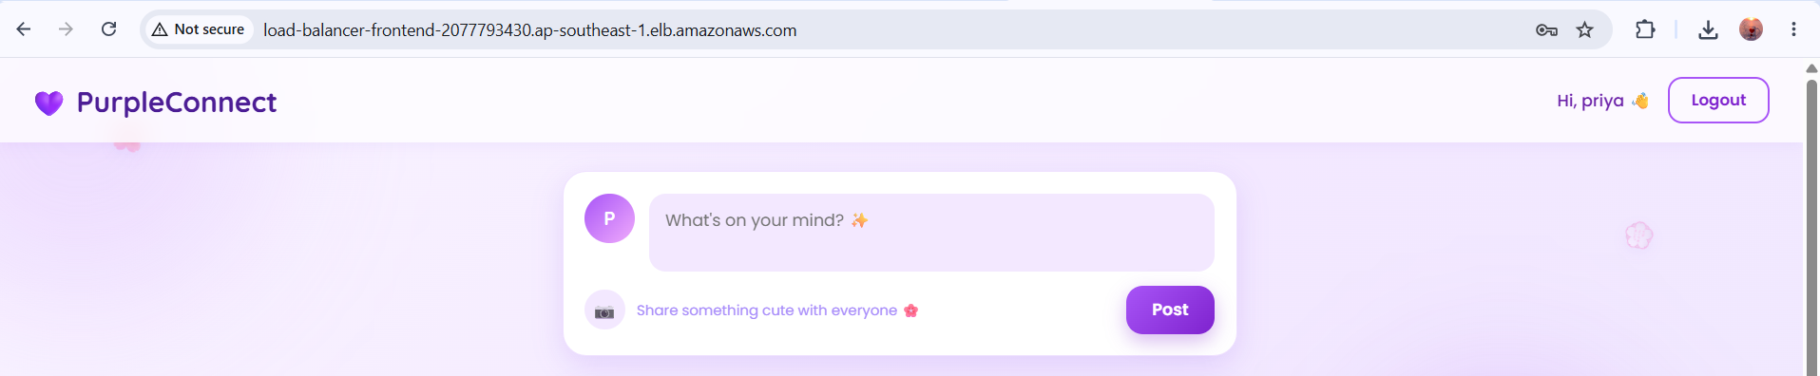
Figure 4: Post creation box

7.5 Image Post
Users can also attach an image to their post, which is displayed within the feed.
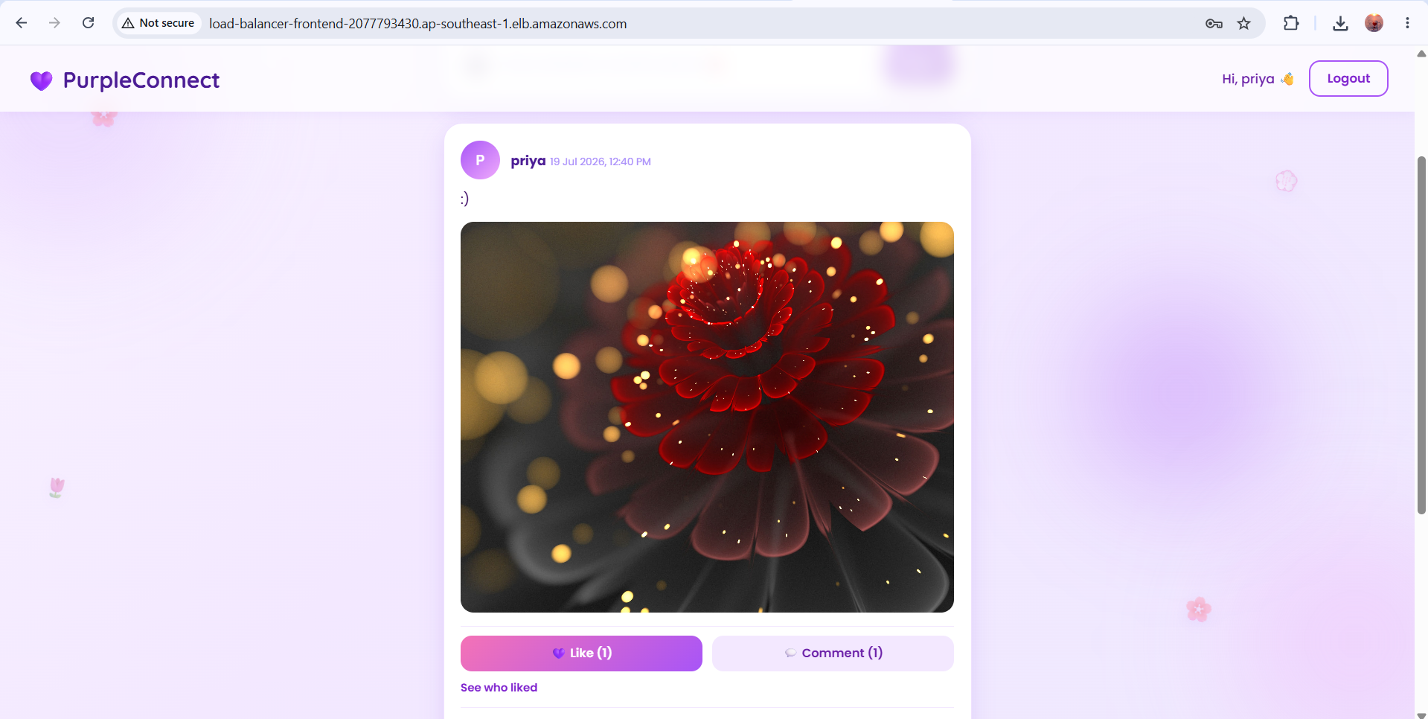
Figure 5: A post containing an uploaded image, with likes and comments

7.6 Viewing Likes
Clicking on “See who liked” opens a dialog listing all the users who liked a particular post.
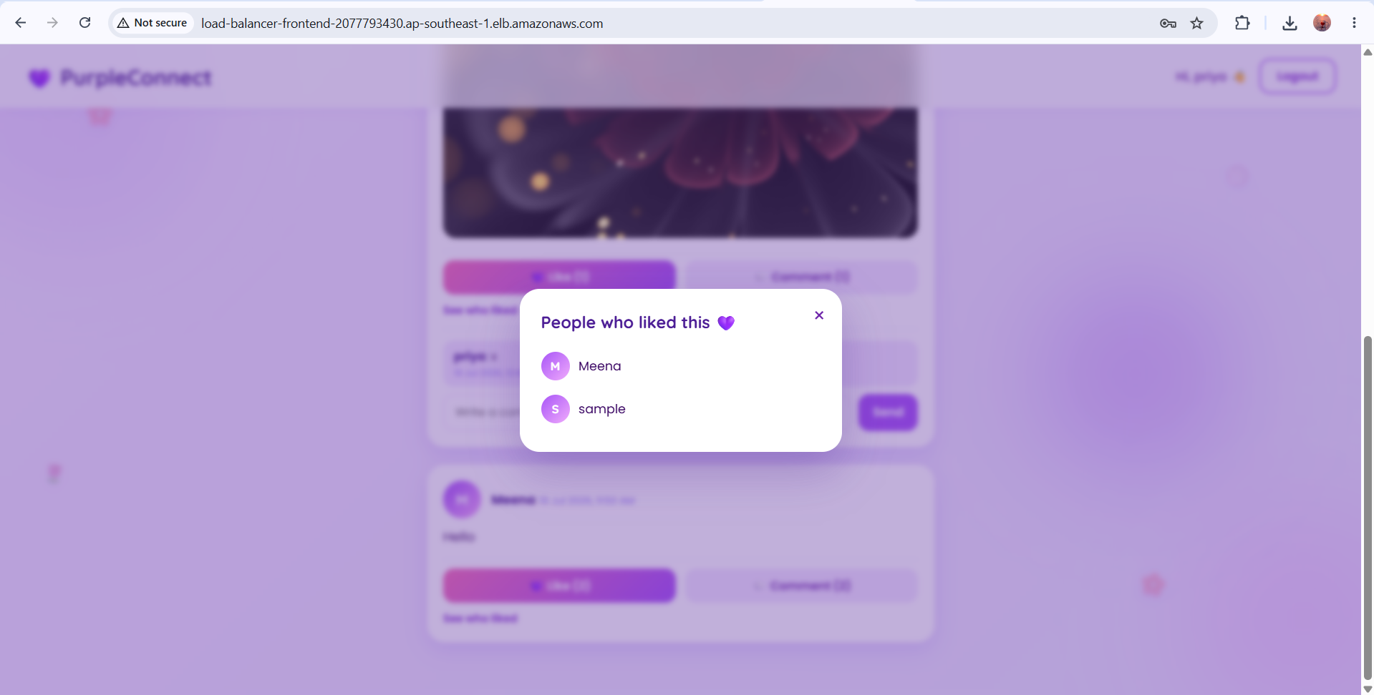
Figure 6: Dialog showing the list of users who liked a post

7.7 Adding a Comment
Users can add a comment to any post using the comment input box below the post.
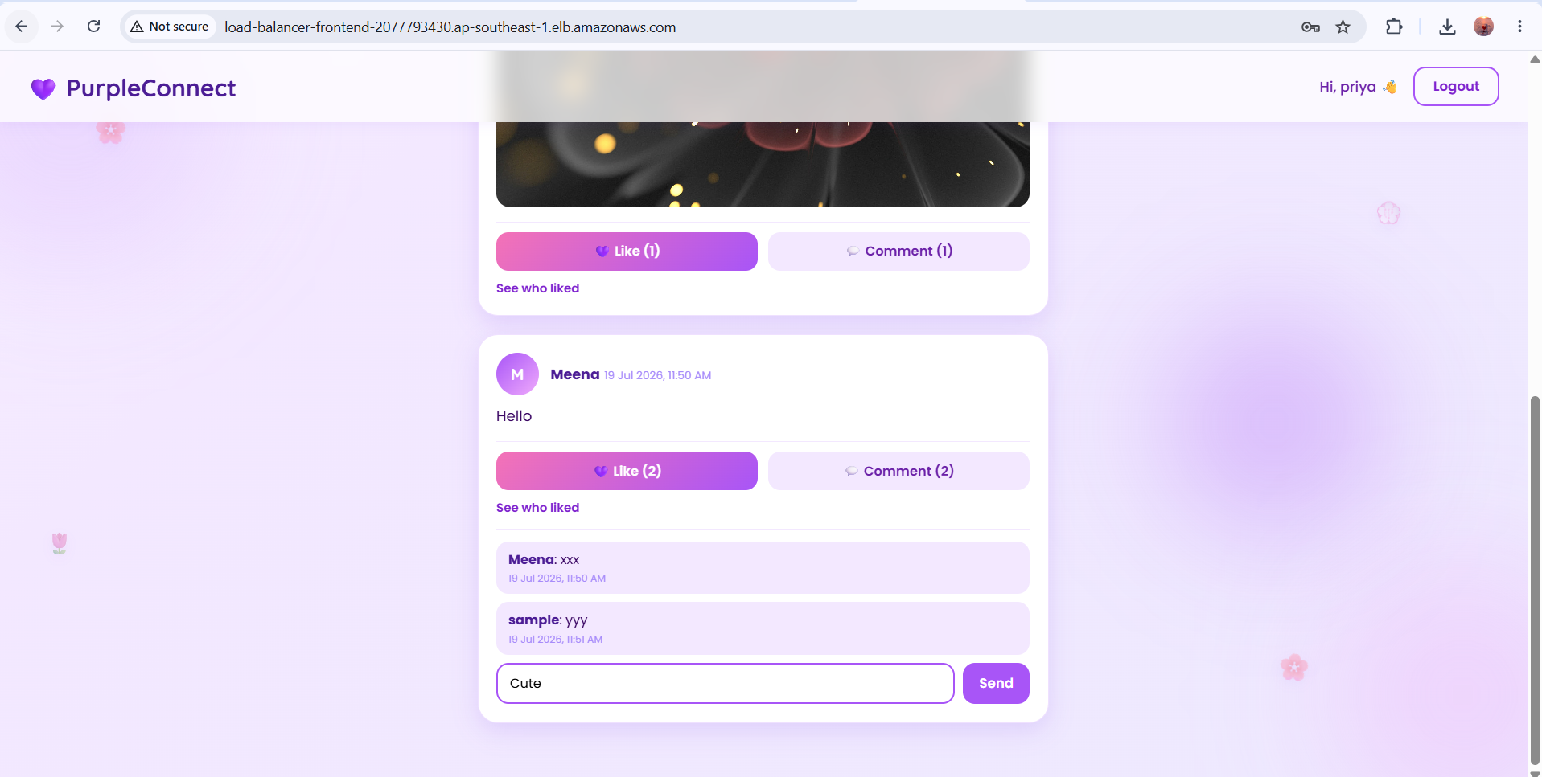
Figure 7: Adding a new comment to a post

8. Database Verification
The following screenshot shows the underlying MySQL database tables (posts, users, comments, and likes) queried directly from the database server, confirming that the application correctly persists user data, posts, comments, and likes.
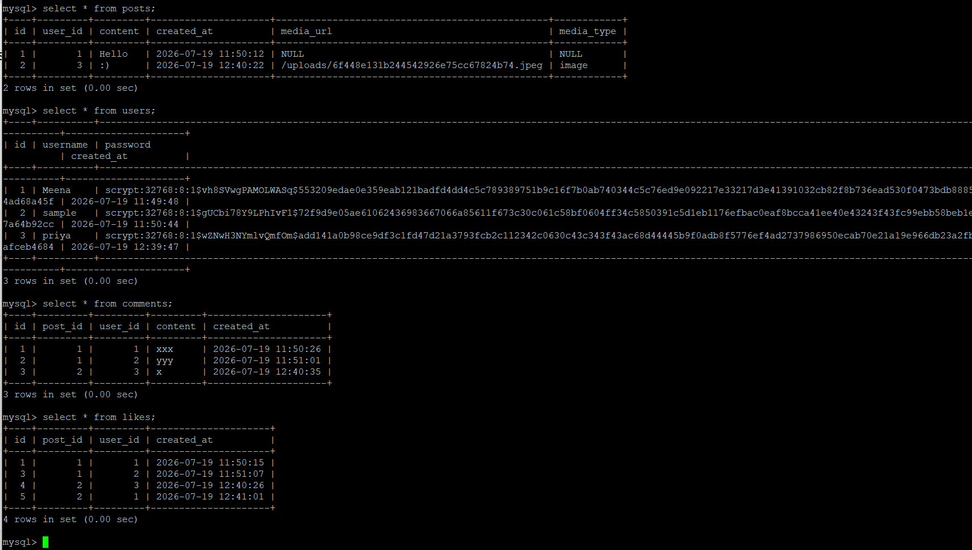
Figure 8: MySQL database tables - posts, users, comments, and likes

9. Conclusion
This project successfully demonstrates the deployment of a two-tier, highly available web application on AWS. The infrastructure uses an Application Load Balancer, Auto Scaling Groups, Launch Templates, Target Groups, and a segmented public/private network protected by five Security Groups, an Internet Gateway, and a NAT Gateway. On top of this infrastructure, a social media website was built and deployed, providing core social networking features such as posts, likes, and comments, backed by a relational MySQL database. The project reflects a practical, production-style approach to designing and deploying cloud infrastructure on AWS.

