**Development Environment Setup**

**MMT** – Member Management Tool

**Java – JDK Installation**

* <http://www.oracle.com/technetwork/java/javase/downloads/jdk8-downloads-2133151.html>
* I had downloaded jdk-8u72-windows-x64.exe on Jan 2016.
* But, the latest one is Java SE Development Kit 8u74 (as of Feb 18th 2016)
* Windows x64 187.31 MB jdk-8u74-windows-x64.exe

**Apache Maven**

* Downloading Apache Maven 3.3.9 – <https://maven.apache.org/download.cgi>
* Binary zip archive apache-maven-3.3.9-bin.zip
* Installing Apache Maven – <https://maven.apache.org/install.html>
* Maven settings.xml can be found at C:\Program Files\apache-maven-3.3.9\conf
* In this xml file, I have entered local maven repository as

<localRepository>E:\WORK\Maven_Repo</localRepository>

**Environment Variable Setup**

* JAVA_HOME
* MAVEN_HOME
* M2_HOME

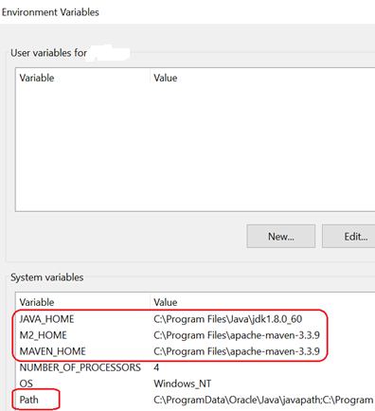

Add “BIN” directories of JAVA and MAVEN into environment variable “**PATH**” like mentioned below:



**How to verify JAVA installation?**

C:\Users\mahe>java -version

java version "1.8.0_72"

Java(TM) SE Runtime Environment (build 1.8.0_72-b15)

Java HotSpot(TM) 64-Bit Server VM (build 25.72-b15, mixed mode)

**How to verify MAVEN installation?**

C:\Users\mahe>mvn --version

Apache Maven 3.3.9 (bb52d8502b132ec0a5a3f4c09453c07478323dc5; 2015-11-11T00:41:47+08:00)

Maven home: C:\Program Files\apache-maven-3.3.9

Java version: 1.8.0_60, vendor: Oracle Corporation

Java home: C:\Program Files\Java\jdk1.8.0_60\jre

Default locale: en_SG, platform encoding: Cp1252

OS name: "windows 10", version: "10.0", arch: "amd64", family: "dos"

**Database – MySQL Installation**

* Follow the steps given in <http://www.mysqltutorial.org/install-mysql/>
* Install all the available components inside the package
* <http://dev.mysql.com/downloads/installer/> – I had used **mysql-installer-web-community-5.7.10.0.msi**. You can use the latest one.
* ***Note:*** MySQL Installer is 32 bit, but will install both 32 bit and 64 bit binaries.

**Eclipse IDE Installation**

* Eclipse IDE Downloads – <https://eclipse.org/downloads/>
* Eclipse downloads - Select a mirror
* <https://www.eclipse.org/downloads/download.php?file=/oomph/epp/mars/R1a/eclipse-inst-win64.exe>

**OR**

* Eclipse IDE for Java EE Developers – <http://www.eclipse.org/downloads/packages/eclipse-ide-java-ee-developers/marsr>
* Eclipse downloads - Select a mirror
* <http://www.eclipse.org/downloads/download.php?file=/technology/epp/downloads/release/mars/R/eclipse-jee-mars-R-win32-x86_64.zip>

**Eclipse Plugin for Maven**

* Eclipse > Help > Install New Software > Add
* Name: m2e
* Location: <http://download.eclipse.org/technology/m2e/releases>

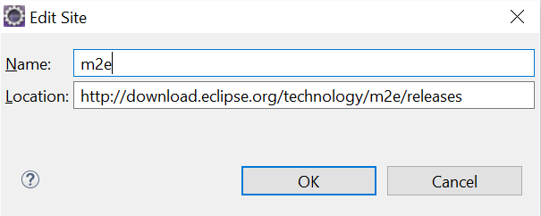

**Eclipse – JRE setup**

Eclipse > Windows > Preferences

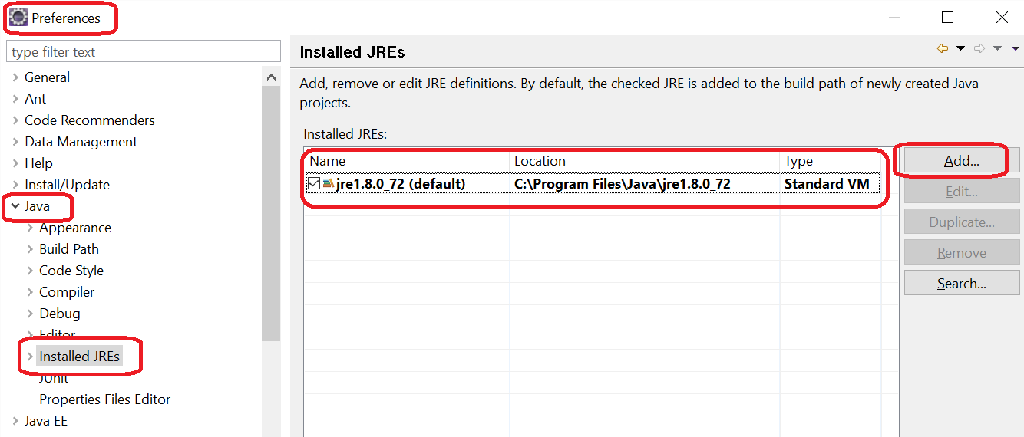

**Eclipse – Maven setup**

Eclipse > Windows > Preferences

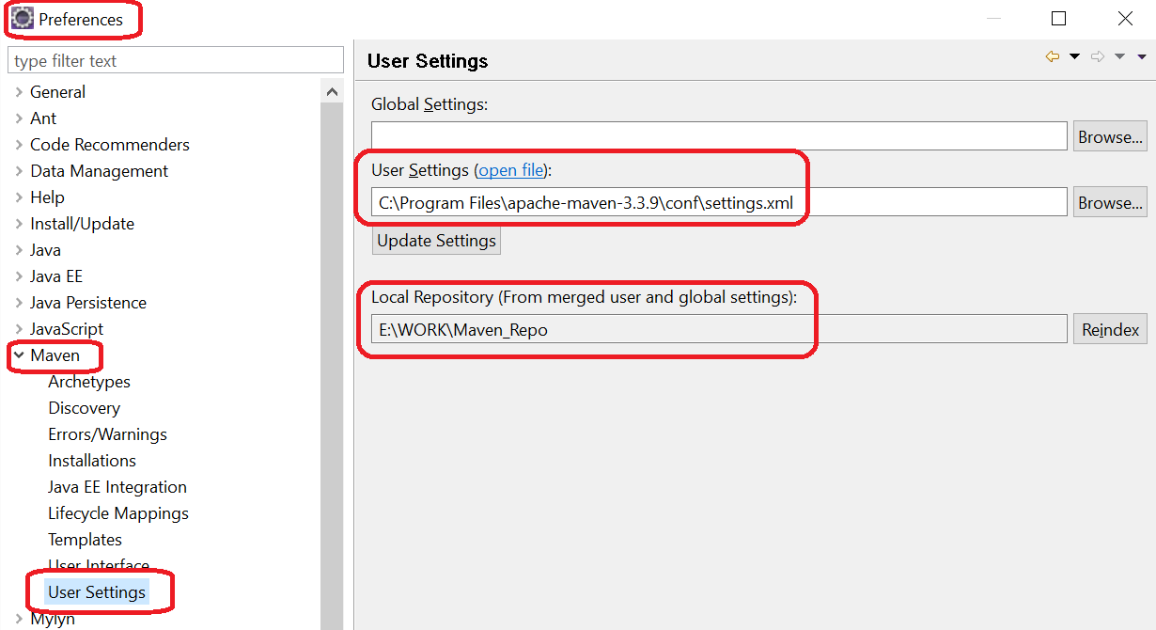

**How to create a new database schema?**

* Copy this SQL file (**Latest – Dump20160302.sql**) to a directory in your workstation





* Open **MySQL Workbench** > Choose a connection (if not available, create a new one. Ex. local)
* Navigate to Server > Data Import
* In the opened window > Tab: Import from Disk
* Choose radio button: “Import from Self-Contained File” > Browse SQL file Dump20160219.sql
* Next 2 sections should be blank (Default Schema… & Selected Database objects…)
* Choose “Dump Structure and Data” from a dropdown at the right side
* Click “Start Import” button at the right bottom
* A new database schema “**mmt**” should be created
* This schema “**mmt**” should contain **6 database tables**

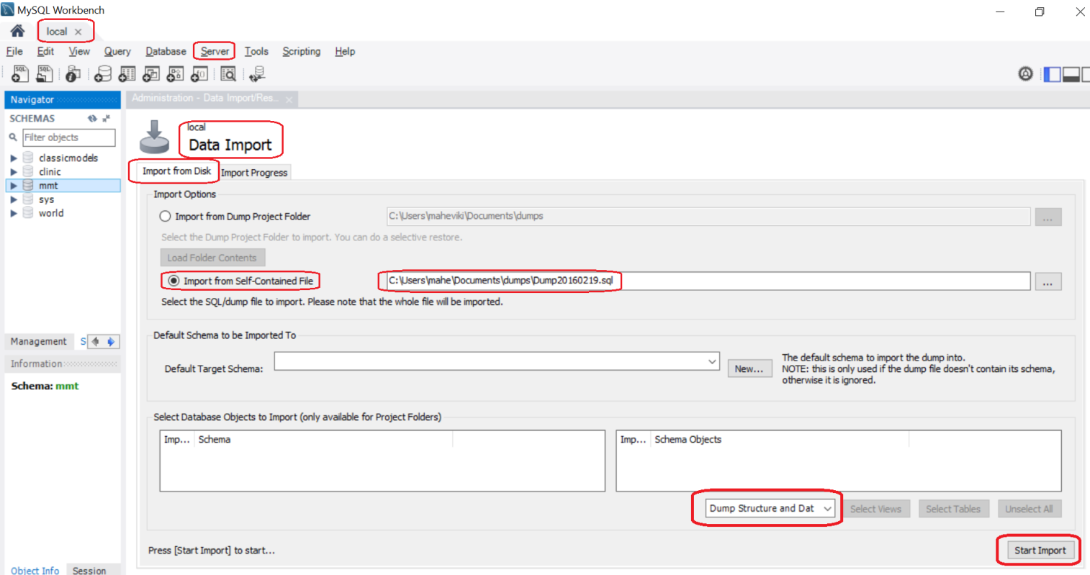

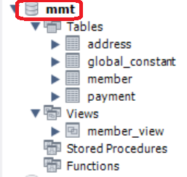

**Download Project Setup from GIT-HUB**

<https://github.com/mahetech/MMT/tree/master>

***Note:***

* The project in GIT is not a perfect working copy
* It is having incomplete codes and compilation issues as well.

**Subversion Setup**

**<Suyambu will update on SVN repository>**

* Download Tortoise SVN
  + <https://tortoisesvn.net/downloads.html>
  + Current version is 1.9.3

**Basics of Angular JS**

* <http://www.w3schools.com/angular/angular_intro.asp>
* <http://www.tutorialspoint.com/angularjs/angularjs_overview.htm>
* <https://thinkster.io/a-better-way-to-learn-angularjs>

**Project Structure**

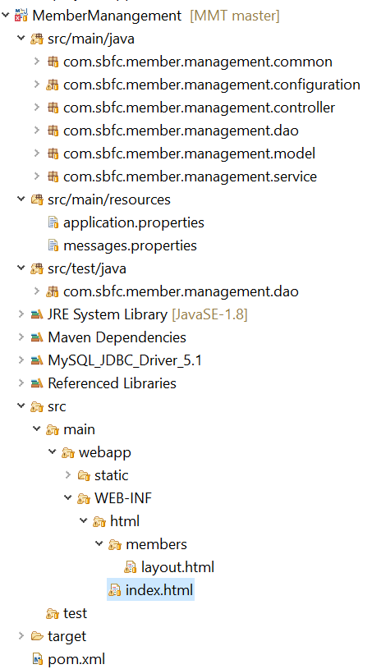

**Files related to Front-end (UI)**

