<http://localhost:8080/MemberManangement>

**First Page**

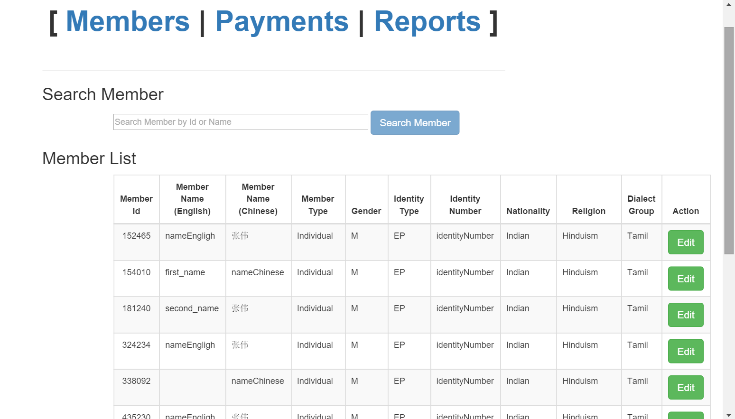

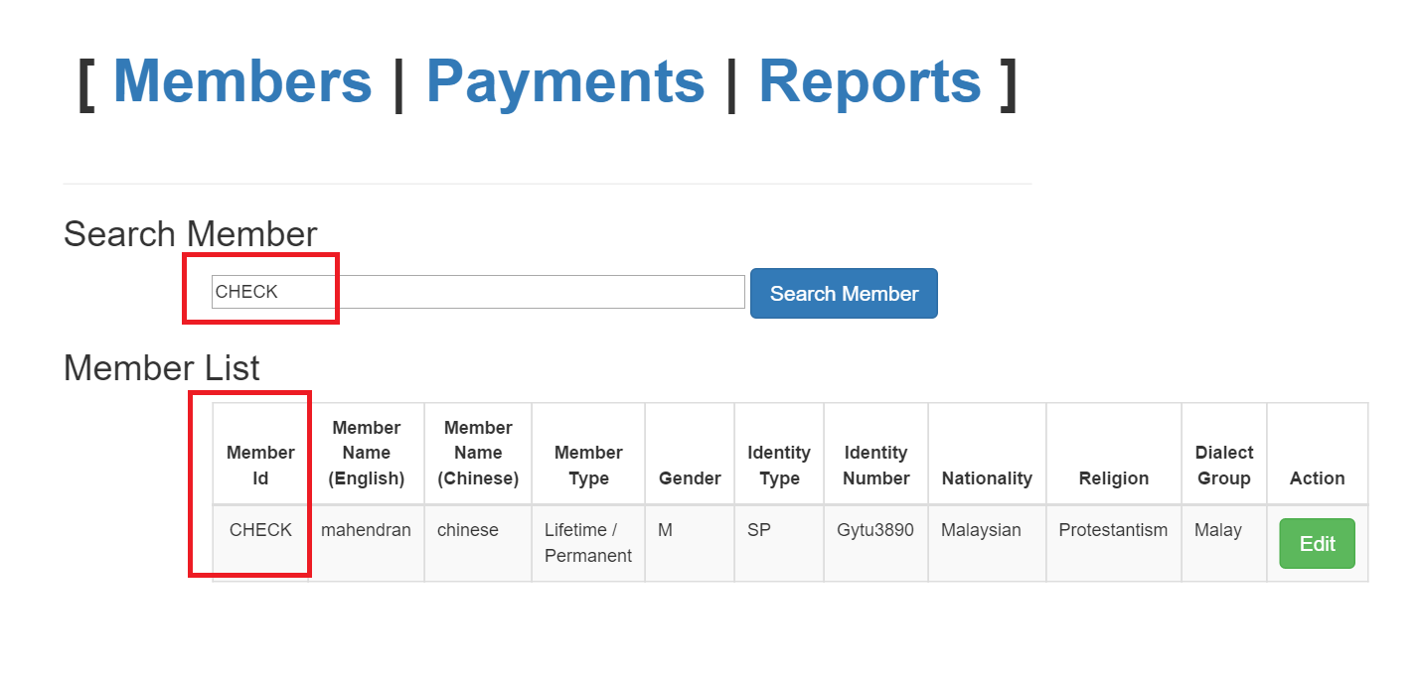

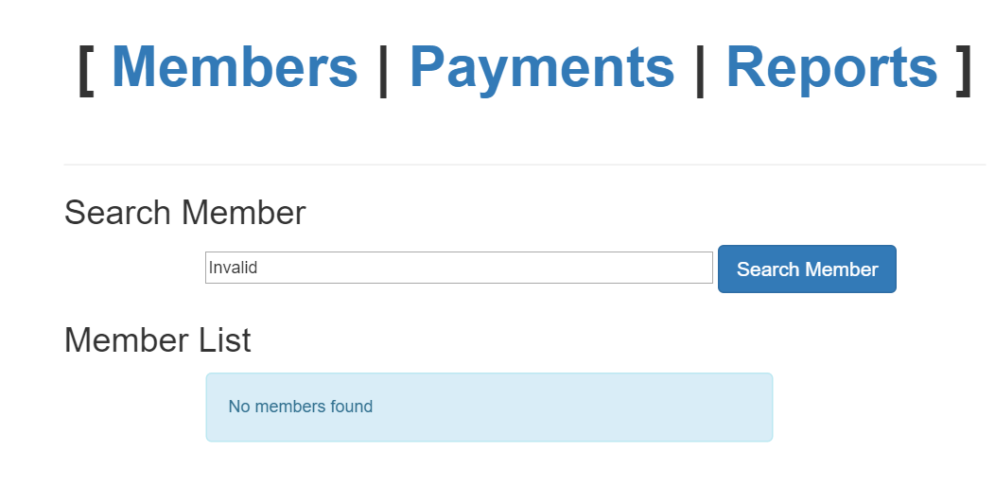

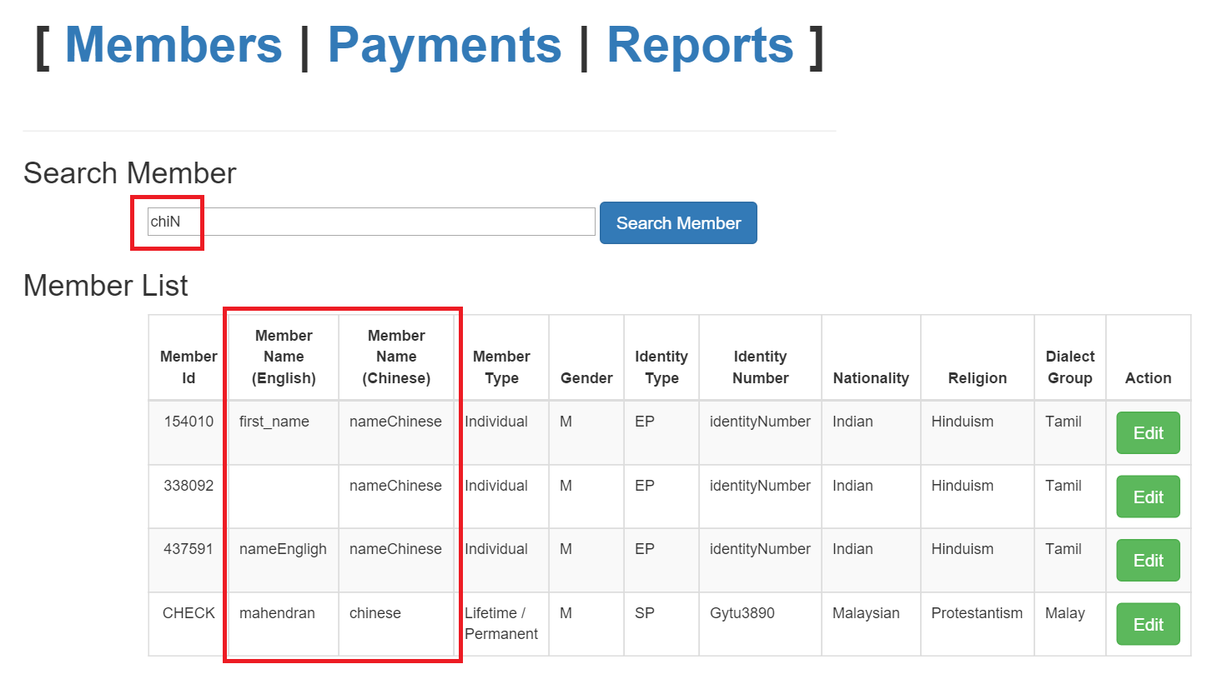

***Pending on 1st page:***

1. Try to include **AngularUI Grid** [**http://ui-grid.info/docs/#/tutorial**](http://ui-grid.info/docs/#/tutorial)
2. Change the table (grid) to support pagination (to show total number of records and number of pages)
3. Change the table / grid to support column sorting
4. Change the table / grid to support dynamic field names
5. Change the input SEARCH field to accept Chinese characters