

**Member Management Tool**

|  |  |
| --- | --- |
| Author | Mahendran Bilendran |
| Cognizant Id | 141089 |

“Singapore Buddhist Free Clinic” wants to develop a new web application to manage the membership details and the payment details for its members. The clinic collects membership fees from the people / organization and provides medical benefits to its member at the subsidized rates.

|  |
| --- |
| **Existing Application** |
| Standalone Application -- 2 Modules - member management & payment management |
| Each member has a set of profile |
| Each member has a set of payment history details |
| Payment received per member has been sent to 3rd party software (**Accounting Ledger**) |
| Then, accounting system sends "Payement Voucher" back to this application |
| **Drawbacks:** No support for advance payment; No support for report generation in CSV |

|  |
| --- |
| **New Application** |
| Standalone Application -- 2 Modules - member management & payment management |
| Each member has a set of profile |
| Each member has a set of payment history details |
| NO NEED TO INTEGRATE this NEW tool with ACCOUNTING LEDGER system |
| Manually, the user has to update voucher number from ledger system into the respective payment record |
| Advance payment - member can pay more than one subscription amount at a time This has to be adjusted to the subsequent payment due amounts |
| Report generation in CSV file format |
|  |
| To load existing member details into this new application - CSV file Import |
| To load existing payment details into this new application - CSV file Import |
|  |
| **Auto creation of "Payment Due" records with specific due amount and due date for ACTIVE members** |
|  |

**Member Attributes**



**Payment Attributes**



The membership fees (**100 SGD**) has been collected on annual basis. If the member did not pay the membership fees for the 2 subsequent years, then the respective membership will be **expired**.

The clinic provides **4 types** of membership:

1. Organization – A contact person from organization should be assigned to interact with the clinic
2. Buddhist Monks
3. Life time membership / Permanent
4. Individuals

**Data Model**

The data model of this tool contains the following 6 base database tables

* **Member**

This DB table contains the attributes about the members. The **member id** should start with the respective alphabet letter to denote the member type. The rest of the numbers in member id can be generated by sequence.

* **A** – for Organization
* **B** – for Buddhist monks
* **L** – for Lifetime / permanent members
* **I** – for individual members
* **Address**

This DB table contains the address details of the members. Each member can have max of 2 address records – one for mailing address and one for permanent address.

* **Contacts**

This DB table contains the contact details of the members.

* **Member_JoinerLeaver**

This DB table contains the joining details and leaving details (if any) of the members.

* **Payment**

This DB table contains the payment details of the member – both payment due for that year and payment paid by the member. For each year, a new payment record should be created for each member mentioning the payment due amount and payment due date. If the member wants to pay the membership fees for the upcoming years in **advance**, then a new payment record should be created with the amount paid and without payment due details.

* **Global_Constant**

This DB table contains the various constant values used in this application. The following are the constant types which in turn having various values that are mapped to the member details. These constant values are used in the drop down values in the application to map with the member details.

1. ADDRESS_TYPE
2. DIALECT
3. IDENTITY_TYPE
4. LEAVING_REASON
5. MEMBER_TYPE
6. NATIONALITY
7. RELIGION

The following SQL file can be used to create a database schema and tables created for this project – **MySQL** database.



The following modules are identified for “Member Management” project of “Singapore Buddhist Free Clinic”. Each module has various use cases in this application.

1. Member Management
2. Payment Management
3. Report Management
4. Data Upload
5. Miscellaneous

**Member Management**

The following use case points are identified in this module “Member Management”. A parent tab “Members” can be created to group the below mentioned use case points.

|  |  |
| --- | --- |
| **Usecase ID** | UC_MM_01 |
| **Usecase Title** | Search members by id / name |
| **Description** | Search member(s) based on Member ID / Member Name.  The input for **name** may be English name or Chinese name. |

|  |  |
| --- | --- |
| **Usecase ID** | UC_MM_02 |
| **Usecase Title** | Search members by type |
| **Description** | 4 types of membership  Search member(s) based on Member Type |

|  |  |
| --- | --- |
| **Usecase ID** | UC_MM_03 |
| **Usecase Title** | View members (with pagination) |
| **Description** | * To show the list of members based on the pagination * The shown list will contain the pre-defined number of members only. For ex., 25 members can be displayed in a single page * Also, basic membership attributes can be displayed in UI – table columns |

|  |  |
| --- | --- |
| **Usecase ID** | UC_MM_04 |
| **Usecase Title** | Edit / View member |
| **Description** | On clicking a member’s record from the member list in UI. A pop-up can be displayed with the following tabs to display the details of the selected member:   * Member attributes * Address * Contact * Member – Joiner / Leaver * Payment History – **READONLY** |

|  |  |
| --- | --- |
| **Usecase ID** | UC_MM_05 |
| **Usecase Title** | Add member |
| **Description** | To add a new member. A pop-up can be displayed with the following tabs to add the details of the new member:   * Member attributes * Address * Contact * Member – Joiner / Leaver * ~~Payment History –~~ **~~READONLY~~** |

|  |  |
| --- | --- |
| **Usecase ID** | UC_MM_06 |
| **Usecase Title** | View payments (with pagination) |
| **Description** | **UC_MM_04** 🡪”Payment History” tab 🡪 To display the payment history of the selected member in a table format with pagination |

|  |  |
| --- | --- |
| **Usecase ID** | UC_MM_07 |
| **Usecase Title** | Search payment by date duration |
| **Description** | **UC_MM_06** 🡪 To display the payment history of the selected member in a table format with pagination for the given date duration (From date – To date) |

**Payment Management**

The following use case points are identified in this module “Payment Management”. A parent tab “Payments” can be created to group the below mentioned use case points.

|  |  |
| --- | --- |
| **Usecase ID** | UC_PM_01 |
| **Usecase Title** | Search payment by date duration |
| **Description** | Search the payment for the given date duration (From date – To date) |

|  |  |
| --- | --- |
| **Usecase ID** | UC_PM_02 |
| **Usecase Title** | Search payment by member id / name |
| **Description** | A member can be selected using **UC_MM_01**  Search the payment for the selected member |

|  |  |
| --- | --- |
| **Usecase ID** | UC_PM_03 |
| **Usecase Title** | View payments (with pagination) |
| **Description** | * To show the list of payments based on the pagination – Default SORT in descending order on Paid date, Due date, Payment Id * The shown list will contain the pre-defined number of payments only. For ex., 25 payments can be displayed in a single page |

|  |  |
| --- | --- |
| **Usecase ID** | UC_PM_04 |
| **Usecase Title** | Add payment |
| **Description** | * A member can be selected using **UC_MM_01** * To add a new payment for the selected member. * A new page / a pop-up can be displayed to enter all the payment attributes – no need of tab * When the member pays the membership fees, the columns “PAID AMOUNT” & “PAID DATE” will be updated. While saving this payment info, a receipt number should be generated. Receipt number should be started with “**M**” |

|  |  |
| --- | --- |
| **Usecase ID** | UC_PM_05 |
| **Usecase Title** | Edit / View payment |
| **Description** | * To view the details of the selected payment from the payment list * To edit the details of the selected payment * When the member pays the membership fees, the columns “PAID AMOUNT” & “PAID DATE” will be updated. While saving this payment info, a receipt number should be generated. Receipt number should be started with “**M**” |

**Report Management**

The following use case points are identified in this module “Report Management”. A parent tab “Reports” can be created to group the below mentioned use case points. **Both English and Chinese languages are used in each report.**

|  |  |
| --- | --- |
| **Usecase ID** | UC_RP_01 |
| **Usecase Title** | Per member - Member info (**PDF**) |
| **Description** | A member can be selected using **UC_MM_01**  To export the profile in PDF for the selected member |

|  |  |
| --- | --- |
| **Usecase ID** | UC_RP_02 |
| **Usecase Title** | Per member - Payment Receipt (**PDF**) |
| **Description** | To export the payment receipt in PDF for the selected member  Reference: UC_PM_04 & UC_PM_05  The amount paid for this payment record should be selected to generate the respective receipt info |

|  |  |
| --- | --- |
| **Usecase ID** | UC_RP_03 |
| **Usecase Title** | Bulk member export (**CSV**) |
| **Description** | To export the profiles in PDF for the set of members  Hint: The members can be selected based on the member type |

|  |  |
| --- | --- |
| **Usecase ID** | UC_RP_04 |
| **Usecase Title** | Payment due for selected duration (**CSV**) |
| **Description** | To export the payment **due** records for the selected date duration |

|  |  |
| --- | --- |
| **Usecase ID** | UC_RP_05 |
| **Usecase Title** | Payment paid for selected duration (**CSV**) |
| **Description** | To export the payment **paid** records for the selected date duration |

|  |  |
| --- | --- |
| **Usecase ID** | UC_RP_06 |
| **Usecase Title** | Per member - Meeting letter (**PDF**) |
| **Description** | To generate general body meeting notification for the selected member (or for all active members) |

|  |  |
| --- | --- |
| **Usecase ID** | UC_RP_07 |
| **Usecase Title** | Per member - Payment reminder (**PDF**) |
| **Description** | To export the payment reminder notification for the selected member (or for all active members who are having payment dues) |

|  |  |
| --- | --- |
| **Usecase ID** | UC_RP_08 |
| **Usecase Title** | Per member - Payment details (**CSV**) |
| **Description** | A member can be selected using **UC_MM_01**  To export payment details (due as well as paid) for the selected member |

**Data Upload / On-boarding**

The following use case points are identified in this module “Data Upload”. A parent tab “On-boarding” can be created to group the below mentioned use case points.

|  |  |
| --- | --- |
| **Usecase ID** | UC_DU_01 |
| **Usecase Title** | Upload member details |
| **Description** | To upload member details into this new tool   1. Existing members – member id already available 2. New members – member id has to be created according the member type |

|  |  |
| --- | --- |
| **Usecase ID** | UC_DU_02 |
| **Usecase Title** | Upload payment details |
| **Description** | To upload payment details into this new tool   1. Existing payments – payment id already available (if such thing given by clinic) 2. New payments – payment id has to be generated |

**Miscellaneous**

The following use case points are identified in this module “Miscellaneous”. A parent tab “Miscell” can be created to group the below mentioned use case points.

|  |  |
| --- | --- |
| **Usecase ID** | UC_MI_01 |
| **Usecase Title** | Generate payment due records |
| **Description** | * To generate payment due records for **active** members who are having payment due to be paid for the upcoming membership year. Advance payment has to be considered here to verify whether the active member has to pay the membership fees for the given year or not * Payment due amount and due date should be given as **inputs** to this functionality |

**TODO**

1. Design documentation
2. Sample GUI screens
3. Sample report documents

**View Members with Pagination:**

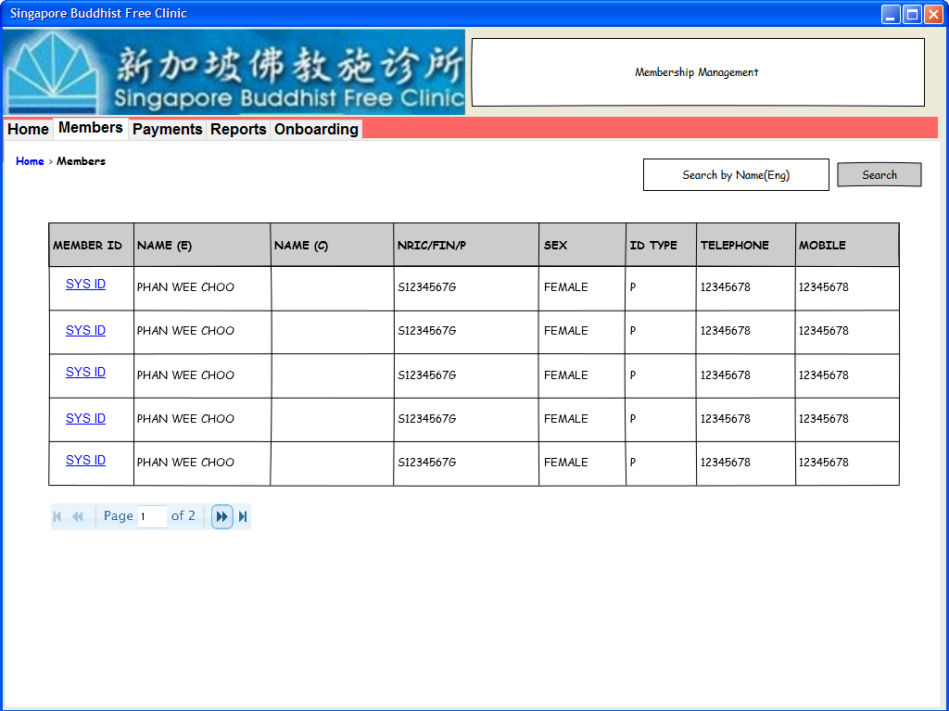

**Technologies proposed**

|  |  |
| --- | --- |
| Programming language | **Java 8** |
| Web Server | **Embedded Tomcat 7.0.57** |
| Database | **My SQL 5.7** |
| Front End (UI) | **JSP + JS** |
| Scripting language | **Angular JS** |
| Development Platform | **Spring 4.x** |
| Transaction management | **Spring 4.x** |
| MVC | **Spring MVC 4.x** |
| Report | **Jasper** |
| Build | **Maven 3.x** |
| ~~ORM – Object Relation Mapping~~ | **~~Hibernate 5.x~~** |

**Queries**

|  |  |  |
| --- | --- | --- |
| **S.No** | **Questions** | **Response** |
| 1 | How to on-board existing membership and payment details to the application – a) File load or b) DB scripts? | There is an existing system but not flexible enough. Not export feature |
| 2 | Do we need to maintain “history” details when the membership data gets changed? For ex., change in address, contact numbers, membership type, occupation. | Archive the data (Not critical) |
| 3 | Subscription duration – Monthly or Yearly? | Yearly |
| 4 | Payment Record – Do we need to create one payment record per member per subscription period? Or one payment record per member always? | Yes |
| 5 | Any email communication need to send to the members about payment due notifications? | Yes, Integrate with **Gmail** |
| 6 | Report generation – simple table format / CSV? | PDF/CSV |
| 7 | Any documentation on requirements? |  |
| 8 | Max number of users accessing the application at a given time? | Currently 1, we can make it multi-user |
| 9 | Web server? |  |
| 10 | Web browser to support? | IE |
| 11 | Internet or Intranet application? | Web App/ Intranet |
| 12 | Standalone application or to integrate with another application? | No |
| 13 | Login page? Authentication info? | None/But we can have multi user |
| 14 | Any preferred web technologies? | PHP/MySQL |
| 15 | Any point of contact for frequent communications? |  |
| 16 | Payment Details - mode of Payment, is there any integration requirement? | Manual |
| 17 | Why the meta data for Payment (receipt / voucher) are not given? Do we need to consider the payment screens also for this project? |  |
| 18 | Membership fees | 100 SGD |
| 19 | Membership expiry? | If the payment is not made for 2 subsequent years |
| 20 | Member count? | 200+ members |