Assignment on Common Network Devices
Introduction
In computer networking, various hardware devices are used to connect, manage, and secure communication between computers and networks. These devices perform specific functions such as data forwarding, filtering, or security. The most common network devices are Hub, Switch, Router, Repeater, Bridge, Gateway, and Firewall. Each plays an important role in building reliable and efficient networks.

🔹 1. Hub
- Definition: A hub is the simplest networking device that connects multiple computers in a local area network (LAN).
- Working Principle: Operates at the Physical Layer (Layer 1) of the OSI model.
- How it Works: When a computer sends data, the hub copies the signal and broadcasts it to all connected devices. The correct device picks it up, but others receive unnecessary traffic too.
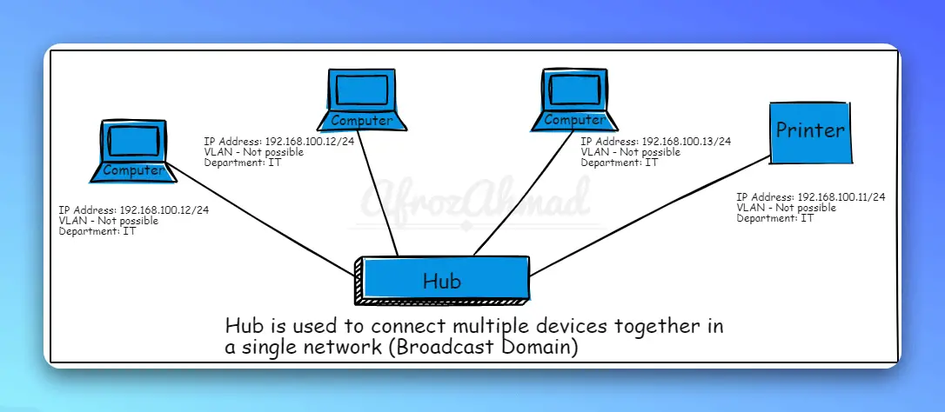

Advantages:
- Low cost.
- Easy to install and use.
Disadvantages:
- Causes unnecessary traffic.
- No security or filtering.
- Collisions occur often, reducing performance.
Real Life Example:
In a small computer training center, a hub may be used to connect 5–6 old PCs for simple file sharing and internet access.

🔹 2. Switch
- Definition: A switch is a network device that connects multiple devices in a LAN but works more efficiently than a hub.
- Working Principle: Operates at the Data Link Layer (Layer 2).
- How it Works: The switch reads the MAC address of incoming data and forwards it only to the intended device, not to all. It maintains a MAC address table to keep track of connected devices.
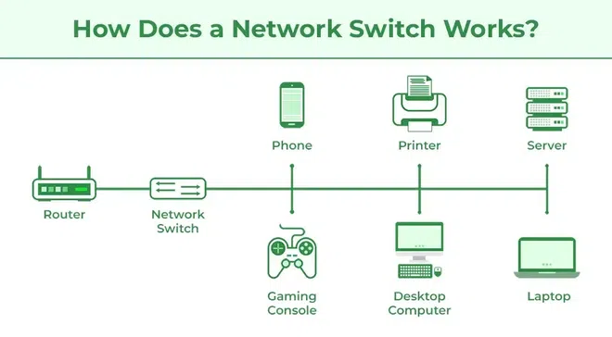
Advantages:
- Faster and more efficient than hubs.
- Provides better performance by reducing traffic.
- Offers security by sending data only to the correct device.
Disadvantages:
- More expensive than hubs.
- Configuration may require technical knowledge.
Real Life Example:
In a university computer lab, a switch is used to connect 50+ computers so that students can access the local network and internet efficiently.

🔹 3. Router
- Definition: A router is a device that connects multiple networks together (e.g., LAN to the Internet).
- Working Principle: Operates at the Network Layer (Layer 3).
- How it Works: A router examines the IP address of packets, finds the best route using routing tables, and forwards data between networks. It can also assign IPs using DHCP and hide devices using NAT.
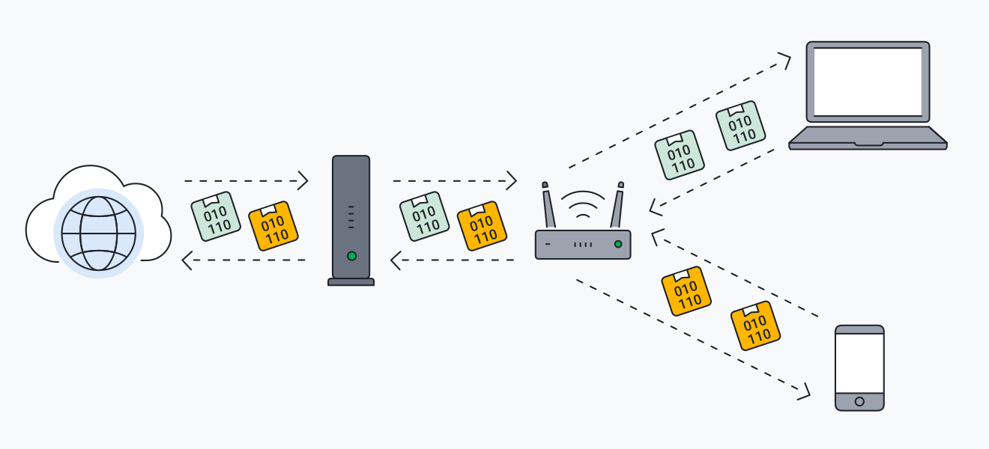
Advantages:
- Connects different networks.
- Provides security features like firewalls and filtering.
- Reduces network congestion with intelligent routing.
Disadvantages:
- More expensive than switches and hubs.
- Slower compared to a switch in LAN-only communication.
Real Life Example:
In a home Wi-Fi setup, a router connects your smartphones, laptops, and smart TVs to the Internet provided by your ISP.

🔹 4. Repeater
- Definition: A repeater is a device that amplifies and retransmits network signals.
- Working Principle: Operates at the Physical Layer (Layer 1).
- How it Works: When a weak or distorted signal arrives at the repeater, it regenerates and retransmits it at the original strength, extending the range of the network.
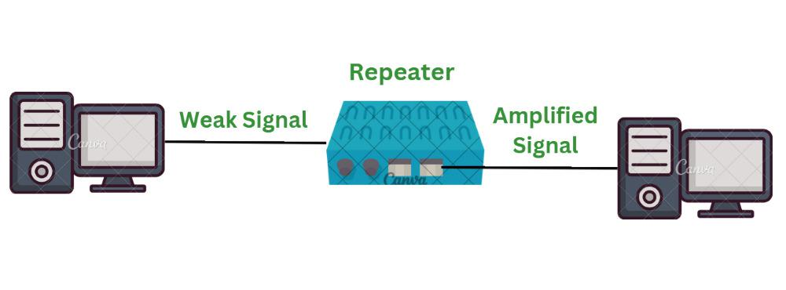
Advantages:
- Increases network coverage.
- Simple and low cost.
Disadvantages:
- Cannot filter or manage traffic.
- Does not reduce congestion.
Example Use:
- Wi-Fi range extenders at home or office.
Real Life Example:
In a large house, a Wi-Fi repeater is used to extend the internet signal from the living room router to the upstairs bedrooms.

🔹 5. Bridge
- Definition: A bridge is a device that connects two LAN segments and manages traffic between them.
- Working Principle: Operates at the Data Link Layer (Layer 2).
- How it Works: A bridge reads the MAC address of data frames and forwards traffic only between the necessary segments. This reduces congestion by filtering unnecessary data.
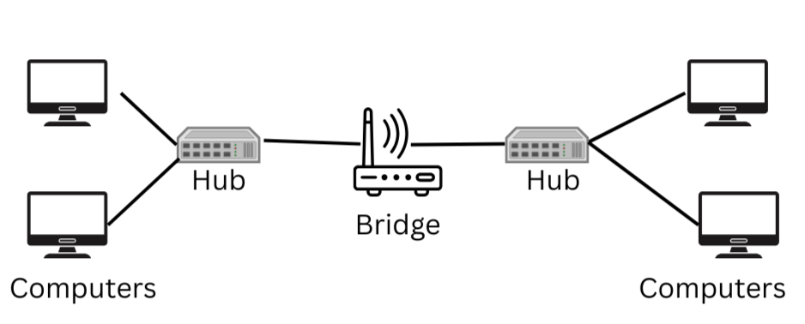
Advantages:
- Reduces collisions in a network.
- Increases performance by segmenting traffic.
Disadvantages:
- Slower than switches.
- Limited functions in modern networks.
Real Life Example:
In a small office with two departments, a bridge can connect the accounting department LAN with the HR department LAN while filtering unnecessary traffic.

🔹 6. Gateway
- Definition: A gateway is a network device that connects two different networks with different communication protocols.
- Working Principle: Operates at multiple layers (often Application Layer).
- How it Works: A gateway acts as a translator between different protocols. For example, it can convert IPv4 packets into IPv6 or connect a LAN to the Internet by reformatting the data.
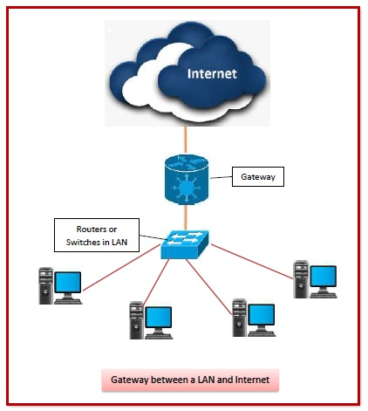
Advantages:
- Connects completely different types of networks.
- Provides protocol translation.
Disadvantages:
- More complex and expensive.
- Slower because of protocol conversion.
Real Life Example:
In a banking system, a gateway allows secure communication between the internal banking LAN and external networks like ATM machines.

🔹 7. Firewall
- Definition: A firewall is a security device (hardware or software) that monitors and controls incoming and outgoing network traffic.
- Working Principle: Works at Network Layer and higher layers.
- How it Works: A firewall checks every packet of data against predefined security rules. If the packet meets the rules, it is allowed; otherwise, it is blocked. Firewalls can perform packet filtering, proxy service, and deep inspection.
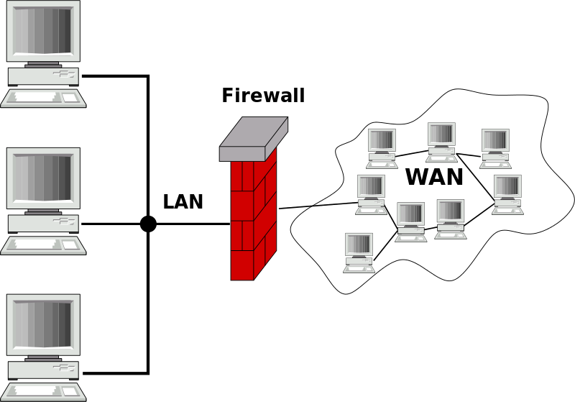
Advantages:
- Protects from unauthorized access.
- Blocks malware and hackers.
- Provides network monitoring.
Disadvantages:
- Can slow down traffic.
- Needs proper configuration.
Real Life Example:
In a university campus network, a firewall is used to block malicious websites and restrict students from accessing gaming sites during class hours.

Conclusion
Network devices are the building blocks of communication systems. Hubs and repeaters are simple but outdated. Switches and bridges manage LAN traffic more efficiently. Routers and gateways connect different networks, while firewalls provide security. Each device has a unique role, and together they make modern networking possible.

