Exp.No: | Experiment Name | Pages
01 | Design and implementation of a Star topology in Cisco Packet Tracer. | 2-4
02 | Design and implementation of a Mesh topology in Cisco Packet Tracer. | 4-6
03 | Static routing configuration for four interconnected networks. | 6-8
04 | Dynamic routing configuration for four interconnected networks.. | 9-11
05 | Design of a complete campus network. | 11-14
Context

Experiment No: 01
Experiment Name: Design and implementation of a Star topology in Cisco Packet Tracer.
Objectives:
• Learned how to configure devices such as switches, routers, and end devices in a star topology.
• Established proper connections between devices and assigning IP addresses for communication.
• Verified end-to-end connectivity through simulation (e.g., using ping commands).
• Analyzed the benefits of using a star topology, such as ease of management, scalability, and fault isolation.
Requirements:
- 1 Switch (central device).
- Here used 6 PCs.
- Ethernet cables (Copper Straight-through).
- Cisco Packet Tracer software.
- IP addressing scheme for all PCs.
- Basic knowledge of assigning IP addresses to end devices.

Design:
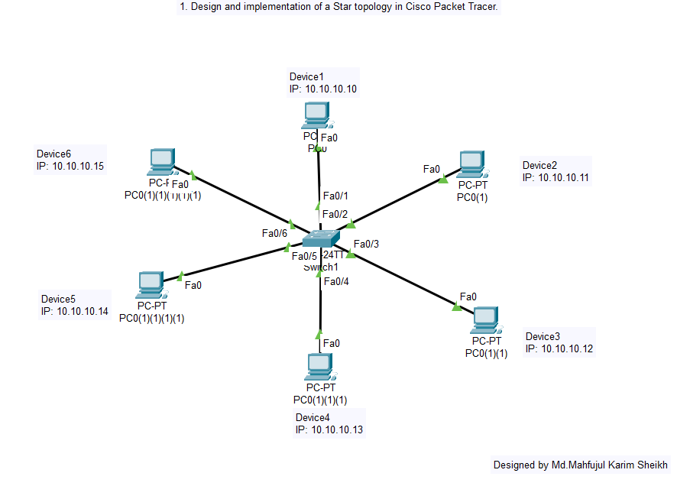
Working Procedure:
1. Opened Cisco Packet Tracer.
2. Drag and drop one switch into the workspace.
3. Added 6 PCs around the switch.
4. Connected each PC to the switch using Straight-through cables.
5. Assigned unique IP addresses to each PC.
6. Test connectivity using the ping command from one PC to another.
7. Verify that all devices can communicate through the central switch (Star Topology).
Result:
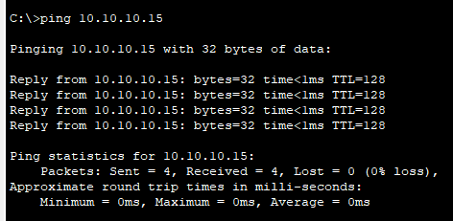

Experiment No: 02
Experiment Name: Design and implementation of a Mesh topology in Cisco Packet Tracer.
Objectives:
• Learned how to interconnect multiple devices so that each device has direct communication with others.
• Configured IP addressing for all connected devices.
• Verified data transfer reliability and fault tolerance using simulation tools.
• Analyzed the advantages of mesh topology in terms of redundancy, fault tolerance, and reliability.
Requirements:
- 6 PCs and 6 Switch and cables.
- Each PC connected to every other PC (point-to-point links).
- Ethernet cables (Copper Cross-over or Straight-through depending on device).
- Cisco Packet Tracer software.
- Proper IP addressing plan.
- Understanding of direct device-to-device communication.
Design:
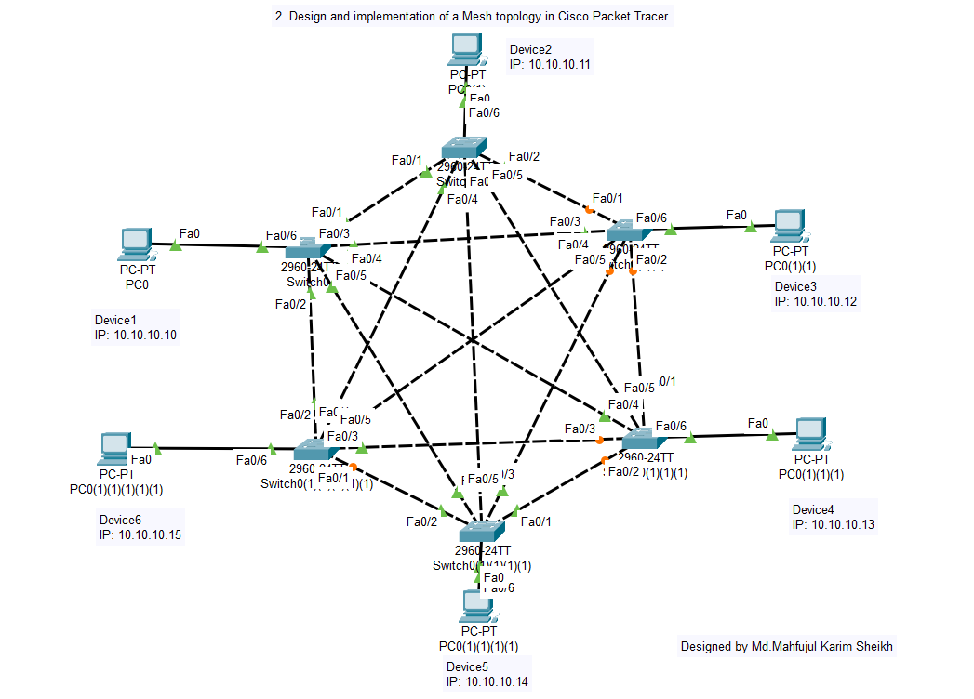
Working Procedure:
1. Opened Cisco Packet Tracer.
2. Placed 6 PCs, 6 switch and necessary cables on the workspace.
3. Connected each PC to every other PC (partial mesh) using Ethernet cables.
4. Assigned a unique IP address to each PC.
5. Useed the ping command to check connectivity between all pairs of PCs.
6. Verified that communication is successful without a central device (direct links).
Result:
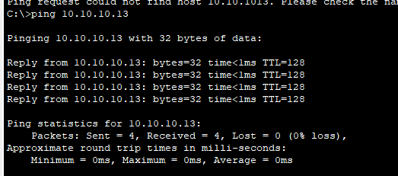
Experiment No: 03
Experiment Name: Static routing configuration for four interconnected networks.
Objectives:
• Understood the concept of static routing and manual route entry.
• Assigned proper IP addressing schemes to all devices in the network.
• Configured static routes in routers to ensure inter-network communication.
• Tested connectivity between all networks using ping and traceroute.
• Analyzed the advantages and limitations of static routing in real-world scenarios.
reliability.
Requirements:
• 4 Routers (to represent 4 networks).
• 4 Switches (for connecting PCs).
• 8 PCs.
• Ethernet cables (Straight-through between PC ↔ Switch, and Cross-over between Router ↔ Router if required).
• IP addressing scheme (subnet planning).
• Cisco Packet Tracer software.
• Knowledge of ip route command for static routing configuration.
Design:
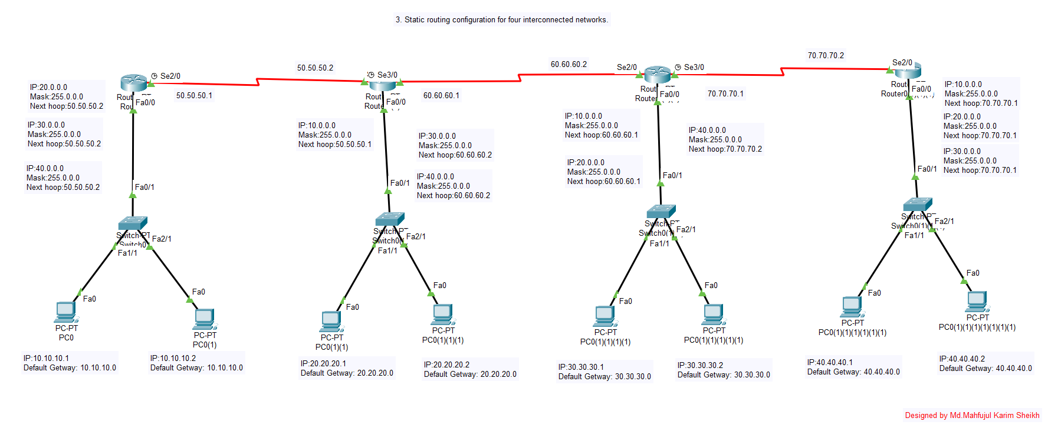
Working Procedure:
- Place 4 routers in the workspace to represent four different networks.
- Connected each router to its own switch and PC .
- Interconnected the routers using serial or Ethernet cables.
- Assigned IP addresses to all PCs, router interfaces, and inter-router links.
- On each router, configured static routes using the ip route command so that each router knows how to reach other networks.
- Tested connectivity by pinging PCs from one network to another.
- Verified that routing is successful only because of the manually configured static routes.
Result:
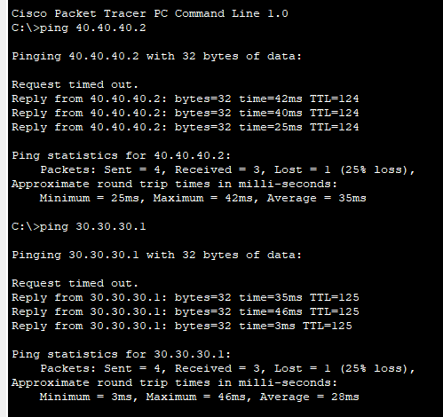

Experiment No: 04
Experiment Name: Dynamic routing configuration for four interconnected networks..
Objectives:
• Understood the working principles of dynamic routing protocols .
• Configured routers to automatically share routing information.
• Verified automatic route updates and communication between all networks.
• Compared dynamic routing with static routing in terms of scalability and efficiency.
• Analyzed the role of dynamic routing in large and complex networks.
Requirements:
• 4 Routers (to represent 4 different networks).
• 4 Switches (for end devices).
• 8 PCs.
• Ethernet cables (Straight-through & Cross-over).
• IP addressing scheme.
• Cisco Packet Tracer software.
• Knowledge of dynamic routing protocols (e.g., RIP, OSPF, or EIGRP).
• Commands for enabling and configuring routing protocols.
.

Design:
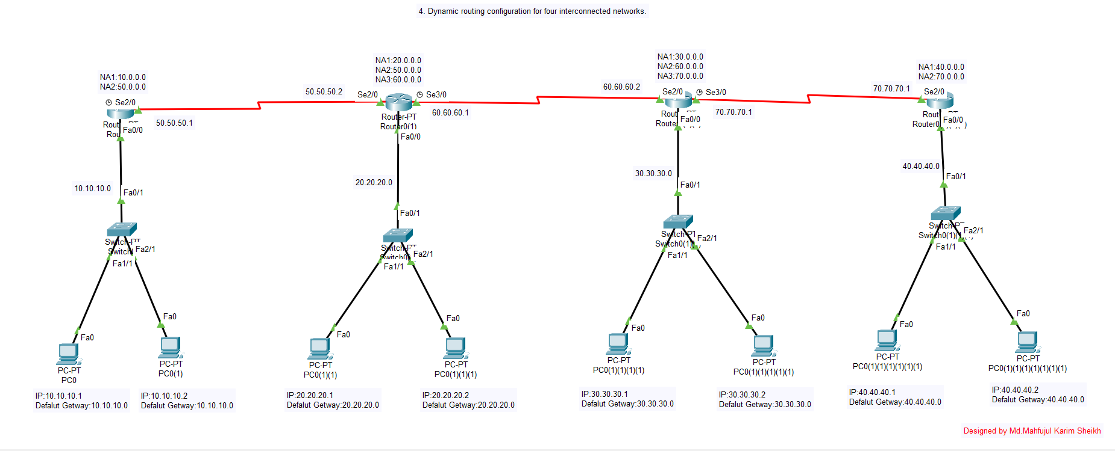

Working Procedure:
• Placed 4 routers, each connected to a switch and PC.
• Connected routers together using cables.
• Assigned IP addresses to PCs, router interfaces, and inter-router connections.
• Enabled a dynamic routing protocol (e.g., RIP, OSPF, or EIGRP) on all routers.
• Ensured all routers exchange routing information automatically.
• Tested connectivity using ping between PCs in different networks.
• Verified that communication is successful without manually configuring static routes.

Result:
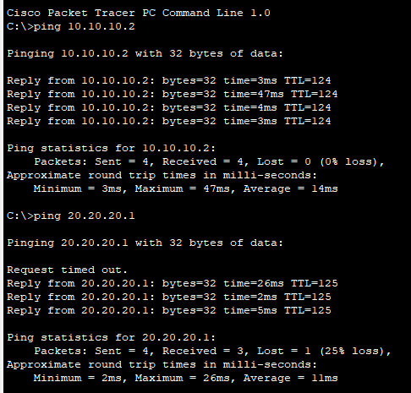

Experiment No: 05
Experiment Name: Design of a complete campus network.
Objectives:
• Designed a hierarchical network structure with core, distribution, and access layers.
• Implemented VLANs, IP addressing, and inter-VLAN routing.
• Configured essential services such as DHCP, DNS, and server-based applications.
• Ensured secure and efficient communication between different segments of the campus network.
• Analyzed the performance, scalability, and security aspects of a campus network design.
Requirements:
• Multiple Routers (core, distribution, and edge).
• Multiple Switches (access and distribution layer).
• PCs/Laptops (for students, staff, admin, etc.).
• Servers (DNS, DHCP, Web, Email).
• Wireless Devices (Access Points, Wireless Routers – if needed).
• Proper IP addressing (subnetting, VLANs if required).
• Cisco Packet Tracer software.
• Knowledge of:
- VLANs and Inter-VLAN routing.
- Static & Dynamic routing.
- DHCP server configuration.
- Basic security (Access Control Lists).
.

Design:
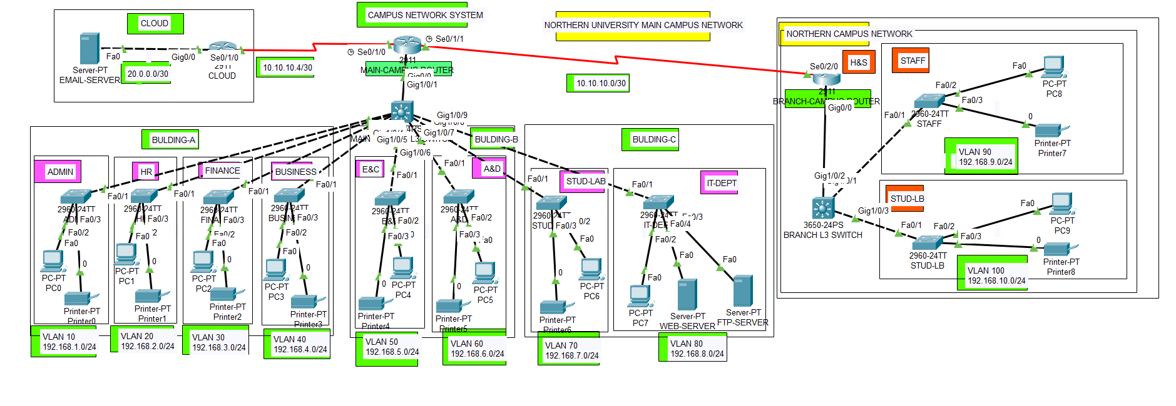

Working Procedure:
• Opened Cisco Packet Tracer and plan a hierarchical network design (Core → Distribution → Access).
• Placed routers (for backbone), switches (for different departments/labs), and PCs/servers.
• Connected end devices to access switches, access switches to distribution switches, and then to the core router.
• Assigned IP addresses using subnetting to separate departments (e.g., Students, Faculty, Admin).
• Configured VLANs for departmental segmentation and use Inter-VLAN routing.
• Added a DHCP server to assign IPs automatically, and configure DNS/Web/Email servers.
• Used a dynamic routing protocol (like OSPF) for inter-router communication.
• Tested connectivity using ping and traceroute across different parts of the network.
• Verified that the complete campus network is functional with internet, server access, and inter-department communication.
Result:
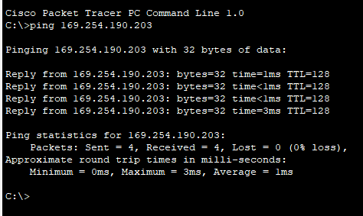

NB: For implementing campus area network , I used directly online resources and AI. Source is collected from this site: https://github.com/Anas436/Campus-Network-System-Using-Cisco-Packet-Tracer/blob/main/Final_Project_CampusNetwork.pkt .

