

**International University of Business Agriculture and Technology**

**Lab Report 8**

**Course Code: CSC 284**

**Course Name: Programming in C++ Lab**

**Submitted To:**

**Engr. A.S.M. Shakil Ahamed**

Senior Lecturer

Dept. of Computer Science and Engineering

International University of Business Agriculture and Technology

**Submitted By:**

Name: Md. Mahfujar Rahman

ID: 23303151

Section: C

**1.Code:**

#include <iostream>

using namespace std;

double convertTemperature(double celsius)

{

    return (celsius * 9.0 / 5.0) + 32;

}

double convertTemperature(double fahrenheit, char)

{

    return (fahrenheit - 32) * 5.0 / 9.0;

}

int main()

{

    double tempC = 25.0;

    double tempF = 77.0;

    cout << tempC << "°C is " << convertTemperature(tempC) << "°F" << endl;

    cout << tempF << "°F is " << convertTemperature(tempF, 'F') << "°C" << endl;

    return 0;

}

**Output:**

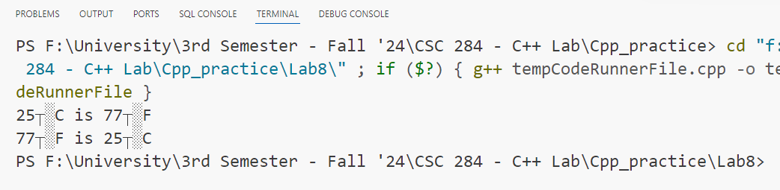

**2.Code:**

#include <iostream>

using namespace std;

const double PI = 3.14159;

double calculateArea(double radius)

{

    return PI * radius * radius;

}

double calculateArea(double length, double width)

{

    return length * width;

}

double calculateArea(double base, double height, char)

{

    return 0.5 * base * height;

}

int main()

{

    double radius = 5.0;

    double length = 10.0, width = 4.0;

    double base = 8.0, height = 6.0;

    cout << "Area of the circle: " << calculateArea(radius) << endl;

    cout << "Area of the rectangle: " << calculateArea(length, width) << endl;

    cout << "Area of the triangle: " << calculateArea(base, height, 'T') << endl;

    return 0;

}

**Output:**

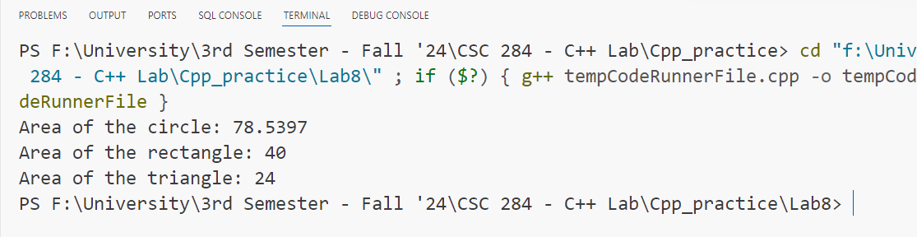

**3.Code:**

#include <iostream>

using namespace std;

const double PI = 3.14159;

double calculateVolume(double side)

{

    return side * side * side;

}

double calculateVolume(double radius, double height)

{

    return PI * radius * radius * height;

}

double calculateVolume(double length, double width, double height)

{

    return length * width * height;

}

int main()

{

    double side = 3.0;

    double radius = 2.0, cylinderHeight = 5.0;

    double length = 4.0, width = 3.0, boxHeight = 6.0;

    cout << "Volume of the cube: " << calculateVolume(side) << endl;

    cout << "Volume of the cylinder: " << calculateVolume(radius, cylinderHeight) << endl;

    cout << "Volume of the rectangular box: " << calculateVolume(length, width, boxHeight) << endl;

    return 0;

}

**Output:**

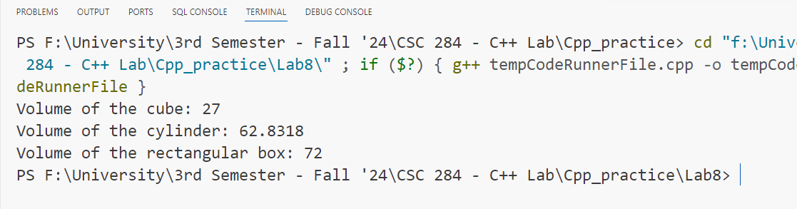

**4.Code:**

#include <iostream>

#include <string>

using namespace std;

int processString(const string &str)

{

    return str.length();

}

int processString(const string &str, char ch)

{

    int count = 0;

    for (char c : str)

    {

        if (c == ch)

            count++;

    }

    return count;

}

int main()

{

    string text = "hello world";

    char targetChar = 'l';

    cout << "Length of the string: " << processString(text) << endl;

    cout << "Count of '" << targetChar << "' in the string: " << processString(text, targetChar) << endl;

    return 0;

}

**Output:**

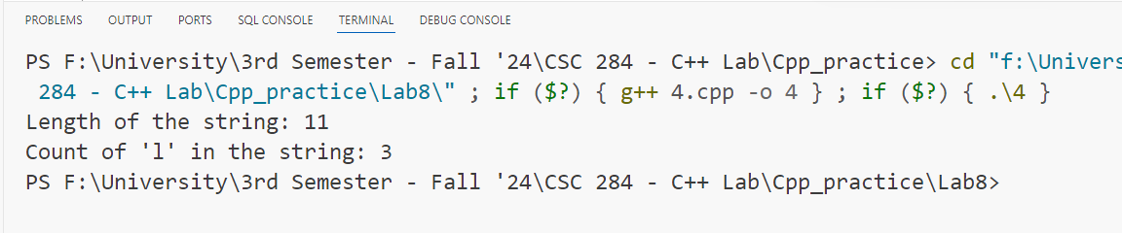

**5.Code:**

#include <iostream>

#include <string>

using namespace std;

int processString(const string &str)

{

    return str.length();

}

int processString(const string &str, char ch)

{

    int count = 0;

    for (char c : str)

    {

        if (c == ch)

            count++;

    }

    return count;

}

int main()

{

    string text = "hello world";

    char targetChar = 'l';

    cout << "Length of the string: " << processString(text) << endl;

    cout << "Count of '" << targetChar << "' in the string: " << processString(text, targetChar) << endl;

    return 0;

}

**Output:**

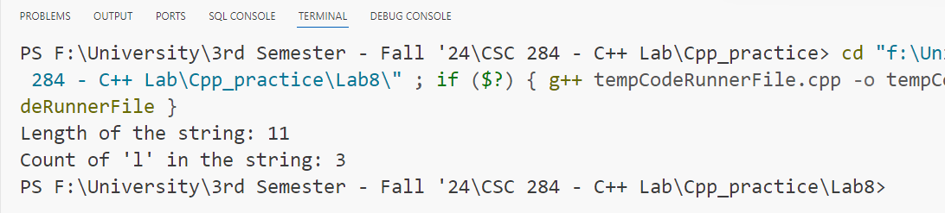

**6.Code:**

#include <iostream>

using namespace std;

double calculateSalary(double hourlyWage, double hoursWorked, char)

{

    return hourlyWage * hoursWorked;

}

double calculateSalary(double baseSalary, double performanceBonus)

{

    return baseSalary + performanceBonus;

}

int main()

{

    cout << "Hourly employee salary: " << calculateSalary(20.0, 40, 'H') << endl;

    cout << "Salaried employee salary: " << calculateSalary(5000.0, 1000.0) << endl;

    return 0;

}

**Output:**

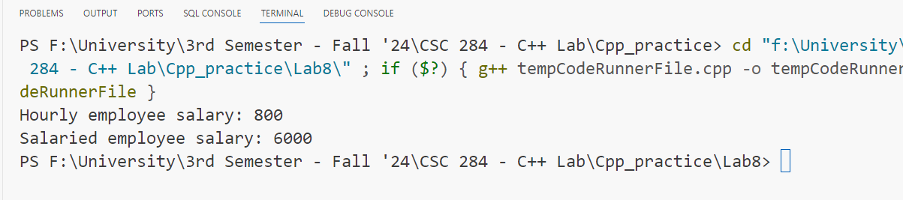

**7.Code:**

#include <iostream>

using namespace std;

double convertCurrency(double dollars, char toCurrency)

{

    if (toCurrency == 'E')

        return dollars * 0.85; // Dollars to Euros

    if (toCurrency == 'P')

        return dollars * 0.75; // Dollars to Pounds

    return dollars;            // Default no conversion

}

double convertCurrency(double euros)

{

    return euros * 1.18; // Euros to Dollars

}

int main()

{

    cout << "Dollars to Euros: " << convertCurrency(100.0, 'E') << endl;

    cout << "Euros to Dollars: " << convertCurrency(85.0) << endl;

    cout << "Dollars to Pounds: " << convertCurrency(100.0, 'P') << endl;

    return 0;

}

**Output:**

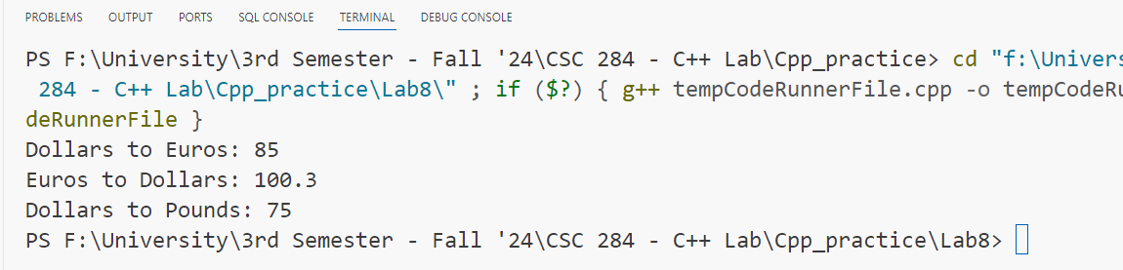

**8.Code:**

#include <iostream>

#include <algorithm>

#include <vector>

using namespace std;

void sort(vector<int> &arr)

{

    sort(arr.begin(), arr.end());

}

void sort(vector<double> &arr)

{

    sort(arr.begin(), arr.end());

}

void sort(vector<string> &arr)

{

    sort(arr.begin(), arr.end());

}

int main()

{

    vector<int> intArr = {5, 3, 8, 1};

    vector<double> floatArr = {5.5, 3.3, 8.8, 1.1};

    vector<string> strArr = {"banana", "apple", "cherry", "date"};

    sort(intArr);

    sort(floatArr);

    sort(strArr);

    cout << "Sorted integers: ";

    for (int x : intArr)

        cout << x << " ";

    cout << "\nSorted doubles: ";

    for (double x : floatArr)

        cout << x << " ";

    cout << "\nSorted strings: ";

    for (string x : strArr)

        cout << x << " ";

    return 0;

}

**Output:**

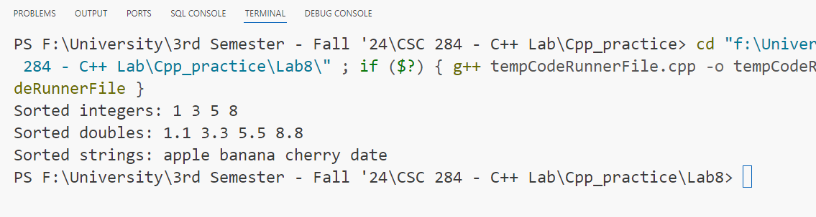

**9.Code:**

#include <iostream>

#include <sstream>

using namespace std;

string formatDate(int day, int month, int year)

{

    ostringstream oss;

    if (day < 10)

        oss << "0";

    oss << day << "/";

    if (month < 10)

        oss << "0";

    oss << month << "/";

    oss << year;

    return oss.str();

}

string formatDate(const string &date)

{

    return date.substr(8, 2) + "/" + date.substr(5, 2) + "/" + date.substr(0, 4);

}

int main()

{

    cout << "Formatted date (integers): " << formatDate(7, 1, 2025) << endl;

    cout << "Formatted date (string): " << formatDate("2025-01-07") << endl;

    return 0;

}

**Output:**

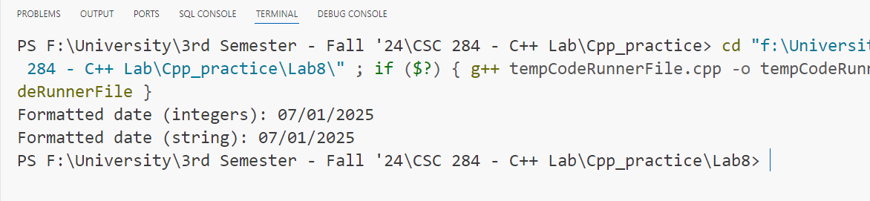

**10.Code:**

#include <iostream>

using namespace std;

double applyDiscount(double price, double percentage)

{

    return price - (price * percentage / 100);

}

double applyDiscount(double price, int flatDiscount)

{

    return price - flatDiscount;

}

double applyDiscount(double price1, double price2, double price3, double percentage)

{

    return (price1 - (price1 * percentage / 100)) +

           (price2 - (price2 * percentage / 100)) +

           (price3 - (price3 * percentage / 100));

}

int main()

{

    double price1 = 100.0, price2 = 200.0, price3 = 300.0;

    cout << "Price after percentage discount: " << applyDiscount(500.0, 10.0) << endl;

    cout << "Price after flat discount: " << applyDiscount(500.0, 50) << endl;

    cout << "Total price after percentage discount: " << applyDiscount(price1, price2, price3, 10.0) << endl;

    return 0;

}

**Output:**

