Experiment No: 02

Experiment Name: Performing file and directory management and understanding file permissions in Linux.

Theory:
Linux provides a command-line interface for efficient file and directory management. Commands such as pwd display the current working directory, ls lists files and directories, mkdir creates directories, cd changes the current directory, touch creates empty files, cp copies files, mv moves or renames files, and rm or rmdir removes files or directories. These commands enable users to organize and manage data effectively.
The ls -l command displays detailed information about files and directories in a long listing format. A typical output such as -rwxr-xr-- 1 user group 1024 Jul 15 10:30 file.txt consists of several fields: the first character indicates the file type (- for a regular file, d for a directory, l for a symbolic link); the next nine characters represent permissions divided into Owner (rwx), Group (r-x), and Others (r--). The following fields show the number of hard links, owner name, group name, file size (bytes), last modification date and time, and finally the file or directory name.

Command Working Principle / Description
pwd Displays the absolute path of the current working directory.
ls -a Lists the all visible $ hidden files/folder within the directory.
ls -l list the file and folder with some details
- .rw-r--r-- 0 user 2 Aug 19:45 file1.txt
- drwxr-xr-x - user 2 Aug 19:46 fol1
mkdir [folder name] … [folder name] Creates multiple directories with the specified name.
mkdir -p [folder name]/ … /[folder name] Creates nested directories.
touch [file name] … [file name] Creates multiple empty files.
cat [file name] Reads and outputs the contents of a file directly to the terminal.
nano [file name] Opens a file inside the Nano terminal text editor for editing.
man to know the existence commands

ScreenShot From Terminal:
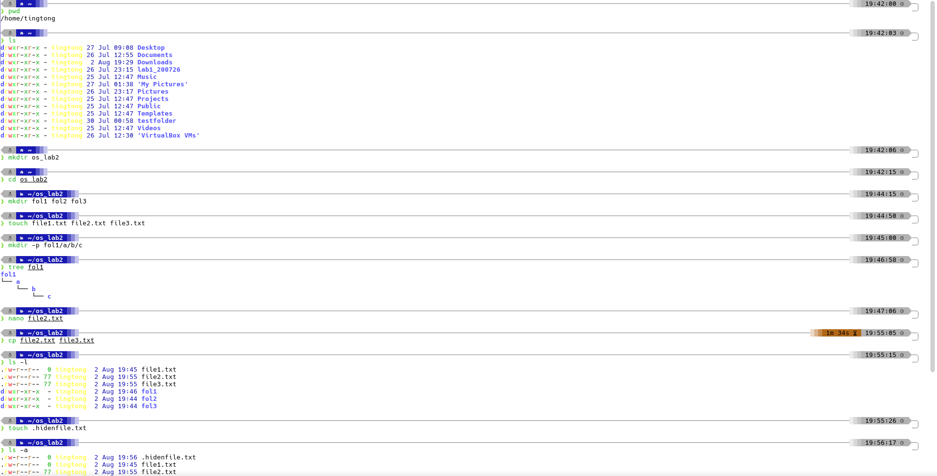
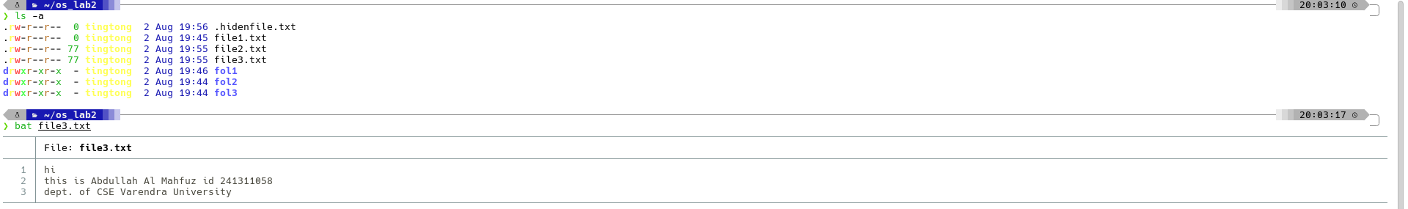

Discussion:
This experiment demonstrated how Linux commands are used to perform essential file and directory management tasks while maintaining security through file permissions. Practical use of commands such as mkdir, touch, cp, mv, rm, and showed how files and directories can be created, organized, modified, and protected. Understanding these commands is fundamental for efficient system administration and daily Linux usage.
The ls -l command was particularly useful for verifying file properties and permissions after performing different operations. By interpreting each field of the long listing format, users can identify the file type, permission settings, ownership, file size, and modification time. This knowledge helps ensure proper access control, troubleshoot permission-related issues, and maintain a secure and well-organized Linux file system.

