**Table of Contents**

1. **Executive Summary**
   * Project Overview
   * Problem Statement
   * Project Objectives
   * Scope of the Project
   * Project Team
2. **Introduction**
   * Background
   * Project Purpose
   * Project Significance
   * Stakeholders
3. **Project Description**
   * Project Goals
   * Features and Functionality
   * Technology Stack
   * Workflow
   * Screenshot of the Project
4. **Problem Statements**
   * Overview of the Problem
   * Problem with Current System
   * Limitations
   * A True Story
5. **Solution Approach**
   * System Design
   * Project Architecture
   * Functional Requirements
   * Non-Functional Requirements
   * Data Flow Diagram
6. **User Requirements**
   * Personal Information
   * Disease Information
   * Hospital Selection
   * Ticket Collection Process
7. **System Benefits**
   * Benefits to Patients
   * Benefits to Hospitals
   * Benefits to Government and Society
8. **Project Implementation**
   * Development Phases
   * Testing and Quality Assurance
   * Deployment and Maintenance
   * Technology Used
9. **Risk Management**
   * Identification of Risks
   * Risk Mitigation Strategies
10. **Conclusion**

**1. Executive Summary**

**Project Overview**

The Hospital eTicketing web app is a revolutionary project designed to address the inefficiencies and challenges associated with acquiring a doctor's appointment in Bangladesh. The project leverages Python Flask to create a user-friendly, web based platform that allows patients to obtain e-tickets for patient to visit doctor. This system will streamline the process of ticket collection and reduce the burden of long queues and valuable times at hospitals.

**Problem Statement**

In Bangladesh, the conventional system of acquiring a doctor's appointment involves physically queuing up at the hospital, resulting in long waiting times and inconvenience for patients. This project aims to solve this issue by providing an online eTicketing system, eliminating the need for patients to be physically present at the hospital to obtain a ticket.

**Project Objectives**

* Develop a user-friendly web application for eTicketing in hospitals.
* Collect patient personal information, disease details, and allow hospital selection.
* Streamline the process, reducing waiting times and improving the overall healthcare experience.

**Scope of the Project**

The project's scope encompasses the development of the Hospital eTicketing web app, including data submission, and ticket collection. The project will initially focus on hospitals within Bangladesh.

**Project Team**

* **Team Leader, Software Architect & Full Stack Developer:** Muhammad Sultan Al Mahfuz
* **Project Proposer:** Md. Nurnobi
* **UI/UX Designer:** Amrito Kumar Pramanik
* **Frontend Developer:** Uzzal Bhowmik

**2. Introduction**

**Background**

In Bangladesh, the existing healthcare system requires patients to physically collect tickets for doctor appointments, resulting in long queues and inconvenience. The Hospital eTicketing web app aims to address this issue by offering an online platform for e-ticket collection.

**Project Purpose**

The primary purpose of this project is to enhance the efficiency and accessibility of healthcare services in Bangladesh by providing patients with a user-friendly and convenient eTicketing system.

**Project Significance**

This project is significant as it contributes to the improvement of the healthcare system in Bangladesh. By reducing physical queues and wait times, it can positively impact the lives of thousands of patients.

**Stakeholders**

1. **Patients:** The end-users who will benefit from the online eTicketing system.
2. **Hospitals:** Healthcare facilities that will utilize the platform.
3. **Government:** May oversee or support the implementation of this system.
4. **Developers and IT Professionals:** The team responsible for designing, developing, and maintaining the web app.

**3. Project Description**

**Project Goals**

The primary goals of the Hospital eTicketing web app project are:

* To provide a user-friendly platform for patients to obtain e-tickets for hospital appointments.
* To streamline the ticket collection process.
* To reduce patient waiting times and improve healthcare access.

**Features and Functionality**

The system allows patients to:

* Provide personal information (name, age, phone number, email).
* Select a disease from a pre-defined list or provide detailed information about their issue.
* Choose a hospital based on location (division, district, zone) for ticket collection.

**Technology Stack**

* **Frontend:** HTML5, CSS3, Javascript
* **Backend:** Python (Flask)
* **Database:** MySQL
* **Hosting:** [Hosting Platform]
* **Security:** SSL, Encryption

**Workflow**

1. Submission of personal and disease information.
2. Selection of the hospital for ticket collection.
3. E-ticket generation and confirmation.
4. Access to the hospital based on the allocated time.

**Screenshot of the Project**

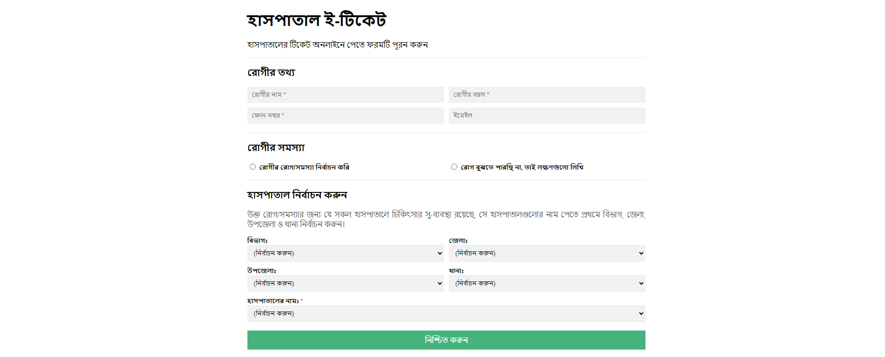

**4. Problem Statements**

**Overview of the Problem**

The existing healthcare system in Bangladesh requires patients to be physically present at hospitals to collect tickets, leading to long queues and inconvenience. This problem results in inefficiencies and negatively impacts the patient experience.

**Problem with Current System**

* Patients must physically visit hospitals to collect tickets.
* Long queues and waiting times are common.
* Inefficient and time-consuming.
* Some dishonest person taking bribe for getting ticket early.

**Limitations**

The current system has several limitations, including:

* Limited accessibility, particularly for those with mobility issues.
* Increased risk of disease transmission in crowded waiting areas.
* Impacts patient satisfaction and healthcare efficiency.

**A True Story**

A team member of this project faced with this situation. Here is the quote from him:

“আমার নাম নূরনবী। আমার বাড়ি নাওগাঁ জেলার বদলগাছী থানা। একবার আমার আন্টির গলার সমস্যা থাকায় আংকেল আমাকে হাসপাতালে নিয়ে যেতে বলেন। আমাদের সকাল সকাল যেতে বলা হয়। আমরা সকাল ৬ টার দিকে হাসপাতালে যাই। সেখানে গিয়ে দেখি অনেক লম্বা লাইন। লাইনে দাড়াঁয়ে অনেক কষ্ট করে টিকেট নিতে হয়। পরে শুনি যে সেখানে নাক, কান গলা বিশেষজ্ঞ কোন ডাক্তার বসে না। তাই আমি আমার আন্টিকে নিয়ে জয়পুরহাটে একটি উপজেলা হাসপাতালে যাই। সেখানে লম্বা লাইনে দাঁড়ায়ে টিকেট নিই এবং ডাক্তারের চেম্বারে গিয়ে দেখি সেখানেও লম্বা লাইন। শুনলাম ডাক্তার নাকি ৯ টায় আসবে। আমাদের টিকেট জমা নেয়া হয়। সেখানে একজন একজন করে ডাকছিলো। আমি একটা জিনিস লক্ষ্য করলাম, যারা টাকা দিচ্ছে তাদের আগে ডাকতেছিলো। যাহোক, অনেকক্ষন পর আমরা আন্টি ডাক্তারের কাছে যেতে পারেন। তাছাড়া আমি দেখলাম ডাক্তার রোগীকে কম সময় নিয়ে দেখেই ছেড়ে দিচ্ছে। তখন আমি ভাবলাম যদি এইসব সমস্যার সমাধান করা যেতো, কতই না ভালো হতো।”

*- Md. Nurnobi, Project Proposer*

**5. Solution Approach**

**System Design**

The web app will have a user-friendly interface with sections for personal information, disease details, and hospital selection. Data will be securely stored in a database, and e-tickets will be generated and confirmed.

**Project Architecture**

The system will follow a client-server architecture, with a secure connection for data transfer and storage. The server will run the Flask application, and a suitable database will be employed.

**Functional Requirements**

* Form submission for personal and disease information.
* Hospital selection based on location.
* E-ticket generation and confirmation.

**Non-Functional Requirements**

* **Security:** Data encryption and user authentication.
* **Performance:** Fast response times and scalability.
* **Usability:** Intuitive and user-friendly design.

**Data Flow Diagram**

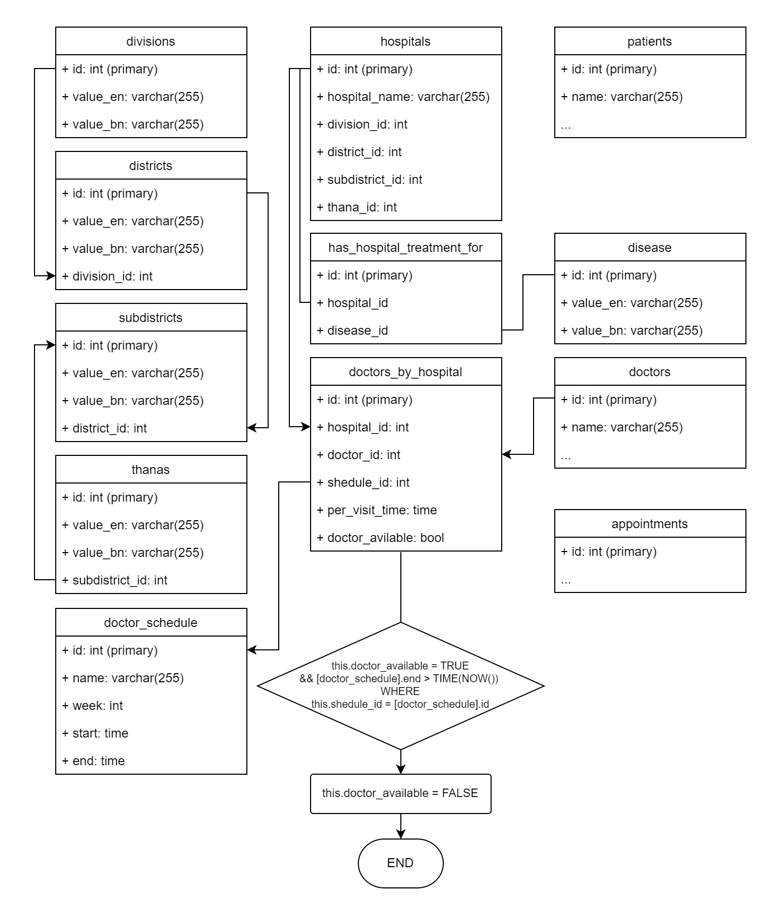

**6. User Requirements**

**Personal Information**

Users will be required to provide:

* Name
* Age
* Phone Number
* Email

**Disease Information**

Users can either:

* Select a disease from a pre-defined list.
* Provide detailed information about their issue.

**Hospital Selection**

Users can choose a hospital based on:

* Division
* District
* Sub-District
* Zone

**Ticket Collection Process**

Upon submission, users will receive a printable e-ticket with a unique id, specifying the allocated time for their hospital visit. They can visit doctor with just this id.

**7. System Benefits**

**Benefits to Patients**

* Reduced waiting times and queuing.
* Improved accessibility for individuals with mobility issues.
* Increased convenience and a better overall healthcare experience.

**Benefits to Hospitals**

* Enhanced appointment management and reduced overcrowding.
* Improved patient satisfaction and loyalty.
* Data collection for resource optimization.

**Benefits to Government and Society**

* A more efficient healthcare system.
* Improved healthcare access for citizens.
* Reduced risk of disease transmission in crowded waiting areas.

**8. Project Implementation**

**Development Phases**

1. Project Planning
2. Design and Prototyping
3. Development
4. Testing and Quality Assurance
5. Deployment
6. Maintenance and Support

**Testing and Quality Assurance**

Rigorous testing will ensure that the system functions reliably, accurately, and securely.

**Deployment and Maintenance**

The system will be deployed on a secure server, and ongoing maintenance will ensure optimal performance.

**Technology Used**

The core technology used for this project is Python Flask, a web framework known for its flexibility and scalability in building web applications.

**9. Risk Management**

**Identification of Risks**

* Technical Challenges
* Security Threats
* User Adoption
* Legal and Compliance Issues

**Risk Mitigation Strategies**

* Continuous monitoring and updates
* Regular security audits
* User training and support
* Legal compliance checks

**10. Conclusion**

The Hospital eTicketing web app is poised to revolutionize the healthcare system in Bangladesh by offering a convenient, online platform for ticket collection, thus reducing waiting times and enhancing the patient experience.

Future enhancements may include expanding the platform to cover more hospitals, integrating with electronic health records, and adding real-time doctor availability information.

This Project report provides an in-depth analysis of the Hospital eTicketing web app project, including its objectives, benefits, and implementation plan. By addressing the current challenges in healthcare access in Bangladesh, this project aims to improve the patient experience and overall healthcare system efficiency.