

**Team Name:**

Karigor (DHAT-000453)

**Members Name:**

Muhammad Sultan Al Mahfuz

Md. Nurnobi

Amrito Kumar Pramanik

Uzzal Bhowmik

**Institute Name:**

Dhaka Polytechnic Instiute

**Index**

1. Introduction
2. Problem Statement
   * Overview of the Problem
   * Problem with Current System
   * Limitations
   * A True Story
3. Methodology
   * Project Goals
   * Project Scope
   * Screenshots
   * Graphical Schema of the Database
   * GitHub Repository
4. Conclusion

**Introduction**

In Bangladesh, the existing healthcare system requires patients to physically collect tickets for doctor appointments, resulting in long queues and inconvenience. The Hospital eTicketing web app aims to address this issue by offering an online platform for e-ticket collection.

The primary purpose of this project is to enhance the efficiency and accessibility of healthcare services in Bangladesh by providing patients with a user-friendly and convenient eTicketing system.

This project is significant as it contributes to the improvement of the healthcare system in Bangladesh. By reducing physical queues and wait times, it can positively impact the lives of thousands of patients.

**Problem Statement**

Overview of the Problem

The existing healthcare system in Bangladesh requires patients to be physically present at hospitals to collect tickets, leading to long queues and inconvenience. This problem results in inefficiencies and negatively impacts the patient experience.

Problem with Current System

* Patients must physically visit hospitals to collect tickets.
* Long queues and waiting times are common.
* Inefficient and time-consuming.
* Some dishonest person taking bribe for getting ticket early.

Limitations

The current system has several limitations, including:

* Limited accessibility, particularly for those with mobility issues.
* Increased risk of disease transmission in crowded waiting areas.
* Impacts patient satisfaction and healthcare efficiency.

A True Story

A team member of this project faced with this situation. Here is his quote:

*“আমার নাম নূরনবী। আমার বাড়ি নাওগাঁ জেলার বদলগাছী থানা। একবার আমার আন্টির গলার সমস্যা থাকায় আংকেল আমাকে হাসপাতালে নিয়ে যেতে বলেন। আমাদের সকাল সকাল যেতে বলা হয়। আমরা সকাল ৬ টার দিকে হাসপাতালে যাই। সেখানে গিয়ে দেখি অনেক লম্বা লাইন। লাইনে দাড়াঁয়ে অনেক কষ্ট করে টিকেট নিতে হয়। পরে শুনি যে সেখানে নাক, কান গলা বিশেষজ্ঞ কোন ডাক্তার বসে না। তাই আমি আমার আন্টিকে নিয়ে জয়পুরহাটে একটি উপজেলা হাসপাতালে যাই। সেখানে লম্বা লাইনে দাঁড়ায়ে টিকেট নিই এবং ডাক্তারের চেম্বারে গিয়ে দেখি সেখানেও লম্বা লাইন। শুনলাম ডাক্তার নাকি ৯ টায় আসবে। আমাদের টিকেট জমা নেয়া হয়। সেখানে একজন একজন করে ডাকছিলো। আমি একটা জিনিস লক্ষ্য করলাম, যারা টাকা দিচ্ছে তাদের আগে ডাকতেছিলো। যাহোক, অনেকক্ষন পর আমরা আন্টি ডাক্তারের কাছে যেতে পারেন। তাছাড়া আমি দেখলাম ডাক্তার রোগীকে কম সময় নিয়ে দেখেই ছেড়ে দিচ্ছে। তখন আমি ভাবলাম যদি এইসব সমস্যার সমাধান করা যেতো, কতই না ভালো হতো।”*

- Md. Nurnobi, Project Participant

**Methodology**

Project Goals

The primary goals of the Hospital eTicketing web app project are:

* To provide a user-friendly platform for patients to obtain e-tickets for hospital appointments.
* To streamline the ticket collection process.
* To reduce patient waiting times and improve healthcare access.

Project Scope

There four types of user can be benefited from this system:

1. **Patients:** The patients (end-users) who will benefit from the online eTicketing system to avoid long queues.
2. **Hospitals:** Healthcare facilities that will utilize the platform.
3. **Government:** May oversee or support the implementation of this system.
4. **Developers and IT Professionals:** The team will be responsible for designing, developing, and maintaining the web app and it could be their professional job.

Screenshots

Here is some screenshots of the web application:

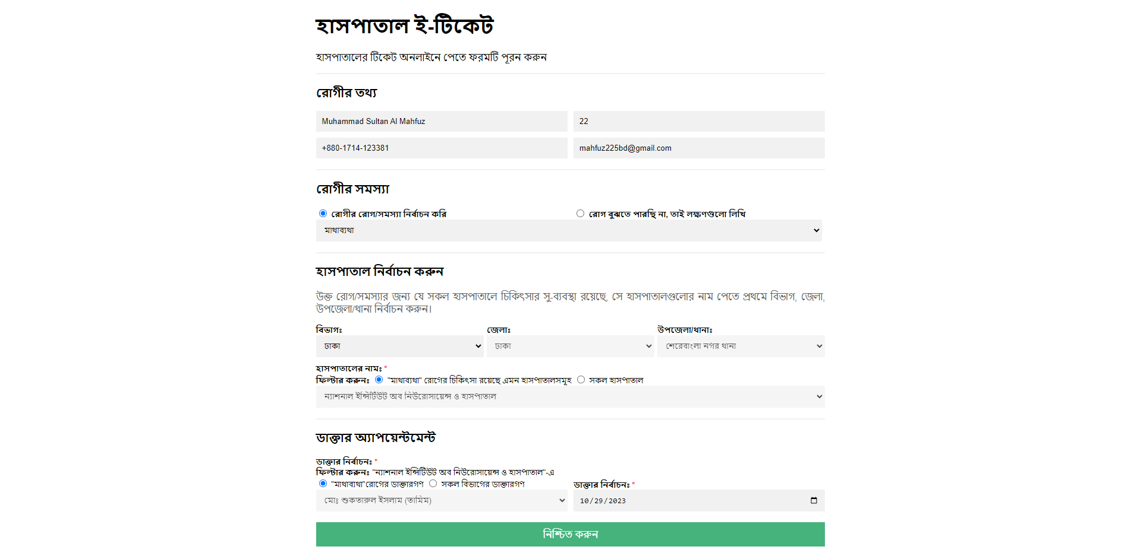

Figure 1: Home Page of the Application

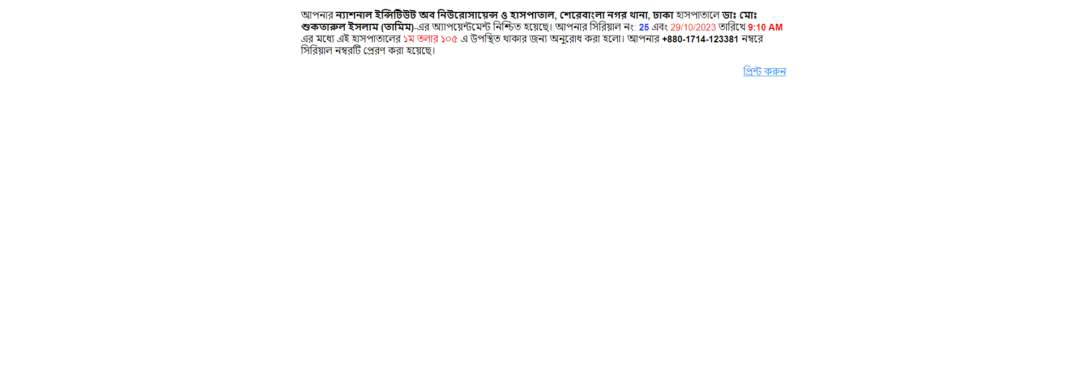

Figure 2: Confirmation Message with Date, Time, Appointed Doctor Information and Serial No.

Graphical Schema of the Database

Here is the graphical schema of the database of this web application.

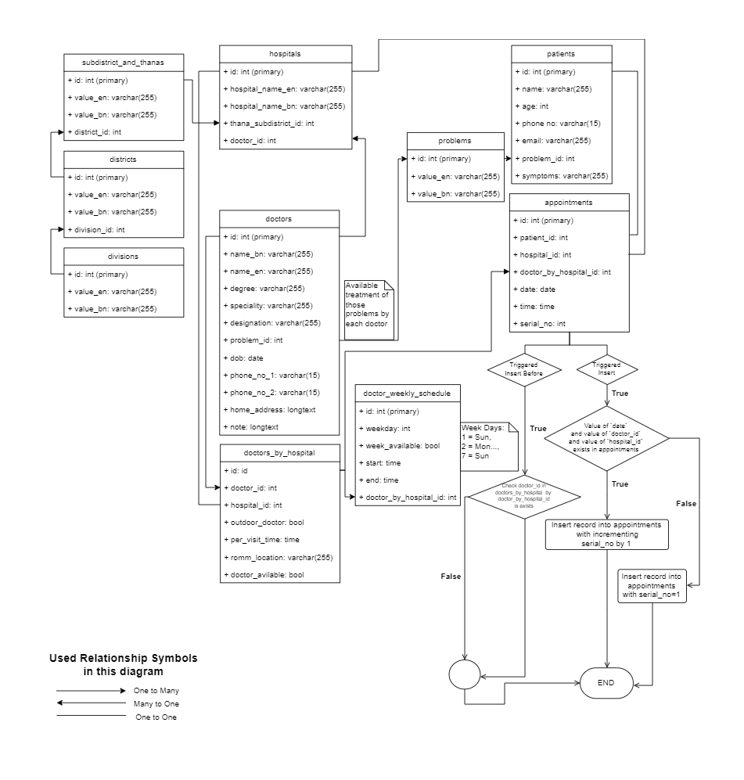

GitHub Repository

We are currently working to this repository: <https://github.com/mahfuz225bd/Hospital-E-Ticketing-System>

**Conclusion**

The Hospital eTicketing web app is poised to revolutionize the healthcare system in Bangladesh by offering a convenient, online platform for ticket collection, thus reducing waiting times and enhancing the patient experience.

Future enhancements may include expanding the platform to cover more hospitals, integrating with electronic health records, and adding real-time doctor availability information.

This Project report provides an in-depth analysis of the Hospital eTicketing web app project, including its objectives, benefits, and implementation plan. By addressing the current challenges in healthcare access in Bangladesh, this project aims to improve the patient experience and overall healthcare system efficiency.