**✅ Day 3.1 - Full Stack Web Development (HTML Learning Notes)**

📅 **Topic Covered**: Images, Table, Lists, and Basic HTML Structure

**🔹 1. <!DOCTYPE html>**

* Declares the document type and version of HTML (HTML5 in this case).
* Must be the first line in an HTML document.
* Helps the browser render the page correctly.

**🔹 2. <html lang="en">**

* The <html> tag is the root of an HTML document.
* The lang="en" attribute sets the language of the content to English.

**🔹 3. <head> Section**

**✅ Includes:**

* <meta charset="UTF-8">: Sets the character encoding to UTF-8 (covers most characters from all languages).
* <meta name="viewport" content="width=device-width, initial-scale=1.0">: Ensures responsiveness on different devices.
* <title>: Sets the title of the page (visible on browser tab).
* <link rel="stylesheet" href="style_Day#3.css">: Links an external CSS file named style_Day#3.css for styling.

**🔹 4. <body> Section**

This is the main content area of the page visible to users.

**🖼️ 5. Image Tag: <img>**

<img width="230" src="busimage1.jpg" alt="bus image 1">

<img height="230" src="busimage2.jpg" alt="bus image 2">

* **<img>**: Embeds images.
* **src**: Path to the image file.
* **alt**: Alternate text shown if image fails to load (important for SEO and accessibility).
* **width / height**: Adjusts image size. You can use only one (height or width), and the other will auto adjust to maintain aspect ratio.

**📋 6. Table Tag: <table>**

Used to display tabular data.

<table>

<caption>Student Details</caption>

<thead>...</thead>

<tbody>...</tbody>

<tfoot>...</tfoot>

</table>

**Table Structure:**

* **<caption>**: Adds a title to the table.
* **<thead>**: Contains header rows.
* **<tbody>** *(missing in your code but optional)*: Holds main content rows.
* **<tfoot>**: For summary/footer rows.

**Other Tags:**

* **<tr>**: Table row.
* **<th>**: Table header cell (bold and centered by default).
* **<td>**: Table data cell (normal text).
* **colspan**: Merges multiple columns into one cell.

**✅ 7. HTML List Tags**

**🔸 Unordered List <ul>**

<ul type="square">

<li>Harry</li>

<li>Mahfuz</li>

<li>Rimon</li>

</ul>

* Displays items with bullets.
* type="square" changes the bullet shape (default is disc).

**🔸 Ordered List <ol>**

<ol type="i">

<li>Harry</li>

<li>Mahfuz</li>

<li>Rimon</li>

</ol>

* Shows a numbered list.
* type="i" makes the numbers appear in lowercase Roman numerals (i, ii, iii, ...).

**🛠️ Things You Practiced Today:**

* Image embedding with alt attributes.
* Creating structured tables with headers and footers.
* Using both ordered and unordered lists.
* Proper HTML document structure (DOCTYPE, head, body).

**🌱 Tips for Improvement:**

* Use <tbody> for better table readability.
* Set consistent widths/heights or use CSS for responsive images.
* Add alt text for every image.
* For styling, start writing CSS in style_Day#3.css to beautify your HTML.



With simple CSS

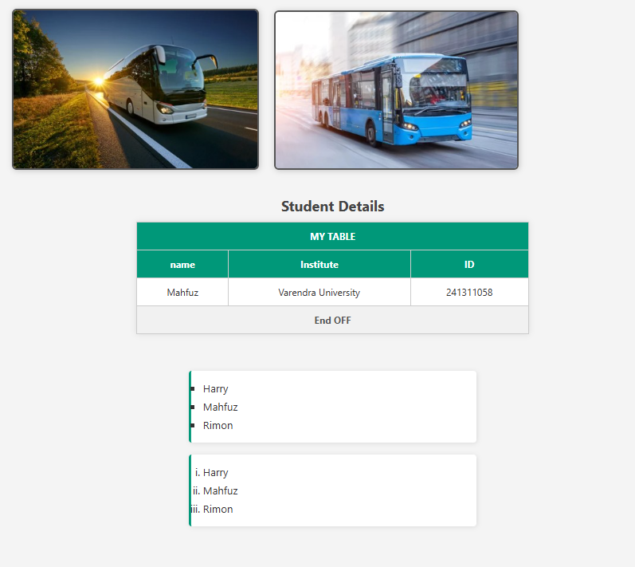

**✅ Day 3.2 – HTML Forms & Input Tags (Full Stack Web Development)**

Today I learned how to **create forms** in HTML to collect user data. Forms are a core part of web development as they allow interaction with users through data entry, selection, and submission.

**📌 1. <form> Tag**

<form action="post">

* The <form> tag is used to collect user input.
* action="post" is incorrect – it should be:
* <form method="post">
* method="post" defines how the data is sent (GET or POST).

**🧾 2. <label> Tag**

<label for="username">Enter your user name</label>

* Labels are linked to form inputs using for="id-of-input".
* Helps screen readers and improves accessibility.

**🧍 3. <input type="text">**

<input type="text" id="username" name="username" placeholder="Enter your name:">

* A **text box** to enter single-line user input.
* placeholder shows a hint inside the box.
* name is the identifier when data is submitted.

**♂️♀️ 4. <input type="radio">**

<input type="radio" id="male" name="gender" value="male">

<label for="male">Male</label>

<input type="radio" id="female" name="gender" value="female">

<label for="female">Female</label>

* Allows user to select only **one option** from a group.
* All radio inputs in a group should share the same name (gender here).
* value defines the data sent when selected.

**☑️ 5. <input type="checkbox">**

<input type="checkbox" id="subscribe" name="subscribe" value="yes">

<label for="subscribe">Subscribe Please</label>

* Allows the user to **select or deselect** an option.
* Can be used for accepting terms, newsletters, etc.
* You can select multiple checkboxes unlike radio.

**💬 6. <textarea>**

<textarea name="comment" id="comment" rows="3" cols="50"></textarea>

* Used for **multi-line** text input (e.g., comments).
* rows = number of visible lines.
* cols = width of the textarea in characters.

**🍎 7. <select> & <option> Dropdown**

<select name="fruits">

<option value="apple">Apple</option>

<option value="banana">Banana</option>

<option value="cherry">Cherry</option>

</select>

* Creates a **dropdown list** of options.
* Each <option> inside the <select> represents a selectable item.
* value is sent when that option is chosen.

**🧠 Summary:**

Today I built a basic HTML form using:

* form, input, label, textarea, select, option elements
* Text input, radio buttons, checkboxes, textarea, and dropdowns
* Learned how forms collect user input for backend/server interaction

