

**Project Report**

Donor Seeker

**Course Name**

Software Engineering and Information System Design

**Course Code**

CSE411

**Section**

**1**

**Submitted by**

Rakibul Alam (2016-3-60-006)

Saqlain Mustak Sagor (2016-3-60-015)

Md. Mahfuzul Islam Mazumder (2016-3-60-048)

**Submitted to**

Md. Mohsin Uddin

Lecturer, Department of Computer Science & Engineering, East West University

**Submission date**

09/05/2020

**Introduction**

**Project definition:** We will build a web application for all kind of people who need emergency blood. This is not like traditional blood banks, it is a place of regular blood donor. The blood seeker will be able to search blood donor by his/her(blood seeker) location, the blood seeker will be able to search by two available options such as he/she can post to forum by his/her certain location, donor will get notification according to certain location. Another option is blood seeker will see the list of all donors by blood groups and locations, blood seeker will be able to call or notify one by one from the list of donors.

**Project motivation:** Frequently we hear that blood seekers can’t find any blood donor according to his/her time and place and this situation is terrible for blood seekers as well as patients. To reduce or solve this problem needs a platform that will work effectively. We wish, this system will provide transparency in this field, make the process corruption free of obtaining blood from a blood bank and make the system of blood bank management effective, via this project people can save time as well as can save others life. This project consists of a central repository containing various blood groups available along with related details.These details include blood type, storage area and date of storage. These details will help in maintaining blood deposits.

**Challenge of development:** The main challenge in developing the project will be keeping track of all the user’s information along with their security issues. Also, choosing the correct tools for developing these features from the ever-changing web development world.

**Requirements**

**Non-functional requirements:**

1. Security: A user’s password and personal information must be encrypted.
2. Performance: Post searching, loading and sent notification should be fast.
3. Interface: The user interface should be kept really simple.
4. Support: Users should get support from the admins whenever there is a need.
5. Collaboration: Collaboration with any other volunteer organization and share idea and help to each other.

**Functional requirements:**

1. Register a user: A user can create their own profile by a simple registration procedure.
2. Post to forum: User (blood seeker) can post to forum by completing few necessary steps and donor will be notified by user information.
3. Search donor: User can search donor by putting his/her blood group and certain location.
4. Post delete: If the donor confirms on the site, post will be automatically deleted while the user will see the confirmation that donor is interested to donate blood. In that case donor will not be able to donate blood for next 120 days (according to WHO). If the donor confirms to donate over the phone, the user have to put the Donor id for deleting the post.
5. User can see all donor: User can see all donor by putting blood group and location. It will show donors according to that blood group and area.
6. Sent notification: when blood seekers post for blood, needed notification will be sent to all available donors according to blood seeker location.

**Technologies**

This project will require HTML, CSS, Bootstrap, JavaScript, JQuery, SQL, php.

**ER Diagram**

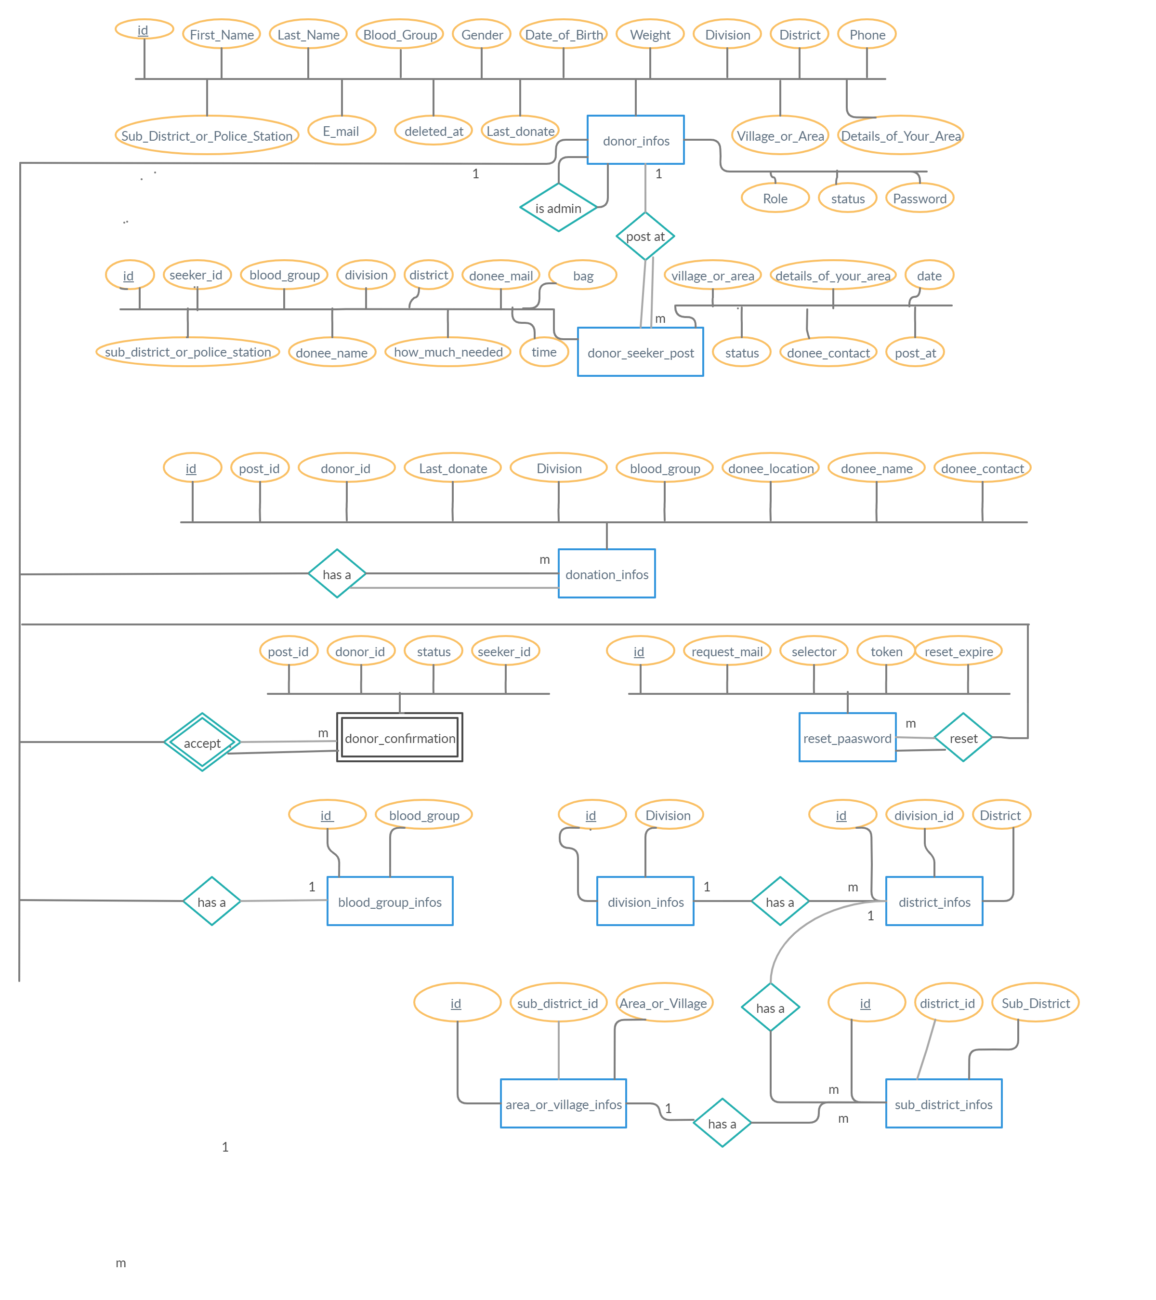

**Use Case Diagram**

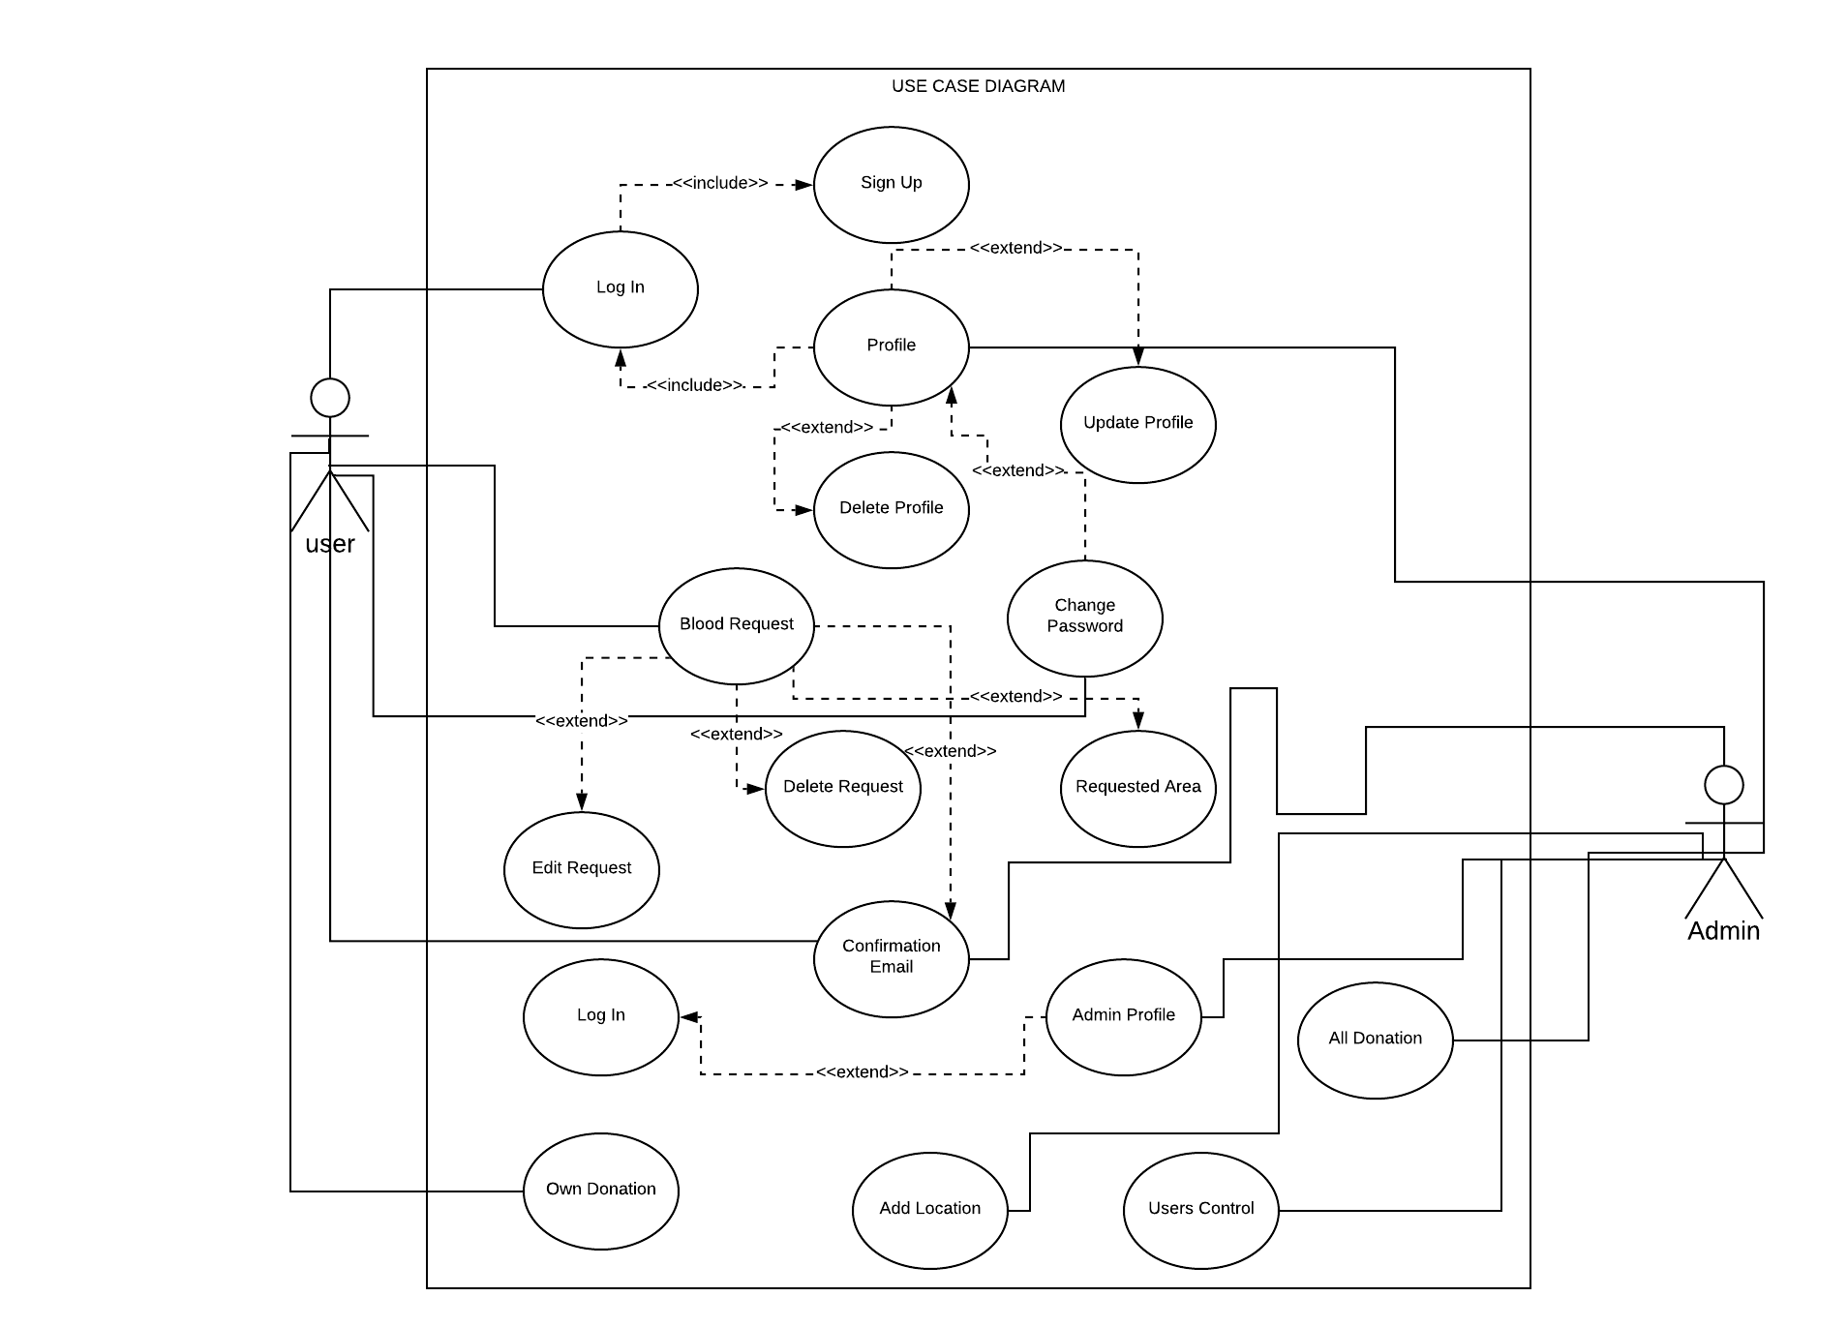

**Class Diagram**

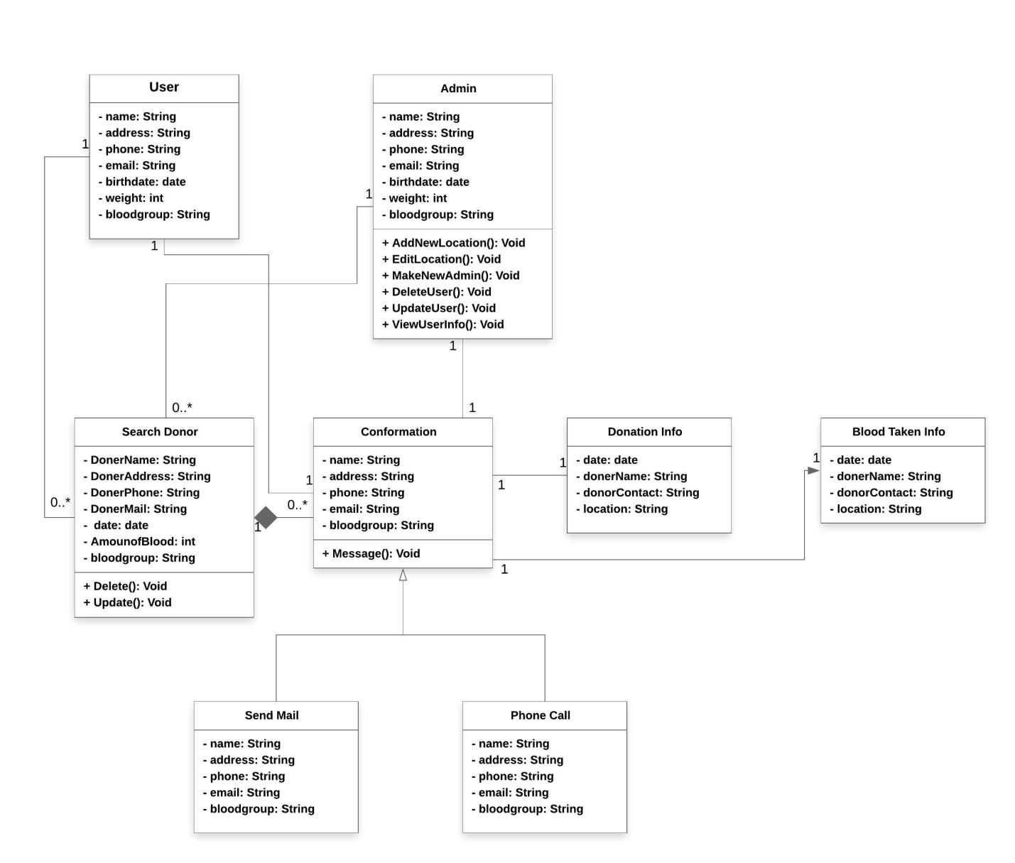

**Activity Diagram For User**

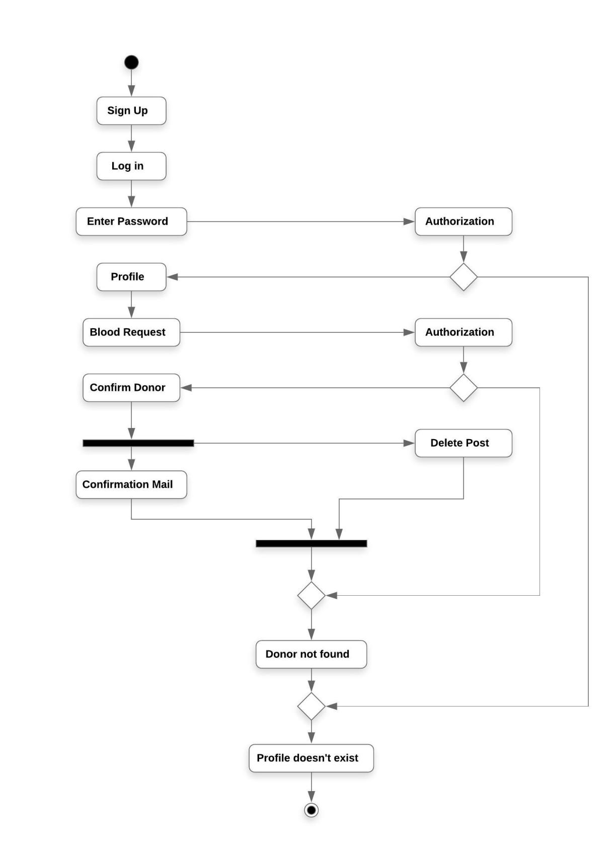

**Activity Diagram For Admin**

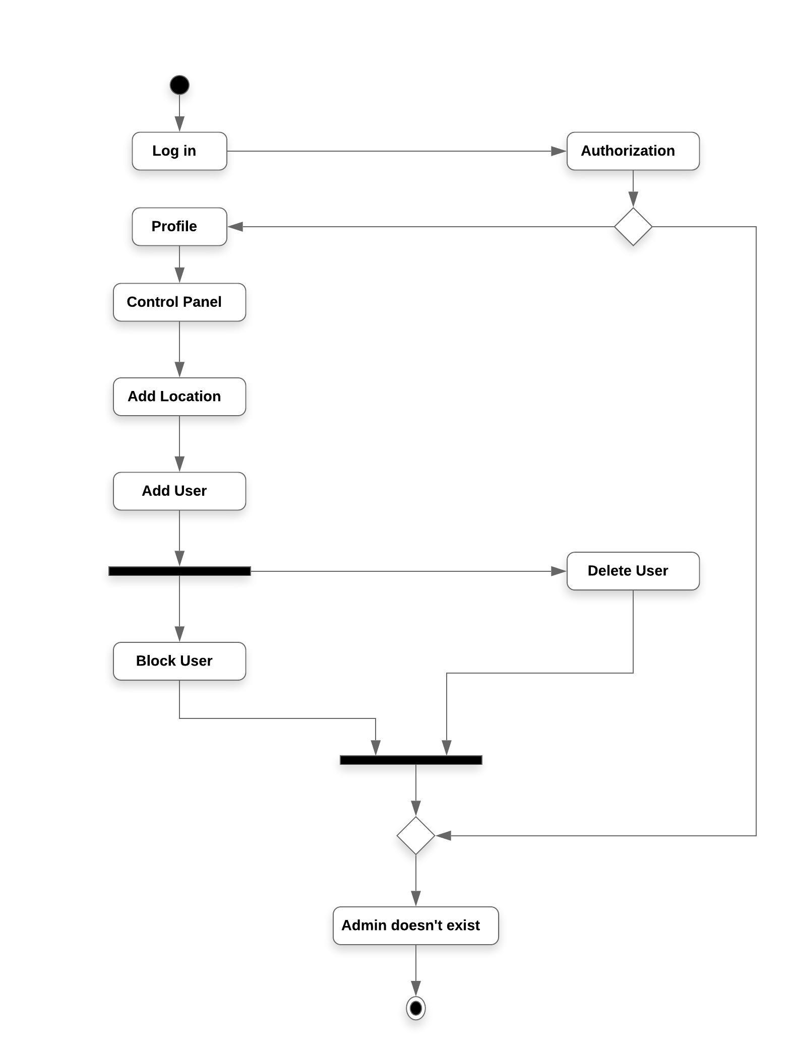

**Sequence Diagram For User**

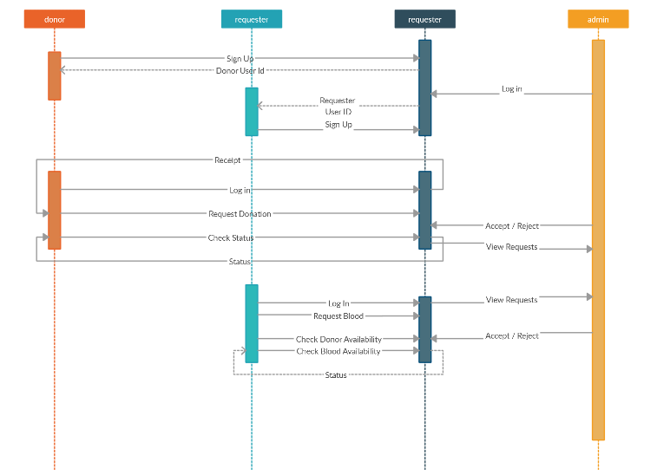

**Sequence Diagram For Admin**

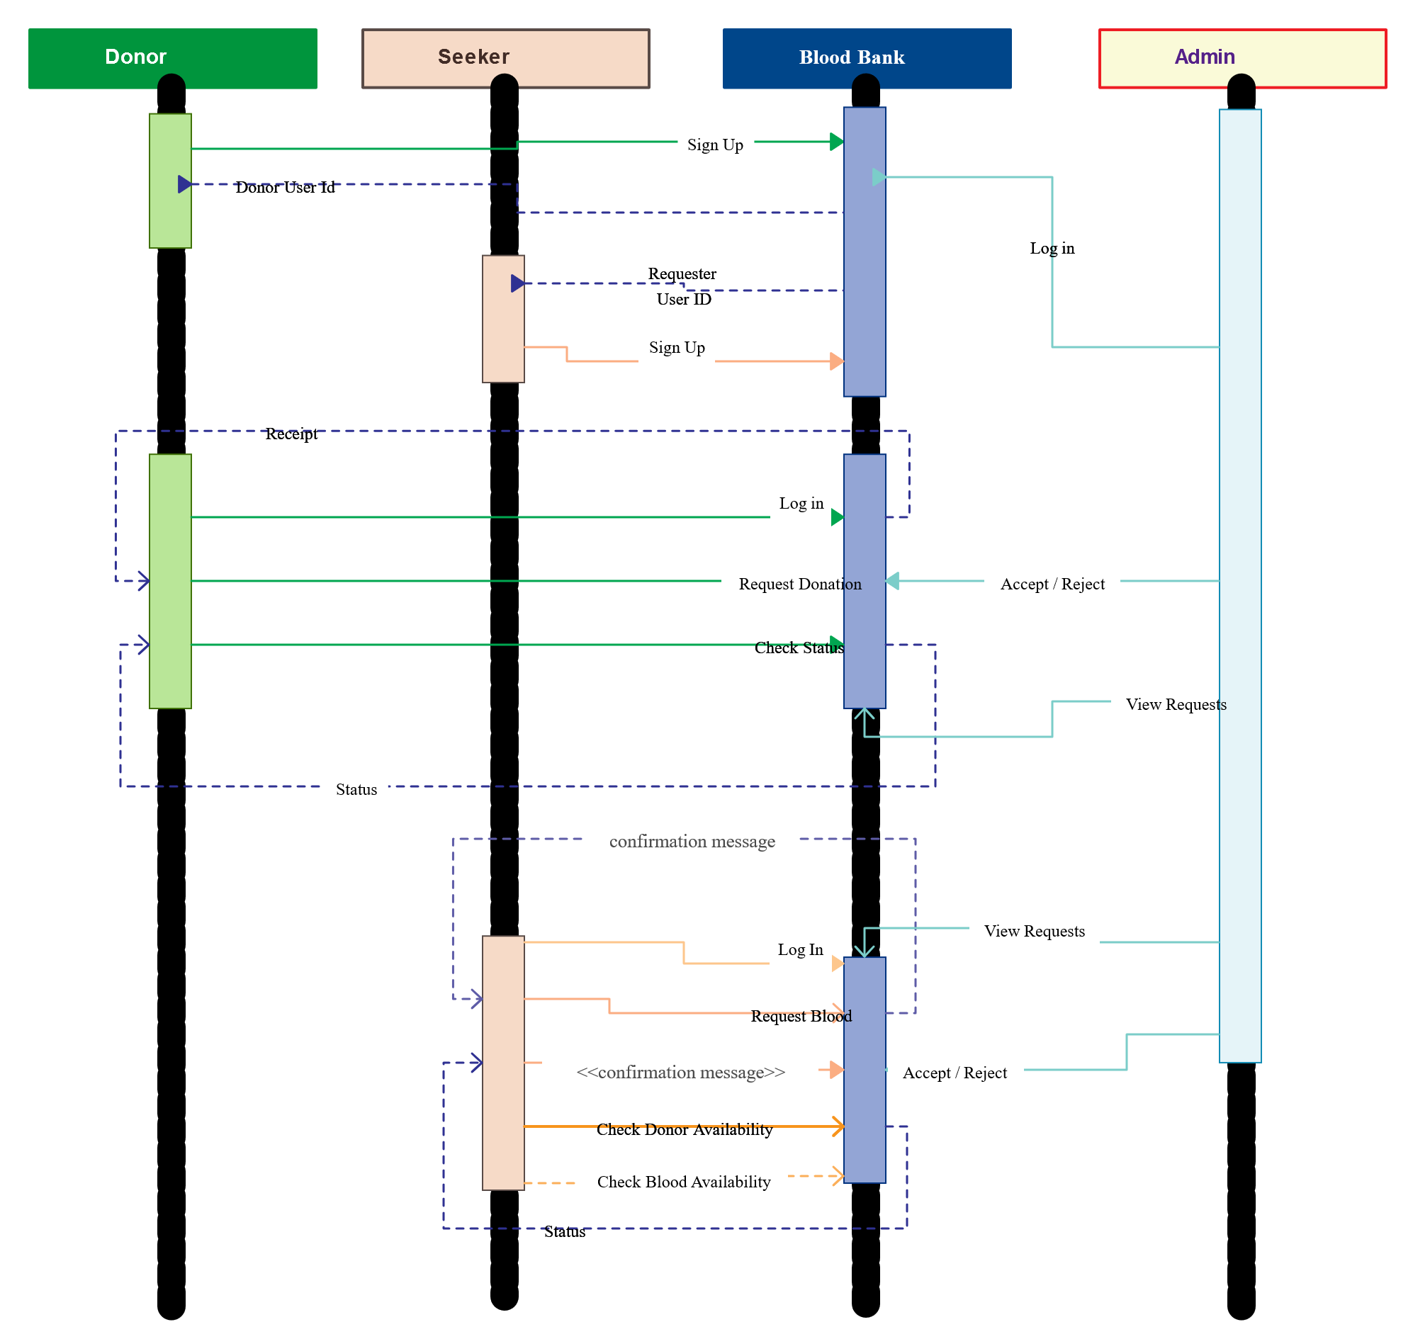

**Conclusion**

This project will build bridge between blood donors and blood seekers. It will save time as well as many lives in emergency cases. It will be the best option for needy and poor people. Blood seeker will not bother to seek blood.