**Introduction:**

A database is a collection of information that is organized so that it can be easily accessed, managed and updated. Data is organized into rows, columns and tables, and it is indexed to make it easier to find relevant information. Data gets updated, expanded and deleted as new information is added. Databases process workloads to create and update themselves, querying the data they contain and running applications against it.

**Project Purpose:**

We have created a project on the basis of database system. Our project title is **“E-Commerce Management System”.** E-commerce (EC), an abbreviation for electronic commerce, is the buying and selling of goods and services, or the transmitting of funds or data, over an electronic network, primarily the internet. The user of this project can be anyone who buy product(s) from this online shopping platform and given services by the admin panel. The main purpose of this project sell the best product and items as per user needs, give product as per the latest technology giving best user experience while purchasing and also easier and comfortable shopping experience beside traditional shopping.

**Project Features:**

This project contains several features. It contains different users. The features options are given below:

Anyone can visit our website and view all products and items category wise. He/She cannot purchase any item(s) unless sign-up user form. After performing sign-up, He/she gets user id and password.

**1.User:**

If any user want to purchase any item(s), he/she must log-in first. User can log-in via their user id or email and password . Then he/she will perform:

* He/She can purchase any item(s) and add to cart.
* He/She will able to select one or more item(s).
* He/She can remove item(s) from add to cart that user choses earlier.
* He/She can check out the cart with total amount.

**2.Admin:**

Admin is basically the controller of our data Database Management. Basically admin is one of the role of our database. If any admin wants to work with this option, the he/she have to get into the database by log-in first. If role is “0” determine user, he/she able to perform above information and role “1” determine admin panel. After successful login there are several options perform by admin.

For example:

* Admin can insert/add item(s) into database.
* Admin can update item(s) information into database.
* Admin can delete item(s) information from database.
* Admin can see all the information of user(except password).

**E-R Diagram for BuyBuzz:**

Log in

**Guest**

View product Register as customer

**Admin**

View customer list product

**Payment**

pay_id user_id amount

Procced to pay

**cart**

cart_id user_id p_id p_quantity total_cost

Add to cart

Cart HAS

**Products**

P_id P_name P_price P_img P_quatity Cate_id

Added to

**cart_item**

cart_item_id quantity total_cost

**Users**

idUsers

uidUsers

emailUsers

ridUsers

pomgUsers

HAS

**BuyBuzz**

HAS

**Schema Diagram:**

**Products**

P_id P_name P_price P_img P_quatity Cate_id

**Cart_item**

cart_item_id

idUsers

quantity

total_cost

**Category**

Cate_id

Cate_name

**cart**

cart_id user_id quantity total_cost

**Users**

idUsers

uidUsers

emailUsers

ridUsers

pomgUsers

**Flow Chart:**

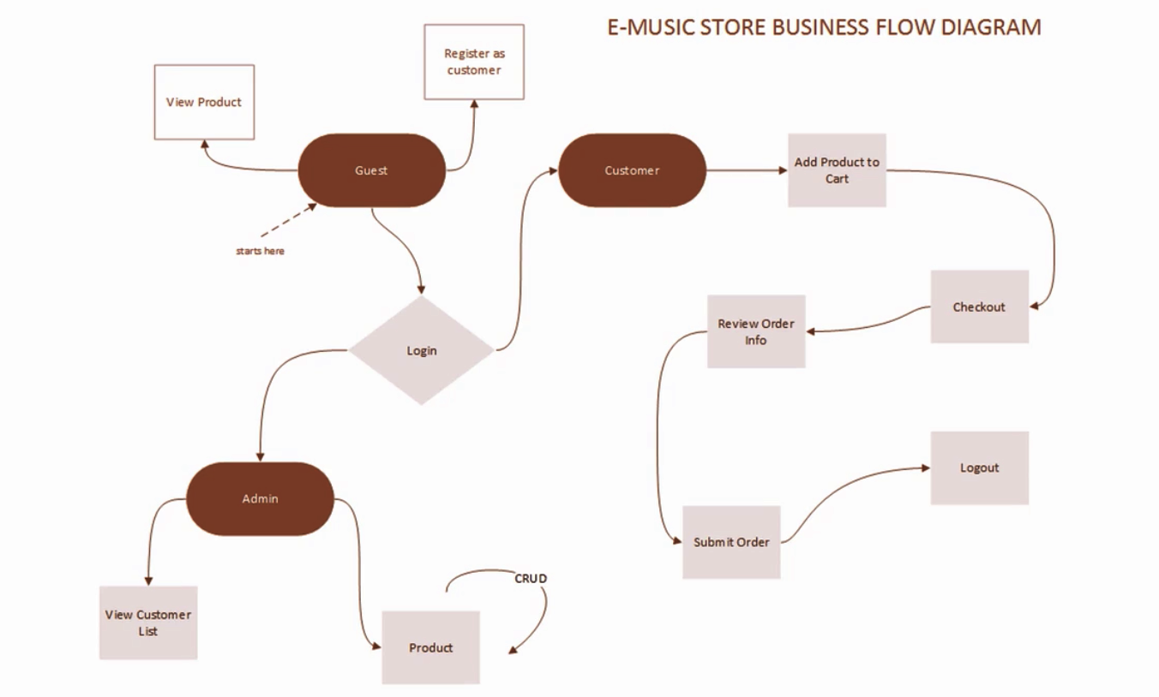

**Table Creation:**

-- phpMyAdmin SQL Dump

-- version 4.8.2

-- https://www.phpmyadmin.net/

--

-- Host: 127.0.0.1

-- Generation Time: Apr 03, 2019 at 05:59 AM

-- Server version: 10.1.34-MariaDB

-- PHP Version: 7.2.8

SET SQL_MODE = "NO_AUTO_VALUE_ON_ZERO";

SET AUTOCOMMIT = 0;

START TRANSACTION;

SET time_zone = "+00:00";

/*!40101 SET @OLD_CHARACTER_SET_CLIENT=@@CHARACTER_SET_CLIENT */;

/*!40101 SET @OLD_CHARACTER_SET_RESULTS=@@CHARACTER_SET_RESULTS */;

/*!40101 SET @OLD_COLLATION_CONNECTION=@@COLLATION_CONNECTION */;

/*!40101 SET NAMES utf8mb4 */;

--

-- Database: `buybuzz`

--

-- --------------------------------------------------------

--

-- Table structure for table `cart_item`

--

CREATE TABLE `cart_item` (

`cart_item_id` int(5) NOT NULL,

`quantity` int(5) DEFAULT NULL,

`total_cost` decimal(6,0) DEFAULT NULL

) ENGINE=InnoDB DEFAULT CHARSET=latin1;

-- --------------------------------------------------------

--

-- Table structure for table `category`

--

CREATE TABLE `category` (

`cate_id` int(3) NOT NULL,

`cate_name` varchar(20) DEFAULT NULL

) ENGINE=InnoDB DEFAULT CHARSET=latin1;

--

-- Dumping data for table `category`

--

INSERT INTO `category` (`cate_id`, `cate_name`) VALUES

(1, 'men'),

(2, 'women'),

(3, 'kids'),

(4, 'Accessories');

-- --------------------------------------------------------

--

-- Table structure for table `products`

--

CREATE TABLE `products` (

`p_id` int(11) NOT NULL,

`p_name` varchar(100) NOT NULL,

`p_price` decimal(6,2) DEFAULT NULL,

`p_img` varchar(500) DEFAULT NULL,

`p_quantity` int(3) DEFAULT NULL,

`cate_id` varchar(3) DEFAULT NULL

) ENGINE=InnoDB DEFAULT CHARSET=latin1;

--

-- Dumping data for table `products`

--

INSERT INTO `products` (`p_id`, `p_name`, `p_price`, `p_img`, `p_quantity`, `cate_id`) VALUES

(2, 'Formal Shirt', '1400.00', 'frmalshrt.jpeg', 6, '1'),

(4, 'Jeans Pant', '500.00', 'jeans.jpg', 20, '1'),

(9, 'Diapers', '350.00', 'diaper.jpg', 20, '3'),

(10, 'Feeder', '150.00', 'feeder.jpg', 20, '3'),

(11, 'Baby Dress', '500.00', 'b_dress.jpg', 10, '3'),

(13, 'Brown Belt', '500.00', 'brbelt.jpg', 2, '4'),

(14, 'Wallet', '700.00', 'wallet.jpg', 10, '4'),

(15, 'Sunglass', '500.00', 'sunglass.jpg', 5, '4'),

(16, 'Ladies Bag', '1500.00', 'lbag.jpg', 5, '4'),

(18, 'Polo T- Shirt', '750.00', 'download.jpg', 700, '1'),

(19, 'Baby T-Shirt', '1200.00', 'b3.jpg', 10, '3'),

(20, 'Half Sleeve Shirt', '700.00', 'cs1.jpg', 5, '1');

-- --------------------------------------------------------

--

-- Table structure for table `users`

--

CREATE TABLE `users` (

`idusers` int(11) NOT NULL,

`uidUsers` tinytext NOT NULL,

`emailUsers` tinytext NOT NULL,

`pwdUsers` longtext NOT NULL,

`ridUsers` int(2) NOT NULL,

`pimgUsers` varchar(200) NOT NULL

) ENGINE=InnoDB DEFAULT CHARSET=latin1;

--

-- Dumping data for table `users`

--

INSERT INTO `users` (`idusers`, `uidUsers`, `emailUsers`, `pwdUsers`, `ridUsers`, `pimgUsers`) VALUES

(1, 'zihad123', 'zihad@gmail.com', '$2y$10$RIy78g2PgwxMYvSmlsYgJu9PB8sfcUFqqg24sMMlSsa/XbsYsuCW2', 1, 'cartoon.jpg'),

(2, 'mahfuz123', 'mahfuz@gmail.com', '$2y$10$6hbrtYPWvxSRqvLYReth3eckG2SEE7n.zjcv2AYmqBveqtOCqgpoi', 0, 'mahfuz.jpg'),

(5, 'ahosan123', 'ahosan@gmail.com', '$2y$10$9HZkMmQKeztUgH.yv6xaiumf3diOV/A8PElKDQTpoK3eHINoxPa3a', 0, 'moon.jpg'),

(6, 'obaydullah69', 'ob@gmail.com', '$2y$10$v6svw.jDkw/MGhYeV29pl.GqSa2p8Ly91MfkJQEag5taEOwyxl1i6', 0, 'ob.jpg'),

(7, 'shuvo123', 'shuvo@gmail.com', '$2y$10$griOMshdrErdC2vRSuQ1uukXPkX557bYqg4dvqeAyfCeP3eOPBzfa', 0, 'shuvo.jpg'),

(8, 'rkb', 'rkb@gmail.com', '$2y$10$euBH5i80TXkbPhl9SMxNTOh.IAZuRE6VSSBo4wbFj2D53BDb.hXBy', 0, 'rkb.jpg');

--

-- Indexes for dumped tables

--

--

-- Indexes for table `cart_item`

--

ALTER TABLE `cart_item`

ADD PRIMARY KEY (`cart_item_id`);

--

-- Indexes for table `category`

--

ALTER TABLE `category`

ADD PRIMARY KEY (`cate_id`);

--

-- Indexes for table `products`

--

ALTER TABLE `products`

ADD PRIMARY KEY (`p_id`);

--

-- Indexes for table `users`

--

ALTER TABLE `users`

ADD PRIMARY KEY (`idusers`);

--

-- AUTO_INCREMENT for dumped tables

--

--

-- AUTO_INCREMENT for table `cart_item`

--

ALTER TABLE `cart_item`

MODIFY `cart_item_id` int(5) NOT NULL AUTO_INCREMENT;

--

-- AUTO_INCREMENT for table `category`

--

ALTER TABLE `category`

MODIFY `cate_id` int(3) NOT NULL AUTO_INCREMENT, AUTO_INCREMENT=5;

--

-- AUTO_INCREMENT for table `products`

--

ALTER TABLE `products`

MODIFY `p_id` int(11) NOT NULL AUTO_INCREMENT, AUTO_INCREMENT=21;

--

-- AUTO_INCREMENT for table `users`

--

ALTER TABLE `users`

MODIFY `idusers` int(11) NOT NULL AUTO_INCREMENT, AUTO_INCREMENT=9;

COMMIT;

/*!40101 SET CHARACTER_SET_CLIENT=@OLD_CHARACTER_SET_CLIENT */;

/*!40101 SET CHARACTER_SET_RESULTS=@OLD_CHARACTER_SET_RESULTS */;

/*!40101 SET COLLATION_CONNECTION=@OLD_COLLATION_CONNECTION */;

**Sample Output:**

**Conclusion:**

That is a mini database project. We worked on database management using php mysql,html.css. We have some limitation in our project because of time shortage. We could better if we had more time. We have learned php,html and css through this project.