**User Side website front End**

[**https://Pharmacy.callgpnow.com**](https://Pharmacy.callgpnow.com)

**username:** [**admin@callgpnow.com**](mailto:admin@callgpnow.com)

**password: 12345**

**username for frontend user:** [**user@callgpnow.com**](mailto:user@callgpnow.com)

**password: 12345**

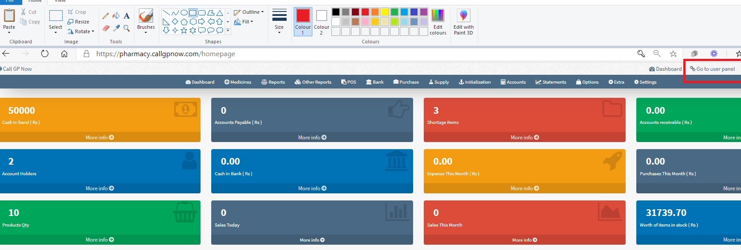

1. In this search box, the user should be able to search for both prescription and non-prescription products.

Text will be --- search Medicines and OTC products

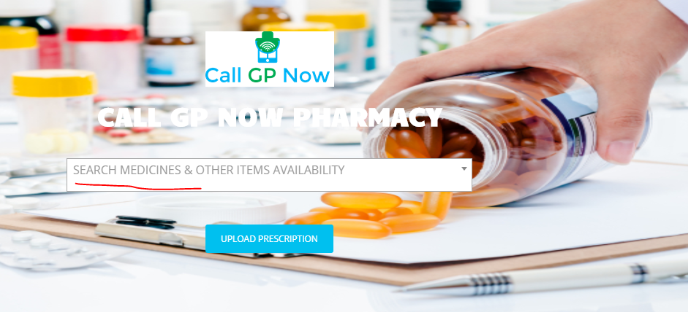

1. Prescription products are already coming in a search result.
2. add Non-prescription products results in search item list like practo.com search

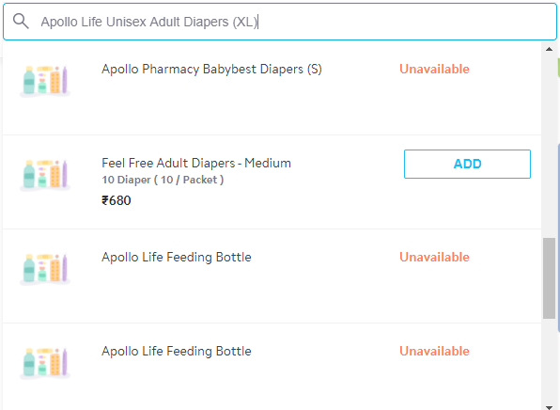

1. The non-Prescription category will be shown on the landing page like this

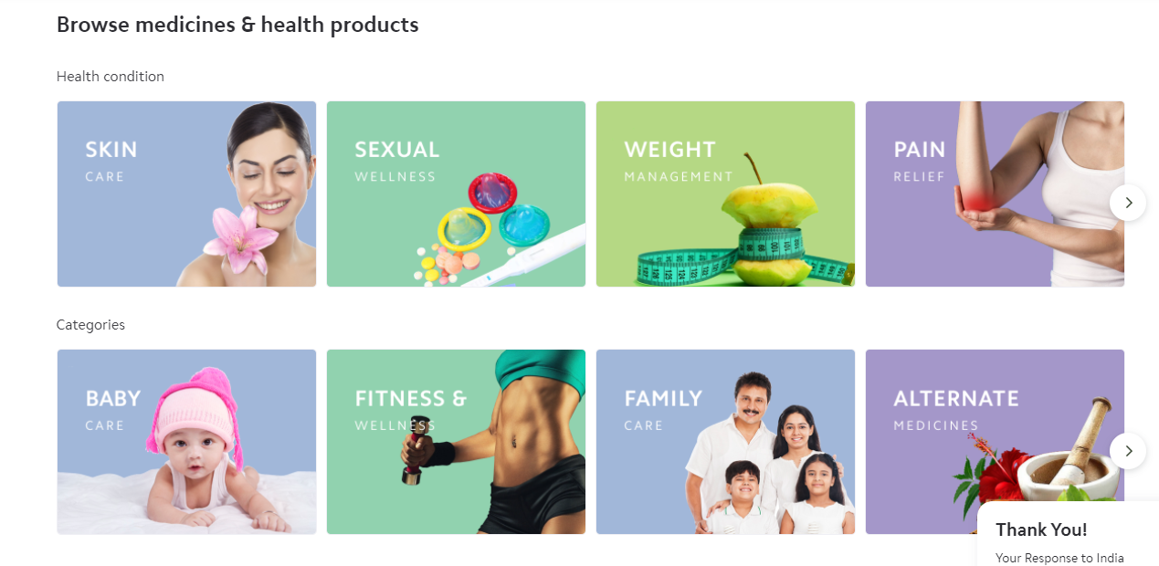

1. When the user will click on any category, the user will see all sub-categories

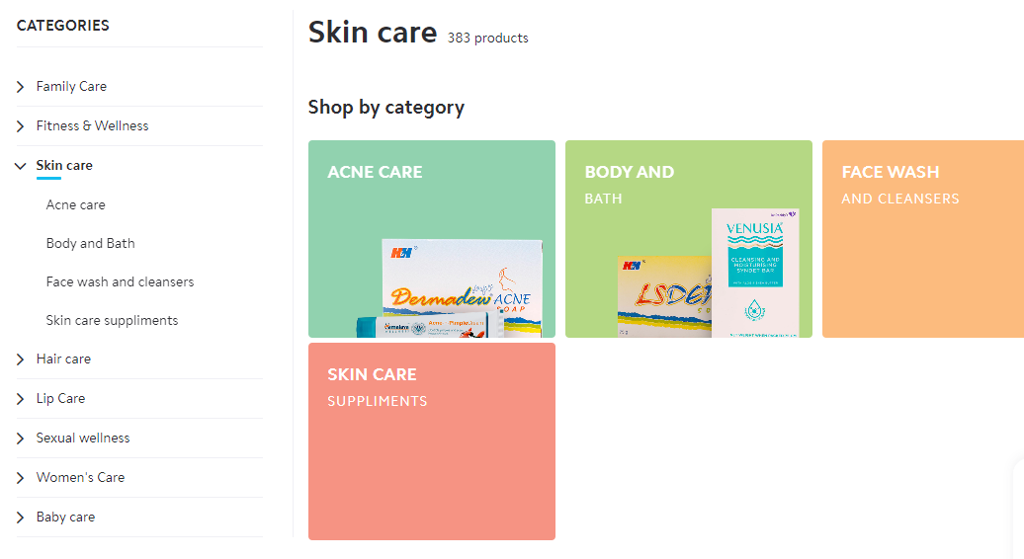

1. When the user will click on any subcategory, then all products of that subcategory will be shown.

**follow the** [**www.practo.com**](http://www.practo.com) **website**

**ADMIN PANEL**

1. “Add Category” option available
2. Adding the sub-category option is missing like the below screenshot. add this option.

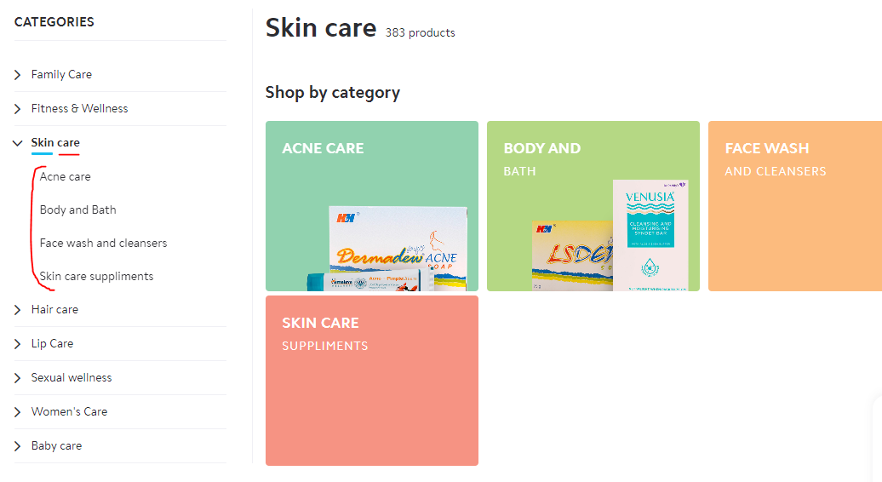

1. When the admin will add a new product, he will select category and subcategory for new products.
2. I will add a new Text Editor for adding product details in a good way.

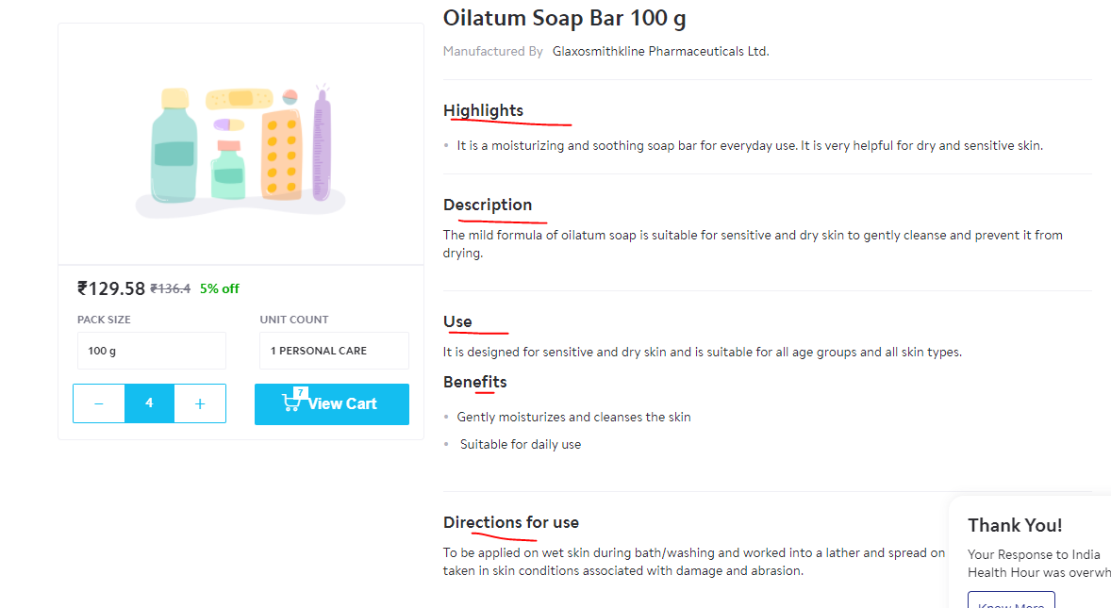

1. Admin will be able to change any product description from the admin panel.
2. Currently, product images are not uploading from the admin panel. correct this.
3. add a new option for upload category images like the below images. 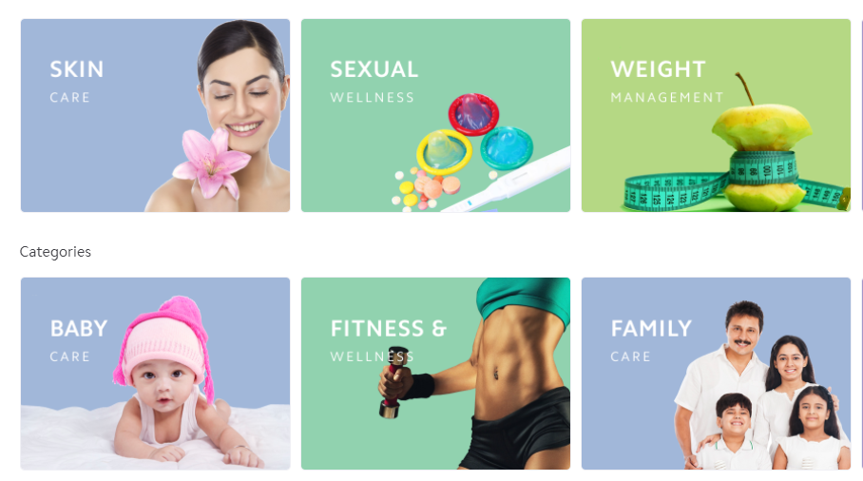

**make these changes to the existing admin panel.**

**Site hosted on**

**A2hosting.com**

**Username:** [**imranlatif@email.com**](mailto:imranlatif@email.com)

**Password: %Forensic%4$12**

**Cpanel you should be able to see folder pharmacy.callgpnow.com**