**Abstract Factory**

The Abstract Factory Pattern provides an interface for creating families of related or dependent objects without specifying their concrete classes.

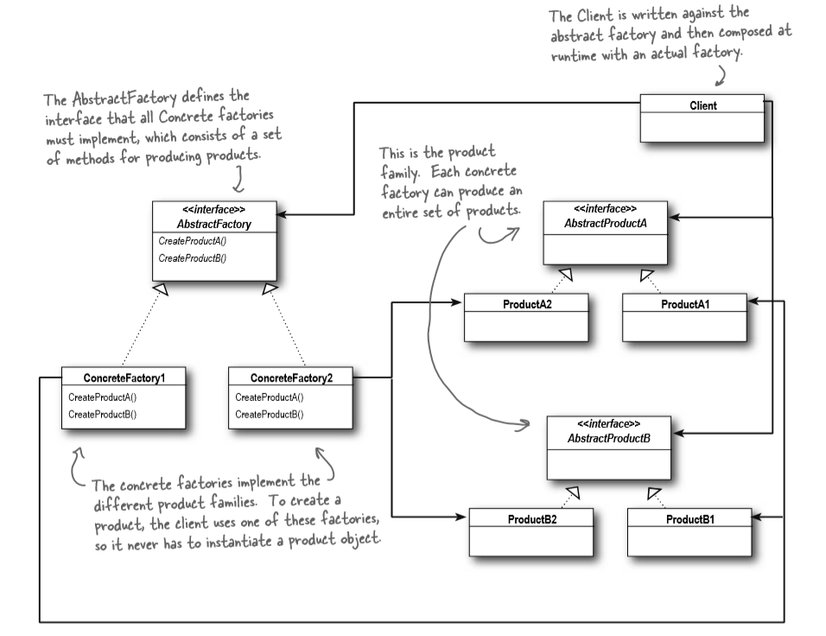

Abstract factory pattern in useful when the client needs to create objects which are somehow related. If we need to create the family of related or dependent objects, then we can use Abstract Factory Pattern.

This pattern is particularly useful when the client doesn't know exactly what type to create.

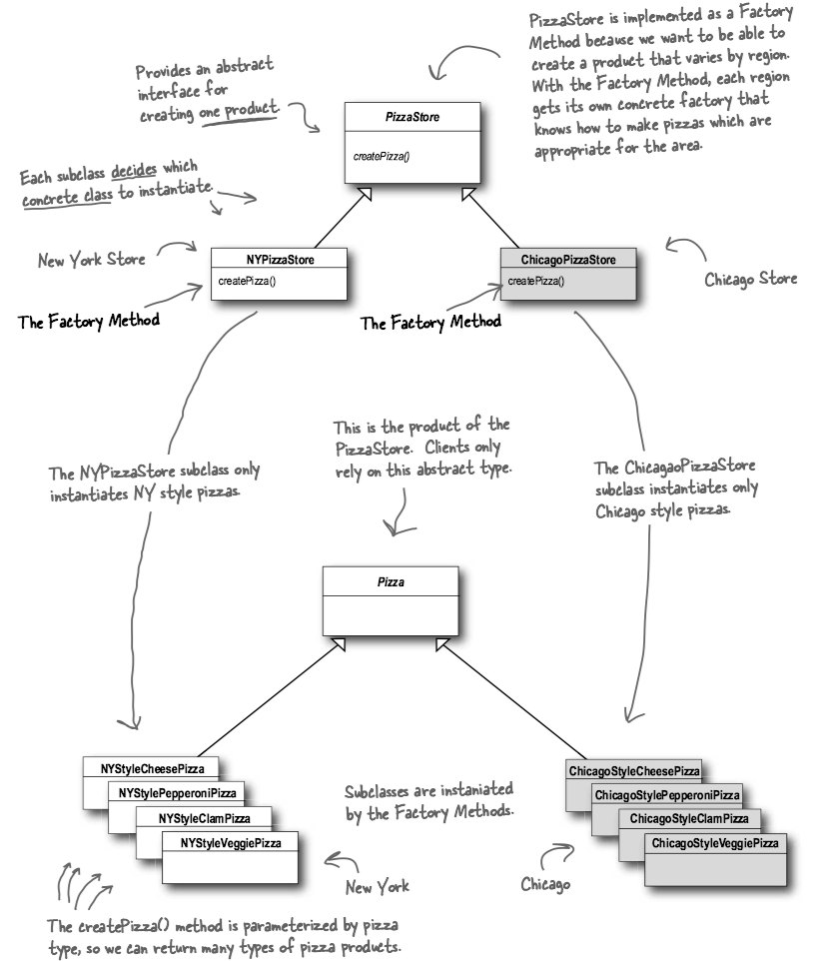

**Dependency inversion principle**

The Dependency Inversion Principle: Depend upon abstractions. Do not depend upon concrete classes.

A few guidelines to help you follow the Principle:

* No variable should hold a reference to a concrete class.
* No class should derive from a concrete class.
* No method should override an implemented method of any of its base classes.