**Factory Pattern**

The factory pattern hides the process of creating objects. It totally abstracts the responsibilities of creating the classes from the client classes. The major benefit of this is that our client code is completely ignorant of creation process of dependent class.

The loose coupling is good from extensibility prospective. Using the factory pattern, the client code also has the possibility of using multiple dependent classes if these dependent classes adhere to the contract; in another words, implements the interface.

The **Factory Method** Pattern defines an interface for creating an object, but lets subclasses decide which class to instantiate. Factory Method lets a class defer instantiation to subclasses.

“Define an interface for creating an object, but let subclasses decide which class to instantiate. Factory Method lets a class defer instantiate to subclasses”

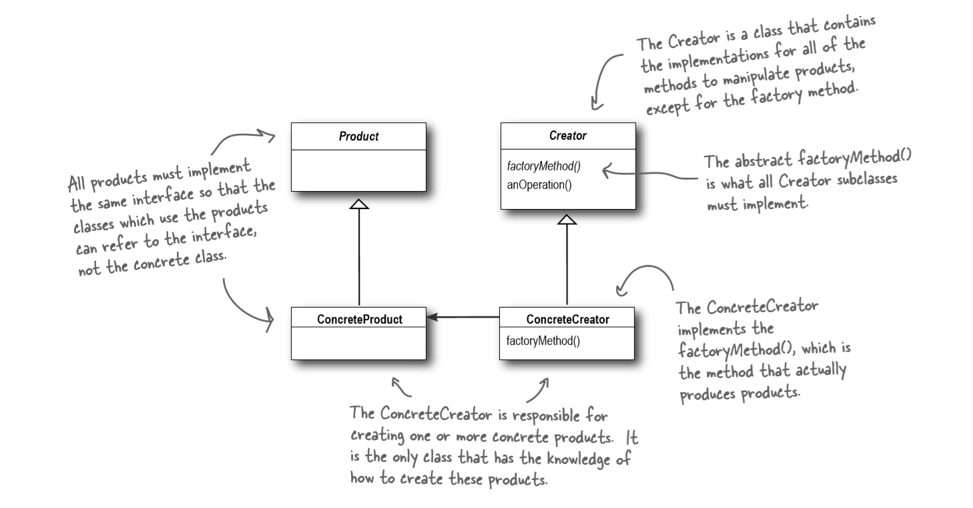

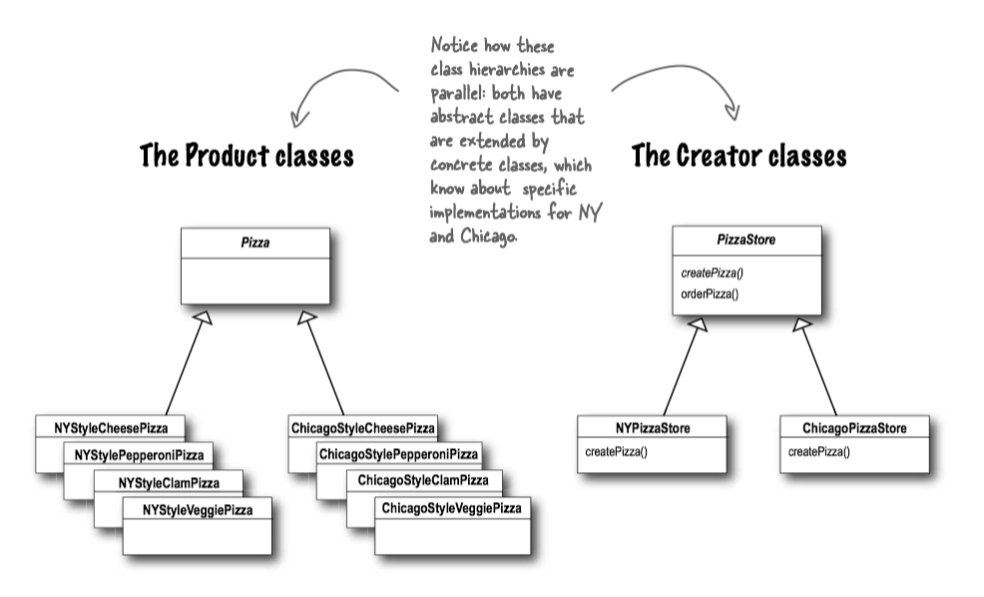

<https://www.codeproject.com/Articles/874246/Understanding-and-Implementing-Factory-Pattern-i-2>