**Singleton**

The Singleton Pattern ensures a class has only one instance and provides a global point of access to it.

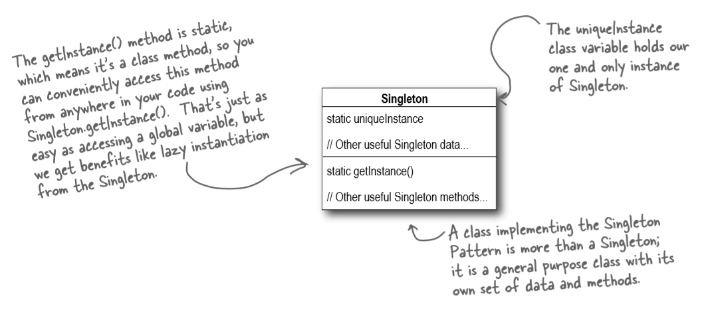

Whenever we have a scenario in our application where:

* A single instance of a class is required in the application and the class itself is able to enforce the single instance on itself. The rest of the system need not have to worry about managing the single instance.
* This single instance class should be accessible by the complete system or say by most part of the system.
* This single instance subsystem should not be created and initialized unless it is required (lazy initialization).