**Adapter Pattern**

The Adapter Pattern converts the interface of a class into another interface the clients expect. Adapter lets classes work together that couldn’t otherwise because of incompatible interfaces.

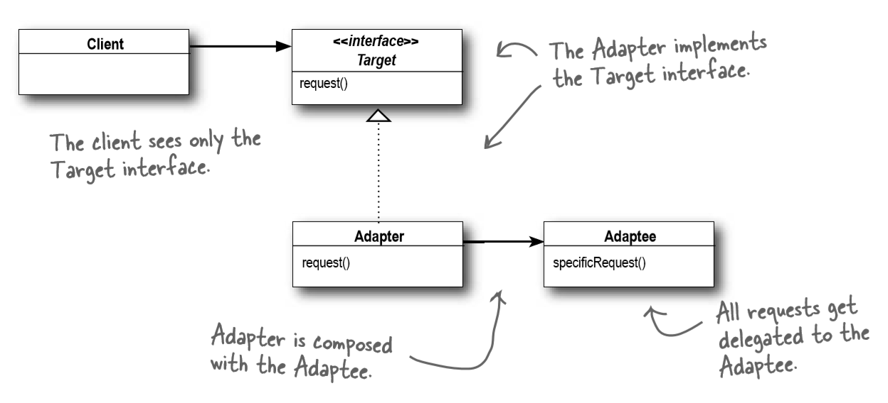

Let us try to understand this class diagram:

* **Target**: Defines the interface that the client uses.
* **Adapter**: It uses (adapts) the Adaptee's interface and exposes the Target interface to the client.
* **Adaptee**: This is the object whose interface needs to be adapted.
* Client: It uses the Adaptee functionality via the adapter interface, i.e., Target.