Page 1 of 5

Core PHP

 **SUMMARY**

**Innovative Senior** Web Developer/ Programmer with almost **7** years of professional experience with all stages of the development cycle for dynamic web projects.

Proven ability to leverage full-stack knowledge and experience to build interactive and user-centered website developments to scale.

**Strong** background in **project management** and customer relations.

** SKILLS**

Top Skills

VueJs

** EDUCATION**

 **MCA** from St. Anthony’s College, Shillong with CGPA 7.46 out of 10 (2013).

 **BCA** from Dibrugarh University with 64% aggregate (2010).

** PROFESSIONAL EXPERIENCE**

 **Lead Programmer** in **Alegra Labs** from 1st Feb 2017.

 **Associate**/ **Senior** Programmer in Alegra Labs from 1st Mar 2014 to 31st Jan 2017.

 Probationer in Alegra Labs from 5th Aug 2013 to 28th Feb 2014.

** PROFESSIONAL PROJECT HISTORY**

 Dec 2019 – May 2020: **Chat Bot**: Machine Learning Project as a **Lead Programmer**.

This project, developed in **Python**, **Flask** & **VueJs**, where have to train QAs to create models. And then based on the models it replies to the queries asked by the user.  
It is built as a **REST API in Flask**. So that it can be easily integrated to a website using only a JS code.  
Project revision history tracked through **Git**.  
**Role**: From inception to deployment, working alone in this Web Application.  
**Demo Link**: [www.alegralabs.com:8892](http://www.alegralabs.com:8892)  
**Reference**: Jay J Das, M.D., Alegra Labs  
 **-----------------------------------**

Python

jQuery

http://smahfuzm.in

mahfuzz786@gmail.com  
mahfuzt786@yahoo.co.in



+919401059543  
+917000031919





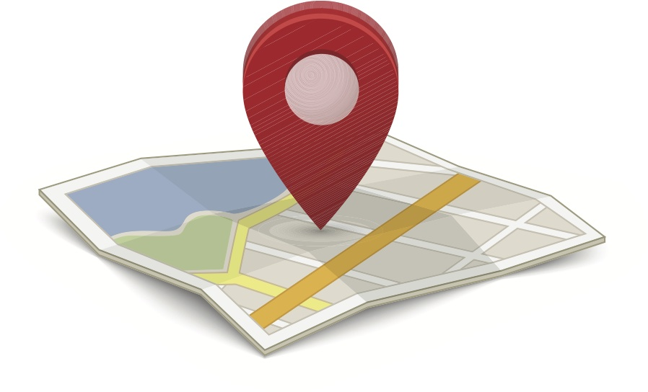

FAA Nagar, Six mile,  
Guwahati-22, Assam, IN

SYED MAHFUZUL MAZID

SENIOR DEVELOPER

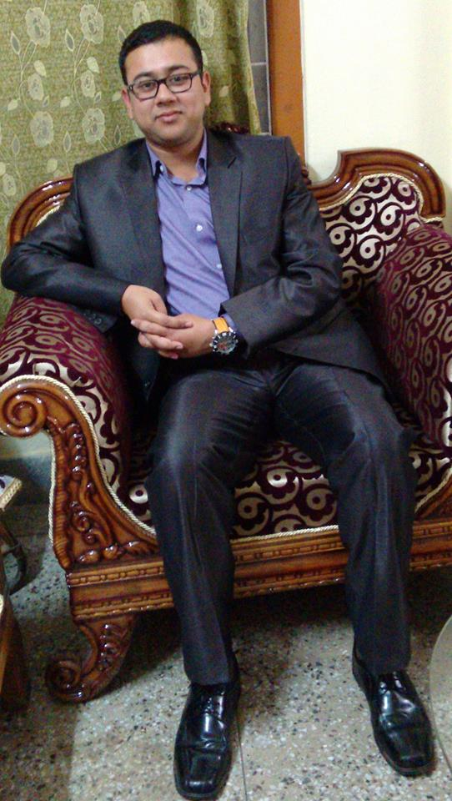

 April 2019 – Dec 2019: **Poster Recognition**: Machine Learning Project as a **Lead Programmer**.

This project, developed in **Python**, **Flask** & **VueJs**, involves recognizing Mobile Photos of Posters in the streets. The photos are taken under various lighting conditions and under various angles. My program identifies the Poster when compared with the Original Poster. This automation has helped **nikolaus-spitzer.de** from thousands of hours of manual work.  
**Role**: From inception to deployment, working alone in this Web Application.  
**Demo link**: http://postrapp.de/  
**Reference**: Jay J Das, M.D., Alegra Labs

**-----------------------------------**

 Apl 2018 – March 2019: **DigiPro** media **CMS**, (FL, USA) as a **Senior Developer**.

This project develops in **PHP7**, **HTML5**, **jQuery , VueJs** and **brisk coder PHP MVC framework**, involves building a CMS. It has two parts. One is the client CMS, other is the main Control panel. Control panel used to sell the packages and deploy organizations. The other is the Front/ Back end that build the Web App and clients can also use.

Worked and manipulated with many **SOAP** and **REST API**s like **Escapia**, **IQware**, **Propay** etc.

Project revision history tracked through **Git**.  
**Role**: Worked in an International team of 15+ members remotely on different modules & APIs and managed the coding aspects of the CMS.  
**Demo link**: homeownerscollection.com, premierisland.com, portofinoisland.com  
**Reference**: Jay J Das, M.D., Alegra Labs

**-----------------------------------**

** Programming Languages**  
**Python3**, **PHP**, PHP 5+ (Object Oriented Programming), Shell Programming under UNIX

** Web Technologies & Framework**  
HTML5, XML, JSON, **Django**, **Flask**, CSS3, **REST API**, SOAP API, Web API's for Google/ Facebook/ Twitter

**CMS**: WordPress, Dolibarr

** Scripts/ UI**  
JavaScript, **jQuery**, **Vue.js**, Web Services with Ajax, **Bootstrap**, LESS, SASS

** Database**  
**MySQL**, PgSQL, Sqlite  
NoSQL: Mongo DB

** Tools/ Versioning**  
**Git**/ SVN

**Npm**, Gulp, webpack, composer

Jira, Slack, Basecamp, Microsoft Team, Taiga

SCRUM

** Application Web Server**  
Linux (CentOS, Ubuntu)  
Amazon AWS

** Deployment Tools**  
Docker  
Kubernetes

** Specialties**  
Artificial Intelligence (Machine Learning in Python, **Chat Bots**, **Image Processing**)

Page 2 of 5

 Jan 2014- Mar 2018: **Kamwo** as a **Junior** **Programmer/Senior Programmer**.  
  
The Project, coded in **PHP5**, **HTML5**, **jQuery , MySQL** & **Firebase**, is for large scale **E-COM** & **ERP** System, who manufactures and ships Chinese Herbal Medicine. The program also manages the Warehousing, Shipping and Logistics. I have also been certified by the client (Joey Lau, New York USA), for best support and service of the Application.  
  
Project revision history tracked through **Git**.  
**Links**: [www.kamwo.com/escript/p-public.php](http://www.kamwo.com/escript/p-public.php)  
Practitioner search website based on US: www.acudirect.com.  
Online herb Guide: www.kamwo.com/escript/herbguide.php  
Hybrid mobile application for the online shopping application using **jQuery-mobile** framework and **Cordova**. App in Google Play Store: **Kamwo**.  
**Role**: From inception to deployment, successfully launched this long-term Web and Mobile Application. Certified by client for outstanding service.  
**References**: Joey Lau, Kamwo, NYC, USA  
 Jay J Das, M.D., Alegra Labs

**-----------------------------------**

 Aug 2013 – Dec 2013: FB app **Picletta** as a **Junior Programmer**.

The module contains to manipulate different properties in an SVG image such as resize, rotate, merging of images, add animation to SVG, embed a YouTube video in an SVG, convert SVG into Circle or Rectangle etc.  
Developed entire process with **jQuery**.

**Role**: Worked in a module with SVG images.  
**Reference**: Jay J Das, M.D., Alegra Labs

**-----------------------------------**

** SOCIAL PROFILES**

 https://www.linkedin.com/in/syedmahfuzulmazid27/

   
https://twitter.com/Syed_Mahfuz

 https://www.facebook.com/syedmahfuzul.mazid/

   
mahfuzt786

   
https://github.com/mahfuzt786

 https://www.instagram.com/main_pal_do_pal_ka_shayar/

** PERSONAL PROFILE**

**Father’s Name**: Syed Mazidur Rahman.

**Mother’s Name**: Syeda Farha Khatun.

**Nationality**: Indian.

**Date of Birth**: 31st July, 1989.

**Language known**: English, Assamese, Hindi.

** ACHIEVEMENT / ROLES**

 Participated as a member of the organising team in **3rd IEEE** National Conference on **EMERGING TRENDS AND APPLICATIONS** IN COMPUTER SCIENCE organised by Department of Computer Science, St. Anthony’s College, Shillong held on 30th, 31st March 2012.

Page 3 of 5

** OTHER PROJECT WORKS**

 Website for Institution of Engineering and Technology, Assam. (www.ietghy.in).  
  
 Website for True-Circle (truecircle.in)  
  
 Website for Shiksha education (shikshaeducation1.com/)

 Android app in Play Store: Khetgyan

 A Web based “Medical **expert system** for our respiratory diseases” as my MCA 6th semester project using **JSF** Framework (of JSP) - **MySQL** and **Prime faces**.

 “File-lock software with **voice recognition**” as my MCA 5th semester project using **Java** and **MATLAB**.

 A “Customer record system” using **C#** & **MS Access** for “BSNL, Sibsagar” during my BCA 6th semester project work.

 An “Office use management system” using **C** for “Handloom & Textiles Dept., Sonari, Assam” during my BCA 5th semester project work.

 Participated as a member of organizing team in Meghabytes 2011 (Meghalaya – IT submits) held on 8th & 9th Sep 2011 in St. Anthony’s College, Shillong.

 Participated as a member of the organising team **2nd IEEE National Conference** on **EMERGING TRENDS AND APPLICATIONS** IN COMPUTER SCIENCE organised by Department of Computer Science, St. Anthony’s College, Shillong held on 4th, 5th March 2011.  
  
 Participated in a two days’ **workshop** on “**EMBEDDED SYSTEMS**” organised by the Dept. of Computer Science, St. Anthony’s College, Shillong in collaboration with IIT, Guwahati on 12th and 13th November 2010.  
  
 Got 10th position in JTSE 2004, a state level talent search examination.  
  
 Won many quiz, essay and Table Tennis Competitions during school days.

Page 4 of 5

** ADDITIONAL QUALIFICATION**

 Completed CCNA (Participation).

Modules:

CCNA 1: Networking Basics

CCNA 2: Routers and Routing Basics

CCNA 3: Switching Basics and Intermediate Routing

CCNA 4: WAN Technologies

 Completed OCA (Participation).   
  
 Completed RHCE (RED HAT CERTIFIED ENGINEER) (Participation).

Page 5 of 5

**DECLARATION**

I hereby declare that the above-mentioned facts and information are true to the best of my knowledge. I will be responsible for any discrepancy found in them.

Place:

Date:

(Syed Mahfuzul Mazid)