CIS 296 Project 4 – chat application

Mahfuzul Haque, Mohammad Rahman

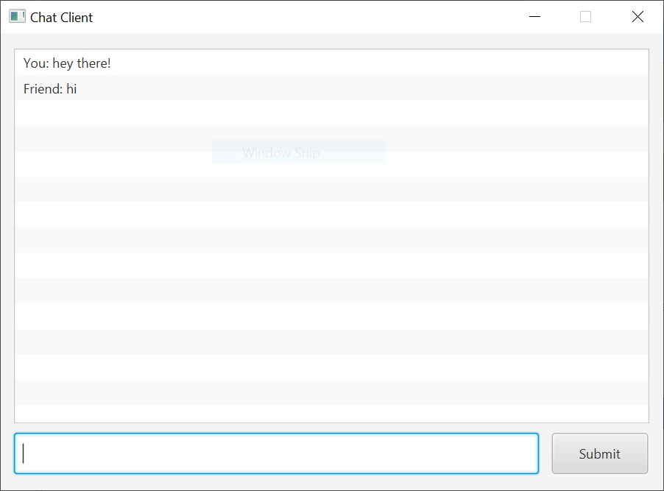

# Design & Implementation

For this project, we designed a GUI interface using JavaFX to simulate a chat application. The way the application works is that a server will be run in which 2 clients at most will be able to connect to. The server is the intermediary entity that will be responsible for the exchange of messages between the 2 clients. The client will be an entity which will be able to send messages to and receive messages from the server after it connects to it. This functionality is made possible by leveraging java server sockets. The server itself will not be made into a GUI interface, rather its sole responsibility will be to handle the socket/networking logic and it will also output the messages that are being sent by the clients into the console. The client GUI was developed using SceneBuilder – it only contains 3 elements which are: listview, textfield, and a button. The listview will be the output window where the user will be able to see all the messages from itself and the 2nd client, the textfield is where the client will be able to input its message, and the button is the submit button which a user can click to send a message, or the user can press enter. Behind the scenes, the client will maintain a thread and data input stream for receiving messages from the server, and it will also maintain a data output stream in which it will send the message to the server. The server connection will be maintained by a socket.

# Team Member Roles

Mohammad Rahman

* Networking/socket logic on the server side
* Ensuring the server properly maintains connections with the clients
* Ensuring the client can connect to the server with the proper networking/socket logic

Mahfuzul Haque

* Designing/implementing the GUI interface for the client
* Ensuring the proper implementation of threading logic in the client
* Ensuring the client can properly send, receive, and display messages on the interface