Student Details
Repository Name | DBS25P211
Registration Number | 2024-CS-211

Project
Project Title | Faculty Management System
Executive Summary | The Faculty Management System is designed to help the university efficiently manage faculty workload and resource allocation. These tasks—such as assigning courses, tracking faculty responsibilities, and handling resource requests (e.g., board markers, consumables)—were managed manually using spreadsheets and emails. This manual process often led to errors, delays, and inefficiencies, making it difficult to track workload distribution and resource availability. With this system, everything is organized in one place. Faculty members log in securely, and their access is based on their role. Faculty can view assigned courses, submit requests for resources, and check their request status. The Department Head oversees the system, ensuring that courses are assigned fairly, faculty requests are reviewed, and resources are distributed efficiently.  When a faculty member needs materials such as board markers, stationery, they can submit a request through the system. The request is marked as Pending until reviewed by the Department Head. Once approved, the requested resource is allocated, and the status is updated to Fulfilled. Faculty members can easily track their requests without needing multiple follow-ups via email.  The system also ensures that faculty workload is evenly distributed. It monitors teaching assignments, research supervision, and administrative responsibilities, preventing any faculty member from being overburdened while others have fewer tasks. Reports can be generated using the given system which will help the department plan better, ensuring smooth operations and compliance with academic requirements. Overall, the system enhances transparency, efficiency, and better resource management for the university.

Interface Name | Roll Selector
Picture

UI Component Name | Type of UI component | Class Attribute name,  Classname, attribute name | Linked to which database column/table
Role Selector | Combo Box | Button1_click | Lookup
Continue | Button | Button1_click

Interface Name | Login Page
Picture
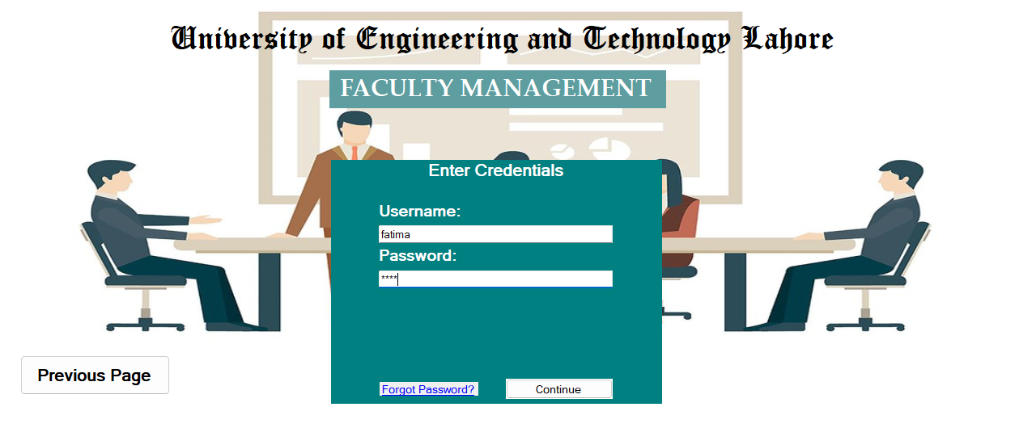

UI Component Name | Type of UI component | Class Attribute name,  Classname, attribute name | Linked to which database column/table
Username | Textbox | CheckCred | Users.username
Password | Textbox | Hash password | Users.passwrod_hash
Forgot Password | Linked Label
Continue | Button

Interface Name | Password Recovery
Picture 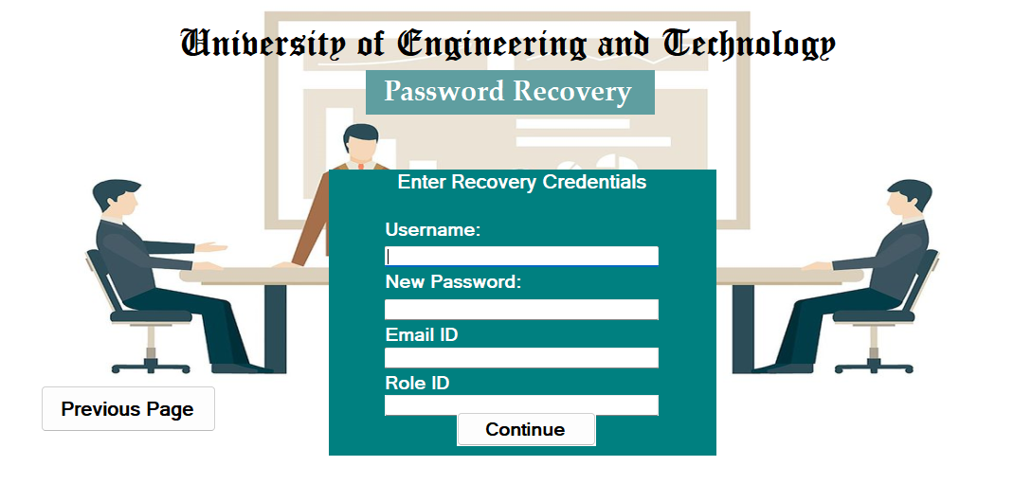

UI Component Name | Type of UI component | Class Attribute name,  Classname, attribute name | Linked to which database column/table
Username | Textbox | Update Password | Users.username
Password | Textbox | Hash Password | Users.password_hash
Email ID | Textbox | Update Password | Users.email
Role ID | Textbox | Update Password | Users.role_id
Continue | Button

Interface Name | Add Profiles (by admin staff)
Picture
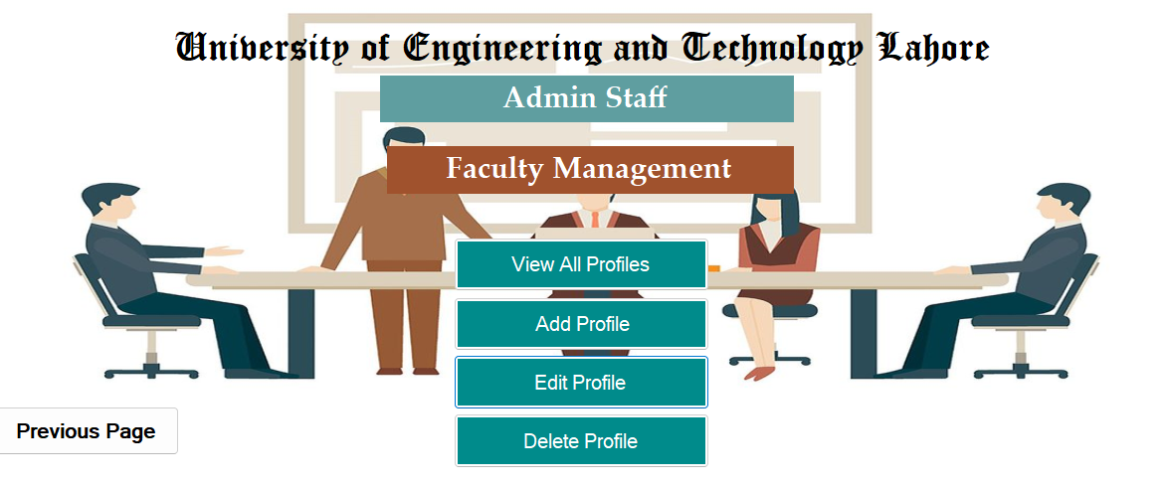
UI Component Name | Type of UI component | Class Attribute name,  Classname, attribute name | Linked to which database column/table
View All Profiles | Button | ShowUsers | Faculty
Add profiles | Button | FacCrud | Users, Faculty
Edit Profiles | Button | FacCrud | Users, Faculty
Deletes Profile | Button | FacCrud | Users, Faculty
Previous Page | Button

Interface Name | Faculty Requests Processing
Picture 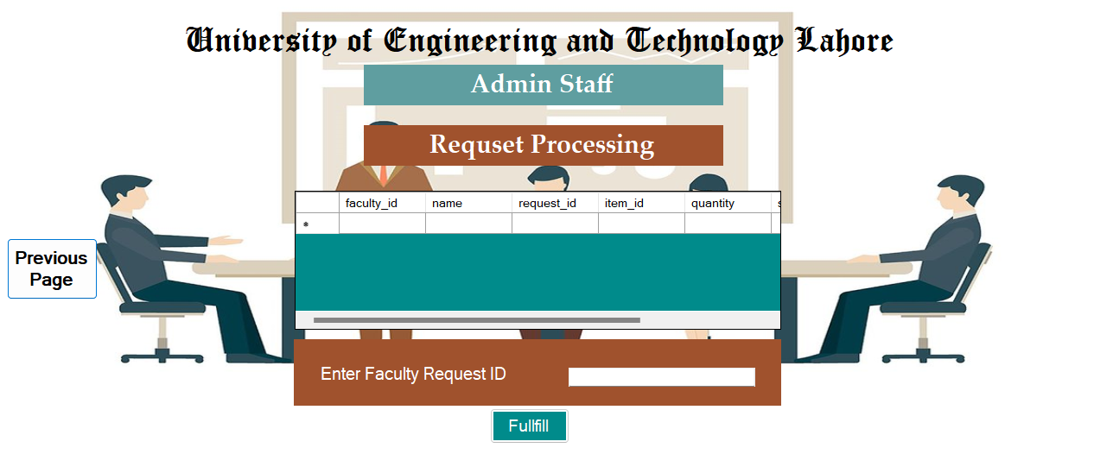

UI Component Name | Type of UI component | Class Attribute name,  Classname, attribute name | Linked to which database column/table
Request Processing | DataGridView | ProcessReq | Faculty_requests

Interface Name | Update User
Picture 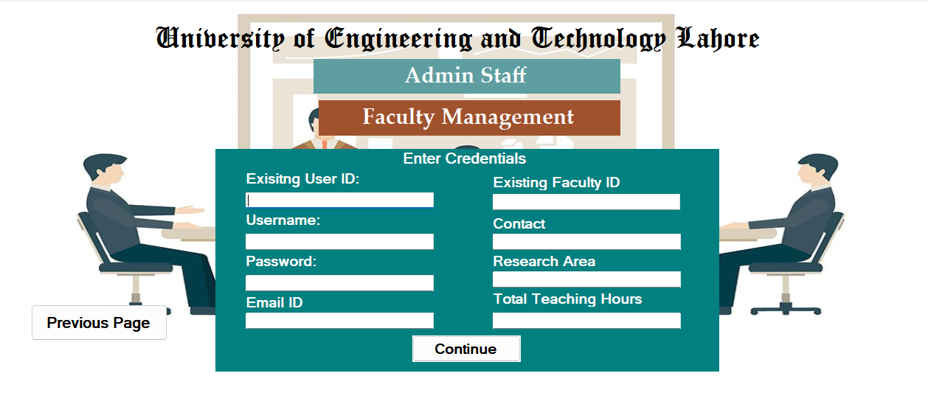

UI Component Name | Type of UI component | Class Attribute name,  Classname, attribute name | Linked to which database column/table
User ID | TextBox | FacCrud | Users.user_id
Username | TextBox | FacCrud | Users.username
Password | TextBox | FacCrud | Users.password_hash
Email | TextBox | FacCrud | Users.email
Faculty Id | TextBox | FacCrud | Faculty.faculty_id
Contact | TextBox | FacCrud | Faculty.Contact
Research Area | TextBox | FacCrud | Faculty.reseacrh_area
Total Teaching Hours | TextBox | FacCrud | Faculty.Total_teaching_hours
Continue | Button

Interface Name | Room Management
Picture 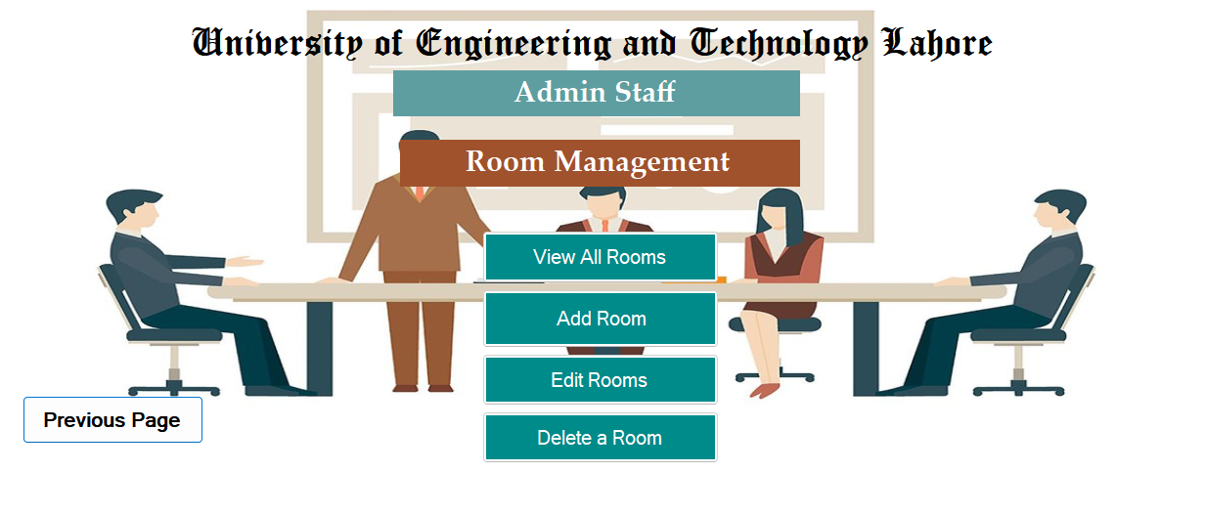

UI Component Name | Type of UI component | Class Attribute name,  Classname, attribute name | Linked to which database column/table
Add Room | Button | RoomCrud | Rooms
Delete Room | Button | RoomCrud | Rooms
Update Room | Button | RoomCrud | Rooms
View All Rooms | Button | ShowRooms | Rooms
Previous Page | Button

Interface Name | Course Management
Picture 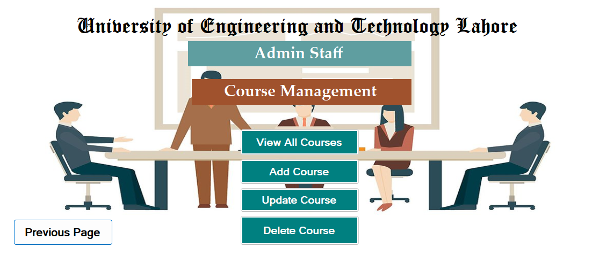

UI Component Name | Type of UI component | Class Attribute name,  Classname, attribute name | Linked to which database column/table
View All Courses | Button | ShowCourses | Courses
Add Course | Button | RoomCrud | Courses
Update Course | Button | RoomCrud | Courses
Delete Course | Button | RoomCrud | Courses
Previous Page | Button

Interface Name | View All Courses
Picture 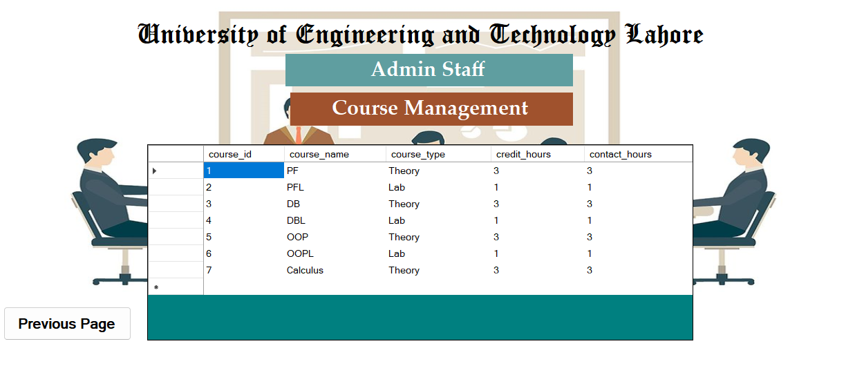

UI Component Name | Type of UI component | Class Attribute name,  Classname, attribute name | Linked to which database column/table
Course View | DataGridView | ShowCourses | Courses

Interface Name | Project Management
Picture 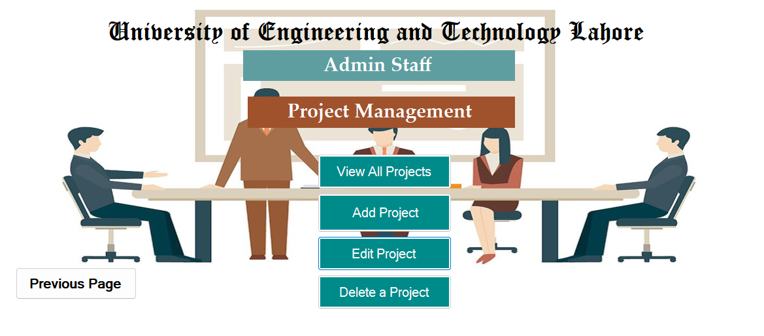

UI Component Name | Type of UI component | Class Attribute name,  Classname, attribute name | Linked to which database column/table
View All Projects | Button | ShowProjects | Projects
Add Projects | Button | ProjCrud | Projects
Edit Project | Button | ProjCrud | Projects
Delete Project | Button | ProjCrud | Projects
Previous Page | Button

Interface Name | Course Assignment
Picture 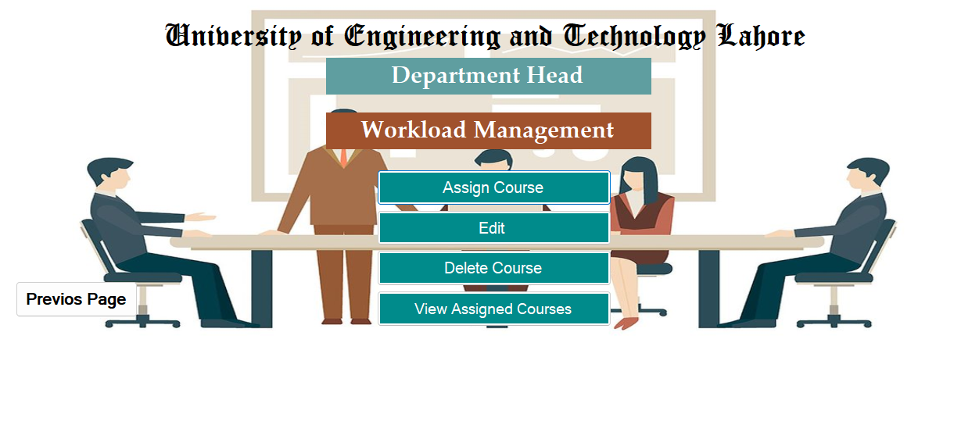

UI Component Name | Type of UI component | Class Attribute name,  Classname, attribute name | Linked to which database column/table
Assign Course | Button | AssignCourseCrud | Faculty_courses
Edit | Button | AssignCourseCrud | Faculty_courses
Delete Course Assignment | Button | AssignCourseCrud | Faculty_courses
View Assigned  Course | Button | ViewCourses | Faculty_courses
Previous Page | Button

Interface Name | Administrative Duties Assignment
Picture 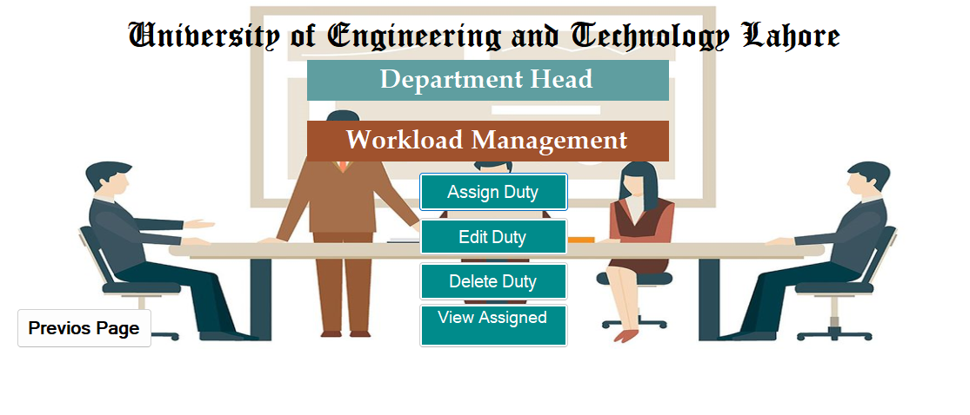

UI Component Name | Type of UI component | Class Attribute name,  Classname, attribute name | Linked to which database column/table
Assign Duty | Button | AdminRoleCrud | Faculty_admin_roles
Edit Duty | Button | AdminRoleCrud | Faculty_admin_roles
Delete Duty | Button | AdminRoleCrud | Faculty_admin_roles
View Assigned Duty | Button | ShowAllRoles | Faculty_admin_roles
Previous Page | Button

Interface Name | Request Approval/Decline
Picture 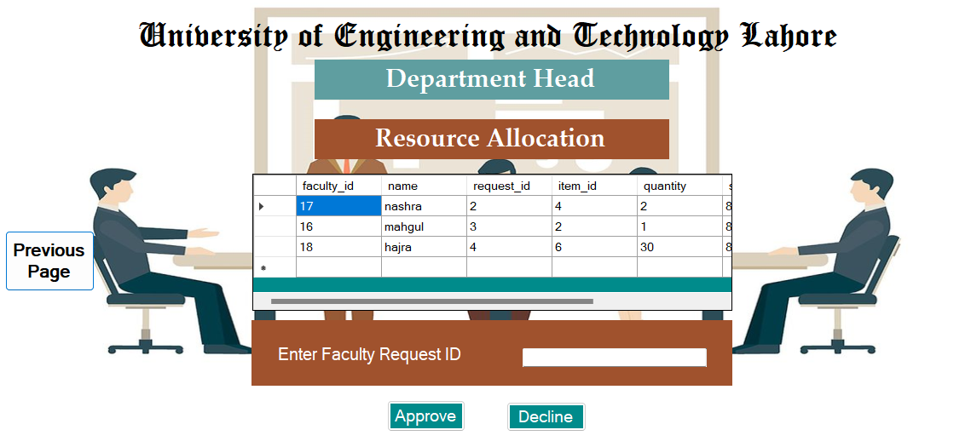

UI Component Name | Type of UI component | Class Attribute name,  Classname, attribute name | Linked to which database column/table
Requests View | DatagridView | ShowReq | Faculty_requests
Approve | Button | Button1_click | Faculty_requests
Decline | Button | Button2_click | Faculty_requests

Interface Name | Room Allocation
Picture 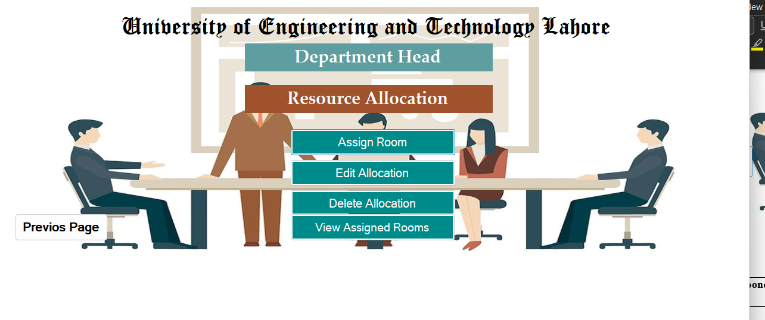

UI Component Name | Type of UI component | Class Attribute name,  Classname, attribute name | Linked to which database column/table
Assign Room | Button | RoomCrud | faculty_room_allocations
Edit Allocation | Button | RoomCrud | faculty_room_allocations
Delete Allocation | Button | RoomCrud | faculty_room_allocations
View Assigned Rooms | Button | RoomCrud | faculty_room_allocations

Interface Name | Delete Room Allocation
Picture 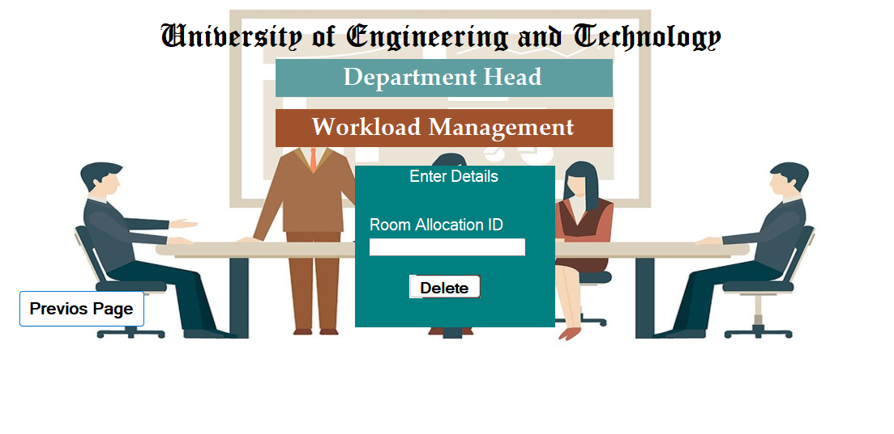

UI Component Name | Type of UI component | Class Attribute name,  Classname, attribute name | Linked to which database column/table
Room Allocation ID | Textbox | RoomCrud | Faculty_room_allocations
Delete | Button | RoomCrud | Faculty_room_allocations
Previous Page | Button

Interface Name | Report and Analytics
Picture 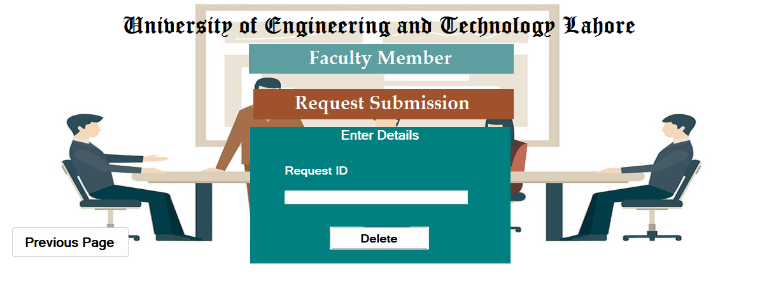

UI Component Name | Type of UI component | Class Attribute name,  Classname, attribute name | Linked to which database column/table
Request Deletion | button | ReqCrud | Faculty_requests
Request Id | Textbox | ReqCrud | Faculty_request
Previous Page | button

Interface Name | Request Submission
Picture
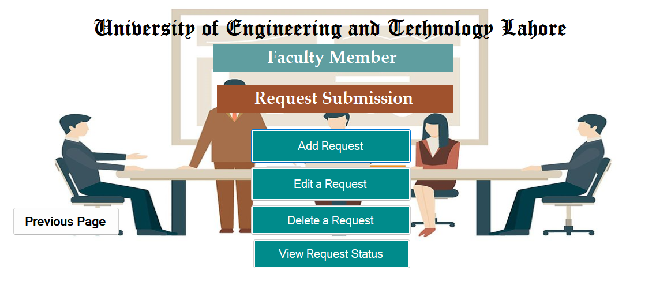
UI Component Name | Type of UI component | Class Attribute name,  Classname, attribute name | Linked to which database column/table
Add Request | button | ReqCrud | Faculty_requests
Edit Request | button | ReqCrud | Faculty_requests
Delete Request | button | ReqCrud | Faculty_requests
View Request Status | button | ShowStatus | Faculty_requests

Interface Name | Faculty Member UI
Picture
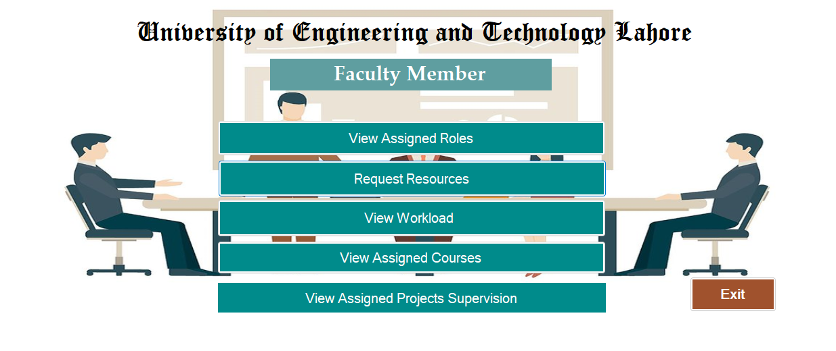
UI Component Name | Type of UI component | Class Attribute name,  Classname, attribute name | Linked to which database column/table
View Assigned Roles | Button | FacReqStat | SELECT faculty_admin_roles.admin_role_id, faculty_admin_roles.faculty_id, faculty.name, faculty_admin_roles.role_name, faculty_admin_roles.semester_id FROM Faculty_admin_roles JOIN faculty ON faculty_admin_roles.faculty_id = faculty.faculty_id WHERE faculty_admin_roles.faculty_id= {faculty_id}";
Request Resources | Button | FacreqSub
View Workload | Button | Workload view | SELECT faculty_course_schedule.schedule_id, faculty_courses.faculty_id, faculty_courses.course_id,courses.course_name, faculty_course_schedule.room_id, rooms.room_name, faculty_course_schedule.day_of_week, faculty_course_schedule.start_time, faculty_course_schedule.end_time FROM faculty_course_schedule JOIN faculty_courses ON faculty_course_schedule.faculty_course_id = faculty_courses.faculty_course_id JOIN courses ON faculty_courses.course_id = courses.course_id JOIN rooms ON faculty_course_schedule.room_id = rooms.room_id WHERE faculty_courses.faculty_id = {faculty_id}";
View Assigned Courses | Button | FacProfile | "SELECT faculty_courses.faculty_id, faculty_courses.course_id,courses.course_name, courses.course_type, courses.credit_hours,courses.contact_hours FROM faculty_courses JOIN courses ON faculty_courses.course_id = courses.course_id WHERE faculty_courses.faculty_id = {faculty_id}";
View Assigned Project Supervision | Button | ProjectSup | "SELECT faculty.faculty_id,faculty.name AS faculty_name, faculty_projects.project_id, projects.title AS project_title, projects.description AS project_description, faculty_projects.semester_id,faculty_projects.supervision_hours FROM faculty JOIN faculty_projects ON faculty.faculty_id = faculty_projects.faculty_id JOIN projects ON faculty_projects.project_id = projects.project_id WHERE faculty.faculty_id ={faculty_id}";
Exirt | Button

Interface Name | Workload View
Picture 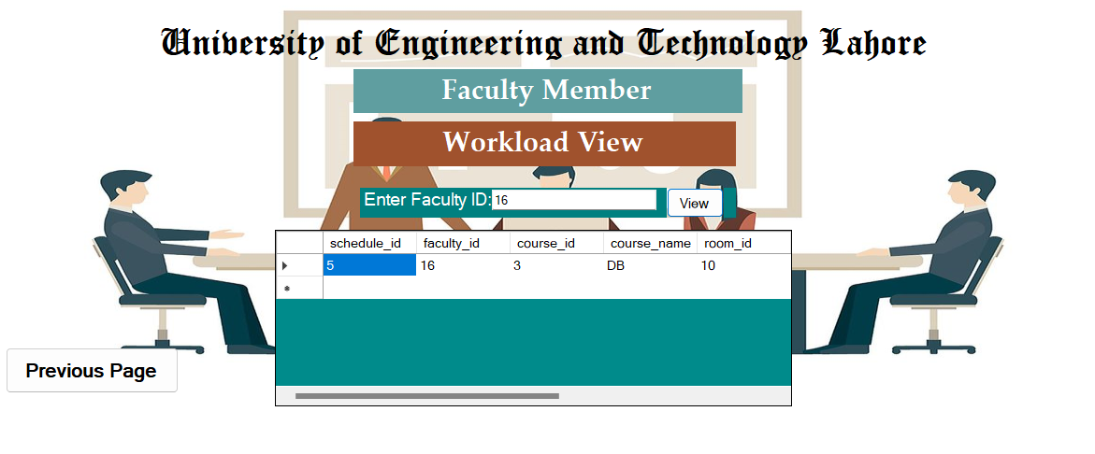
UI Component Name | Type of UI component | Class Attribute name,  Classname, attribute name | Linked to which database column/table
Workload view | button | WorkloadView | SELECT faculty_course_schedule.schedule_id, faculty_courses.faculty_id, faculty_courses.course_id,courses.course_name, faculty_course_schedule.room_id, rooms.room_name, faculty_course_schedule.day_of_week, faculty_course_schedule.start_time, faculty_course_schedule.end_time FROM faculty_course_schedule JOIN faculty_courses ON faculty_course_schedule.faculty_course_id = faculty_courses.faculty_course_id JOIN courses ON faculty_courses.course_id = courses.course_id JOIN rooms ON faculty_course_schedule.room_id = rooms.room_id WHERE faculty_courses.faculty_id = {faculty_id}";
Faculty_id | Textbox

Interface Name | Project Supervison
Picture
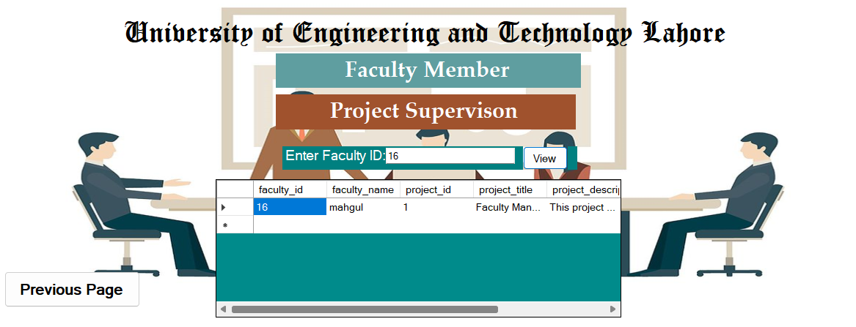
UI Component Name | Type of UI component | Class Attribute name,  Classname, attribute name | Linked to which database column/table
Assigned Project Supervision | DataGridView | ProjectSup | "SELECT faculty.faculty_id,faculty.name AS faculty_name, faculty_projects.project_id, projects.title AS project_title, projects.description AS project_description, faculty_projects.semester_id,faculty_projects.supervision_hours FROM faculty JOIN faculty_projects ON faculty.faculty_id = faculty_projects.faculty_id JOIN projects ON faculty_projects.project_id = projects.project_id WHERE faculty.faculty_id ={faculty_id}";
Faculty_id | Textbox

Business Report-1
Business Report Name: Faculty Workload Details
Sample of report: 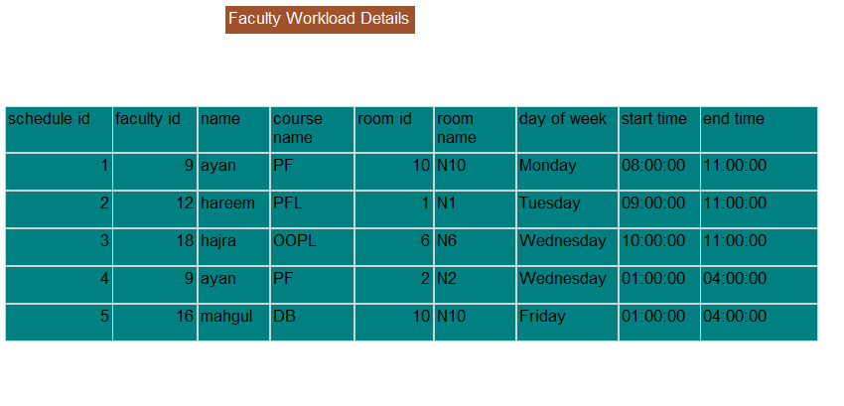
Query to build Report: "SELECT faculty_course_schedule.schedule_id, faculty.faculty_id,faculty.name AS faculty_name,courses.course_name,faculty_course_schedule.room_id, rooms.room_name, faculty_course_schedule.day_of_week, faculty_course_schedule.start_time, faculty_course_schedule.end_time FROM faculty_course_schedule JOIN faculty_courses ON faculty_course_schedule.faculty_course_id = faculty_courses.faculty_course_id JOIN faculty ON faculty_courses.faculty_id = faculty.faculty_id JOIN courses ON faculty_courses.course_id = courses.course_id JOIN rooms ON faculty_course_schedule.room_id = rooms.room_id";

Business Report-2
Business Report Name: Faculty Users Details
Sample of report: 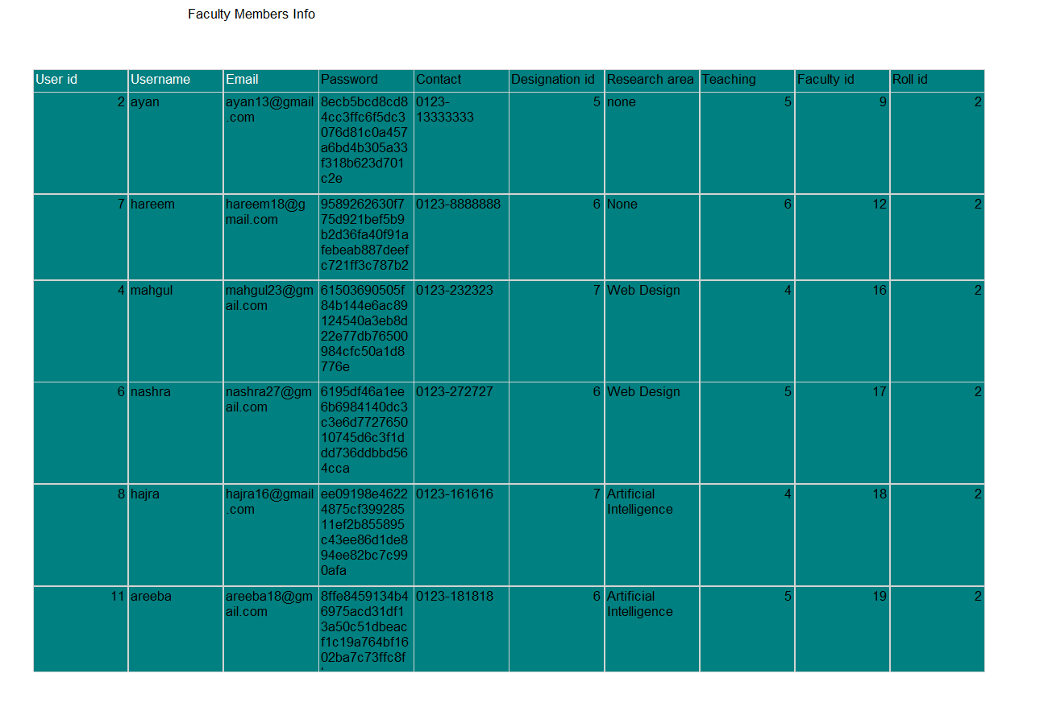
Query to build Report: SELECT users.username,users.password_hash AS password, users.email, users.role_id, faculty.contact, faculty.research_area, faculty.total_teaching_hours , faculty.designation_id, users.user_id,faculty.faculty_id FROM faculty JOIN users ON faculty.user_id = users.user_id

Business Report-3
Business Report Name: Faculty Requests Details
Sample of report: 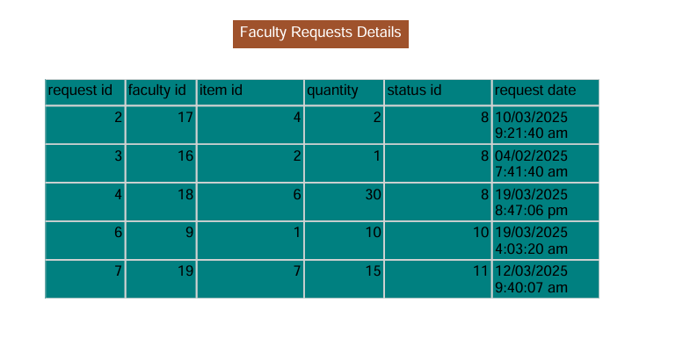
Query to build Report: SELECT faculty_requests.request_id,faculty.faculty_id,faculty_requests.item_id, faculty_requests.quantity, faculty_requests.status_id, faculty_requests.request_date FROM faculty_requests JOIN faculty ON faculty_requests.faculty_id = faculty.faculty_id

Business Report-4
Business Report Name: Courses Assigned to Faculty Members
Sample of report: 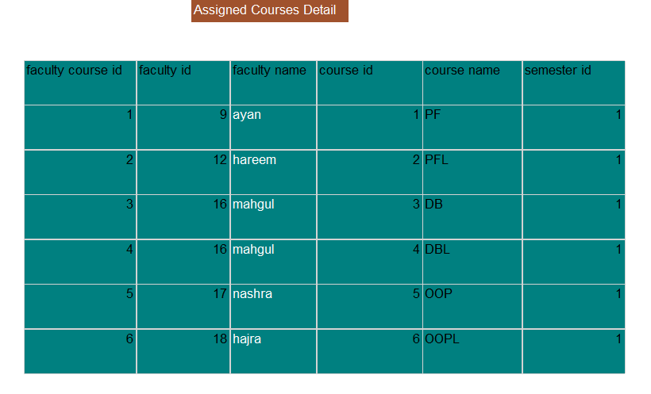
Query to build Report: SELECT faculty_courses.faculty_course_id,faculty.faculty_id,faculty.name , faculty_courses.course_id, courses.course_name , faculty_courses.semester_id FROM faculty_courses JOIN faculty ON faculty.faculty_id = faculty_courses.faculty_id JOIN courses ON faculty_courses.course_id = courses.course_id

