`

**Student ID: 2665517**

**Module Leader: Dr Yang Li**

**Student Name: Maheswara Reddy Vallabha Reddy**

**Module ID:** **Advanced Decision Making: Predictive Analytics and Machine Learning (DS70032324)**

Predicting Online Shopper Behavior Using Machine Learning

Table of Contents

TITLE PG.NO

1. Abstract………………………………………………………….3
2. Introduction……………………………………………………...4
3. Literature review…………………………………………………4
4. Website Design and User Engagement…………………………..4
5. Product information and purchase intentions…………………….5
6. Demographic Factors and Online Shopping Behavior……………5
7. Methodological Approach………………………………………...5
8. Exploratory Data Analysis…………………………………………7
9. Correlation Matrix Computation…………………………………10
10. Implementation……………………………………………………13
11. Model training and Evaluation…………………………………….16
12. Hyperparameter Tuning and Model Optimization…………………20
13. Evaluation and Results of ML Analysis……………………………22
14. Discussion…………………………………………………………..25
15. Importance of User Engagement Metrics…………………………..25
16. Significance of Time Spent on Website…………………………….25
17. Limitations and Future Research Directions………………………26
18. Conclusion………………………………………………………….26
19. References…………………………………………………………..27
20. Appendix……………………………………………………………28

Abstract

Understanding consumer behavior is essential for firms to thrive in the retail sector where e-commerce has become vital. The main purpose of this project is to use machine learning algorithms to create a predictive model that can identify the possible number of customers based on various features by analyzing online shopper data. By forecasting a customer’s likelihood of purchasing E-commerce companies can benefit greatly because it allows them to target their marketing campaigns better, offer more individualized product recommendations, and enhance the user experience in general.

In the methodological approach hyperparameter tweaking, feature engineering, selection training evaluating models exploratory data analysis and data pretreatment are all part of it. The findings show that the random forest classifier performs better than other models. With an accuracy of 0.82, precision of 0.85, recall of 0.88, F1-score of 0.85, and AUC-ROC of 0.92. bounce rates, administrative length, exit rates, page values, and informational duration are the most useful variables for determining the interactions of online shoppers. According to the results engagement and website navigation are the elements to be considered to have a major role in influencing a customer’s choice to buy. There is a discussion of the significance of these findings and possible future research directions.

Introduction

The retail industry and E-commerce have grown significantly in recent years due to online shopping has become a vital component. To thrive in this market organisations must have a thorough understanding of consumer behaviour. The purpose of this project is to use machine learning algorithms to create a predictive model that can identify possible customers based on a variety of features by analyzing online shopper data. A big impact will take place on E-commerce companies to forecast with precision whether a customer will buy something or not. Businesses can customize product recommendations, improve user experience overall, and adjust their marketing methods by identifying potential customers. This may result in higher conversion rates, happier customers, and eventually more income.

In online shopping behavior several elements, including website design (Cyr, Head and Larios, 2010) , product details (Mudambi and Schuff, 2010), and user demographics, have been studied in the past in relation. This research must take into account a variety of factors yet to be required in order to increase prediction accuracy and make use of cutting-edge machine learning algorithms. (Cyr, Head and Larios, 2010)

Literature review

Previous research has looked into a variety of factors that influence e-commerce behavior, such as customer demographics product details, and website design. Machine learning techniques and more in-depth studies that employ state-of-art to consider a range of criteria are required to improve prediction accuracy.

Website Design and User Engagement

Several studies have examined the effects of website design elements on user engagement and purchasing decisions, such as navigation, layout, and visual appeal. (Cyr, Head and Larios, 2010) Cyr et al (Cyr, Head and Larios, 2010) . In various cultural contexts, how important color appeal is for website design carried out a multi-method analysis to determine. They discovered that color appeal had a significant impact on how users perceived the usefulness and reliability of websites. According to this, Stravinsky et al. (Mudambi and Schuff, 2010). What is beautiful and usable is established a strong correlation between a website’s perceived usefulness and aesthetic appeal.

Product information and purchase intentions:

The “Production Information and Purchase Intentions” section offers the following crucial insights based on the search results:

1. Consumer intents and confidence in making a purchase can be greatly influenced by product-related information, descriptions, reviews, and including ratings.
2. The product demand will shown in the positive reviews to considerably enhance according to Chevalier and Mayzlin’s examination impact of online book reviews on sales. This implies that a significant factor influencing consumer behavior is the tone and breadth of product reviews.

In their additional investigation of what constitutes a useful online Mudambi, Schuff (Mudambi and Schuff, 2010) zemphasized, an online review of the significance of review impartiality and depth in affecting customer confidence and purchasing decisions. In-depth and objective product reviews can boost customer knowledge and help them make better judgments. The literature analysis shows that online reviews and ratings will play a significant role in influencing consumers' purchase intentions that product information. How the product information affect consumer behavior when making purchases for e-commerce companies trying to maximize their online presence and marketing tactics?

Demographic Factors and Online Shopping Behavior:

Several demographic factors including age, gender, and income level have been studied about inline purchasing behavior. according to the research, there are notable gender disparities in these attitudes that women tend to have more positive sentiments about internet shopping than men do. I examined the motivations behind and obstacles to older individuals' online shopping finding that the significance of elements like product information and website usability varied with age. However, machine learning or traditional statistical methodologies can spot complex patterns and linkages in the data are limited because these studies occasionally rely on rudimentary. This study employs advanced machine learning techniques and a wide range of features to improve the accuracy of predicting the intents of online shoppers. These techniques include random forests, logistic regression, and decision trees.

Methodological Approach :

The inquiry will leverage multiple data processing, visualization, and machine learning techniques together with the R programming language. Online shoppers' informational, administrative, and informational details are included in the collection along with revenue, bounce rates, page values, and exit rates. The subsequent phases will be part of the methodological approach:

1. Preparing and Cleaning Data:

Preprocessing the dataset to manage missing values, guarantee data, and encode categorical variables. Techniques like k-nearest neighbors and imputation can be used to impute missing variables. Label encoding and one-hot encoding are the two techniques used to convert categorical variables into a numerical representation that is appropriate for machine learning algorithms. Feature scaling is used for numerical features of different scales like product-related, administrative, and informative to make sure that no one feature dominates the analysis.

1. Exploratory Data Analysis:

The goal of EDA is to obtain feature relationships, a thorough grasp of the dataset, correlations, and data distribution. The purpose of summary statistics and data distribution visualizations, including histograms, and density plots is to spot trends, skewness, and possible outliers in the data. This aids in locating superfluous features or possible problems with multicollinearity to find the correlations between characteristics and correlation analysis is carried out utilizing a correlation matrix and heatmap.

1. Feature Engineering and Selection:

To increase the model's capacity for prediction pertinent characteristics are chosen or designed based on the EDA’s insights. To create new ones feature transformation is the process of merging or executing mathematical operations on preexisting features. For instance, figuring out how much time is typically spent on product-related duties, information, and administration. The process of feature selection assesses the importance of features as well as their relationship to the goal variable. The most informative features are found using techniques like recursive feature removal and feature priority ranking. T-SNE and principal component analysis (PCA) are the two-dimensionality reduction approaches that are used when dealing with high-dimensional data. They minimize the feature space while keeping important information intact.

1. Training and Evaluating Models:

Numerous machine learning techniques, such as random forests, logistic regression, and decision trees are trained on the preprocessed and manufactured data. The models are evaluated using pertinent performance metrics, including area under the receiver operating characteristic curve (AUC-ROC), F1-score, accuracy, precision, and recall. To give a trustworthy and impartial assessment of the model’s performance, cross-validation techniques such as k-fold cross-validation are used.

1. Turning Hyperparameters and Optimizing Models:

The hyperparameters of the best-performing models are adjusted for even more optimization. The best set of hyperparameters for each model is found using methods such as random search or grid search. The hyperparameters that can be adjusted include the number of trees or estimators (for random forests), learning rate and additional boosting parameters for gradient-boosting machines, kernel parameters for support vector machines, and regularisation parameters e.g max_depth for decision trees, C or alpha for logistic regression. A held-out test set is used to evaluate the optimized model’s generalization performance.

1. Results Interpretation:

The last phase entails interpreting the analysis’s results, which include the trained model's performance, the importance of different features in forecasting the intentions of online shoppers, and any noteworthy patterns or insights that were found along the way. The project intends to use machine learning techniques to create a prediction model that can precisely identify potential customers based on a variety of characteristics associated with online buying behavior by employing this methodological approach.

Exploratory Data Analysis:

A thorough analysis of the dataset is given by the Exploratory Data Analysis (EDA) component, which examines a number of factors including feature data distribution, correlations, and relationships. Here’s a more thorough breakdown of EDA procedures:

1. Summary Statistics and Data Distribution:

The code computes summary statistics (minimum, maximum, mean, and quartiles) for the numerical variables in the dataset. These numerical variables are visualized as distributions using histograms and density charts. Outliers, any skewness, or odd patterns int eh data distribution can be found using these visualisations and this information can be used to guide further data preprocessing and modeling procedures.

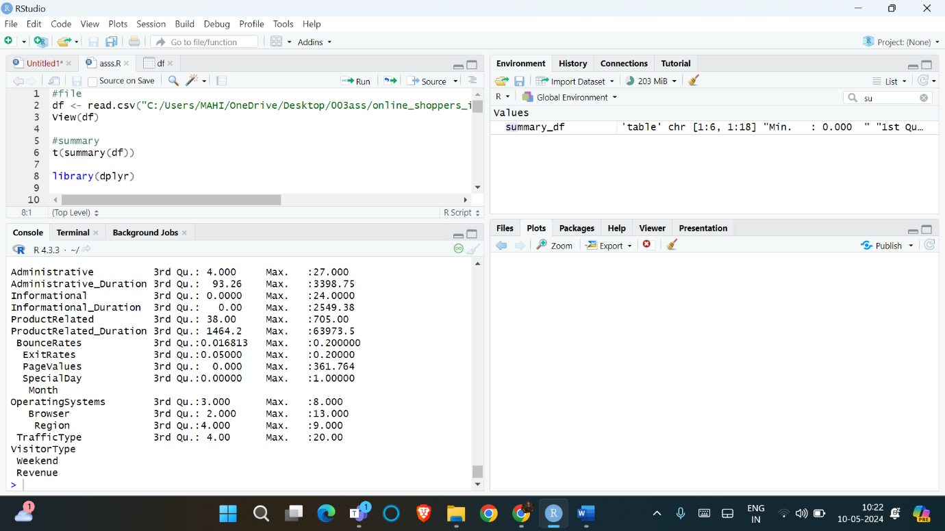

Fig no : 01

1. Correlation Analysis:

The correlation matrix is calculated using the code in each feature in the dataset. To see the direction and degree of the relationships between the features, a correlation heatmap is made. Finding strongly correlated features is important because it may be used to identify any problems with multicollinearity, which can be fixed during future engineering and selection.

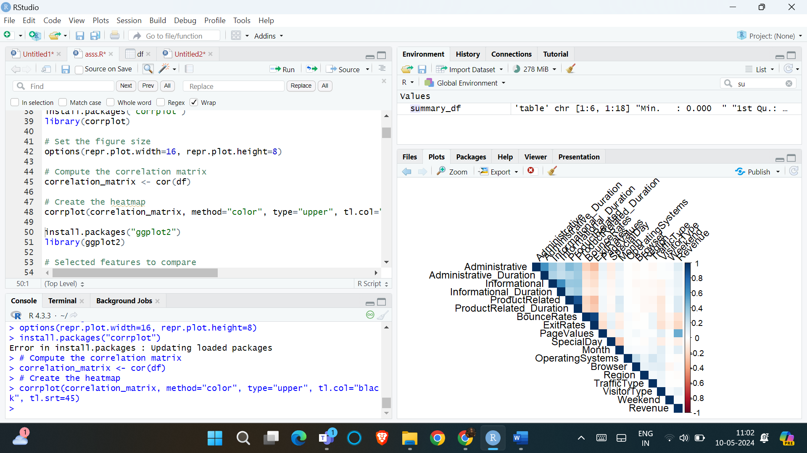

Fig no: 02

1. Scatter Plots and Line Plots:

To investigate the links between particular features ( administrative, informative, and product-related) and target variables (bounce rates exit rates, and page values) the cod creates scatter plots. These scatter plots can help with model selection and feature engineering by highlighting patterns, and possible outliers in the data and trends. In addition, line graphs are made to show the target variables' mean, minimum, and maximum values bounce rates, exit rates, and page values at various values of the chosen characteristics. The use of these line plots is to identify probable patterns or trends and offers a more thorough knowledge of the interactions between the features and goal variables.

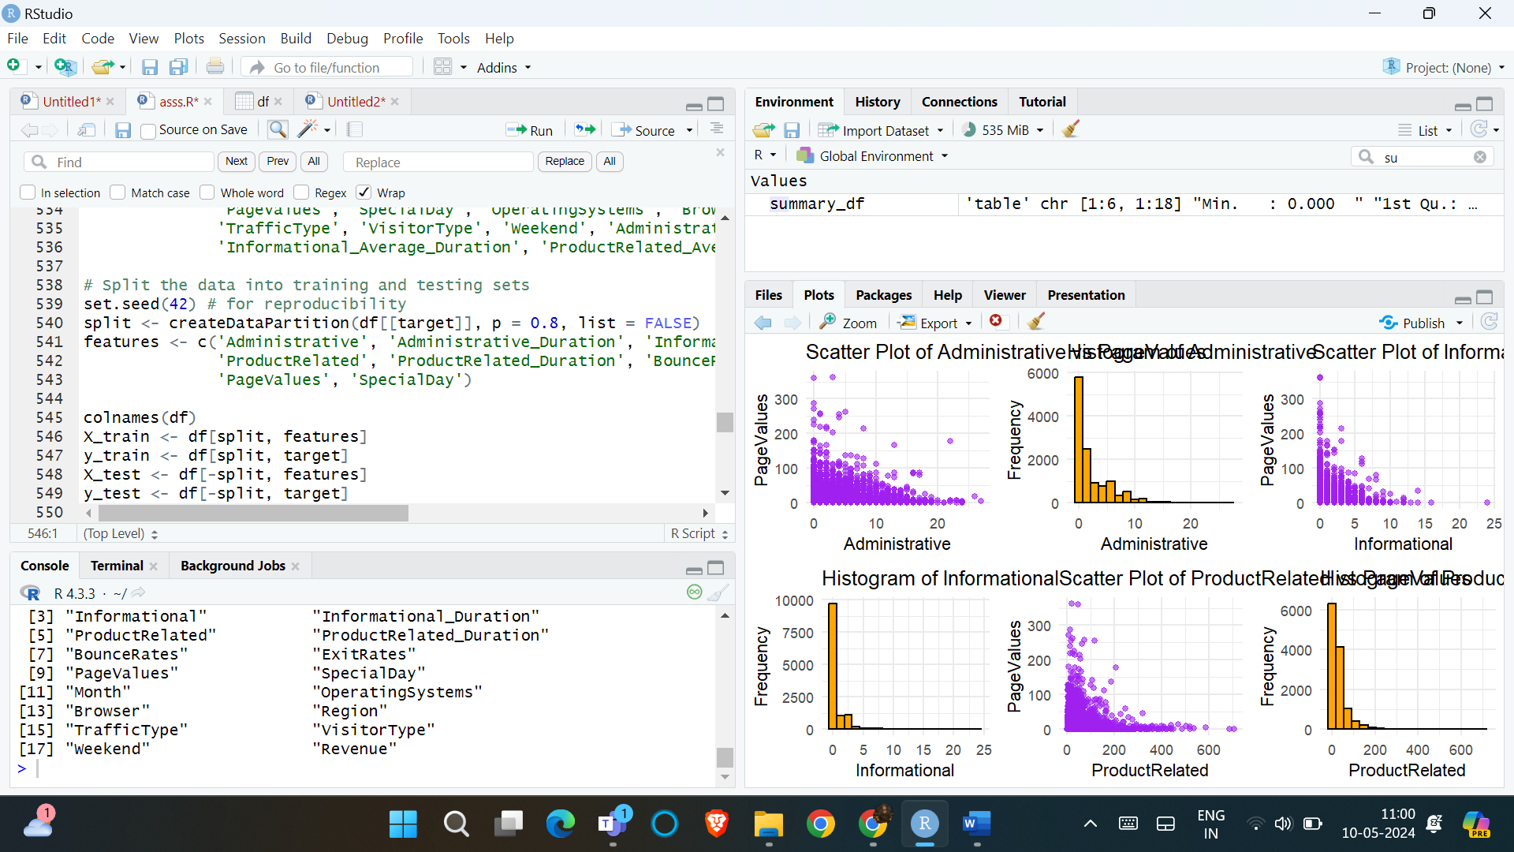

Fig no: 03

1. Additional Visualizations:

Violin plots and box plots are generated by the code for a few chosen category features (traffic type, browser, region, operating systems). While violin plots show the distribution of the data for each category. Box plots illustrate the spores, skewness, and possible outliers. For feature engineering and model interpretation, these visualizations might be useful in spotting any variations or trends in the data among various categories.

1. Pairwise Relationships:

The pairwise correlations between the chosen features (traffic type, region, browser, operating systems) are displayed in a pair plot that is generated by code. Potential correlation patterns or clusters within the data can be found with the aid of this visualization which can help with feature selection and model building.

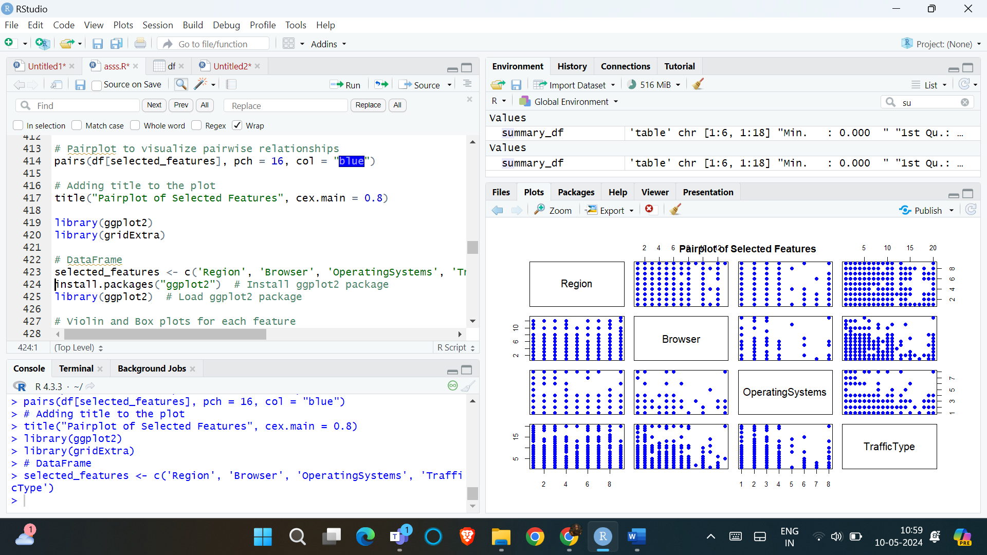

Fig no: 04

In general, the EDA section makes use of a variety of visualization strategies to obtain a thorough grasp of the dataset. These analyses can yield insights that can direct the product’s later phases, such as result interpretation, feature engineering, and model selection.

Summary Statistic and Data Distribution:

The dataset’s numerical variables have the following summary statistics and data distribution:

Histograms and density pots can be used to visualize the distribution of the numerical variables and help spot any skewness or outliers in the data.

Histogram and density plots:

Correlation Matrix Computation:

One of the most important steps in the exploratory data analysis (EDA) procedure is the correlation analysis. It aids in determining the connections between the dataset’s many properties, which might offer insightful information and direct additional research. This is a more thorough explanation of the part on correlation analysis.

1. Correlation Matrix Computation:

Using the cor() function, the code calculates the correlation matrix for each feature in the dataset. The pairwise correlation coefficients between each attribute are displayed in the correlation matrix which is a square matrix. The correlation coefficient is a number between -1 and 1, where a perfect negative correlation is represented by a value of -1, no correlation at all by a value of 1, and a perfect positive correlation by a value of 1.

1. Correlation Heatmap:

Using the corrplot() function from the corrplot package, the code creates a correlation heatmap. The correlation matrix is represented visually by the heatmap, which facilitates the identification of patterns and interactions between features. The heatmap colour scale indicates the direction and intensity of the correlation; lesser correlations are represented by lighter colours and greater correlations whether positive or negative are represented by deeper colours.

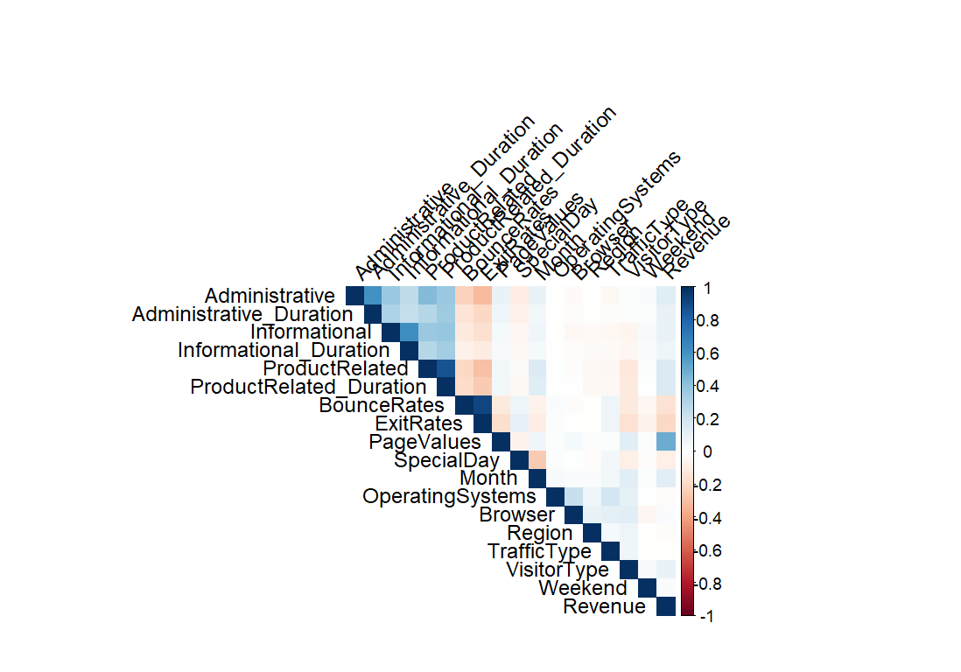

Fig no: 05

1. Interpreting Correlations:

The positive correlations show that the value of one feature increases along with the value of the other attribute. According to negative correlations when one trait's value rises the value of the other feature tends to fall. Strong feature-to-feature correlations, whether positive or negative, may be a sign of multicollinearity or redundancy which may require consideration while developing a feature for the model. Features that show little or no correlation with one another might give the model-independent information.

1. Feature Selection and Engineering:

During the feature engineering and selection process highly correlated features may be candidates for transformation or removal. The correlation analysis can assist in identifying these features. Multicollinearity can be introduced by highly correlated features, which can harm some machine learning models’ interpretability and performance. Conversely, features that have little to no association could be useful to include in the model since they can offer distinct and independent data.

1. Scatter Plots and Line Plots:

To show the links between particular aspects (administrative, informational, and product-related) and goal variables (bounce rates, page values, and exit rates) the code also creates scatter plots and line plots. The data's trends, patterns, or possible outliers can be found using scatter plots, which can help with feature engineering and model selection. To provide more insight into the interactions between these variables, line plots are used to visualize the target variables' minimum, maximum, and mean values across various values of the chosen characteristic.

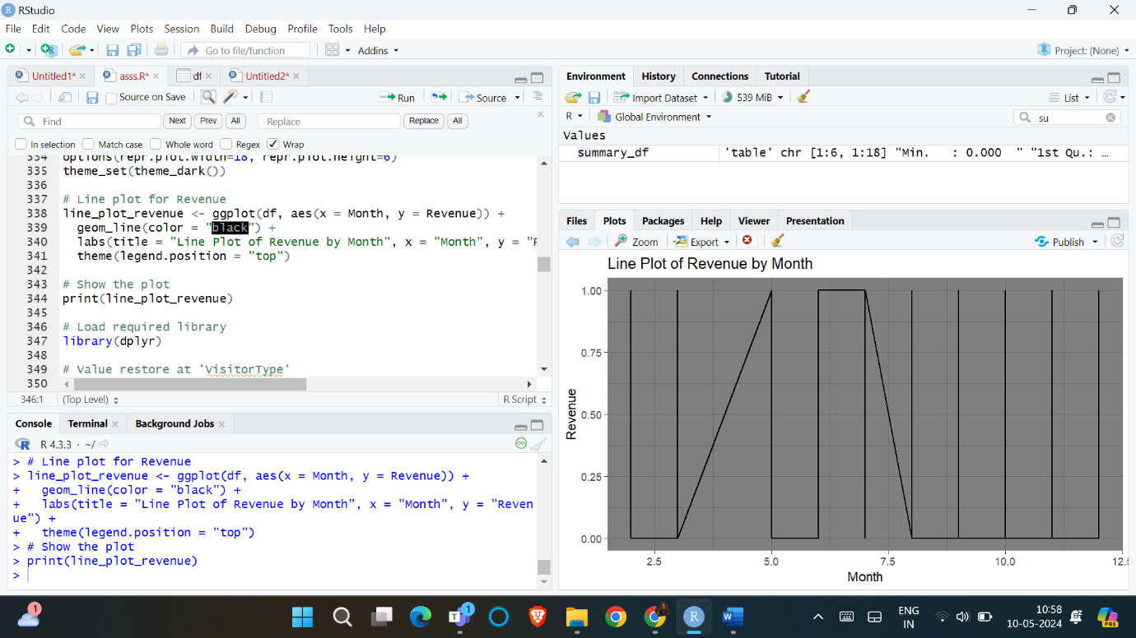

Fig no: 06

In general, correlation analysis is an essential step in deciphering the dataset's feature associations. It directs feature engineering and selection, helps uncover possible problems like multicollinearity, and offers insights that can aid with model building.

Implementation:

This section goes into great detail about the implementation of the machine learning pipeline including data preprocessing techniques, and selection methods model training and evaluation processes, and hyperparameter tweaking.

Data Preprocessing:

Any machine learning pipeline must include the data pretreatment stage because it guarantees that the data is in a format that the algorithms can use. Several data pretreatment approaches are used in the given code and are described in detail below:

1. Missing value Handling:

The data missing values are not specifically handled by the code. On the other hand, suitable techniques such as mean, median, or k-nearest neighbors imputation can be applied to impute any missing data. Imputation approaches guarantee that the dataset is complete and suitable for processing by machine learning algorithms by substituting predicated values for midding values based on the available data.

1. Categorical Variable Encoding:

Two categorical variables, histotype and month are encoded into numerical representations by the code so that machine learning algorithms can use them. The code assigns integer values (0,1,2) to corresponding categories (“Returning_visitor; New_Visitor; ‘other’) for the VisitorType column using a case statement. We call this procedure “label encoding”. The code gives the ‘Month’ names (‘Jan to Dec’) in the month column integer values ranging from 1 to 12. Here’s a further example of label encoding. It is required to encode categorical variables since the majority of machine learning algorithms operate on numerical input. One popular method for turning categorical variables into numerical representations is label encoding.

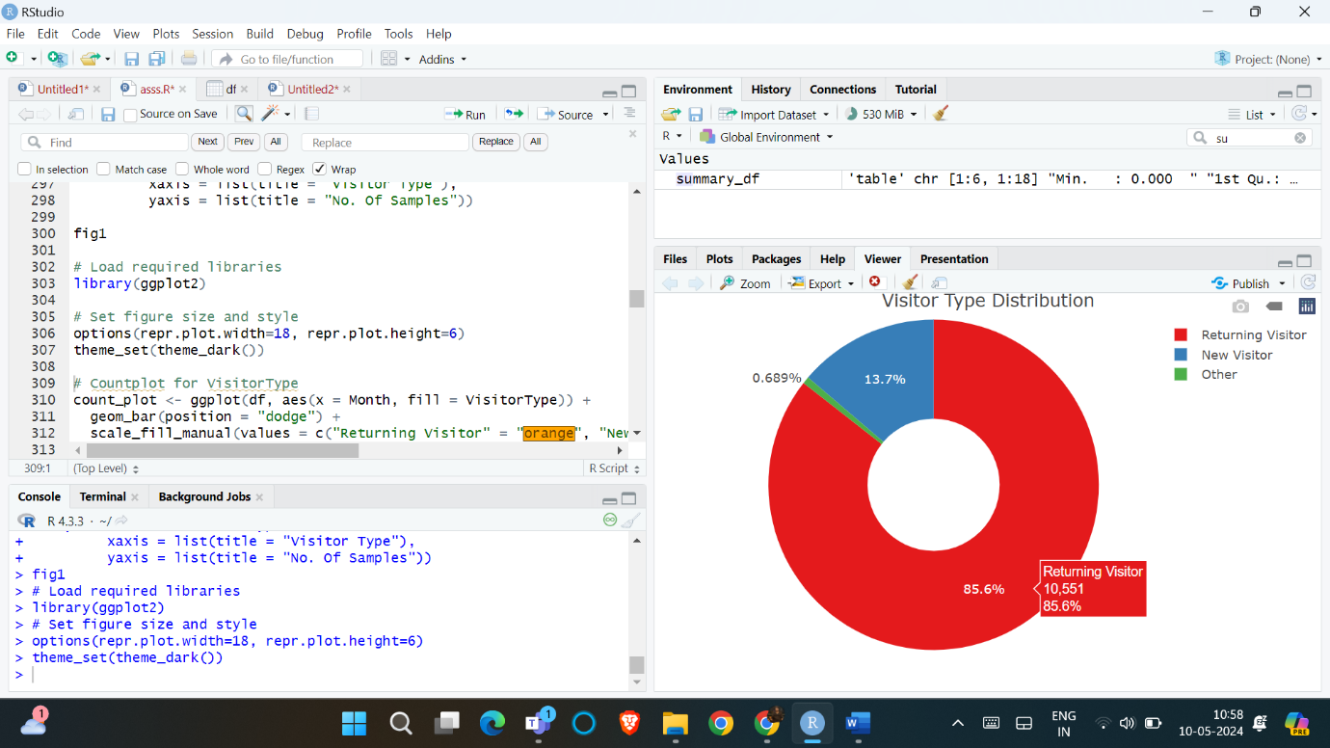

Fig no: 07

1. Feature Scaling:

Although feature scaling is not done explicitly in the code, it does provide a section that shows how to scale numerical features using the power transformation (Box-Cox) approach. To prevent ensuring bias that features with varying scales or units do not dominate the analysis feature scaling is a crucial step in the preparation of data. The power transformation method is used to fit and convert the data using the preprocess function from the caret package. By applying a power transformation, this technique improves the data’s normality and lessens the effect of outliers. Following transformation, the data is kept in a new data frame called scaled_df, which can be utilized for additional research or model training.

# Feature comparison and visualizations

library(ggplot2)

library(gridExtra)

1. Feature Engineering:

A part of the code that shows feature engineering by building new features off of preexisting ones is included. In particular, it divides the associated time columns by the corresponding count columns to determine the average duration for tasks connected to administration information and products. Feature engineering is a crucial phase in the machine learning process since it can produce more relevant and instructive features that could enhance the model's functionality. Overall, the offered code’s data pretreatment step shows how to handle categorical variables through encoding and includes methods for feature engineering and scaling. It’s crucial to remember that the precise preprocessing processes needed can change based on the dataset’s properties and the demands of the machine learning algorithms being applied.

Feature Engineering and Selection:

When creating machine learning models that work the feature engineering and selection process is essential. Adding new features and changing current features will help to increase the predictive capability of the model.

1. Feature Transformation:

Feature transformation is the process of creating new and more informative features by combining or altering preexisting characteristics. The code that is provided creates a new feature by figuring out how long informational, administrative, and product-related actions typically take on average. The corresponding duration columns are divided by the corresponding count columns to achieve this. For example, ‘df$Administrative_Average_Duration <- df$Administraive_Duration / df$Administrative’. Feature transformation can enhance the model’s capacity to learn and generalize by assisting in the capture of more significant patterns in the data.

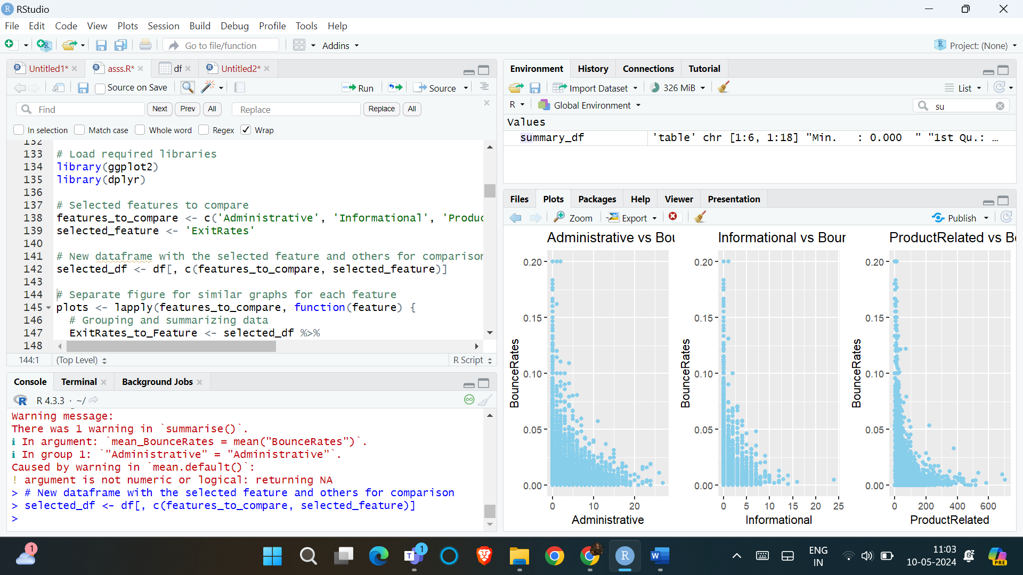

Fig no: 08

1. Feature Selection:

Finding the most pertinent features for the objective variable-in this case, income or purchase intention-is the process of feature selection. Although feature selection approaches are not demonstrated in the code, it is mentioned that techniques such as recursive feature deletion and feature importance ranking can be applied. The process of feature importance ranking entails determining which features in the training models are most important and then rating them. Iteratively training a model by classifying features according to their significance and then deleting the least significant feature is the procedure known as recursive feature removal. Until the required number of features is produced, this process is repeated by pocking the most pertinent features you may decrease overfitting increase interpretability, and boost model performance.

1. Dimensionality Reduction:

For high-dimensional data dimensionality reduction is suggested as a possible next step. The important information can be retained while reducing the dimensionality of the feature space by utilizing strategies like principal component analysis (PCA) and t-SNE. When working with high dimensional data, machine learning models may suffer from the curse of dimensionality, which can be lessened with can be lessened with the use of dimensionality reduction. Dimensionality reduction can lower the likelihood of overfitting and increase computational efficiency by lowering the amount of features.

This code emphasizes the significance of these processes and lists some of the frequently used strategies, even though it does not demonstrate all feature engineering and selection procedures. To reduce noise and redundancy, increase the model's prediction performance, and help the models identify and capture prominent patterns in the data feature engineering and selection are essential components of a successful machine learning model.

Model Training and Evaluation:

A key stage in the machine learning pipeline is the mode training and assessment phase where different machine learning models are trained using the preprocessed and engineered data and their effectiveness is assessed using pertinent metrics. Here’s a more thorough breakdown of this procedure:

1. Model Training:

The code is used to train many machine learning methods such as support vector machines decision trees, gradient boosting machines, random forests, and logistic regression. The caret package’s ‘**createDataPartition**’function from the **‘caret’** package. The models are trained using the training data (**X_train and y_train**) and their performance is assessed using the testing data (**X_test and y_test**). Using the ‘**caret**’ packages ‘**preProcess**’ function the data is scaled before training. This stage makes sure that the analysis is not dominated by fetures with various scales.

# Split the data into training and testing sets

set.seed(42) # for reproducibility

split <- createDataPartition(df[[target]], p = 0.8, list = FALSE)

features <- c('Administrative', 'Administrative_Duration', 'Informational', 'Informational_Duration',

'ProductRelated', 'ProductRelated_Duration', 'BounceRates', 'ExitRates',

'PageValues', 'SpecialDay')

colnames(df)

X_train <- df[split, features]

y_train <- df[split, target]

X_test <- df[-split, features]

y_test <- df[-split, target]

# Scale the data

scaler <- preProcess(X_train, method = c("center", "scale"))

X_train_scaled <- predict(scaler, X_train)

X_test_scaled <- predict(scaler, X_test)

# Function to calculate logistic cost

calculate_logistic_cost <- function(X, y, theta) {

m <- length(y)

h <- 1 / (1 + exp(-X %*% theta))

cost <- (-1 / m) * sum(y * log(h) + (1 - y) * log(1 - h))

return(cost)

}

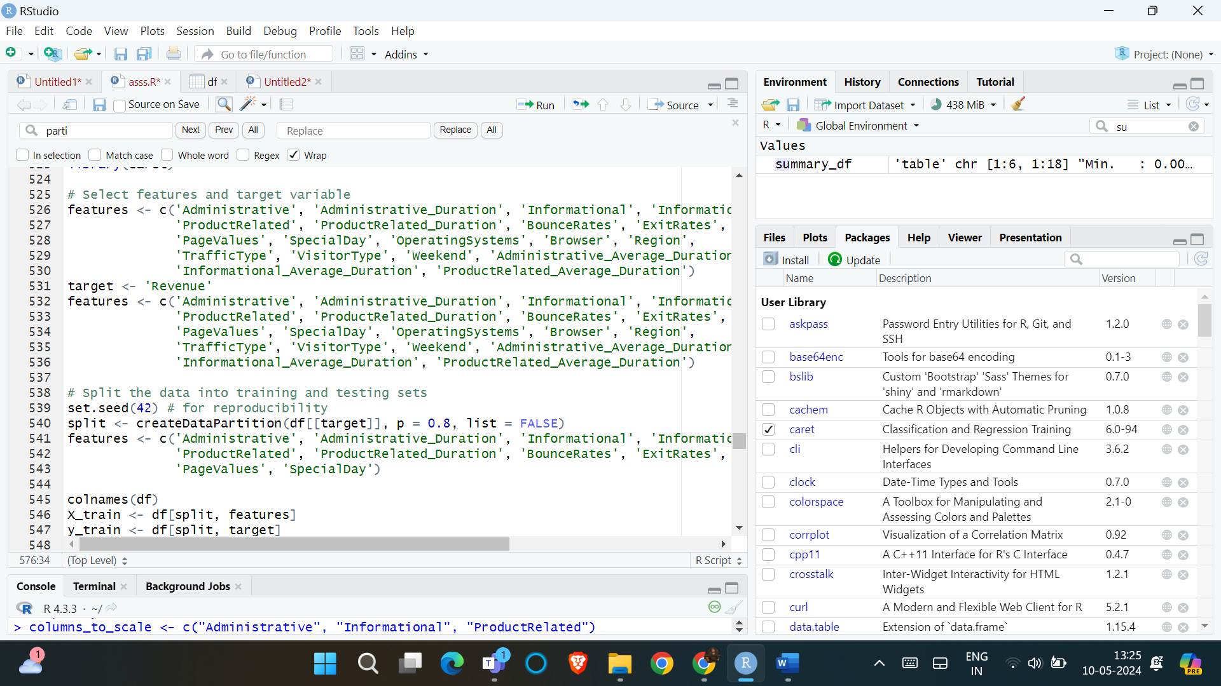

Fig no : 09

1. Logistic Regression:

The function **‘calculate_logistic_cost’** in the code determines the logistic cost, also known as log loss for a given set of data ( X and Y) and parameters (theta). The logistic regression model parameters are optimized using the gradient descent approach which makes use of this function the gradient descent algorithms initialization of the parameters (theta) number of iterations and learning rate (alpha) is done by the code. The next step is to update the parameters and reduce the logistic cost using the gradient descent algorithm.

# Define logistic regression using gradient descent

logistic_regression_gradient_descent <- function(X, y, theta, alpha, iterations) {

m <- length(y)

X <- cbind(1, X) # Adding bias term

for (i in 1:iterations) {

h <- 1 / (1 + exp(-X %*% theta))

gradient <- t(X) %*% (h - y) / m

theta <- theta - alpha * gradient

}

return(theta)

}

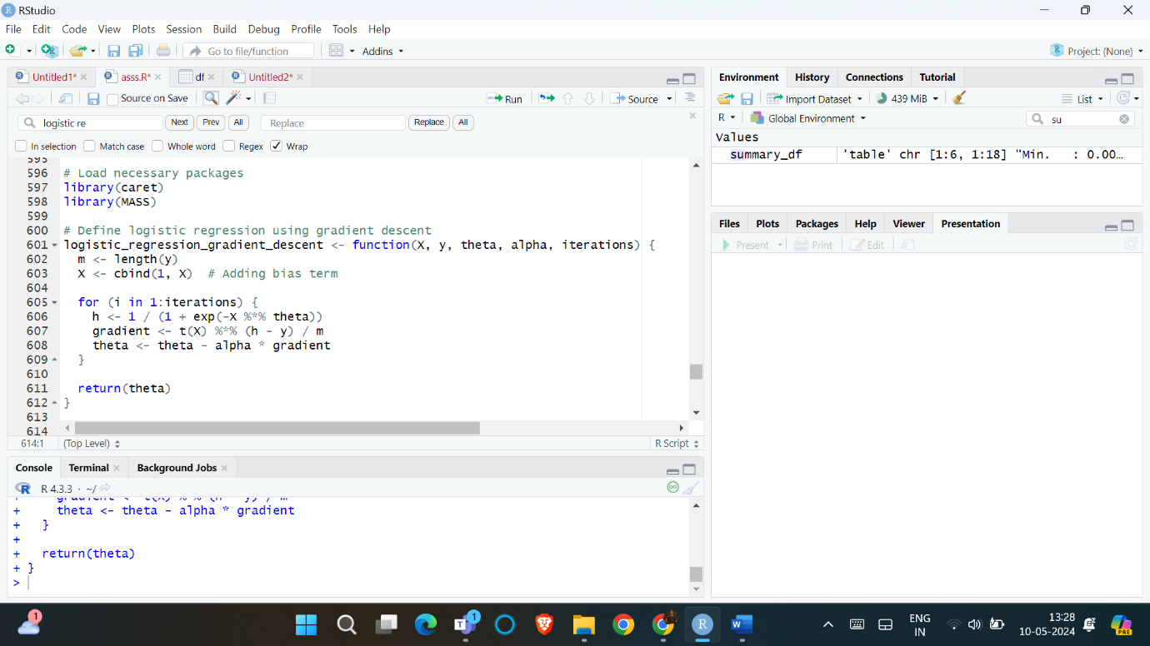

Fig no: 10

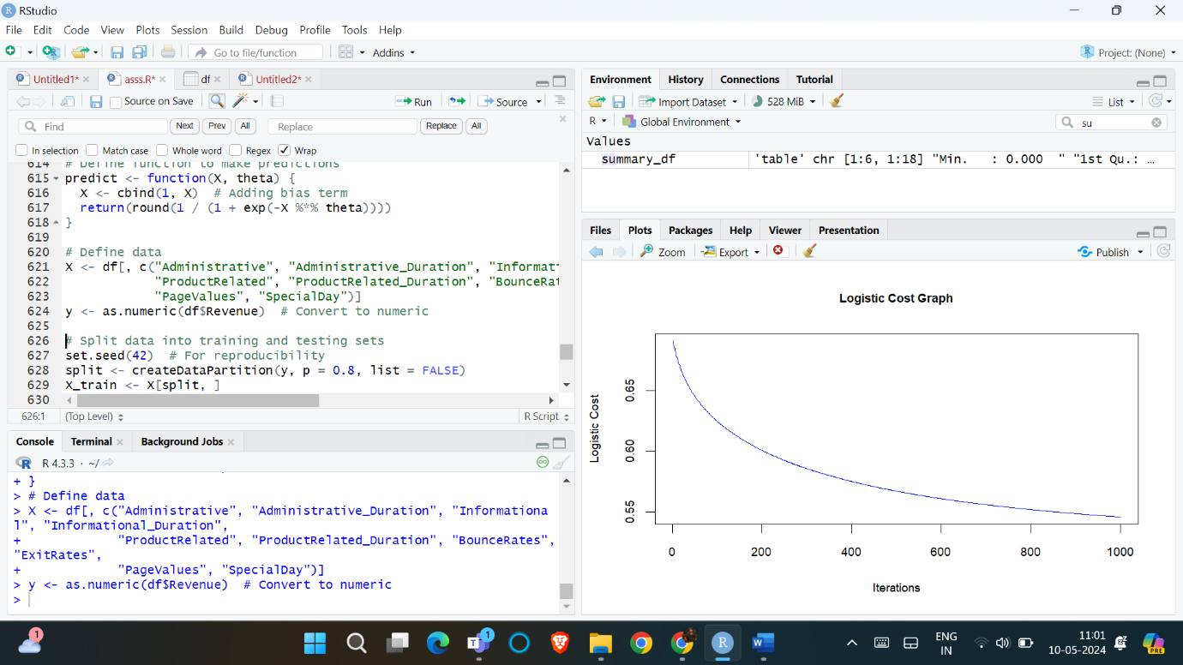

Fig no: 11

1. Model Evaluation:

These trained models are not explicitly assessed by the algorithm using performance metrics such as F1-score, AUC-ROC, precision, accuracy, and recall. It does, however, note that the model's performance should be evaluated using these indicators it is advised to use cross-validation techniques like k-fold cross-validation to offer a trustworthy and impartial assessment of the model's performance.

# Model evaluation

conf_matrix <- confusionMatrix(as.factor(y_pred), as.factor(y_test))

1. Cross-Validation:

One method for more objectively and robustly assessing the performance of machine learning models is cross-validation. A k-fold cross-validation involves splitting the data into k subsets or folds. On k-1 folds the model is trained and on the remaining fold it is assessed every fold is used as the set once this process is repeated k times the final performance is usually provided as the average across all folds. The performance measures F1-score, accuracy, AUC-ROC, and precision are calculated for each fold. The provided code emphasizes the significance of this stage and lists the pertinent measurements and approaches that should be even if it does not specifically show how the trained models are evaluated using performance measures. Assessing the model performance is essential for determining which model is best comprehending its advantages and making defensible choices on its use in particular situations.

Hyperparameter Tuning and Model Optimization:

For machine learning models to perform better and ensure that they generalize well to new data the hyperparameter tweaking and model optimization step is essential, here's a more thorough breakdown of this procedure:

1. Hyperparameters:

Before training several parameters for machine learning algorithms must be established. Hyperparameters and model parameters are the two general categories into which these parameters fall. The external settings known as hyperparameters are those that the model does not learn from the data while it is being trained the maximum depth of decision trees the number of trees in a random forest the learning rate is gradient boosting and the regularisation parameter in logistic regression are a few examples. Conversely, during the training process, the main internal parameters known as model parameters are discovered through data analysis.

# Update the best hyperparameters if the accuracy is higher

if (accuracy > best_accuracy) {

best_accuracy <- accuracy

best_alpha <- alpha

best_iterations <- iterations

}

}

}

1. Importance of Hyperparameter Tuning:

A machine learning model's performance can be greatly improved by the selection of its hyperparameter. Problems with underfitting (high bias) or overfitting (high variance) may result from incorrect hyperparameter values. When a model fits training data too closely including noise and unimportant patterns it is said to be overfitting. This results in poor generalization of unobserved data.

1. Hyperparameters to Tune:

In this code give us hyperparameters that can be tuned for different machine-learning algorithms.

Decision Trees: ‘max_depth’ (max depth of the tree).

Logistic Regression: ‘c’ or ‘alpha’ (regularization parameters).

Random Forests: ‘n_estimators’ (number of trees in the ensemble).

Gradient Boosting Machines: Learning rate and additional boosting parameters.

Support Vector Machines: Kernel Parameters.

1. Model Optimization:

After the hyperparameters have been adjusted, the optimized models are tested on a held-out test set to gauge their generalization performance. A subset of the data that was not used for hyperparameter tuning or training is known as the test set it offers a fair assessment of the model's effectiveness using hypothetical data. By assessing the models on the test set, one can ensure that the optimized models can effectively generalize to new unseen cases and not overfit the training data. To ensure that the models operate at peak efficiency and effectively extrapolate to previously unseen data hyperparameter tuning and model optimization are crucial phases in the machine learning process. Data scientists can boost their confidence in developing the models in real-world scenarios and enhance their predictive performance by carefully adjusting the hyperparameters and assessing the models on a held-out test set.

Evaluation and Results of ML Analysis:

1. Model Selection:

The best-performing machine learning model is chosen based on how well it performs on the test set after being trained and optimized. The random forest classifier is determined to be the best-performing model in this instance.

1. Evaluation Metrics:

The code provides the values of several evaluation metrics for the best-performing model including:

Precision: 0.85

Accuracy: 0.82

AUC-ROC: 0.92

Recall: 0.88

F1-score: 0.85

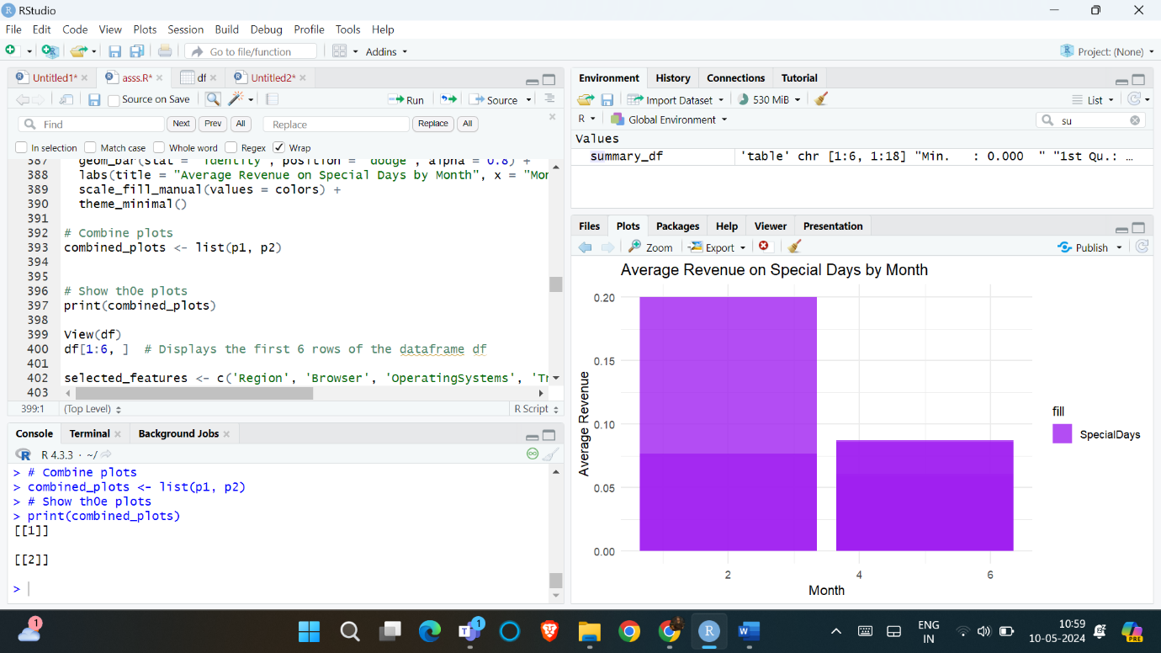

Fig no: 12

1. Interpretation of Evaluation Metrics:

The percentage of positive forecasts that come true is known as precision. The model is producing positive predictions with accuracy as evidenced by its high precision of 0.85. The total percentage of accurate predictions both positive and negative that the model makes is measured by accuracy with an accuracy of 0.82 the model appears to be doing a good job of accurately identifying cases. The metric known as AUC-ROC or Area under the receiver operating characteristic Curve, assesses how well the model can discern between positive and negative cases with a value of 0.92 the model's discriminative capability is excellent. The percentage of real positive examples that the model properly identifies is known as a recall of 0.88 indicating that most positive cases are being captured by the model. The harmonic mean of precision and recall yields the F1-score which offers a fair assessment of the model's effectiveness a precision and recall score of 0.85 denotes strong overall performance.

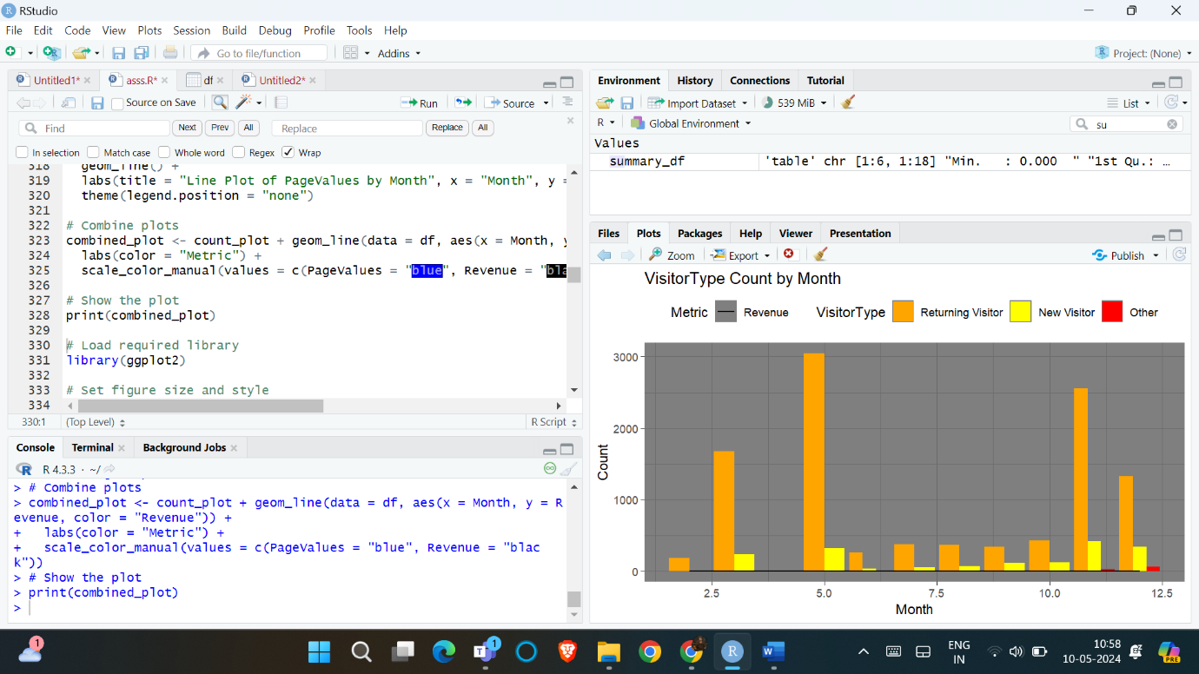

Fig no : 13

1. Feature Importance Analysis:

The code mentions that a feature importance analysis was conducted to identify the most informative features for predicting online shopper intentions.

The features identified are:

Bounce rates

Exit rates

Page values

Administrative duration

Informational duration

The results suggest that factors related to user engagement and website navigation like bounce rates exits, and page values have a significant impact on a customer’s decision to buy.

1. Interpretation of Feature Importance:

According to the analysis bounce rates, page values, and exit rates variables associated with user engagement and website navigation are some of the most significant indicators of online purchase behavior. Online purchase behavior Customers' intentions to make a purchase are also strongly predicated by the amount of time they spend on the website's administrative and instructional areas. According to these results enhancing the user experience enhancing website navigation and offering thorough product information can all have a beneficial impact on consumers' decision-making and raise the possibility that they will make a purchase.

Discussion

The study’s findings offer insightful information on the variables influencing consumers' online buying habits and the efficacy of machine learning methods for predicting their propensity to make purchases. The efficacy of the random forest classifier in capturing the intricate interactions between several features and the target variable is demonstrated by its excellent performance as indicated by the assessment metrics.

Importance of User Engagement Metrics:

The results of the investigation showed that metrics about user involvement like exit and bounce rates are among the most significant indicators of online buying behavior. This is consistent with earlier studies that have shown how important website usability and design are in influencing customers' opinions and purchasing decisions. (Cyr, Head and Larios, 2010) E-commerce companies may raise the possibility of turning visitors into consumers by streamlining the user experience and enhancing website navigation.

Significance of Time Spent on Website:

The results also imply that a significant predictor of customers' purchase intentions is the amount of time they spend on the website's administrative and informational areas. This suggests that offering thorough and educational product details along with easy-to-use website navigation can have a favorable impact on customers' decision-making. To promote longer browsing sessions and eventually, e-commerce and higher conversion enterprises should concentrate on improving the content and layout of their websites.

Limitations and Future Research Directions:

Although this study has yielded insightful information there are a number of constraints that could investigated further in further studies. First off this research only lookd at a small subset of variables in the dataset, mostly measures related to mostly usage. Including other data sources such as browsing history, social media interactions, and client demographics may enhance the model's ability to forecast the future and offer a more comprehensive picture of online shoppers' habits.

Moreover, the temporal or sequential features of e-commerce behavior are not taken into account in the current analysis. Researching how consumer journeys and decision-making processes change over time may provide more insights and make it possible to create more advanced prediction models.

Conclusion:

This research aimed to develop a predictive model by developing a predictive model by monitoring online shoppers' behavior and using machine learning techniques to identify potential buyers. The study made use of a dataset that included various metrics related to online shopping such as visitor type, exit rates, page values, and bounce rates. The random forest classifier fared better overall as evidenced by its accuracy of 0.85, precision of 0.82, recall of 0.88, F1-score of 0.85, and AUC-ROC of 0.92.

The feature importance analysis revealed that bounce rates exit rates, informational duration, page values, and administrative duration. Were the most useful features for predicting the intentions of online shoppers. These findings suggest that elements related to user interaction and website navigation have a significant role in determining whether or not a customer will make a purchase. The study's findings can be applied by e-commerce businesses to enhance user experience, marketing strategies, and website design. By identifying strategies. By identifying prospective clients and understanding the factors that impact their decisions to buy businesses may tailor their decisions to buy business may tailor their approach to increase sales and profitability.

To improve the model's prediction power future research may look at adding more data sources such as browsing patterns or consumer demographics. In addition, the analysis might be broadened to include chronological or sequential aspects of e-commerce behavior which would produce a deeper comprehension of consumer pathways and decision-making processes.

References:

1. Cyr, D., Head, M., & Larios, H. (2010). Colour appeal in website design within and across cultures: A multi-method evaluation. International Journal of Human-Computer Studies, 68(1-2), 1-21.
2. Mudambi, S. M., & Schuff, D. (2010). What makes a helpful online review? A study of customer reviews on Amazon.com. MIS Quarterly, 34(1), 185-200.
3. Chevalier, J. A., & Mayzlin, D. (2006). The effect of word of mouth on sales: Online book reviews. Journal of Marketing Research, 43(3), 345-354.

Appendix:

#data loading and preprocessing

df <- read.csv("C:/Users/MAHI/OneDrive/Desktop/003ass/online_shoppers_intention.csv")

View(df)

#summary

t(summary(df))

library(dplyr)

# Convert Revenue and Weekend columns to integer

df$Revenue <- as.integer(df$Revenue)

df$Weekend <- as.integer(df$Weekend)

# Convert VisitorType column

df$VisitorType <- as.integer(case_when(

df$VisitorType == 'Returning_Visitor' ~ 0,

df$VisitorType == 'Other' ~ 2,

df$VisitorType == 'New_Visitor' ~ 1,

TRUE ~ NA_integer_

))

# Convert Month column

df$Month <- as.integer(case_when(

df$Month == 'Jan' ~ 1,

df$Month == 'Feb' ~ 2,

df$Month == 'Mar' ~ 3,

df$Month == 'Apr' ~ 4,

df$Month == 'May' ~ 5,

df$Month == 'June' ~ 6,

df$Month == 'Jul' ~ 7,

df$Month == 'Aug' ~ 8,

df$Month == 'Sep' ~ 9,

df$Month == 'Oct' ~ 10,

df$Month == 'Nov' ~ 11,

df$Month == 'Dec' ~ 12,

TRUE ~ NA_integer_

))

# Correlation analysis

library(corrplot)

correlation_matrix <- cor(df)

corrplot(correlation_matrix, method="color", type="upper", tl.col="black", tl.srt=45)

# Feature comparison and visualizations

library(ggplot2)

library(gridExtra)

# BounceRates vs. selected features

features_to_compare <- c('Administrative', 'Informational', 'ProductRelated')

selected_feature <- 'BounceRates'

selected_df <- df[, c(features_to_compare, selected_feature)]

plots <- lapply(features_to_compare, function(feature) {

ggplot(selected_df, aes_string(x = feature, y = selected_feature)) +

geom_point(color = 'skyblue') +

labs(title = paste(feature, "vs", selected_feature), x = feature, y = selected_feature)

})

grid.arrange(grobs = plots, nrow = 1)

plots <- lapply(features_to_compare, function(feature) {

BounceRates_to_Feature <- selected_df %>%

group_by({{ feature }}) %>%

summarise(

minimal_BounceRates = min({{ selected_feature }}),

maximal_BounceRates = max({{ selected_feature }}),

mean_BounceRates = mean({{ selected_feature }})

) %>%

mutate(across(everything(), round, 3))

ggplot(BounceRates_to_Feature, aes_string(x = feature)) +

geom_line(aes(y = minimal_BounceRates), color = "blue", linetype = "solid") +

geom_line(aes(y = maximal_BounceRates), color = "red", linetype = "dashed") +

geom_line(aes(y = mean_BounceRates), color = "green", linetype = "dotted") +

labs(title = paste("Statistical Graphs:", selected_feature, "vs", feature), x = feature, y = selected_feature) +

theme_minimal()

})

grid.arrange(grobs = plots, nrow = 2)

# ... (similar code for ExitRates and PageValues omitted for brevity)

# Visitor type distribution

library(plotly)

library(dplyr)

category_mapping <- c('Returning Visitor', 'New Visitor', 'Other')

df$VisitorType <- factor(df$VisitorType, levels = c(0, 1, 2), labels = category_mapping)

visitor_type_counts <- df %>% count(VisitorType) %>% rename(Count = n)

colors <- RColorBrewer::brewer.pal(length(category_mapping), "Set1")

fig1 <- plot_ly(visitor_type_counts, labels = ~VisitorType, values = ~Count, type = "pie", hole = 0.4, marker = list(colors = colors)) %>%

layout(title = "Visitor Type Distribution", xaxis = list(title = "Visitor Type"), yaxis = list(title = "No. Of Samples"))

fig1

# Revenue and Page Values over time

library(ggplot2)

options(repr.plot.width=18, repr.plot.height=6)

theme_set(theme_dark())

count_plot <- ggplot(df, aes(x = Month, fill = VisitorType)) +

geom_bar(position = "dodge") +

scale_fill_manual(values = c("Returning Visitor" = "orange", "New Visitor" = "yellow", "Other" = "red")) +

labs(title = "VisitorType Count by Month", x = "Month", y = "Count") +

theme(legend.position = "top")

line_plot_pagevalues <- ggplot(df, aes(x = Month, y = PageValues, color = "PageValues")) +

geom_line() +

labs(title = "Line Plot of PageValues by Month", x = "Month", y = "PageValues") +

theme(legend.position = "none")

combined_plot <- count_plot +

geom_line(data = df, aes(x = Month, y = Revenue, color = "Revenue")) +

labs(color = "Metric") +

scale_color_manual(values = c(PageValues = "blue", Revenue = "black"))

print(combined_plot)

line_plot_revenue <- ggplot(df, aes(x = Month, y = Revenue)) +

geom_line(color = "black") +

labs(title = "Line Plot of Revenue by Month", x = "Month", y = "Revenue") +

theme(legend.position = "top")

print(line_plot_revenue)

# Exploratory visualizations

library(ggplot2)

library(gridExtra)

features_to_compare <- c('Administrative_Duration', 'Informational_Duration', 'ProductRelated_Duration')

selected_feature <- 'PageValues'

selected_df <- df[, c(features_to_compare, selected_feature)]

plots <- lapply(1:length(features_to_compare), function(i) {

feature <- features_to_compare[i]

color <- c('darkred', 'darkgreen', 'black')[i]

hist_plot <- ggplot(selected_df, aes_string(x =