Vactrack
Functionality Description Document

This document is a property of Mindfire Solutions and contains some confidential information and hence no part of this document should be distributed or copied elsewhere without permission of PL/TL/AL. This document is for internal purpose only.

Change Log
# | Description | Author | Date
1 | Document Creation for e-retail | Mahesh Gupta | 29/09/21
2
3
4

Table of Contents
1. Overview 4
2. Features 5
3. Feature 1: 6
4. Feature 2: 7

1. Overview
This application wants to provide an 'Online Products buying/selling solution' for various categories of organizations and service providers. The application will be developed as per current market trends. 'E-Retail'(application) is an e-commerce platform where users can buy different products easily. It helps the users to search, select and order different products without any hassle.

There will be three categories of users:
- Administrator: Responsible for user management, product definition, adding & modifying products.
- Registered User: Can view the catalog and can buy products after making payments as per the available online payment options.
- Guest User: Can view the catalog. Guest users can become registered users by submitting their details through an online registration form for free of cost.

The milestones are mentioned below which the team(Mindfire Solutions) is planning to achieve within 2 weeks.
Milestone 1 (1 week):
- Designing the application API modules.
- Developing the decoupled APIs and opening the endpoint.
- Testing the APIs for processing information by different user types.

Milestone 2 (1 week):
- Designing the website UI.
- Developing the UI for different environments and devices.
- Integrating the APIs with the UI for displaying data.
- Testing the UI/UX on different devices and a single source of truth for data.

2. Features
The platform will provide a search bar for easy lookup. The products are shown in the tabular form on the homepage. The platform aims to be used by the customers for placing orders of daily essential items. Users can add products to the cart without signing in. Users can include the out-of-stock items while searching for products but cannot add them to the cart. A category drop-down will also be provided to filter out the product categories. In the cart, users can increase or decrease the product quantity which they intend to order. The minimum quantity is one, if the quantity is less than 1, the product will be removed from the cart. There is no upper limit, If the quantity exceeds the available stock, the place order button will be disabled. Users can remove the available items from the cart using the remove button. While checkout, if the user is not signed in, they will be redirected to the sign-in page. A user can create a new account from the sign-up page. The login and sign-up page links will be available in the profile menu which will be located at the top right corner in the application bar. After signing in, the profile icon changes to the user Initials, and the menu option will contain a logout link. The payment options will be provided by a third party (Braintree by Paypal). Users can add and save their card details while checkout. After placing the order, it can be viewed in the 'My Orders' section present in the top left menu. All other previous purchases made by the user will also be visible under the same section. (See Appendix A for system mock up)

3. Feature 1:
Product Catalog with searching and filtering option
One of the important features which are needed is a Product Catalog. The product catalog will be displayed in a tabular form with a category selection drop-down placed above the table. The selection in the drop-down will filter the products in the table. The maximum number of rows in the table on a single page will be five. If the product count is more than five, the products will be divided into different pages using pagination. Users can select any page using the page navigator which will be placed at the bottom of the table. The search option will be added in the menu tab bar. When the user starts typing the initials of a product, the products in the catalog will be filtered out dynamically. Both these searching and filtering options will improve the user experience with minimal click count on the screen.

4. Feature 2:
User Sign-in and Sign-up Options
For added security and user privacy, the other important feature required is user sign-up and sign-in. A guest user can scroll through the product catalog, but cannot place the order. A guest user can become a registered/verified user after filling a sign-up form which will be validating the user credentials. After the verification, the user can sign in with the same credentials and can place orders. User can also view their previous orders under the order history tab. A signed-in user will be signed out as soon as they close the website or press the logout button.

Appendix A
Screenshot of mock-ups
1) Login Page
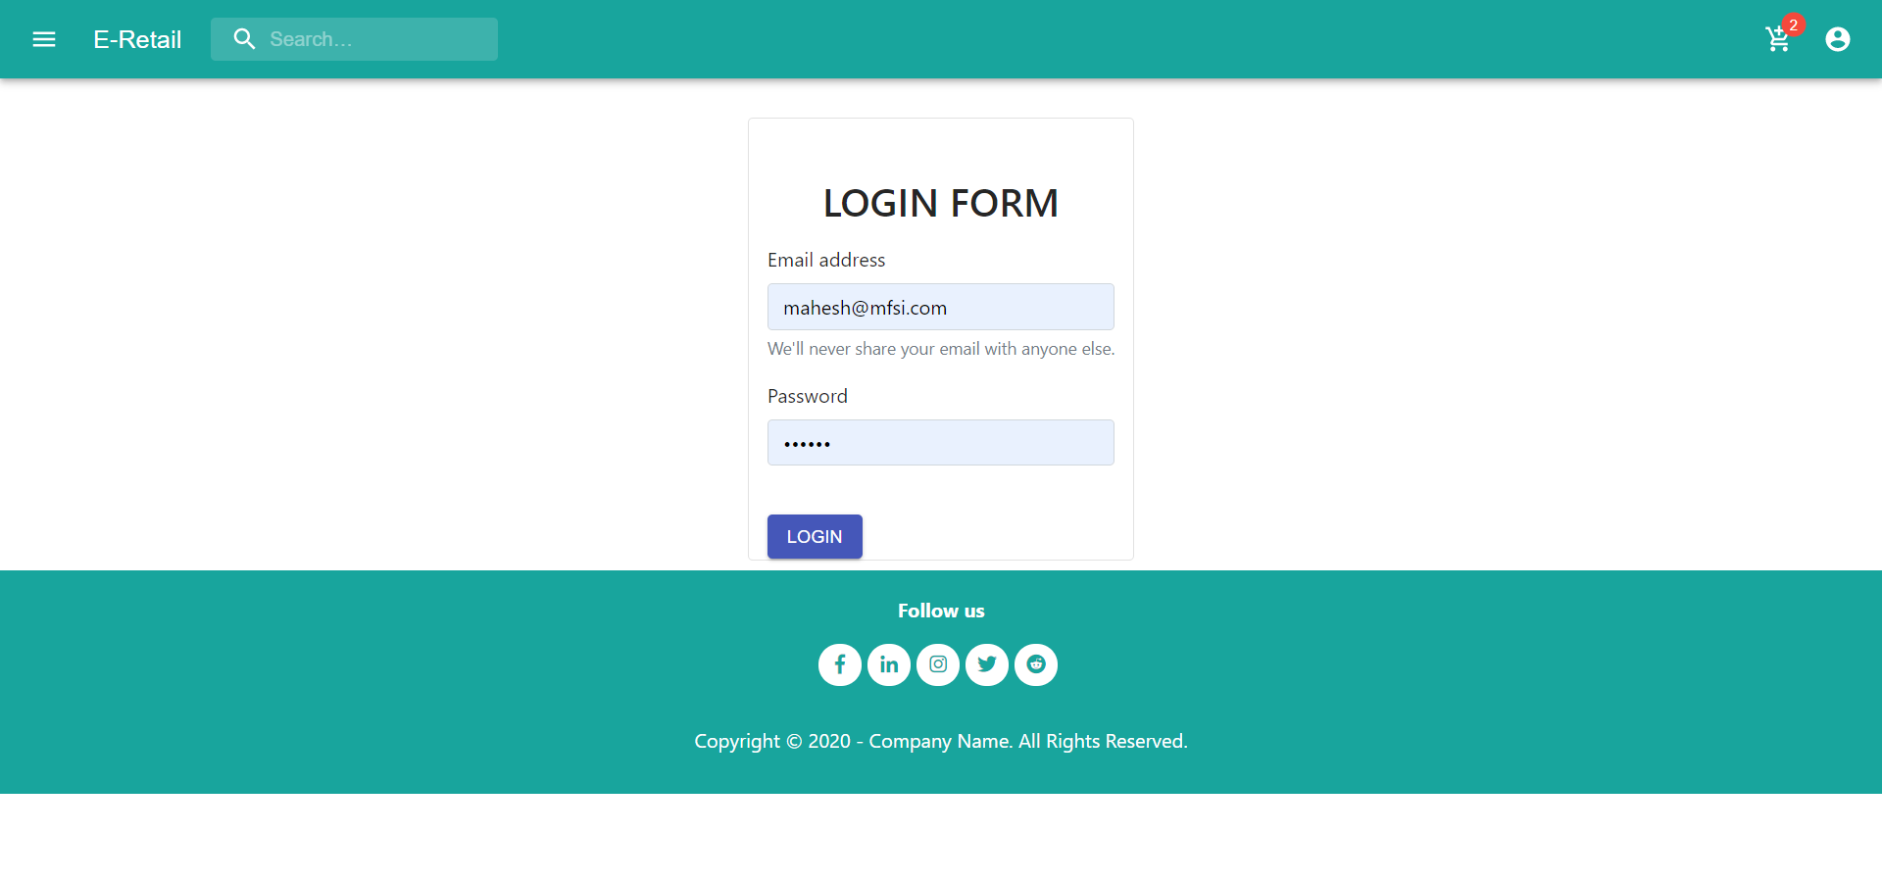
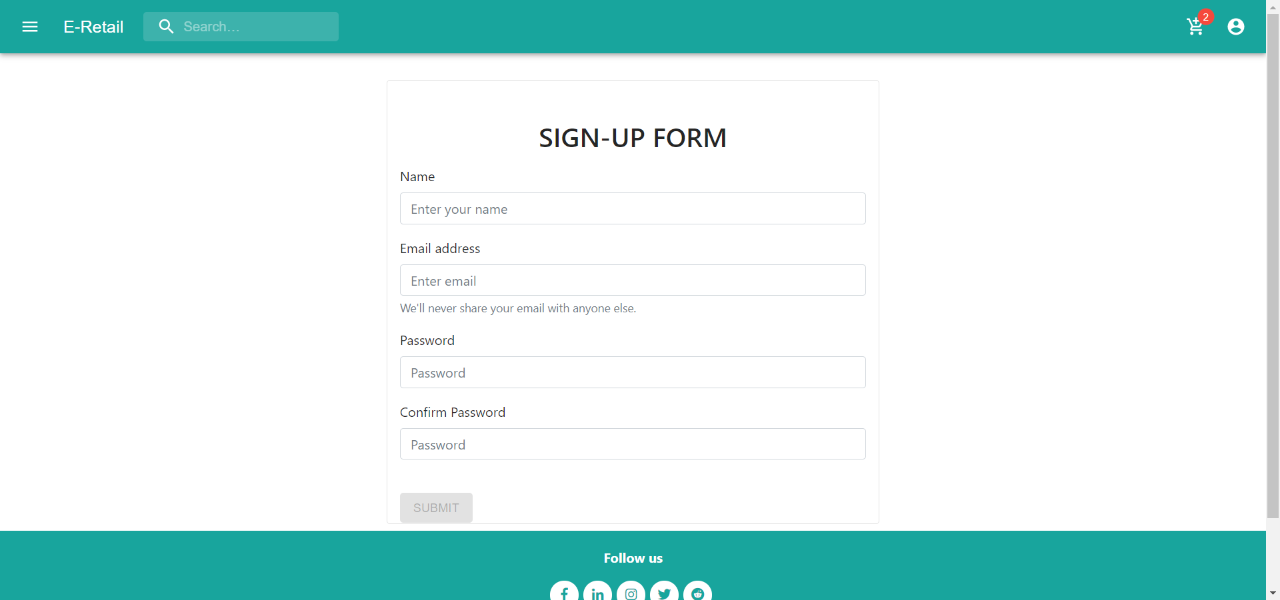
2) Signup Page

3) Product Catalog
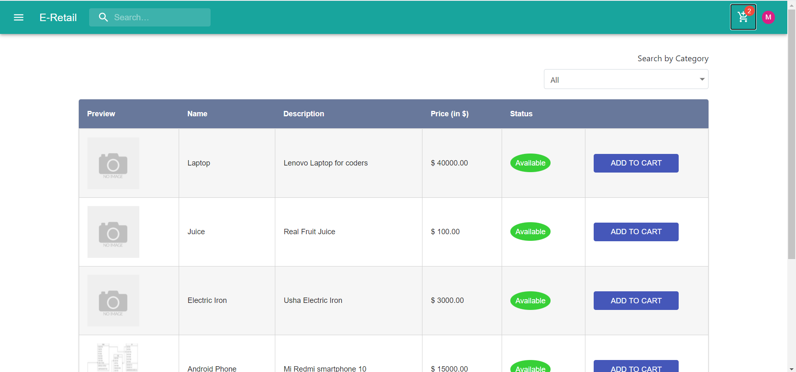
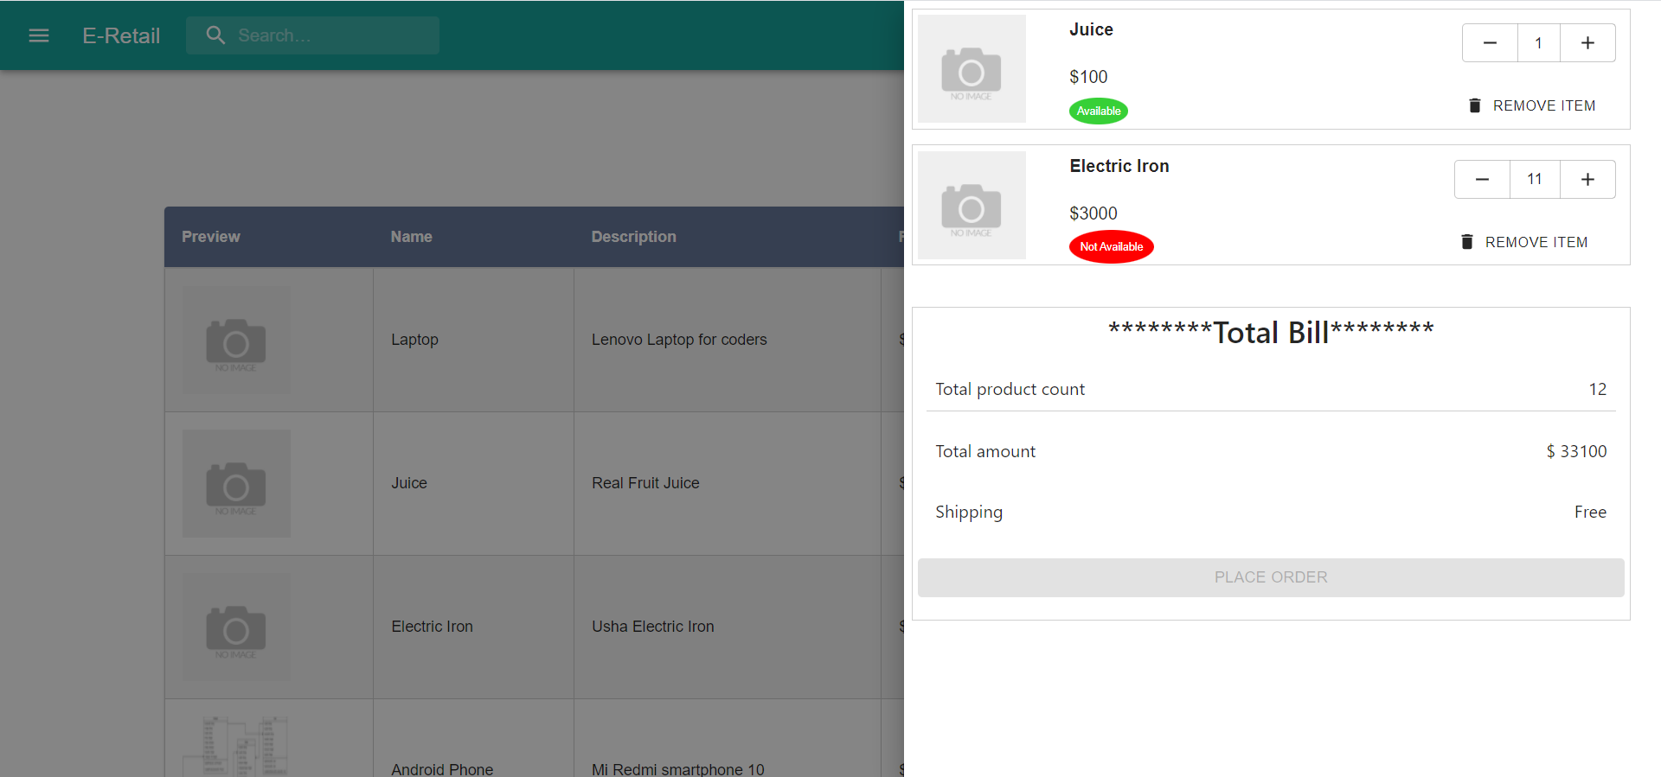
4) Cart

5) Payment Dropin by Braintree
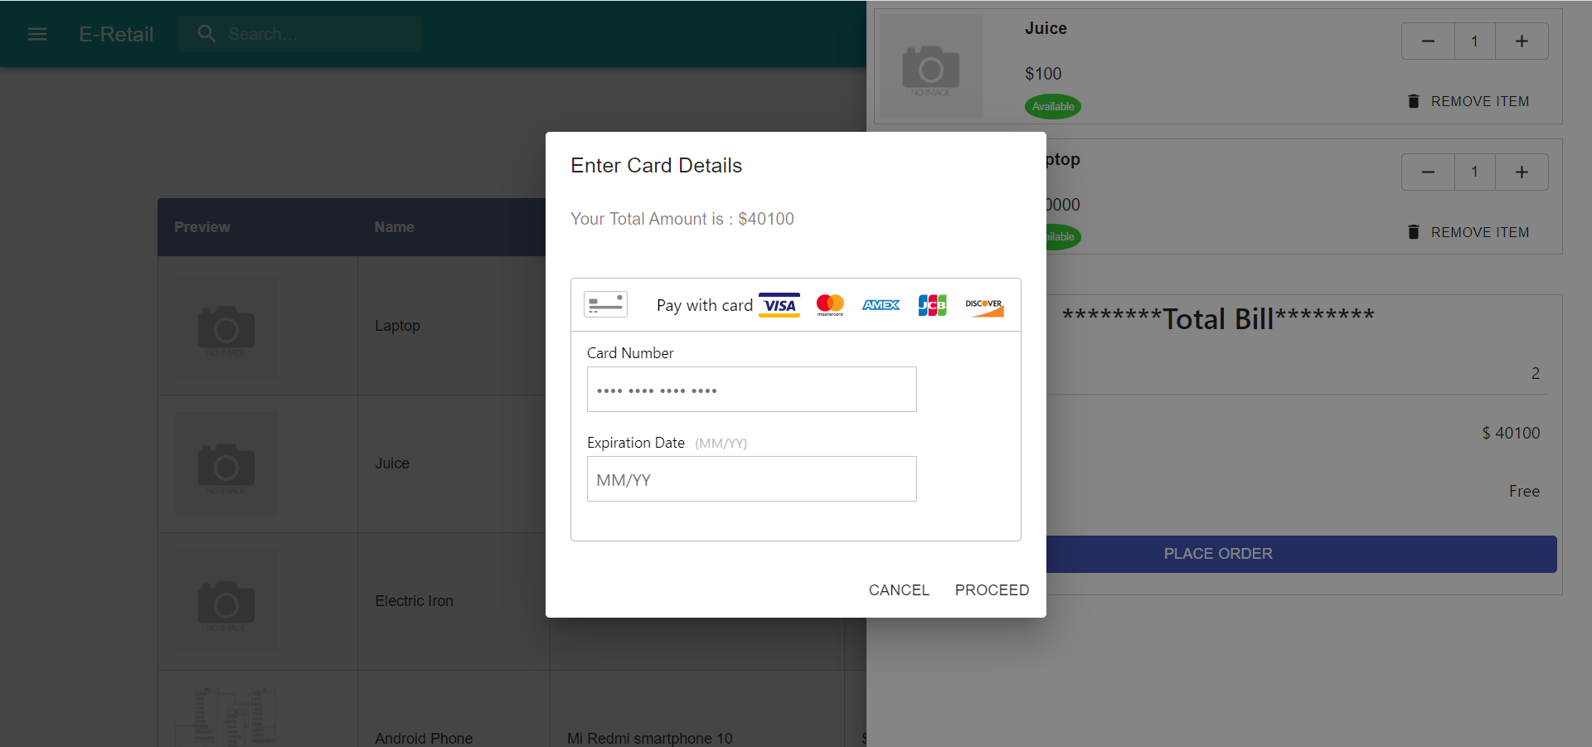
6) Previous Orders
