Enhancement of Job Recommendation
System using Hybrid Filtering

Uma Maheswari Gundapu
Department of Computer Science and Engineering
Bapatla Engineering College
(Autonomous)
(Affiliated to Acharya Nagarjuna University)
Bapatla, India
maheswariu403@gmail.com
Sai Jahnavi Damacharla
Department of Computer Science and Engineering
Bapatla Engineering College
(Autonomous)
(Affiliated to Acharya Nagarjuna University)
Bapatla, India
saijahnavi.damacharla@gmail.com
Hema Latha Ande
Department of Computer Science and Engineering
Bapatla Engineering College
(Autonomous)
(Affiliated to Acharya Nagarjuna University)
Bapatla, India
hemaande.406@gmail.com

Abstract— In today's dynamic job market, efficient job recommendation systems play a crucial role in connecting job seekers with relevant employment opportunities. This project proposes a novel approach to job recommendation leveraging hybrid filtering techniques, which combines collaborative filtering and content-based filtering. Unlike traditional methods that primarily rely on either user behaviour or item attributes, our hybrid model integrates both resume or user data and job descriptions to enhance recommendation accuracy.
The system begins by collecting comprehensive user data, including resume information such as skills, experience, and education. Next, it employs collaborative filtering to analyse user similarities based on their profiles and historical job interactions. Simultaneously, content-based filtering extracts semantic features from job descriptions and aligns them with the user's skill set and preferences. These two approaches are then combined using a weighted hybrid model. The proposed system addresses the limitations of conventional recommendation systems by providing personalized job suggestions that match the user's qualifications, preferences, and career objectives. By integrating user-specific data from resumes with job descriptions, the hybrid filtering approach offers more accurate and diverse recommendations, thereby enhancing user satisfaction and increasing the likelihood of successful job matches.
Keywords—recommendation, collaborative, hybrid, content-based, personalized, suggestions, jobs, similarity

Introduction
In the technologically evolving modern era, it is really hard to find the best suitable job for a candidate’s profile and interests in the outer world’s vast job market. A job recommendation system powered by machine learning holds significant importance in today's dynamic job market. Traditional job search methods often result in information overload for job seekers, making it challenging to find relevant job opportunities that align with their skills, experience, and career goals. In contrast, a machine learning-based job recommendation system can analyze vast amounts of data, including job seeker profiles and job postings, to deliver personalized recommendations tailored to each user's unique preferences and qualifications. By leveraging advanced algorithms and predictive analytics, such a system can not only streamline the job search process for job seekers but also enhance hiring outcomes for employers. Moreover, job recommendation systems have the potential to reduce bias in the hiring process by focusing on objective criteria rather than subjective judgements, thereby promoting diversity and inclusion in the workforce. Overall, the development of a job recommendation system as a machine learning project represents a crucial endeavor in addressing the complexities of modern job searching and hiring, ultimately benefiting both job seekers and employers alike.
As multi-levelled equations, graphics, and tables are not prescribed, although the various table text styles are provided. The formatter will need to create these components, incorporating the applicable criteria that follow.

Literature Review
Pradeep Kumar Singh, Pijush Kanti Dutta Pramanik, Avick Kumar Dey, Prasenjit Choudhury [1] this paper provides a comprehensive study on the RS covering the different recommendation approaches, associated issues, and techniques used for information retrieval.
[2]. This paper gives an overview of increasing data and explains users disadvantages to access useful recommendation information. The paper depicts use of user’s requirements, user’s factors like location, music, shopping into recommendation system for giving possible recommendations.
Ravita Mishra, Sheetal Vikram Rathi [3] explains three types of recommendation algorithms i.e., Collaborative filtering, Content Based filtering, Content Based Filtering and Hybrid Filtering. It explains about various advantages and disadvantages of these algorithms.
Tanya V. Yadalam, Vaishnavi M. Govda, Vandhita Shiva Kumar, Disha Girish [4] explains about different methods such as Natural Language Processing, Cosine Similarity, Content Based Filtering, etc. Here, the paper depicts the use of Natural Language Processing for sentiment analysis on user feedback and also introduces encryption technique to handle data in a more secured manner.
Marwa Hussien Mohamed, Mohamed Helmy Khafagy, Mohamed Hasan Ibrahim [5] explains about Content Based Filtering and Collaborative Filtering. This paper proposed about various methods such as classification of data, cluster analysis, outlier detection, regression analysis, association analysis.
Greg Linden, Brent Smith, Jeremy York [6] gives a brief summary about customer to customer and item to item recommendations for amazon.com
Kunal Shah, Akshaykumar Salunke, Saurabh Dongare, Kisandas Antala [7] presents an overview of the field of recommender systems and describes the present generation of recommendation methods.
Gomez [9] introduce a business model while also building recommendation system. The paper also introduces the use of A/B test in recommendation system. It mentions some issues while designing and interpreting A/B tests. Thiengburanathum P, Cang S, Yu H [10] aims to build destination recommendation system. It introduces use of various algorithm to build recommendation model. The use of weighted hybrid and cascade hybrid methods is more depicted and used in the recommendation model.

Proposed System
The suggested solution is to develop a job recommendation system using a hybrid filtering model, which combines the strengths of collaborative filtering and content-based filtering approaches. Collaborative filtering analyses past user behavior and preferences to generate recommendations, while content-based filtering examines the attributes of items (in this case, job postings) and user profiles to make personalized recommendations. By integrating these two methods, the system can overcome the limitations of each approach and provide more accurate and relevant job recommendations. Additionally, the use of machine learning algorithms will enable the system to continuously learn and adapt to user feedback, further enhancing its effectiveness over time. Overall, the hybrid filtering model represents a promising solution to the challenges of job matching, offering improved accuracy, personalization, and efficiency in the job search process for both job seekers and employers.

There are basically two types of recommendation systems.

Content-based filtering
In Content-based filtering, the final recommendations are generated based on user’s profile data. This system provides the suggestion based on user’s similarity with the items. Mainly, the concept of Term Frequency Inverse Document Frequency(TFIDF) is used in information retrieval and content-based recommendation system. TFIDF basically computes the frequency of words in respective documents.

Limitation of Content-based Recommendation System:

• Sparsity problem is the situation which concerns about insufficient data present in the dataset.
• Generally, the content based approach faces sparsity problem. Which means, this methods limits the recommendation only to user specifics.
• As the method only involves using the user related data, the dataset is insufficient as it does not involve rating given by the other users.
• The recommendation engine developed will not recommended anything besides user’s interest.
• Hence this approach only helps to recommend the result based on user’s interest and not based on other users preferences.

Collaborative filtering
In Collaborative Filtering, historical data of users is used to make the recommendations. Based on the explicit ratings given by the users, the user to user similarity is calculated and then the corresponding items are recommended to the users.

Memory-based Collaborative Filtering:
• The idea behind implementing memory based collaborative filtering is to compute the similarity between different users based on their historical data.
• The approach works on ratings given by different users and then finally recommends the similar jobs to the users.

Model-based Collaborative Filtering:
• In Memory-based CF, SVD(Singular Value Decomposition) a machine learning algorithm is used to predict the user’s ratings on unrated items.
• In this technique, various algorithms can be applied but the most common and suitable approach would be matrix factorization model to apply SVD and reconstruct the rating matrix
• Finally, top recommendations for particular users and produced based on their predicted ratings.

Limitation of Collaborative Filtering:
• The recommendation system experiences cold start problem as it does not have any relevant past data of the users.The cold start problem is experienced in case of new user. When a new user register himself to the system, the proposed model does not know about his interest and the user did not make any rating to the existing companies. Due to this scenario the system won’t be able to recommend anything to the user.
• This approach uses more amount of data consisting of different perspective of different users.
• There is also sparsity problem which leads due to undefined similarity between different users.
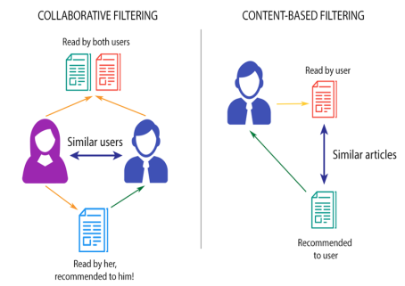

Hybrid Filtering
As explained in the above two approaches, both collaborative and content-based filtering techniques have their limitations. To resolve this, hybrid filtering techniques are used which is the combination of the above two mentioned approaches. Hybrid filtering, which combines both content-based filtering and collaborative filtering approaches, offers several advantages over using each method individually. In summary, hybrid filtering offers benefits such as improved recommendation accuracy, enhanced personalization, mitigation of the cold start problem, diverse recommendation generation, and robustness to sparse data, making it a powerful approach for building effective Recommendation Systems.

The working flow of hybrid filtering is as follows:
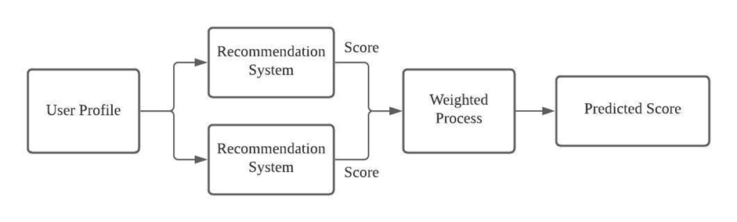

DESIGN METHODOLOGY
To initiate the content-based filtering approach, we acquired a dataset of companies through web scraping from Ambition Box. Following data collection, we conducted preprocessing to categorize skills into distinct fields such as languages, frameworks, databases, etc., for better processing. Additionally, we gathered user details from a dataset named survey-results, containing information on skills and domains. For the collaborative approach, we adopted a similar procedure.

The input methods include three categories:
a) With a predefined user ID,
b) With a resume, and
c) Manual input by the user.

In the mentioned methods, we aim to determine the similarity between user skills and domains and job requirements. To achieve this, we employ two predefined similarity metrics: cosine and Jaccard. These metrics vary in their computation methods and their typical applications. Cosine similarity is adept at comparing vectors in high-dimensional spaces, whereas Jaccard similarity is well-suited for comparing sets of data.

V. EQUATIONS
A. Cosine Similarity: Cosine similarity is used to calculate the degree of similarity between two vectors in n-dimensional space. It is widely used in information retrieval.
sim(a.b) = a.b
|a|.|b|

B. Jaccard similarity: It is a measure of similarity between two sets, calculated as the size of the intersection divided by the size of the union of the sets.
J(A,B)= ∣A∪B∣
∣A∩B∣​

RESULTS

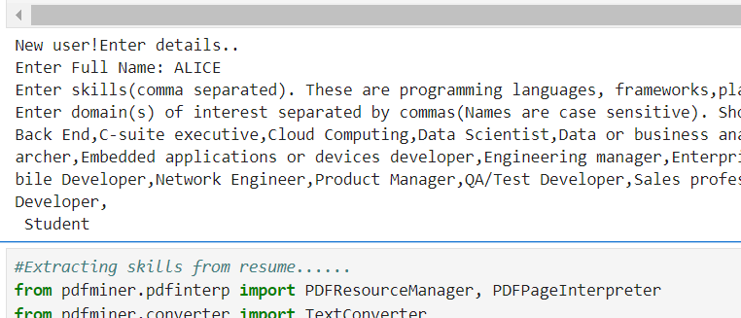

Figure 1: Reading Input from User



Figure 2: Job Recommendations after processing
User data

DATASETS

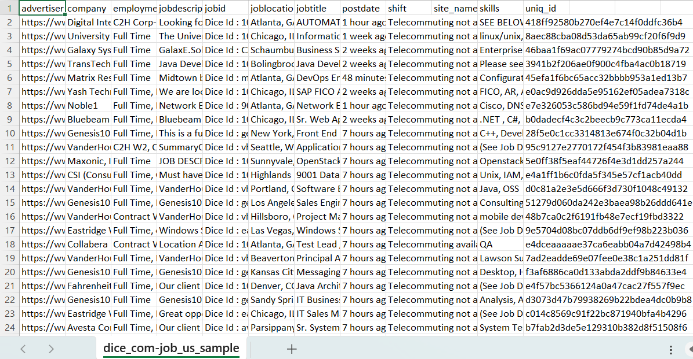

Jobs Dataset

VIII. CONCLUSION
Hybrid filtering within job recommendation systems presents a robust solution for connecting job seekers with suitable opportunities, offering advantages to both candidates and employers in navigating the intricacies of the job landscape. Its merits encompass heightened precision, broader inclusion of job listings, fortified resilience against data gaps and initial user data constraints, and heightened user contentment through tailored suggestions. Moreover, the flexible design of hybrid filtering ensures scalability and responsiveness to changing data dynamics and user needs.

IX. FUTURE SCOPE
The future scope of a job recommendation system includes enhancements in personalization through machine learning algorithms, integration with emerging technologies like AI chatbots for better user interaction, expansion to include remote work opportunities, and incorporation of real-time job market data for more accurate recommendations. Additionally, leveraging blockchain for secure data management and expanding to global job markets are potential areas for development.

Acknowledgment

The authors would like to thank Ass. Prof. Mr. P. Nanda Kishore, Bapatla Engineering College, Bapatla for guiding throughout the work and the authors would also thank research paper writers for providing base to our Work

References
[1] Pradeep Kumar Singh, Pijush Kanti Dutta Pramanik, Avick Kumar Dey, Prasenjit Choudhury.” Recommender Systems: An Overview, Research Trends, and Future Directions”, 2021.
[2] Dr. Alka Singhal, Shivangi Rastogi, Nikhil Panchal, Shivani Chauhan, Shradha Varshney.” Research Paper on Recommendation System”, Volume 9, Issue 8, August 2021.
[3] Ravita Mishra, Sheetal Vikram Rathi, Efficient and Scalable Job Recommender System Using Collaborative Filtering, ResearchGate, 19 May 2020. Mishra Ravita, Rathi Sheetal, Efficient and Scalable Job Recommender System Using Collaborative Filtering, In: Kumar A., Paprzycki M., Gunjan V. (eds) ICDSMLA 2019. Lecture Notes in Electrical Engineering, vol 601. Springer, Singapore, 19 May 2020.
[4] Tanya V. Yadalam, Vaishnavi M. Govda, Vandhita Shiva Kumar, Disha Girish, Career Recommendation Systems using Content based Filtering, Published in 5th International Conference on Communication and Electronics Systems (ICCES), 10 July 2020.
[5] Marwa Hussien Mohamed, Mohamed Helmy Khafagy, Mohamed Hasan Ibrahim, Recommender Systems Challenges and Solutions Survey, Published in International Conference on Innovative Trends in Computer Engineering (ITCE), 2 February 2019.
[6] Greg Linden, Brent Smith, Jeremy York,” Amazon.Com Recommendation”, IEEE Computer Society, 2003.
[7] Francesco Ricci, Lior Rokach, Bracha Shapira and Paul B. Kantor, Recommender Systems Handbook, Springer, 2010

