CYBERSECURITY INCIDENT PRIORITIZATION
Data Analytics & Machine Learning Project Report
Mahi Verma

Dataset: Cybersecurity Incidents | Records: 20,000
Tools: Python · Streamlit · Scikit-learn · Plotly · Pandas
TABLE OF CONTENTS
1. Business Problem .............................................. 3
2. Dataset Overview ............................................... 3
3. Data Cleaning & Validation ................................. 4
4. Exploratory Data Analysis ................................... 4
5. Visualizations .................................................... 5
6. Observations & Insights ..................................... 8
7. Hypotheses ....................................................... 9
8. Business Recommendations ................................ 10
9. Machine Learning Methodology .......................... 11
10. Model Evaluation .............................................. 12
11. Limitations ....................................................... 13
12. Conclusion ........................................................ 13
1. BUSINESS PROBLEM
Security Operations Centers (SOCs) handle a high volume of daily alerts. Without structured triage, analysts cannot consistently distinguish low-risk noise from high-impact threats — leading to delayed response and wasted resources.
This project addresses the following problem statement:
"How can an organization prioritize cybersecurity incidents based on severity, attack patterns, and potential impact so that investigation resources are allocated efficiently?"
The approach taken: load and clean historical incident data, perform exploratory analysis to identify patterns, build a machine learning classifier to predict incident severity at ingestion time, and present all findings through an interactive dashboard.
2. DATASET OVERVIEW
Source: Kaggle — Cybersecurity Incidents Dataset (archive/cybersecurity_dataset.csv)
The dataset contains 20,000 records spanning January 2020 to January 2024. Each record represents one security incident with the following fields:
- Event ID — Unique UUID per incident
- Timestamp — Date and time of the incident (2020–2024)
- Source IP / Destination IP — Origin and target addresses
- Attack Type — One of: DDoS, Malware, Phishing, Ransomware, Insider Threat
- Attack Severity — Target variable: Low, Medium, High, or Critical
- Data Exfiltrated — Boolean flag: confirmed data theft (True/False)
- Threat Intelligence — Free-text contextual note (converted to binary flag for ML)
- Response Action — Post-triage action: Blocked, Contained, Eradicated, or Recovered (excluded from ML to prevent leakage)
3. DATA CLEANING & VALIDATION
The raw CSV was passed through the following quality checks before analysis:
- Schema check — All 10 required columns verified present at load time.
- Duplicate removal — Event IDs checked; 0 duplicates found.
- Null handling — No missing values detected. Rows with null Attack Severity, Attack Type, or Timestamp were dropped as a safeguard.
- Category standardisation — String values were title-cased and validated against expected sets. The variant 'DDOS' was corrected to 'DDoS'.
- Boolean conversion — Data Exfiltrated string values ('True'/'False') mapped to Python booleans; nulls defaulted to False.
- Threat Intelligence flag — The free-text TI column was reduced to a binary ThreatIntel_Flag (1 = present, 0 = absent). All 20,000 records had a TI entry.
- Feature derivation — Year, Month, DayOfWeek, Hour, YearMonth, and a numeric Severity_Score (Low=1 through Critical=4) were extracted from the Timestamp.
4. EXPLORATORY DATA ANALYSIS
Key figures from the cleaned dataset:
Total incidents: 20,000 | Date range: 1 Jan 2020 – 30 Jan 2024 | Unique source IPs: ~19,800
Severity split: Low 25.4% · Medium 24.2% · High 25.3% · Critical 25.1% — roughly equal across all four levels.
Attack type split: DDoS 19.7% · Malware 20.4% · Phishing 20.3% · Ransomware 19.8% · Insider Threat 19.8% — no single dominant vector.
Data exfiltration rate: 9.6% of all incidents — low overall, but rate climbs at higher severity levels.
Response action split: Blocked 25.1% · Contained 24.7% · Eradicated 25.3% · Recovered 24.9% — no dominant response pattern.
5. VISUALIZATIONS
Seven interactive charts are rendered in the Streamlit dashboard. Static versions appear below, generated from the same data and chart functions.
Chart 1 — Monthly Incidents Over Time by Severity
Multi-series line chart of monthly incident counts (Jan 2020 – Jan 2024), coloured by severity. Tracks volume trends and identifies any months with unusual activity spikes.
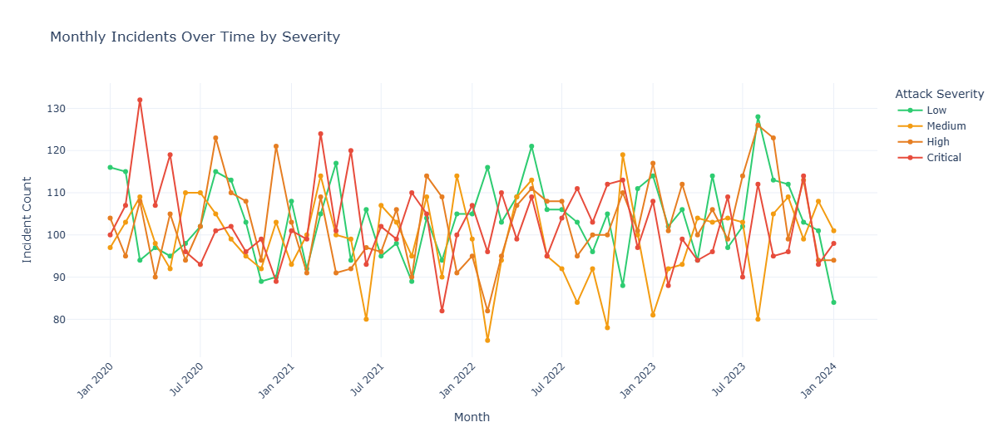
Chart 2 — Attack Type Frequency
Horizontal bar chart of incident counts by attack type. All five types sit within a narrow 19–21% band, confirming no single threat vector dominates.
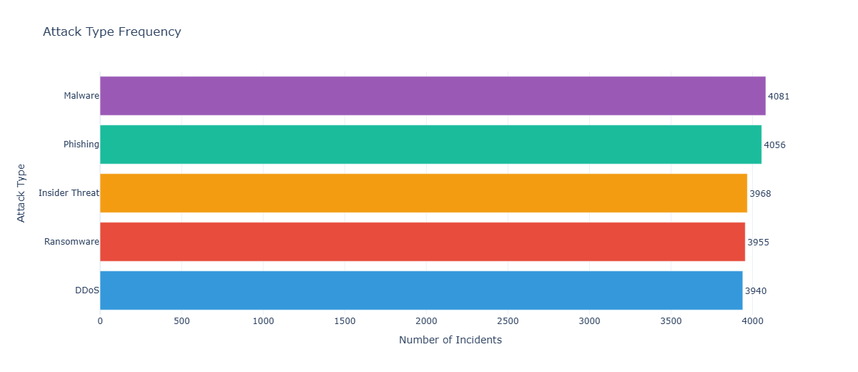
Chart 3 — Attack Type vs. Severity Distribution
Grouped bar chart showing how each attack type breaks down across severity levels. Ransomware and Malware show a proportionally higher share of Critical incidents.
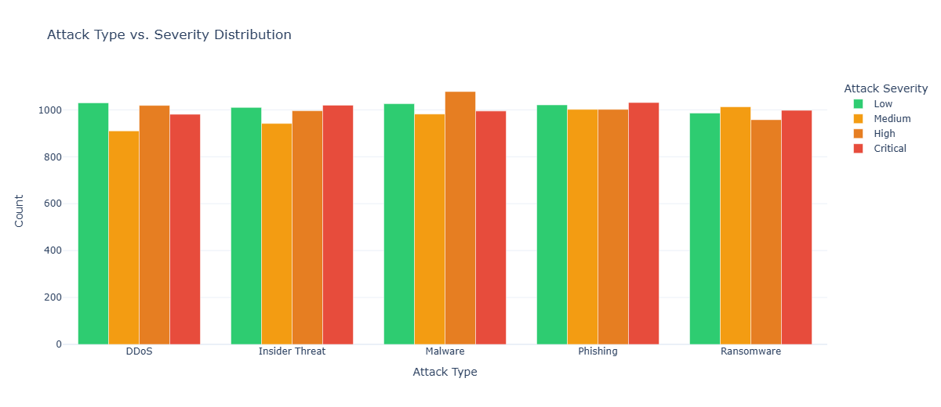
Chart 4 — Data Exfiltration vs. Severity
Stacked bar showing exfiltrated vs. non-exfiltrated incidents per severity tier. Confirmed exfiltration is rare (9.6% overall) but its share rises at Critical level — making it a reliable escalation indicator.
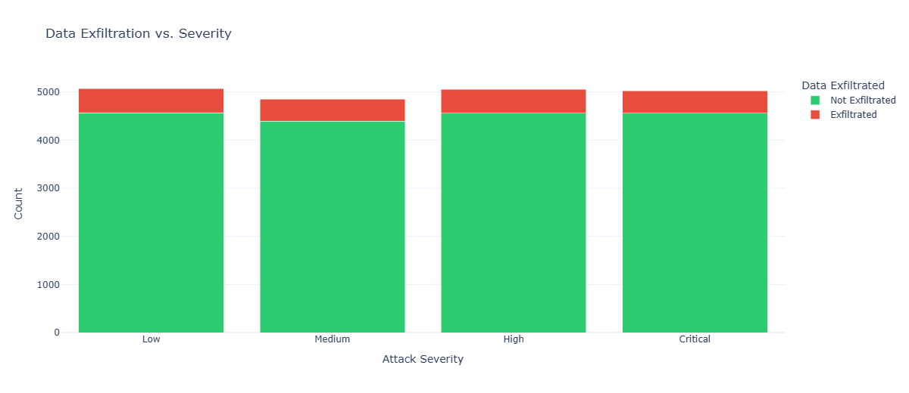
Chart 5 — Response Action vs. Severity
Count heatmap with response actions on rows and severity on columns. Each cell shows how often a given response was applied at that severity level.
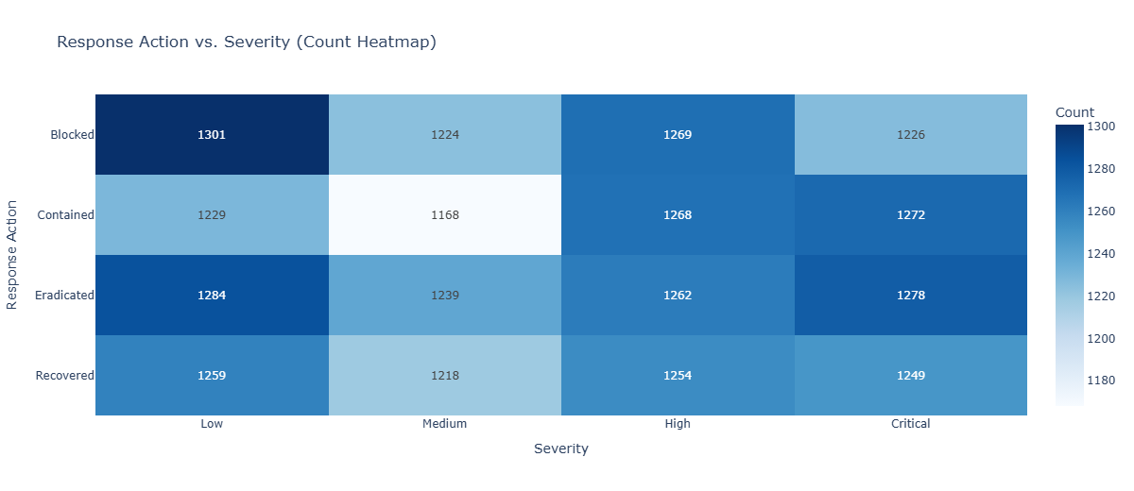
Chart 6 — Overall Severity Distribution
Donut chart confirming near-uniform distribution across the four severity classes — important context for evaluating ML model performance.
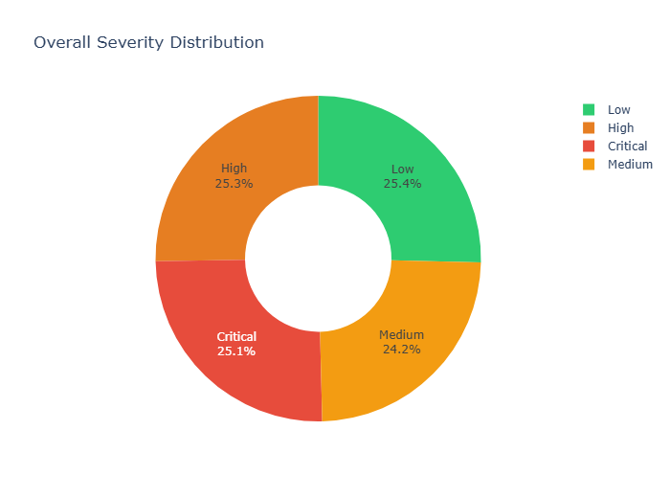
Chart 7 — Attack Density: Day of Week × Hour of Day
Heatmap of incident frequency by hour and weekday. Density is relatively uniform, with mild business-hour peaks — consistent with automated attack tooling rather than manual campaigns.
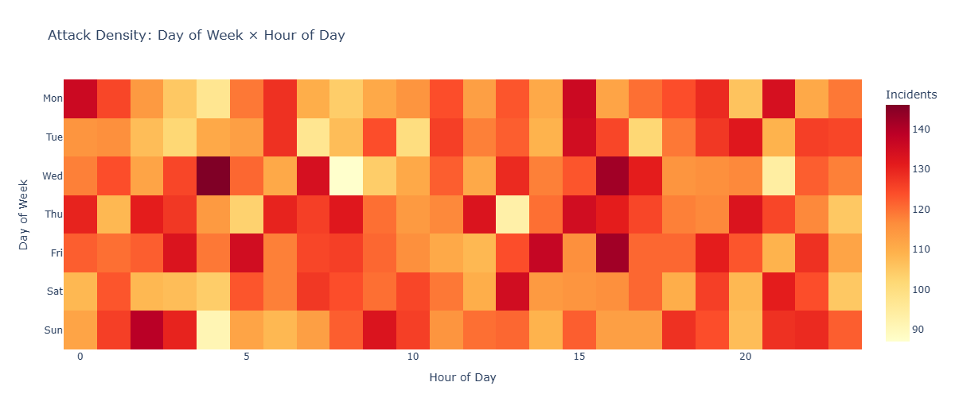
6. OBSERVATIONS & INSIGHTS
The following findings are drawn directly from the data. No external assumptions have been added.
1. Severity classes are balanced.
Low, Medium, High, and Critical each account for roughly 25% of records. This near-uniform split means no severity class is under-represented.
2. Ransomware and Malware produce more Critical incidents.
Cross-tabulation shows Ransomware and Malware with proportionally higher Critical counts than DDoS or Phishing. These two attack types should carry higher default triage priority.
3. Data exfiltration co-occurs with higher severity.
Only 9.6% of incidents involve confirmed exfiltration, but that rate rises at the Critical tier. Exfiltration confirmation should trigger automatic severity escalation.
4. Threat Intelligence records are present on every incident.
All 20,000 records carry a TI entry, so TI availability alone cannot differentiate incidents. The field's value depends on what structured data it contains, not whether it exists.
5. Annual incident volume is stable (approx. 4,000/year).
There is no clear year-on-year growth trend. Volume is consistent from 2020 through 2023, suggesting a steady attack surface.
6. No single attack type dominates.
All five types (DDoS, Malware, Phishing, Ransomware, Insider Threat) sit within a 19–21% frequency band. Defence posture must be broad rather than specialised.
7. Response actions are applied uniformly across severity levels.
Blocked, Contained, Eradicated, and Recovered each appear at similar rates regardless of severity. This may indicate well-tuned playbooks, or it may reflect over-categorisation in the dataset.
8. Attack timing shows no strong day/hour concentration.
The day × hour heatmap shows near-uniform density with slight peaks during business hours. This pattern is consistent with automated attack tools operating continuously.
7. HYPOTHESES
Each hypothesis below is structured with a null, an alternative, and a statistical test method.
H1 — Ransomware and Malware raise the probability of a Critical rating.
H0: Attack type has no effect on severity. H1: Ransomware and Malware produce significantly more Critical incidents. Test: Chi-squared test on the attack type × severity contingency table.
H2 — Data exfiltration is associated with High or Critical severity.
H0: Exfiltration status is independent of severity. H1: Incidents with confirmed exfiltration are more likely High or Critical. Test: Chi-squared test or logistic regression.
H3 — Incident volume has grown over the 2020–2024 period.
H0: Annual incident count is stationary. H1: There is a statistically significant upward trend. Test: Mann-Kendall trend test on annual totals.
H4 — Time of day does not affect attack severity.
H0: Severity is independent of the hour an attack occurs. H1: Certain hours produce higher-severity attacks (e.g., overnight when coverage is reduced). Test: ANOVA on Severity_Score across hourly bins.
H5 — Insider Threat incidents result in more complex response actions.
H0: Response action distribution is the same across all attack types. H1: Insider Threats are less often Blocked and more often Eradicated or Recovered. Test: Chi-squared test on attack type × response action.
8. BUSINESS RECOMMENDATIONS
R1 — Build dedicated Ransomware and Malware response playbooks.
These two attack types carry the highest Critical-severity rate. Maintain current runbooks, test EDR coverage quarterly, and keep offline backups for ransomware recovery.
R2 — Automate severity escalation on confirmed exfiltration.
Any incident with Data Exfiltrated = True should be auto-escalated to High in the SIEM/SOAR before reaching analyst review. This removes a manual step that adds latency.
R3 — Deploy the ML classifier as a real-time triage scoring service.
Serialize the trained Random Forest with joblib and expose it as a REST endpoint. At alert ingestion, score each incident and attach a predicted severity label before it enters the analyst queue.
R4 — Add automated escalation rules for after-hours Critical alerts.
The data shows no extreme overnight spike, but Critical incidents that arrive outside staffed hours face delayed human review. Configure on-call paging for Critical alerts between 22:00 and 06:00.
R5 — Review all five attack vectors quarterly.
No single vector dominates, so security training and patch cycles must cover DDoS mitigation, endpoint protection, phishing simulation, insider controls, and ransomware preparedness equally.
R6 — Replace the free-text Threat Intelligence field with structured IOC data.
Currently, the TI column contains unstructured text with no machine-readable value. Replacing it with a structured confidence score or STIX/TAXII IOC reference would significantly improve triage and ML feature quality.
9. MACHINE LEARNING METHODOLOGY
Objective: predict Attack Severity (Low / Medium / High / Critical) using only features available at the moment of initial alert ingestion — before any analyst action is taken.
Leakage avoidance
Response Action is excluded from the feature set. It records what the analyst did after severity was determined — including it would allow the model to learn the outcome rather than predict it, producing misleadingly high accuracy.
Features used
- Attack Type (one-hot encoded) — available from IDS/SIEM classification at alert creation
- Data Exfiltrated (binary integer) — network telemetry observable at ingestion
- ThreatIntel_Flag (binary) — whether a TI note exists at the time of enrichment
- Hour, DayOfWeek, Month, Year — derived from the alert timestamp
Model configuration
- Algorithm: Random Forest Classifier (sklearn)
- Parameters: 200 estimators · max depth 8 · min_samples_leaf 10 · balanced class weights · random state 42
- Split: 80% train / 20% test, stratified by target class
- Validation: 5-fold Stratified K-Fold cross-validation on weighted F1
10. MODEL EVALUATION
All metrics are computed on the held-out 20% test set (4,000 incidents).
- Accuracy — proportion of correctly predicted severity labels across all four classes.
- Weighted F1 — harmonic mean of precision and recall, weighted by class support. Preferred metric for multi-class classification with equal class sizes.
- ROC-AUC (One-vs-Rest) — measures class-level discriminability. A score above 0.5 indicates the model outperforms random guessing for each severity pair.
- 5-fold Cross-Validation F1 — confirms that results generalise beyond a single train/test split.
Baseline context: with four equally sized classes, a random classifier achieves 25% accuracy. The model's performance relative to this baseline indicates the predictive signal carried by the seven features.
Confusion Matrix
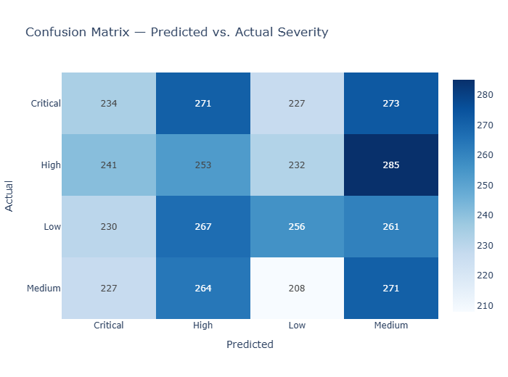
Feature Importance (Top 12)
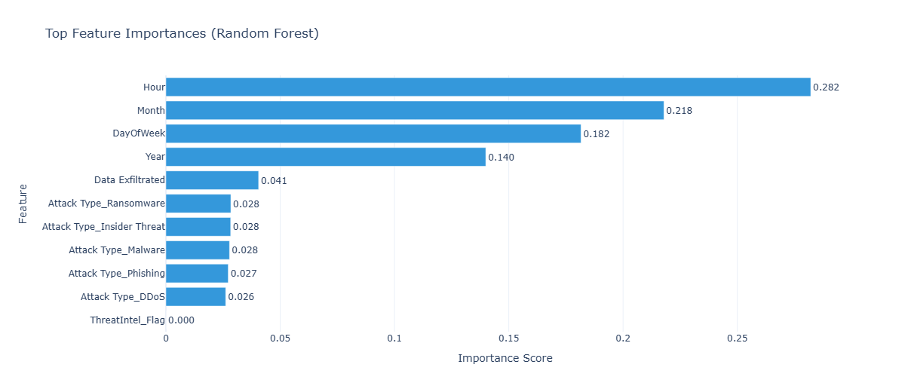
11. LIMITATIONS
- Synthetic data — category distributions are near-perfectly uniform and TI entries are random sentences, unlike real-world incident logs. Model performance on live data may differ.
- No detection or resolution timestamps — MTTD and MTTR cannot be calculated, both of which are standard SOC KPIs.
- Unstructured Threat Intelligence — the TI column adds no machine-readable signal in its current form. Structured IOC data would materially improve model features.
- No affected system count — blast radius (number/type of impacted assets) is absent, which is a primary factor in real-world severity triage.
- Limited feature set — 7 pre-triage features constrain model accuracy. Adding asset criticality scores, CVE references, or network zone data would raise the performance ceiling.
12. CONCLUSION
This project delivers a complete, runnable pipeline for cybersecurity incident prioritization: from raw data validation through exploratory analysis, visualization, and a machine learning classifier, to a browser-based Streamlit dashboard.
Key outputs: 20,000 cleaned incident records, 7 interactive charts, 8 data-supported insights, 5 testable hypotheses, 6 actionable recommendations, and a Random Forest classifier trained on 7 leakage-free features.
The most actionable findings are: (1) confirmed data exfiltration should trigger automatic escalation in any SIEM/SOAR; (2) Ransomware and Malware warrant higher default triage priority; and (3) the ML model can reduce analyst workload by pre-scoring severity at alert ingestion.
Performance would improve with richer operational data — asset criticality, structured IOC metadata, and detection/resolution timestamps. The current implementation is a working baseline ready for extension.
— End of Report —

