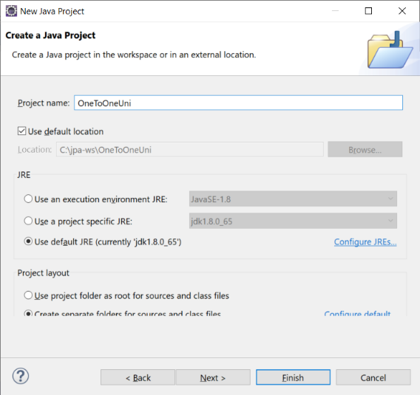

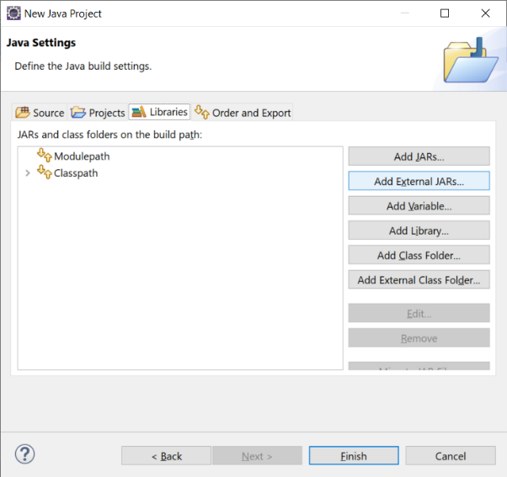

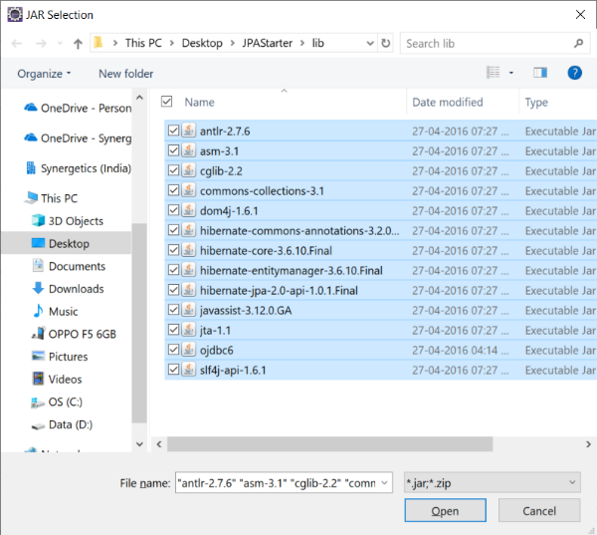

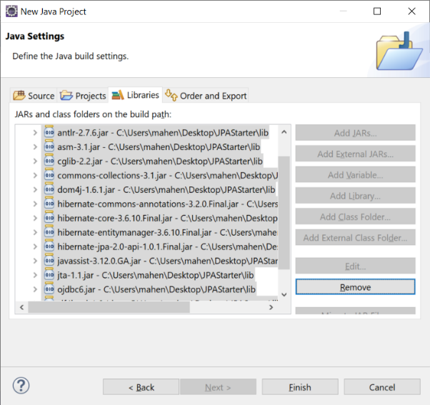

Create new XML file META-INF/persistence.xml

<?xml version=*"1.0"* encoding=*"UTF-8"*?>

<persistence xmlns=*"http://java.sun.com/xml/ns/persistence"*

xmlns:xsi=*"http://www.w3.org/2001/XMLSchema-instance"*

xsi:schemaLocation=*"http://java.sun.com/xml/ns/persistence*

*http://java.sun.com/xml/ns/persistence/persistence_2_0.xsd"*

version=*"2.0"*>

<!-- define name of PU, and Transaction type (LOCAL) -->

<persistence-unit name=*"JPA-PU"* transaction-type=*"RESOURCE_LOCAL"*>

<!-- Name of JPA Implementation provider -->

<provider>org.hibernate.ejb.HibernatePersistence</provider>

<!-- List of ENTITY CLASSES -->

<class>com.cg.onetoone.entities.Student</class>

<class>com.cg.onetoone.entities.Address</class>

<properties>

<property name=*"javax.persistence.jdbc.url"* value=*"jdbc:oracle:thin:@localhost:1521:XE"* />

<property name=*"javax.persistence.jdbc.user"* value=*"hr"* />

<property name=*"javax.persistence.jdbc.password"* value=*"hr"* />

<property name=*"javax.persistence.jdbc.driver"* value=*"oracle.jdbc.driver.OracleDriver"* />

<!-- Inform Hibernate about RDBMS being used -->

<property name=*"hibernate.dialect"*

value=*"org.hibernate.dialect.OracleDialect"*/>

<property name=*"hibernate.show_sql"* value=*"true"*/>

</properties>

</persistence-unit>

</persistence>

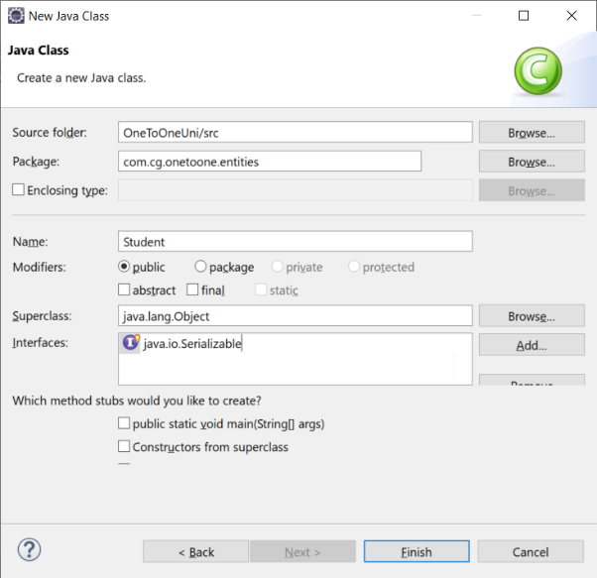

Modify Java Class:

**package** com.cg.onetoone.entities;

**import** java.io.Serializable;

**import** javax.persistence.*;

@Entity

@Table(name="students")

**public** **class** Student **implements** Serializable {

@Id

**private** Integer studentId;

**private** String name;

}

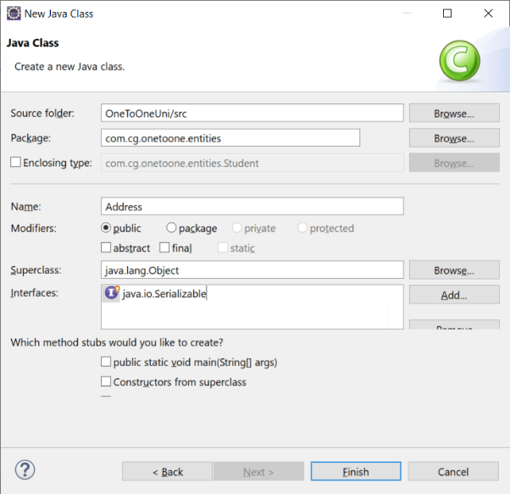

**import** javax.persistence.*;

**import** java.io.Serializable;

@Entity @Table(name="address")

**public** **class** Address **implements** Serializable {

@Id @Column(name="address_id")

**private** Integer addressId;

@Column(name="address_street")

**private** String street;

@Column(name="address_city")

**private** String city;

@Column(name="address_state")

**private** String state;

@Column(name="address_zipcode")

**private** String zipcode;

Generate Getters/Setters

Modify “Students.java”

//Every time a new Student is created,

//Create Address as well!

@OneToOne(cascade=CascadeType.***PERSIST***)

//Reference to FORIENG KEY

@JoinColumn(name="address_id")

Generate Setters/Getters for All fields

Create Main class (Client code)

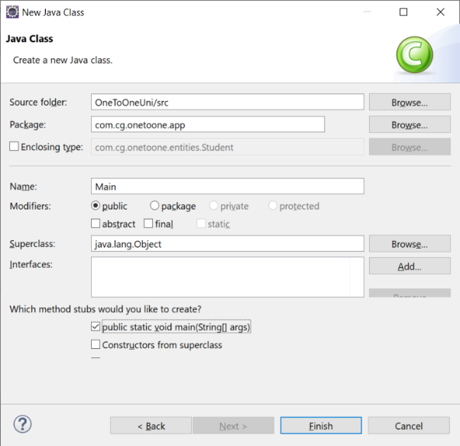

Add import statement:

**import** javax.persistence.*;

Add following lines inside MAIN method

EntityManagerFactory fact = Persistence.*createEntityManagerFactory*("JPA-PU");

EntityManager em = fact.createEntityManager();

Address address = **new** Address();

address.setAddressId(10001);

address.setCity("Chennai");

address.setState("Tamilnadu");

address.setZipcode("600130");

address.setStreet("Old Mahabalipuram Road");

Student st = **new** Student();

st.setAddress(address);

st.setName("Hemanth");

st.setStudentId(11011);

EntityTransaction tn = em.getTransaction();

**try** {

tn.begin();

em.persist(st); // No need of em.persist(address)

tn.commit();

}**catch**(Exception ex) {

ex.printStackTrace();

**if**(tn!=**null**) {

tn.rollback();

}

}