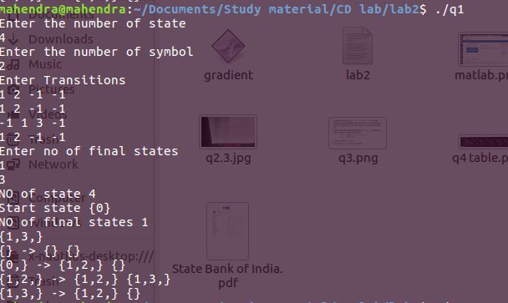
NAME: MAHENDRA KUMAR(15114043)
sample 1:

INPUT Table | a | b
0 | {1,2}
1 | {1,2}
2 |  | {1,3}
3 | {1,2}

Output table | a | b
{} | {} | {}
0 | {1,2} | {}
{1,2} | {1,2} | {1,3}
{1,3} | {1,2} | {}

sample 2:
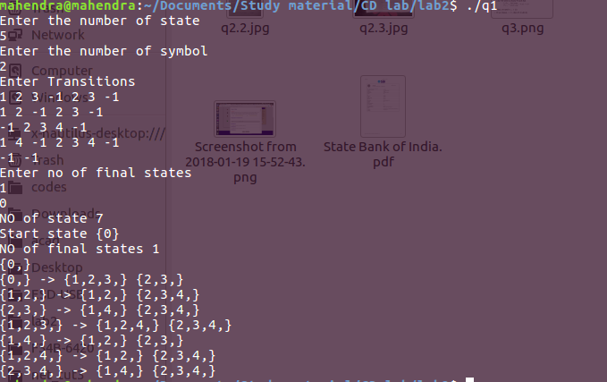

Input table | a | b
0 | {1,2,3} | {2,3}
1 | {1,2} | {2,3}
2 |  | {2,3,4}
3 | {1,4} | {2,3,4}
4

Output table | a | b
0 | {1,2,3} | {2,3}
1,2 | {1,2} | {2,3,4}
2,3 | {1,4} | {2,3,4}
1,2,3 | {1,2,4} | {2,3,4}
1,4 | {1,2} | {2,3}
1,2,4 | {1,2} | {2,3,4}
2,3,4 | {1,4} | {2,3,4}

Input : -1 means end of input
Ouput : {} is dead state

Code explain:

Here I'm using bit masking. Every state is coded with 20 bit number

like :
0 : 00000000000000000001 =2^0=1
1 : 00000000000000000010 =2^1=2
2 : 00000000000000000100 =2^2=4
3 : 00000000000000001000 =2^3=8

Now I'm using recursion (DFS) from start state and finding other states on basis of NFA
like
0 --> {1 ,2} on a
then 00000000000000000001 --> 00000000000000000110 on a

