Architecture of Social Network

Social networking services offer friends a space where they can maintain their relationships, chat with each other and share information. Moreover, they offer the opportunity to build new relationships through existing friends.
Distributed Social Networking Protocol (DSNP) allows everyone to collaborate to create one social network that is decentralized, like email. It is an open technology that supports private communications, in a manner that users of modern social networks have come to expect.

Examples of Social networking sites:
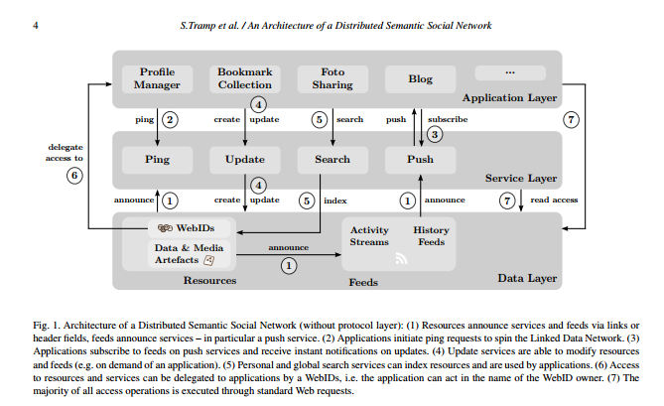
Facebook , Twitter, Whatsapp , Instagram etc.

Application Layer
Application layer provides a user interface to end user . It provides facilites of managing our profile. It manages bookmarks ,subscription. It provides facility of photo or vedio sharing . We can post our blog or some news feed.
This layer is supported by lower layers like service layer and data layer.

Internet Relay Chat (IRC) is an application layer protocol that facilitates communication in the form of text. The chat process works on a client/server networking model. IRC clients are computer programs that a user can install on their system. These clients communicate with chat servers to transfer messages to other clients. IRC is mainly designed for group communication in discussion forums, called channels,but also allows one-on-one communication via private messages as well as chat and data transfer,including file sharing.

Service Layer
Common services are :
1. Ping-
The ping service provides an endpoint for any incoming pingback request for the resources of a user. First and foremost, it is used with the WebID for friending but also for comment notification and discussions. One application instance can provide its services for multiple resources. In a minimal setup, a ping service provides only a notification service via email. In a more complex setup, the ping service has access to the update service of a user (via access delegation) and can do more than sending notification.
It uses protocols like VoIP , IRC (Internet Relay Chat) .

2. Update :
Update service provides an interface to modify and create user resources in terms of SPARQL update queries. In the same way as private search services, update services are secured by means of the WebID protocol and accept requests only by the user itself and by agents in access delegation mode.

3. Push:
This service to posting new feed , making comments on any feed etc.

4. Search:
In our architecture, these public services are used to search for new contacts as well as other artefacts in the same way as people can use a standard Web search engine. The main advantage in using Semantic Web search engines lies in their ability to use graph patterns for a search .
A private search service is used for all users and queries from applications which act on behalf of the user. The underlying resource index of a private search service is used as a callback for all push notifications from feeds to which the user has subscribed.

Data Layer:
Data layer manages our data on servers.It manages our WebID , massages, our feeds, our files. To manages user id it uses WebID protocol. WebID protocol ensures privacy and uniqueness of every user.
It also maintains history of our activites.

