Computer Networks

CLIENT SERVER MODEL

& DISTRIBUTED COMPUTING

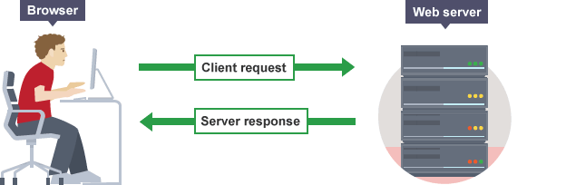

Group 12 Members:

Anuj (15114015)

Mahendra Meghwal (15114043)

Nitin Gaurav Singh (15118049)

Karan (15114036)

What is Client Server Model?

The client-server model is a distributed communication framework of network processes among service requesters, clients and service providers. The client-server connection is established through a network or the Internet.

The client-server model is a core network computing concept also building functionality for email exchange and Web/database access. Web technologies and protocols built around the client-server model are:

- Hypertext Transfer Protocol (HTTP)

- Domain Name System (DNS)

- Simple Mail Transfer Protocol (SMTP)

- Telnet

Clients include Web browsers, chat applications, and email software, among others.

Servers include Web, database, application, chat and email, etc.

A server manages most processes and stores all data. A client requests specified data or processes. The server relays process output to the client. Clients sometimes handle processing, but require server data resources for completion.

The client-server model differs from a peer-to-peer (P2P) model where communicating systems are the client or server, each with equal status and responsibilities. The P2P model is decentralized networking. The client-server model is centralized networking.

Problems with Client-server Model

- Network Blocking or Network Congestion

As the number of simultaneous client requests to a given server increases, the server can become overloaded. Contrast that to a P2P network, where its bandwidth actually increases as more nodes are added, since the P2P network's

overall bandwidth can be roughly computed as the sum of the bandwidths of every node in that network. In addition to this, the server is also susceptible to DOS(Denial of Service) attacks.

2​. Single Point of Failure

As the number of simultaneous client requests to a given server increases, the server can become overloaded. Contrast that to a P2P network, where its bandwidth actually increases as more nodes are added, since the P2P network's overall bandwidth can be roughly computed as the sum of the bandwidths of every node in that network. When a server goes down all the operations associated with it are ceased.

3​. Lack of Scalability

As the number of simultaneous client requests to a given server increases, the load on the server increases and hence it is not a scalable system. New and better quality servers must be added to improve system performance, which is a very tedious task. Scalability can only be done in the vertical direction.

4​. High Costs

Servers are especially designed to be robust, reliable and high performance and none of this is cheap. The operating system is also more costly that the standard stand-alone types as it has to deal with a networked environment.

Distributed Computing

Distributed computing is a field of computer science that studies distributed systems. A distributed system is a model in which components located on networked computers communicate and coordinate their actions by passing messages. The components interact with each other in order to achieve a common goal. Three significant characteristics of distributed systems are: concurrency of

components, lack of a global clock, and independent failure of components. Examples of distributed systems vary from SOA-based systems to massively multiplayer online games to peer-to-peer applications.

There are many alternatives for the message passing mechanism, including pure HTTP, RPC-like connectors and message queues.

A goal and challenge pursued by some computer scientists and practitioners in distributed systems is location transparency; however, this goal has fallen out of favour in industry, as distributed systems are different from conventional non-distributed systems, and the differences, such as network partitions, partial system failures, and partial upgrades, cannot simply be "papered over" by attempts at "transparency" (CAP theorem).

Distributed computing also refers to the use of distributed systems to solve computational problems. In distributed computing, a problem is divided into many tasks, each of which is solved by one or more computers, which communicate with each other by message passing.

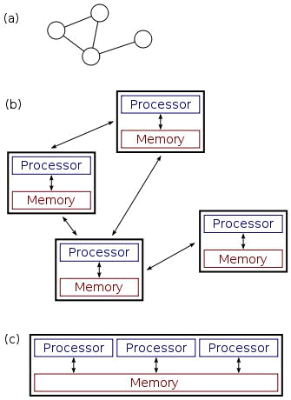

a), (b): a distributed system.

(c): a parallel system.


Challenges in Distributed Computing

- Fault Tolerance or Partition Tolerance

Failures are inevitable in any system. Some components may stop functioning while others continue running normally. So naturally we need a way to:

  - Detect Failures – Various mechanisms can be employed such as checksums.

  - Mask Failures – retransmit upon failure to receive acknowledgement

  - Recover from failures – if a server crashes roll back to previous state

  - Build Redundancy – Redundancy is the best way to deal with failures. It is achieved by replicating data so that if one sub system crashes another may still be able to provide the required information.

2​. Concurrency

Concurrency issues arise when several clients attempt to request a shared resource at the same time. This is problematic as the outcome of any such data may depend on the execution order, and so synchronisation is required.

A lot of research is also focussed on understanding the asynchronous nature of distributed systems.

3​. Availability

Every request receives a response, without guarantee that if it contains the most recent version of the information.

Achieving availability in a distributed system requires that the system remains operational 100% of the time. Every client gets a response, regardless of the state of any individual node in the system.

4​. Transparency

A distributed system must be able to offer transparency to its users. As a user of a distributed system you do not care if we are using 20 or 100’s of machines, so we hide this information, presenting the structure as a normal centralized system.

- Access Transparency – where resources are accessed in a uniform manner regardless of location
- Location Transparency – the physical location of a resource is hidden from the user
- Failure Transparency – Always try and Hide failures from users

5​. Security

The issues surrounding security are those of

- Confidentiality

- Availability

To combat these issues encryption techniques such as those of cryptography can help but they are still not absolute. Denial of Service attacks can still occur, where a server or service is bombarded with false requests usually by botnets (zombie computers).

Client Server Model in Distributed System

The client-server model is basic to distributed systems. It is a response to the limitations presented by the traditional mainframe client-host model, in which a single mainframe provides shared data access to many dumb terminals. The client-server model is also a response to the local area network (LAN) model, in which many isolated systems access a file server that provides no processing power.

Client-server architecture provides integration of data and services and allows clients to be isolated from inherent complexities, such as communication protocols. The simplicity of the client-server architecture allows clients to make requests that are routed to the appropriate server. These requests are made in the form of transactions. Client transactions are often SQL or PL/SQL procedures and functions that access individual databases and services.

The system is structured as a set of processes, called servers, that offer services to the users, called clients.

The client-server model is usually based on a simple request/reply protocol,

implemented with send/receive primitives or using remote​ procedure calls (RPC)
or remote​ method invocation (RMI).​

RPC/RMI :

- The client sends a request (invocation) message to the server asking for some service
- The server does the work and returns a result (e.g. the data requested) or an error code if the work could not be performed.

Sequence of events :

- The client calls the client stub. The call is a local procedure call, with parameters pushed on to the stack in the normal way.
- The client stub packs the parameters into a message and makes a system call to send the message. Packing the parameters is called marshalling.
- The client's local operating system sends the message from the client machine to the server machine.
- The local operating system on the server machine passes the incoming packets to the server stub.
- The server stub unpacks the parameters from the message. Unpacking the parameters is called unmarshalling.
- Finally, the server stub calls the server procedure. The reply traces the same steps in the reverse direction.

