*LAB 6 ANSWER*
NAME: MAHENDRA KUMAR
ENROLLMENT NO. 15114043

Q.1 Ans
client source
IP address: 192.168.1.102
port : 138
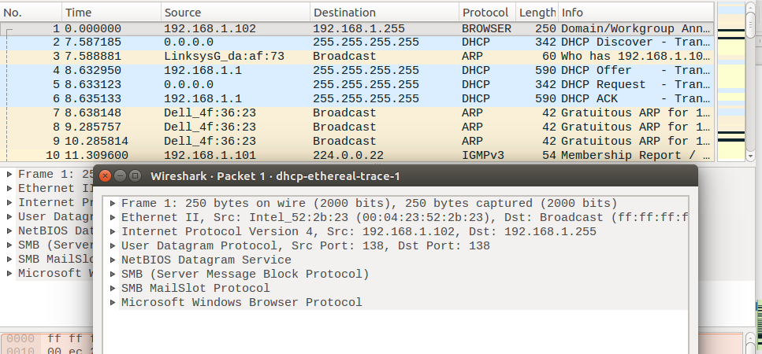
Q.2 Ans
destination
IP address: 192.168.1.255
port : 138

Q.3. Ans
client source
IP address: 192.168.181.162
port : 45624

destination
IP address: 128.119.245.12
port : 80

Q.4 Ans

the sequence that starting the connection
seq. no. = 0
it is determined by control bit in header here SYN bit =1 and ACK bit=0
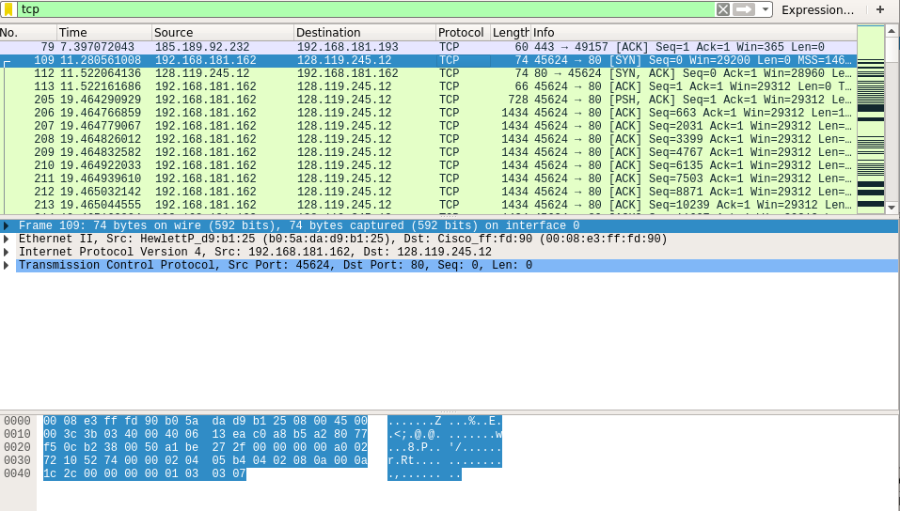
Q.5 Ans

in SYNACK segment
seq.no = 0
ack no =1 i.e. now server is saying that I have got data upto sequence no 0 now send data from sequence no. 1

it is determined by control bit in header here SYN bit =1 and ACK bit=1

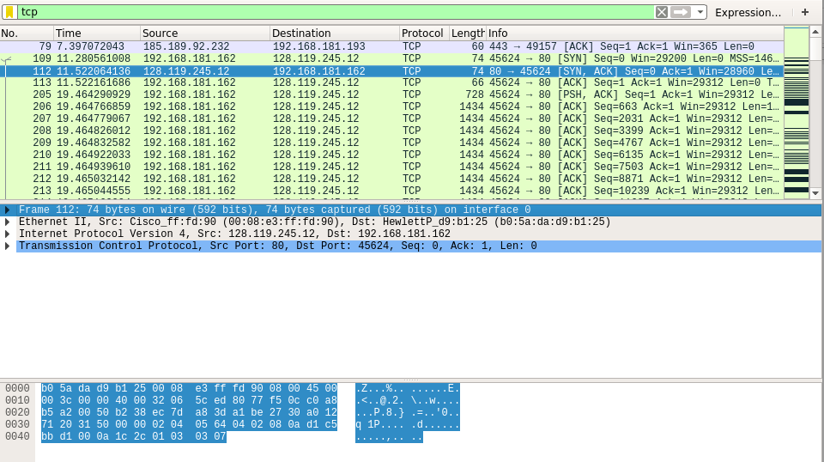

Q.6 ANS

http post segment
seq. no.= 148407

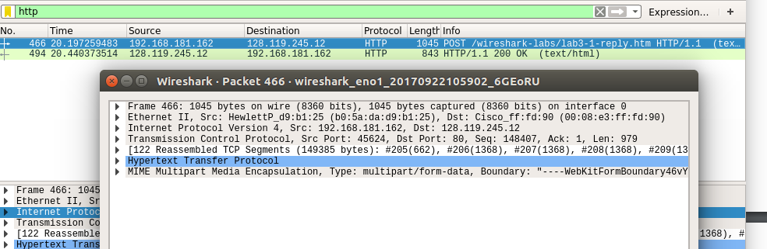

Q.7 Ans
segment fragmented in 122 frames
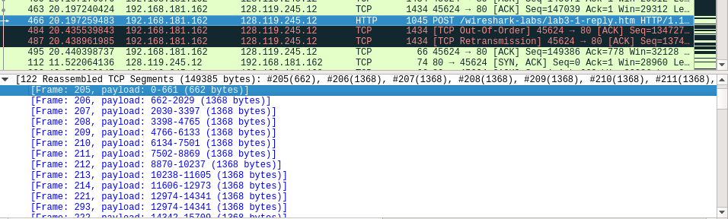
first 6 segments are
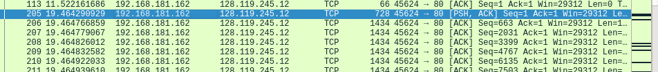

seq no of 1 segment= 1
seq no of 2 segment= 663
seq no of 3 segment= 2031
seq no of 4 segment= 3399
seq no of 5 segment= 4767
seq no of 6 segment= 6135

their acknowledgemnt are

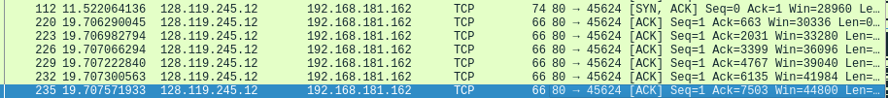

segment | Sent time | Ack time | RTT
1 | 19.464299929 | 19.706290045 | 0.241990116
2 | 19.464766859 | 19.7069822794 | 0.242018279
3 | 19.464779067 | 19.707066294 | 0.242051897
4 | 19.464826012 | 19.707222840 | 0.242095013
5 | 19.464832582 | 19.707300563 | 0.242141634
6 | 19.464922033 | 19.707571933 | 0.242205167

EstimatedRTT = 0.875 * EstimatedRTT + 0.125 * SampleRTT

EstimatedRTT after the receipt of the ACK of segment 1:
EstimatedRTT = RTT for Segment 1 = 0.241990116 second

EstimatedRTT after the receipt of the ACK of segment 2:
EstimatedRTT = 0.875 * 0.241990116 + 0.125 * 0.24221542 = 0.242018279

EstimatedRTT after the receipt of the ACK of segment 3:
EstimatedRTT = 0.875 * 0.242018279 + 0.125 * 0.242287227 = 0.242051897

EstimatedRTT after the receipt of the ACK of segment 4:
EstimatedRTT = 0.875 * 0.242051897+ 0.125 * 0.242396828 = 0.242095013

EstimatedRTT after the receipt of the ACK of segment 5:
EstimatedRTT = 0.875 * 0.242095013 + 0.125 * 0.242467981= 0.242141634

EstimatedRTT after the receipt of the ACK of segment 6:
EstimatedRTT = 0.875 * 0.242141634+ 0.125 * 0.2426499 = 0.242205167

Q.8 Ans

first 6 segment are

length of first segment = 728 byte
and other 5 are of 1434 byte

Q.9 Ans:

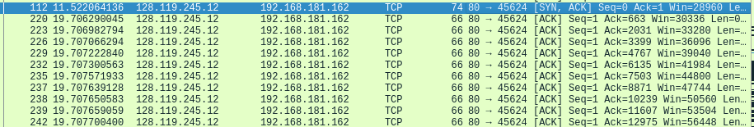
Minimum window size= 28960

which shows in the first acknowledgement from the server. This receiver window grows steadily until a maximum receiver buffer size of 56448 bytes. The sender is never throttled due to lacking of receiver buffer space by inspecting this trace.

Q.10 Ans

Yes there are around 7 segment are retransmitted
this can be analysed using below graph if at a time our sequence number is less than neighbouring point

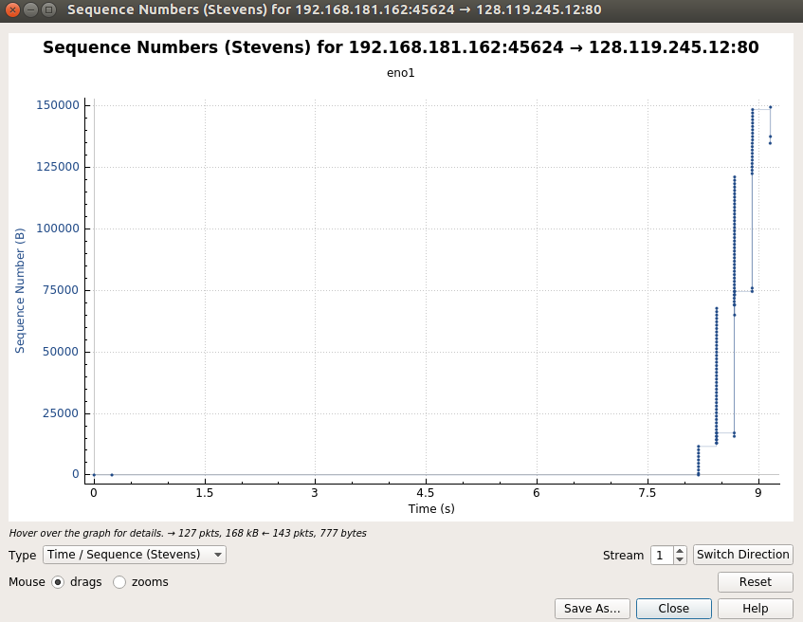

Q 11.Ans

here it is typically acknowledging 1368 byte data
this can be derived from sequence number of seq packets as well acknowledgement

Q.12 Ans

tcp first segment :
seq. No. = 1
Time: = 19.464290929

tcp last ACK time :
ack . No. = 149386
Time: = 20.440057251

throughput=(149386-1)/(20.440057251-19.464290929)=153095.0563 bytes/sec

