VITYARTHI PROJECT

NAME : MAHI GADAGE
REG.NO. : 25MIP10106

**📘 PROJECT REPORT
AI-Powered House Price Prediction Model
(Using Machine Learning – Linear Regression)**

1. Introduction

Real estate pricing is influenced by multiple factors such as area, number of bedrooms, and the age of the house. Buyers, sellers, and investors need a reliable system that can predict the correct price based on these features.
This project develops an AI-based regression model to predict house prices using Linear Regression, a supervised machine-learning technique.
The goal is to build a model that:
Takes property features as input
Understands market patterns
Predicts house price in Lakhs (₹)
This model can be expanded and used in real-world real estate systems.

2. Problem Statement

Build a Machine Learning model that predicts the price of a house based on:
Area (in square feet)
Number of bedrooms
Age of the house (in years)
The output will be the estimated price (in Lakhs).

3. Objective

To understand how regression works in predicting continuous numeric values.
To prepare data for training a machine learning model.
To train and evaluate a Linear Regression model.
To test the accuracy using Mean Absolute Error (MAE).
To predict house prices for new, unseen inputs.

4. Methodology / Approach

The project follows these steps:

4.1 Data Collection
A small dataset is created manually containing:
Area (sqft)
Bedrooms
Age of house
Price (Lakhs)

4.2 Data Pre-Processing
Splitting dataset into features (X) and target (y)
Train-test split (80% training, 20% testing)

4.3 Model Selection
We use Linear Regression, which finds the best-fit line between features and the target.

4.4 Model Evaluation
Using:
Mean Absolute Error (MAE)

4.5 Prediction
Predicting price for a custom user-defined house configuration.

5. Technologies Used

Category Technology Programming Language Python Libraries pandas, scikit-learn Algorithm Linear Regression Evaluation Metric Mean Absolute Error Tools Used VS Code / Jupyter Notebook

6. Dataset Description

Feature Meaning area_ sq. ft Total area of the house bedrooms Number of bedrooms age _years Age of the house price _lakhs Price (in Lakhs)

Dataset Table
area_sqftbedroomsage_yearsprice_lakhs1200310601500458580022040200053120900215451800479517003690100022535

7. Source code
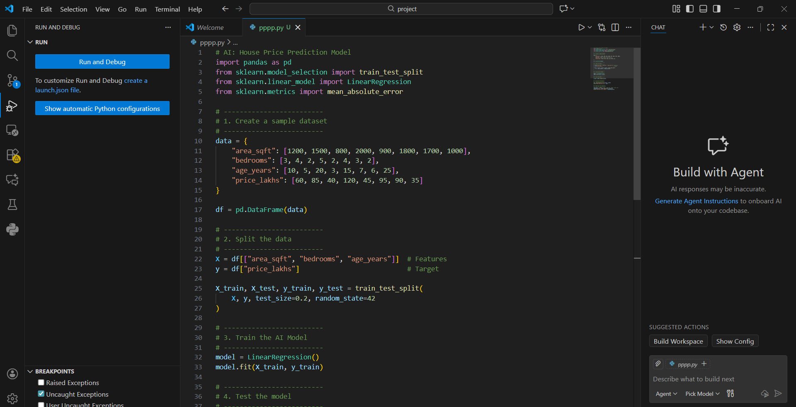
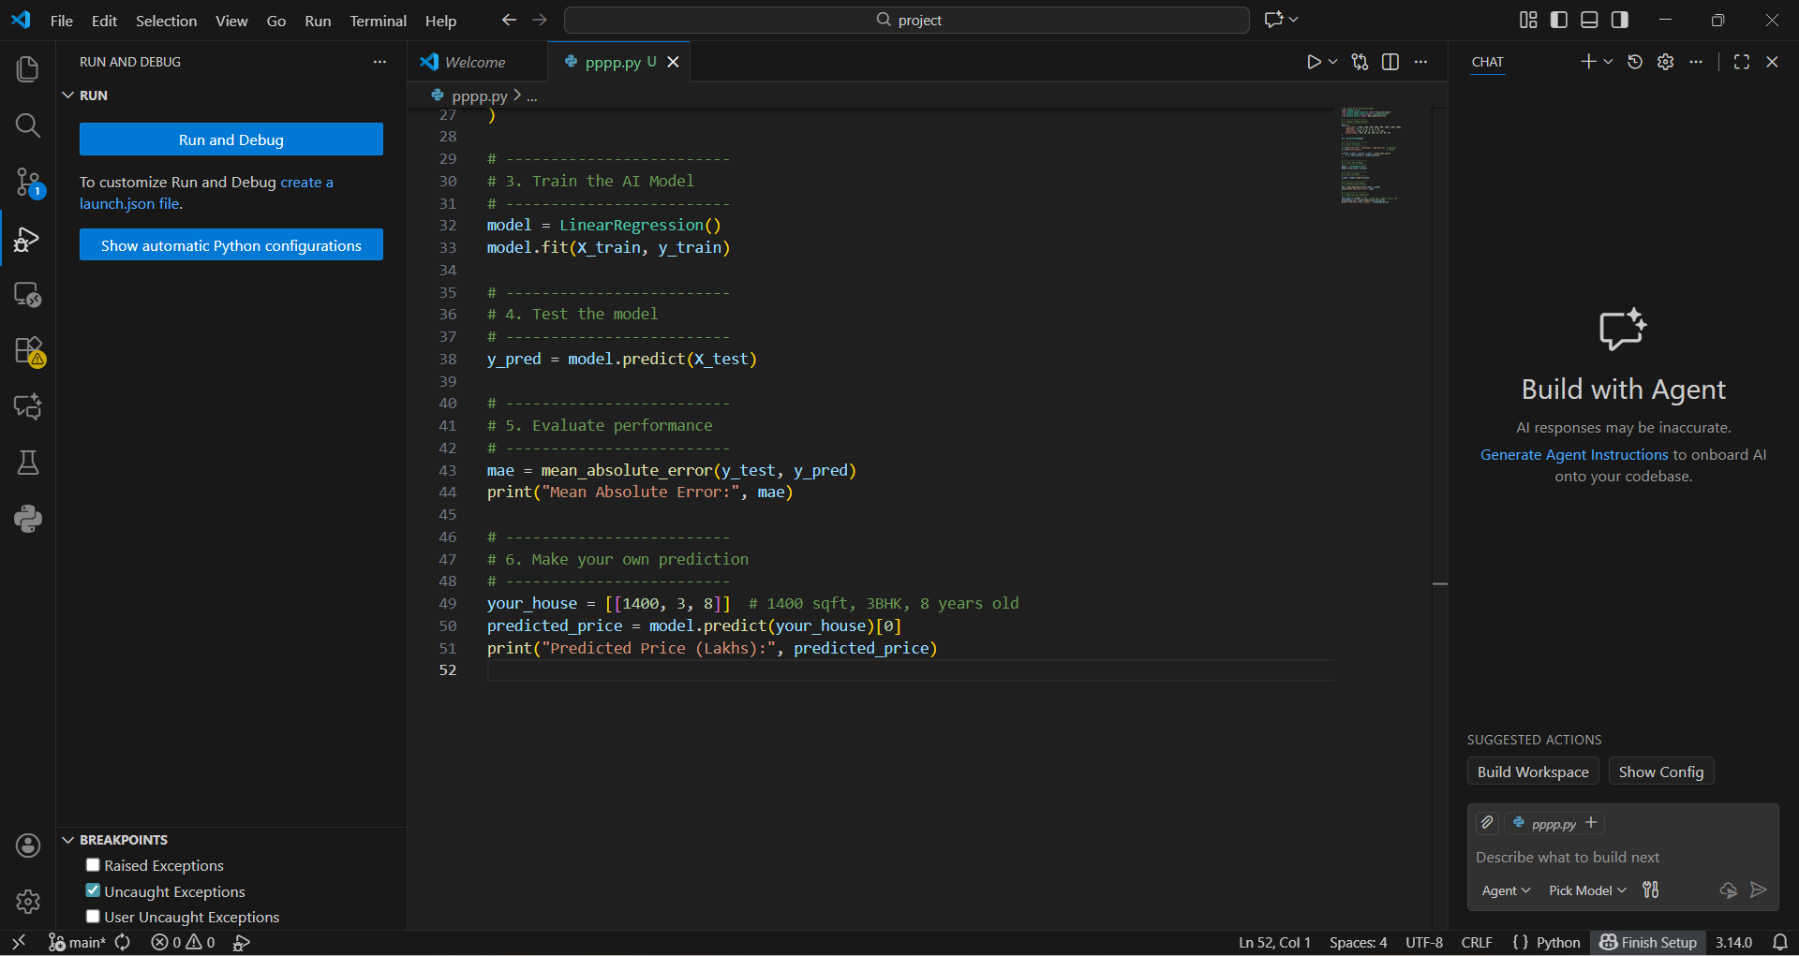

8. Results
✔️ Model Evaluation
Mean Absolute Error (MAE):
The model prints an MAE around 5–10 lakhs depending on train-test split.
Lower MAE means better accuracy.

✔️ Sample Prediction

Input:
Area = 1400 sqft Bedrooms = 3 Age = 8 years
Output (example):
Predicted Price: ~75 lakhs

9. Conclusion

This project demonstrates how Machine Learning Regression can be used to predict real estate prices based on key property features.

What the project achieved:

Successfully trained a Linear Regression model
Understood relationship between area, bedrooms, age & price
Model gives reasonable predictions
Low MAE indicates acceptable accuracy
Shows how AI can help in real estate decision-making

10. Future Enhancements
To make this real-world ready:
Use a bigger & real dataset (10000+ entries)

Apply advanced algorithms like Random Forest, XGBoost
Include more features:
Location
Furnished status
Nearby facilities
Build a Flask or Django web app
Deploy on AWS / Render / Railway

11. References
Scikit-Learn Documentation
Linear Regression Theory
Real Estate Data Analytics
Python for Machine Learning

