**Empowering The Future: A Literacy Rate Analysis For A Better Future Tomorrow**



**1.INTRODUCTION**



**PROJECT REPORT**

**Team ID: LTVIP2023TMID07890**

**Team Size: 2**

**Team Leader: Shaik.Mahimoon Team Member: Kande. Varsha**

**Faculty Mentor:** V VAMSIKRISHNA T

* 1. Overview:

To know development in a society, Literacy is another proper indicator of economic Development For purpose of census, a person in age limit of seven and above, who can both write and read with understanding in any of the language is considered as a literate in India. Literacy plays a major role in the economic development of a nation. Although India has raised its current literacy rate of 74.04% (2021) from 12% at the time of Independence in 1947, its still lag behind the world average literacy rate of 84%.

Compared with other nations, Republic of India has the largest illiterate population.

|  |  |
| --- | --- |
| India Literacy Rate (According to 2011 Census) | |
| Overall | 74.04% |
| Male | 82.14% |
| Female | 65.46% |

* Majority of states in India has shown majors signs of improvement in their overall illiteracy rate thus, contributing towards a literate nation. Here we are analysing literacy rate in India

for 2021.

* This dataset contains a record Literacy rate each state of India, here we are going to analyse State wise, Region wise and Overall Literacy rate among Children, Women and Men in India in India.

## PURPOSE:

An empowering literacy education is one that builds on the cultural capital and funds of knowledge children bring to school with them. Conversely, Freire maintains that there exists a “pedagogy of the oppressed”—a system in which marginalized learners are given inadequate educational opportunities.

* Literacy plays a major role in the economic development of a nation. Although India has raised its current literacy rate of 74.04% (2021) from 12% at the time of Independence in 1947, its still lag behind the world average literacy rate of 84%. Compared with other nations, Republic of India has the largest illiterate population.

## LITERATURE SURVEY:

* 1. EXISITING PROBLEM:

A problem statement is a clear and concise description of the issue or challenge that needs to be addressed. It should define the problem in a way that is understandable to stakeholders and provide a basis for developing a solution or course of action.

## PROPOSED SOLUTION:

* Read aloud. Early reading can hugely benefit from collective read-alouds.
* Graphic organizers
* Encouraging students to bring their own, special experiences
* Group discussions.

## THEORITICAL ANALYSIS:

* 1. Block diagram

Empowering The Future: A Literacy Rate Analysis for better Future

Define Problem/Problem Understanding

**Data Collection &Extraction from Database**

**Collect the**

**Dataset**

(DOWNLOADED DATSET FROM KAGGLE)

Connect IBM

DB2 with IBM Cognos

**Data Preparation**

(LOGGED INTO IBM COGNOS ANALYTICS AND CREATED DATA)

Prepare the Data

for Visualization

(CREATED SEVERAL UNIQUE

**Creating New Dashboard**

(CREATED LITERACY RATE ANALYSIS DASHBOARD)

**Creating New Story**

(GUIDED JOURNEY SLIDESHOW)

**Creating New Report**

(VISUALIZATIONS WITH DETAILED INFO)

**Web Integration**

(DASHBOARD, REPORT, STORY WAS DEPLOYED INTO UI WITH FLASK)

**TECHNICAL ARCHITECHTURE:**

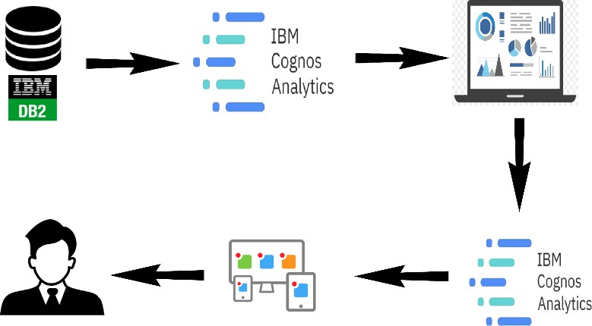

## Hardware /Software designing

#### Hardware Requirements:

* + - Processor
    - Memory (RAM)
    - Storage
    - Graphics Processing Unit (GPU)
    - Internet Connection

#### Software Requirements:

* + - IBM Cognos analytics Tool
    - Flask
    - Integrated Development Environment (IDE)- Visual studio code (Bikin Template)

1. **RESULT:**

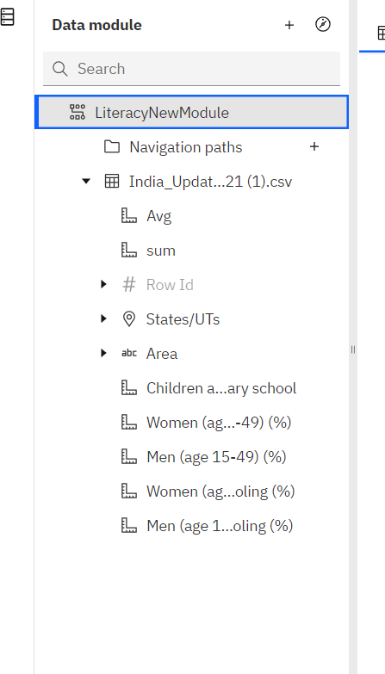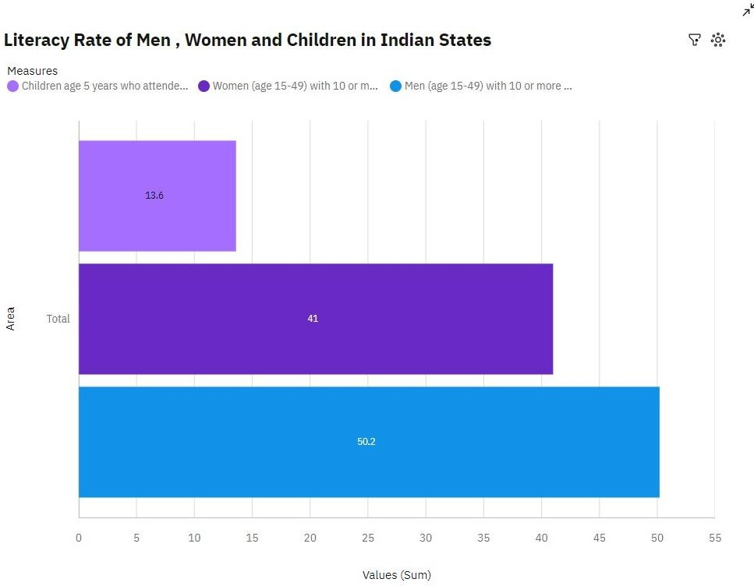

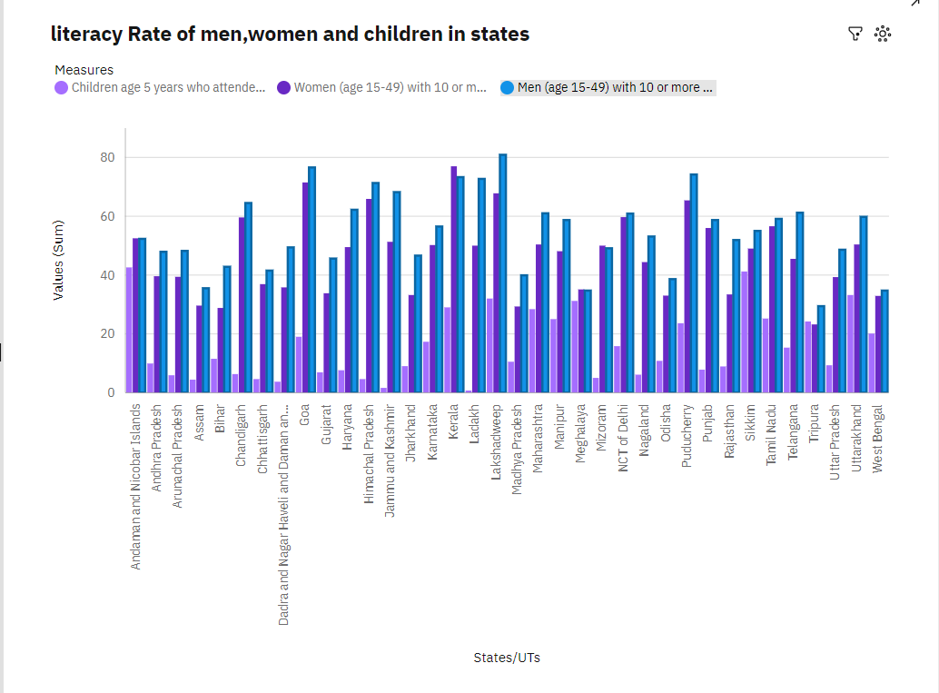

# DASHBOARD

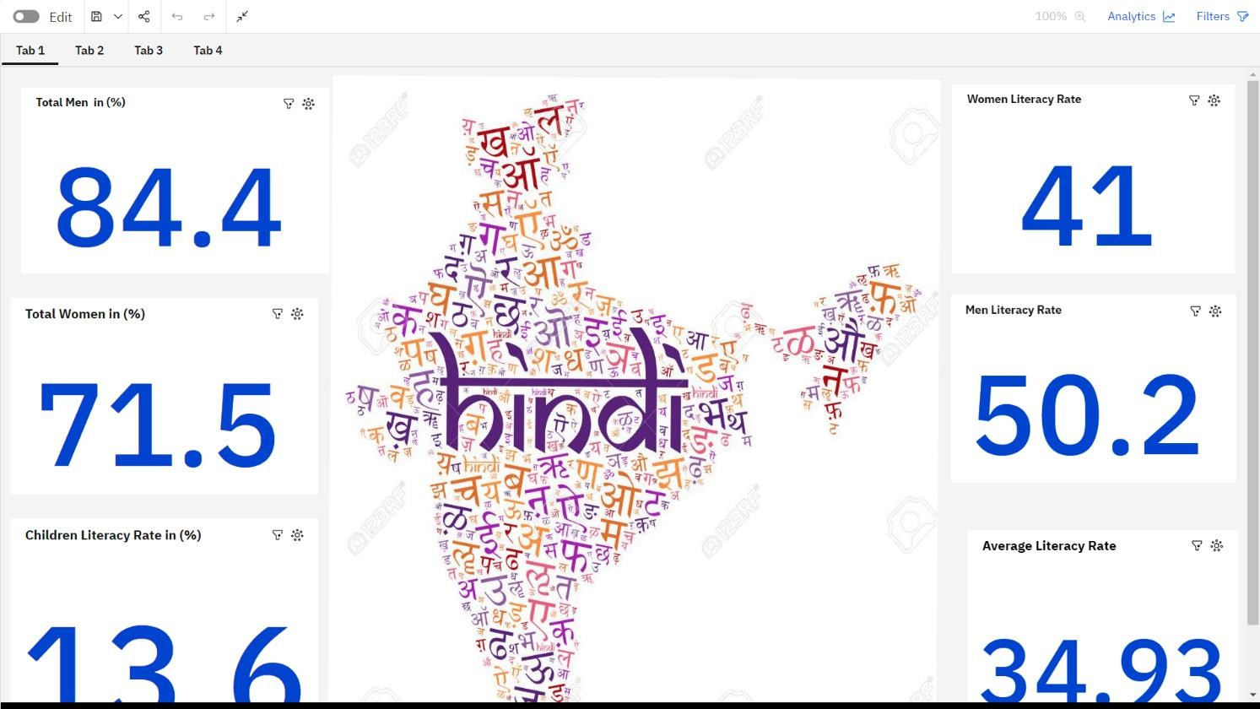

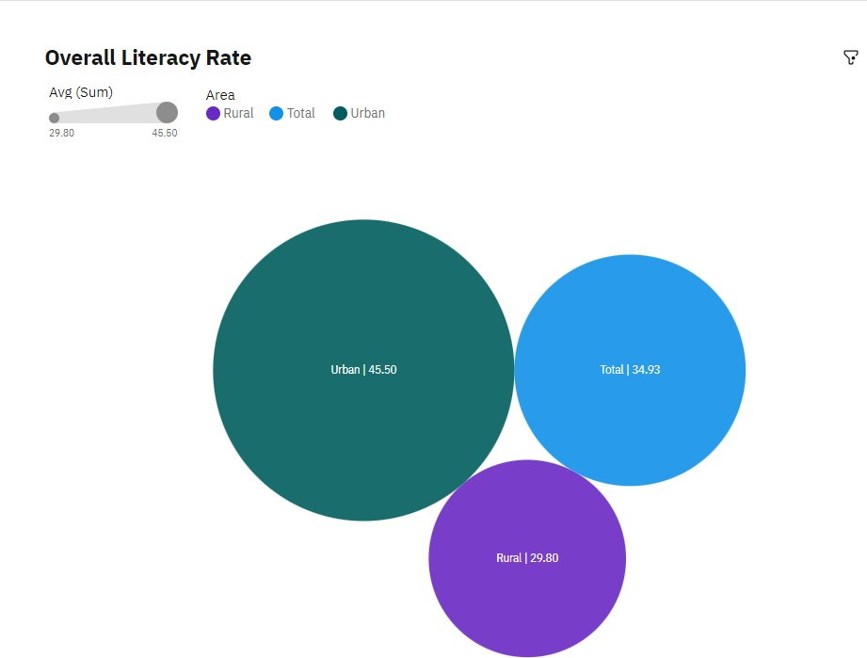

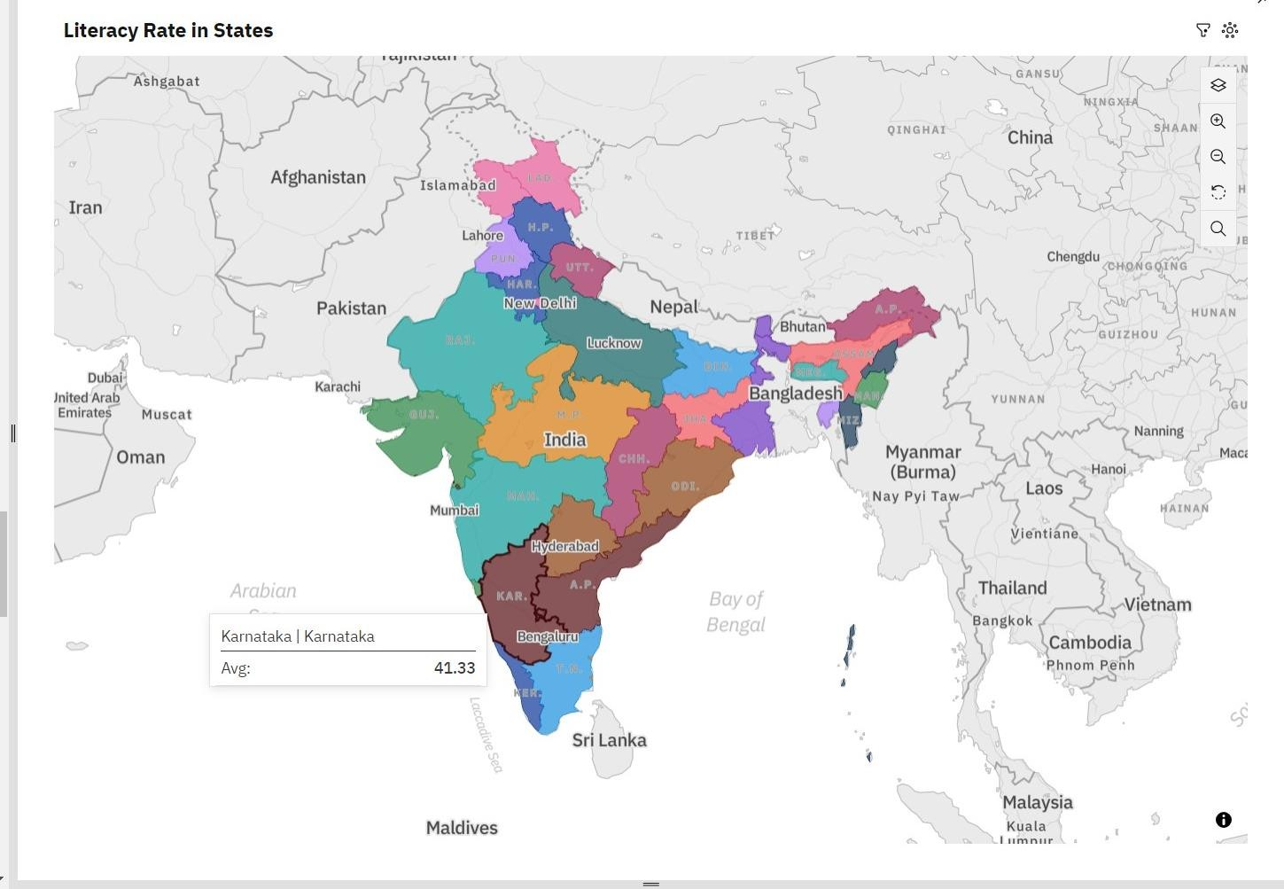

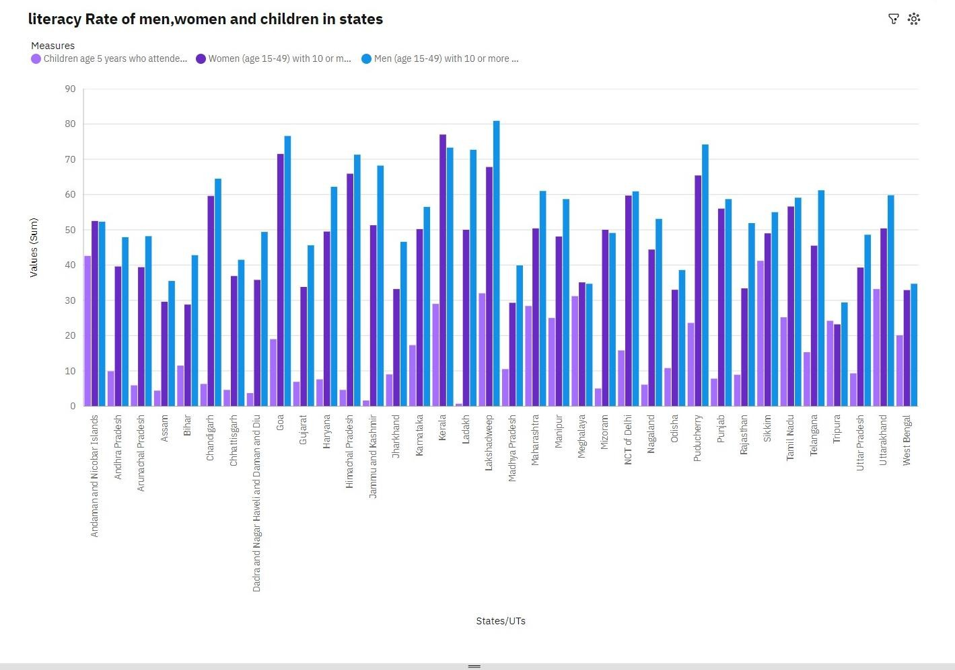

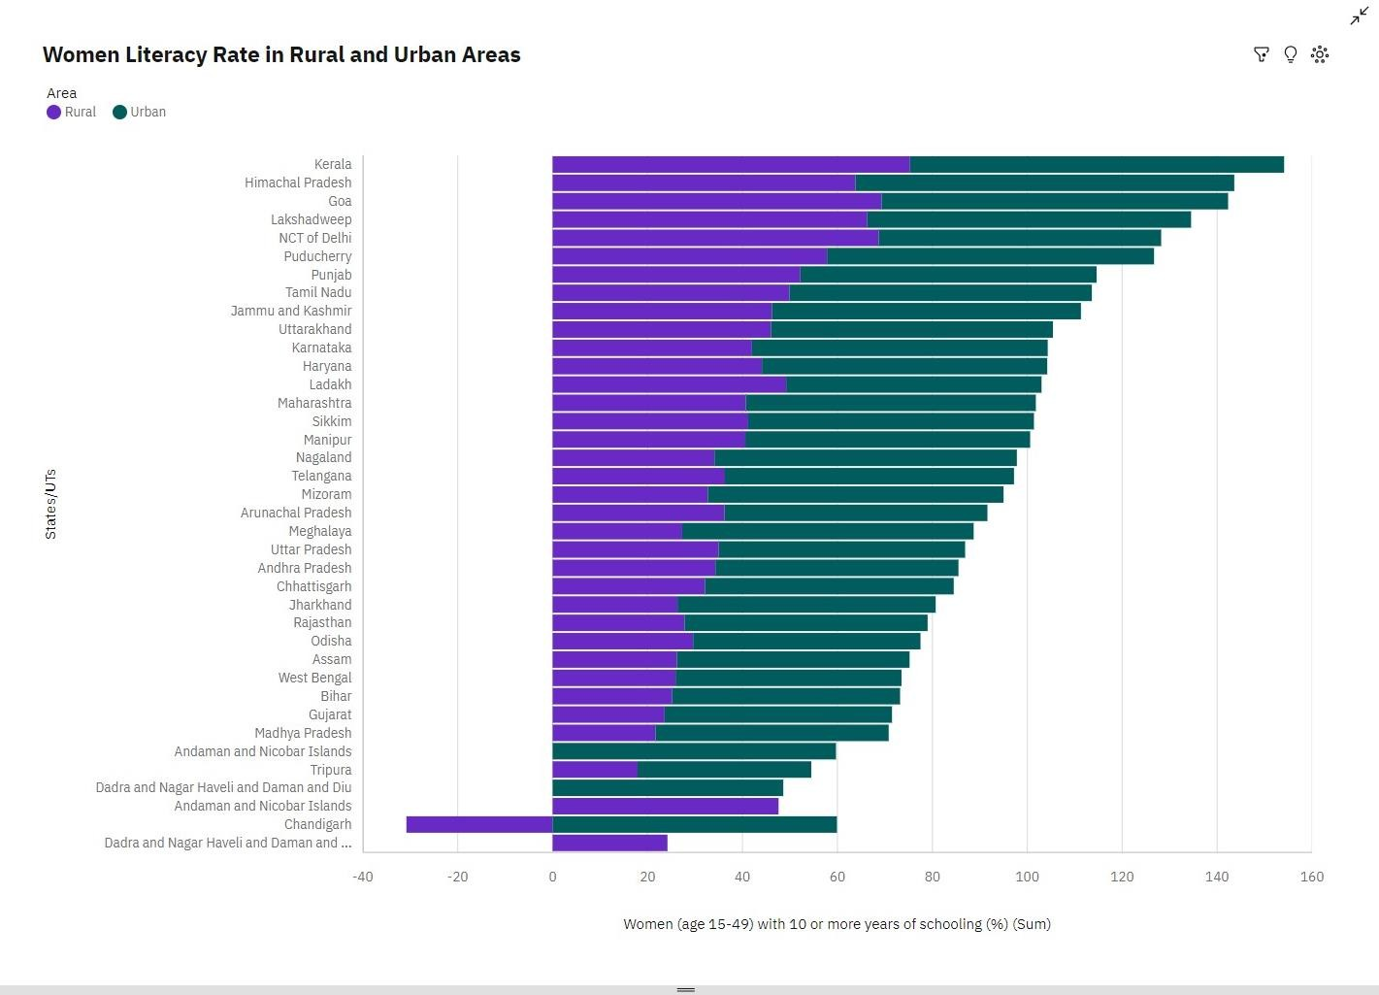

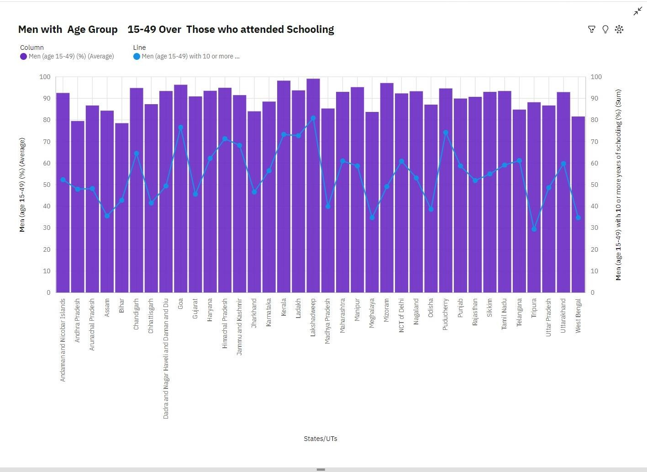

**STORY**

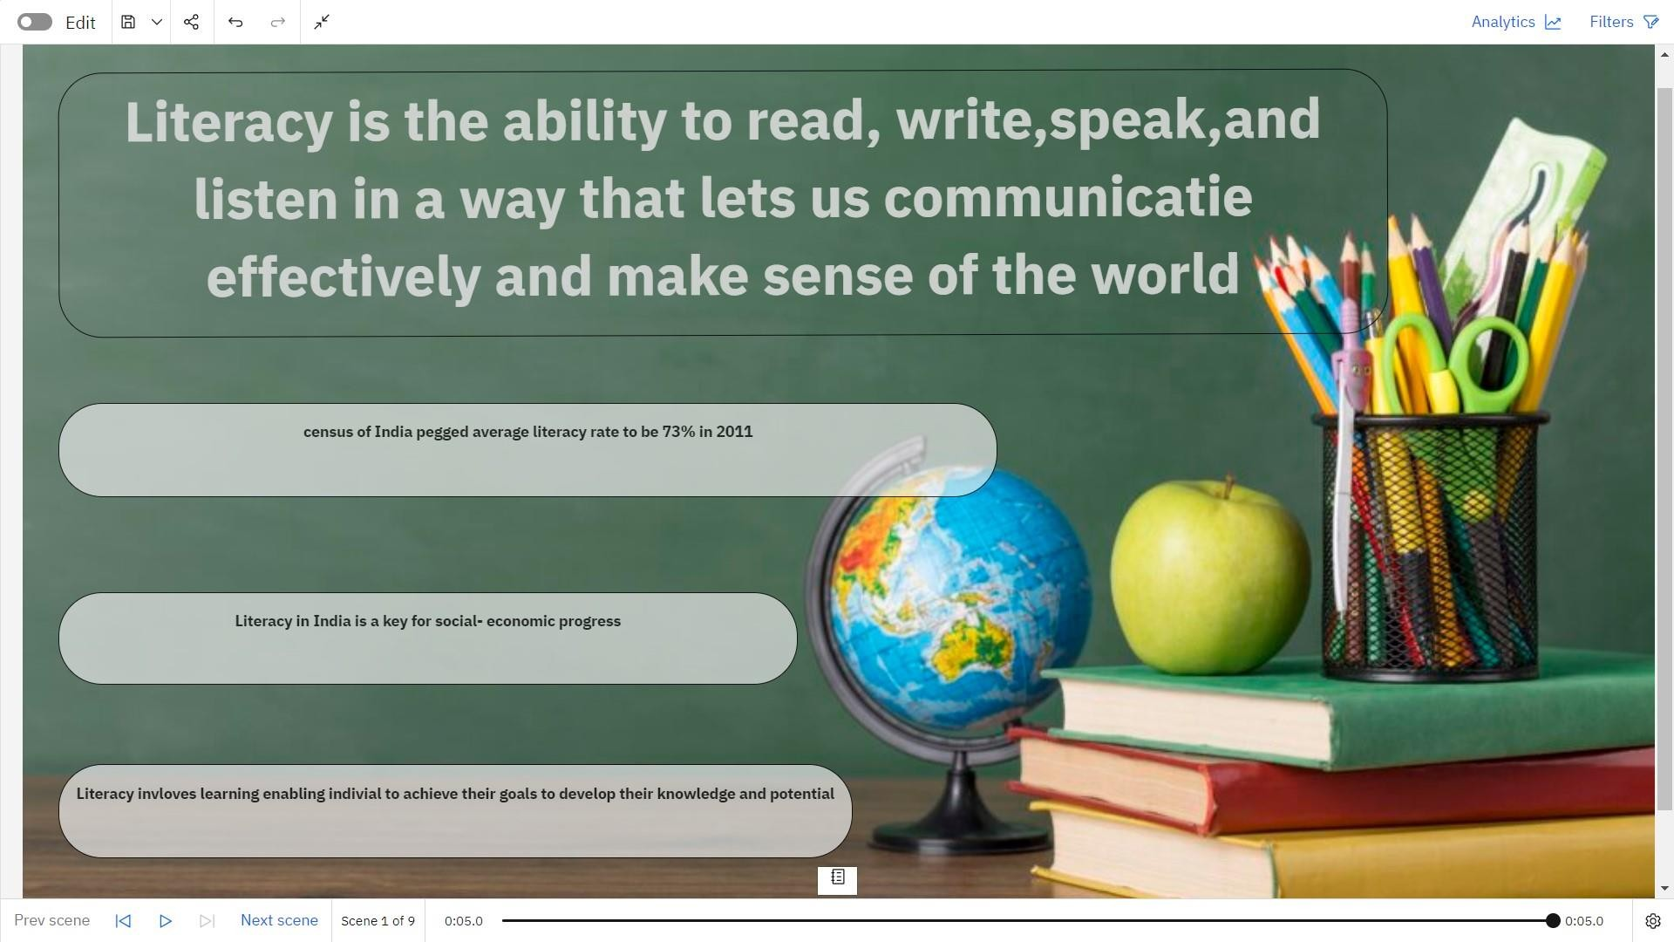

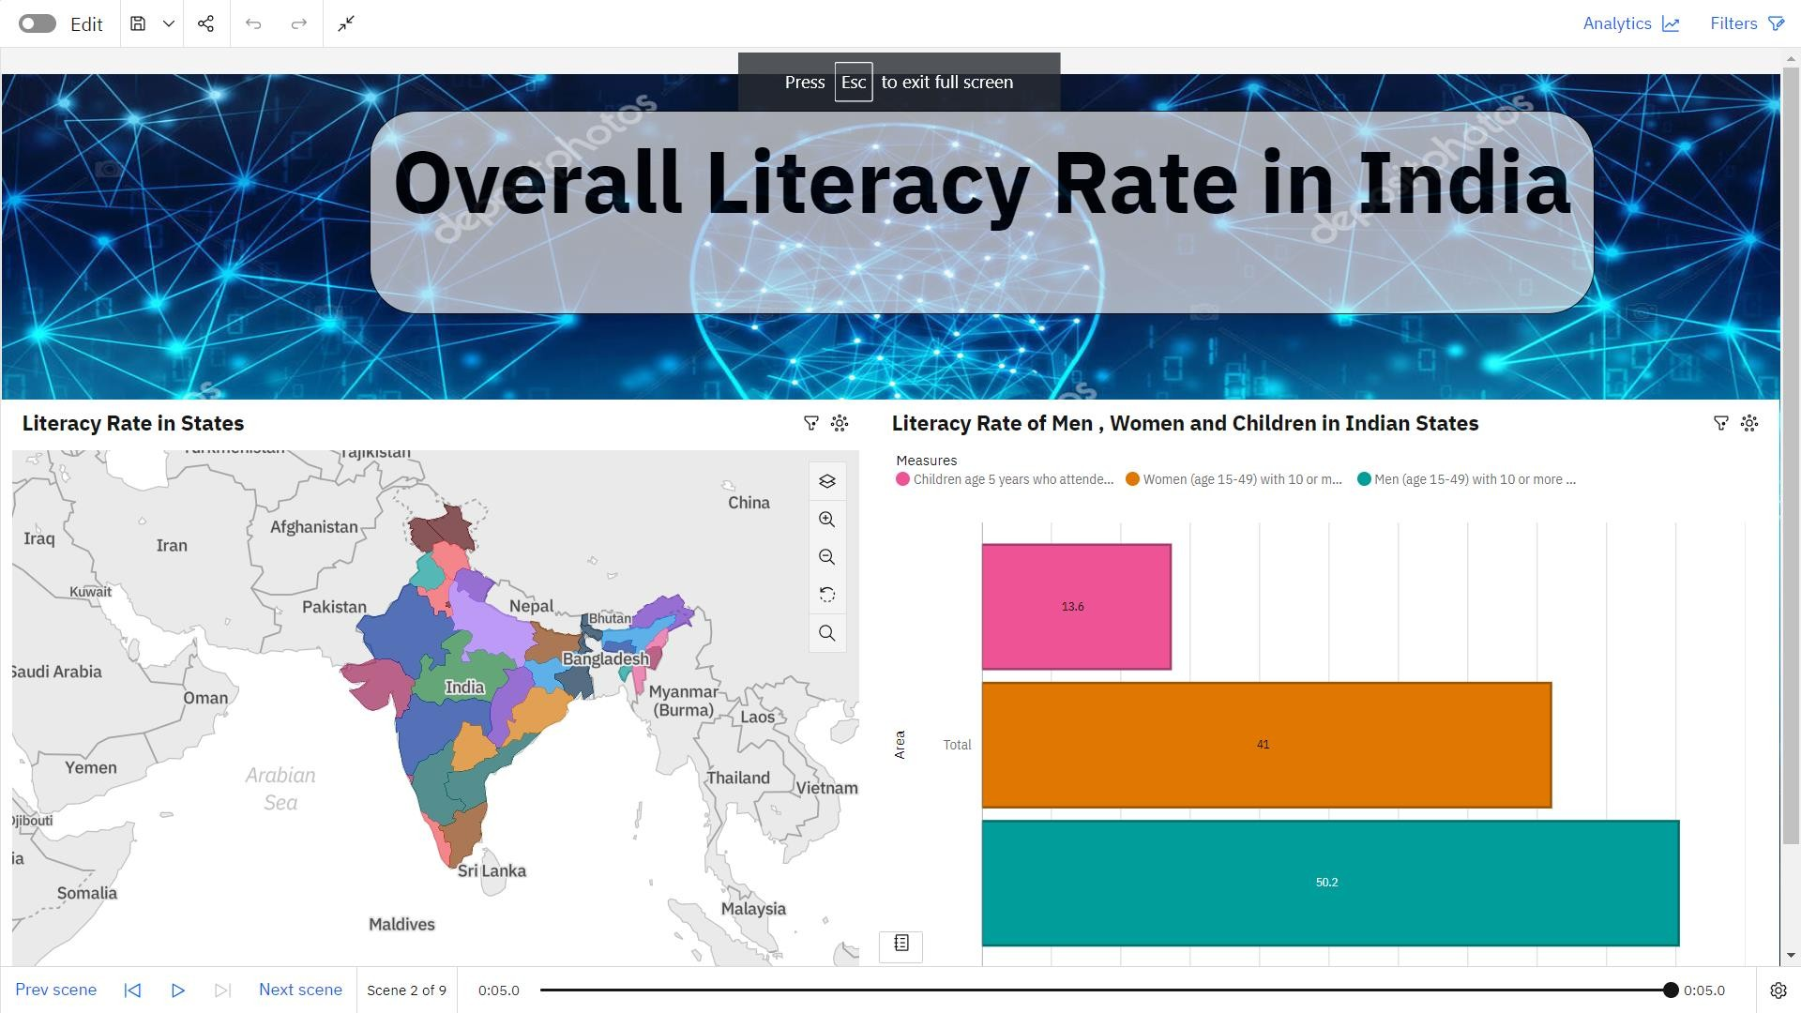

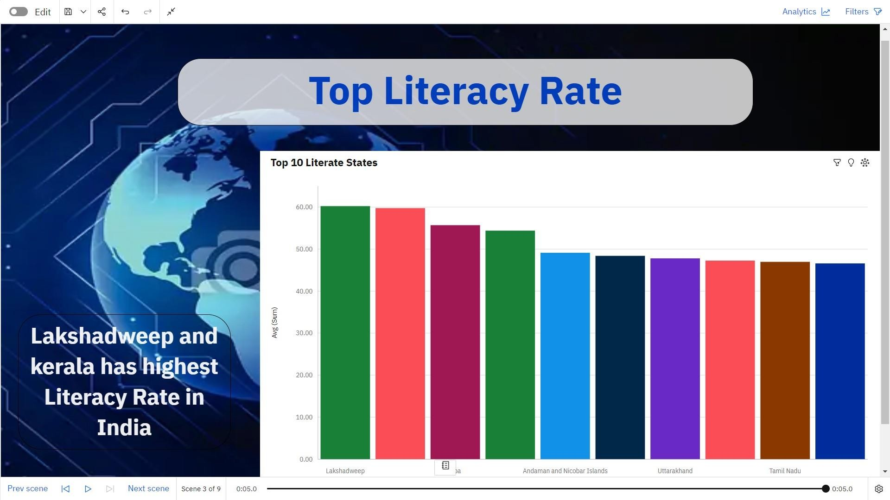

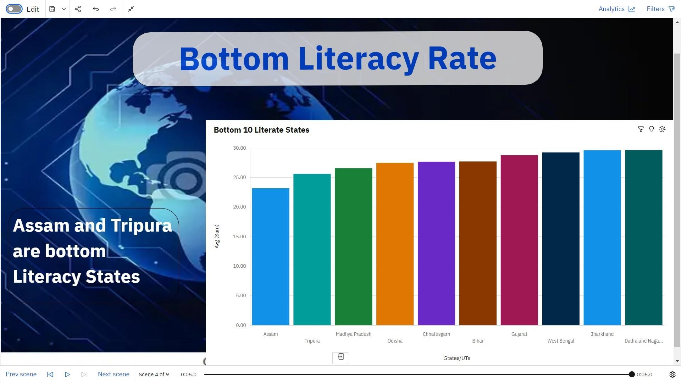

•

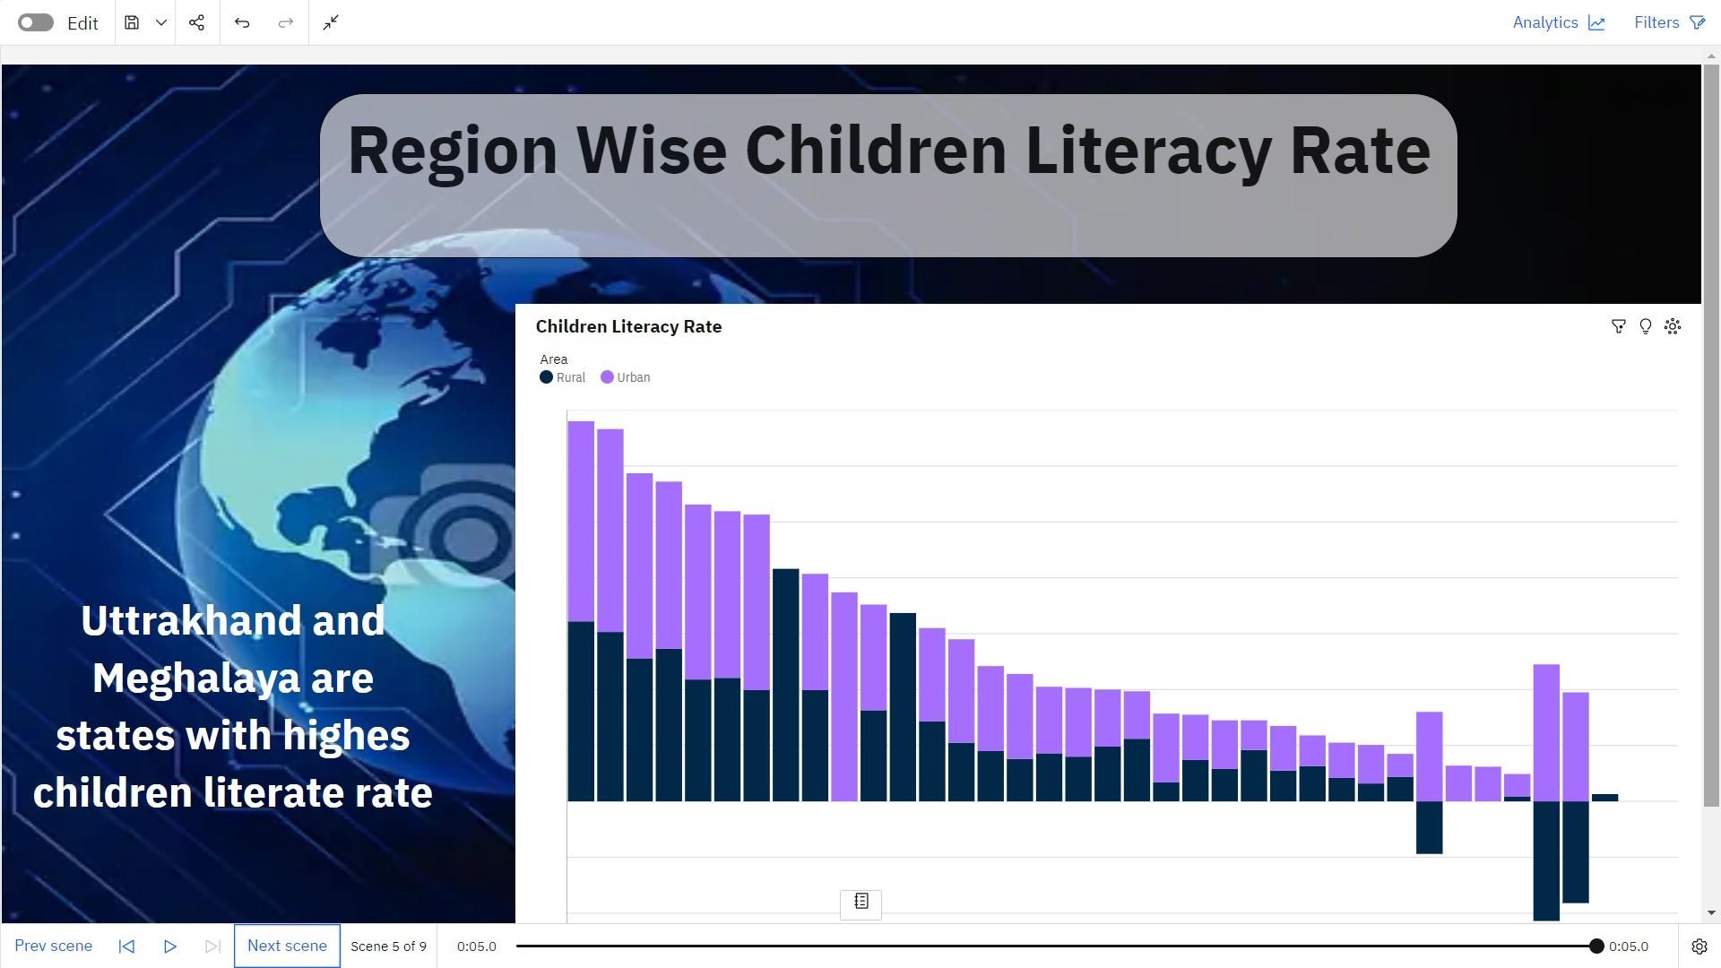

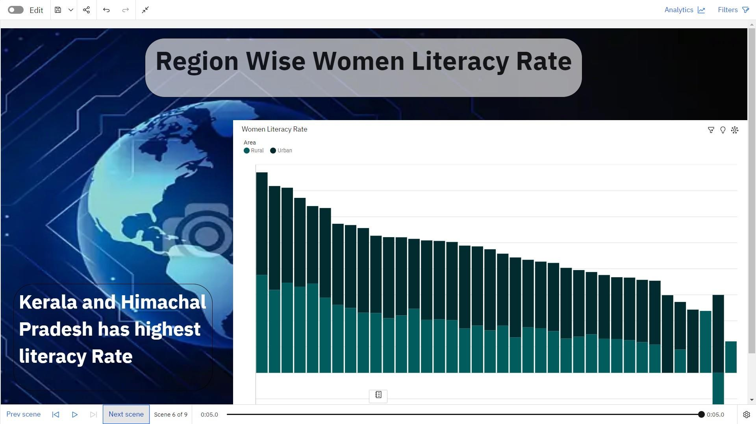



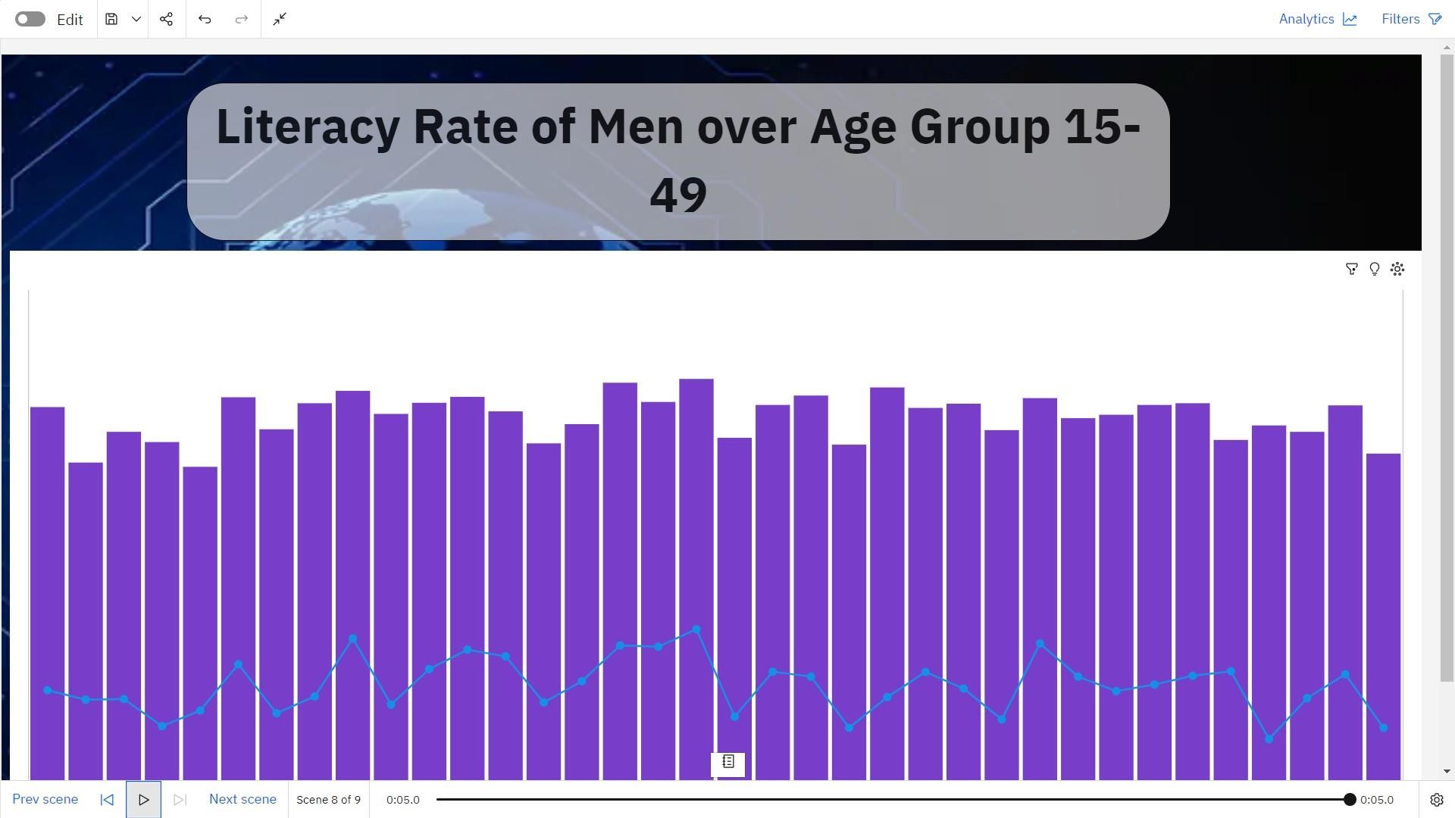

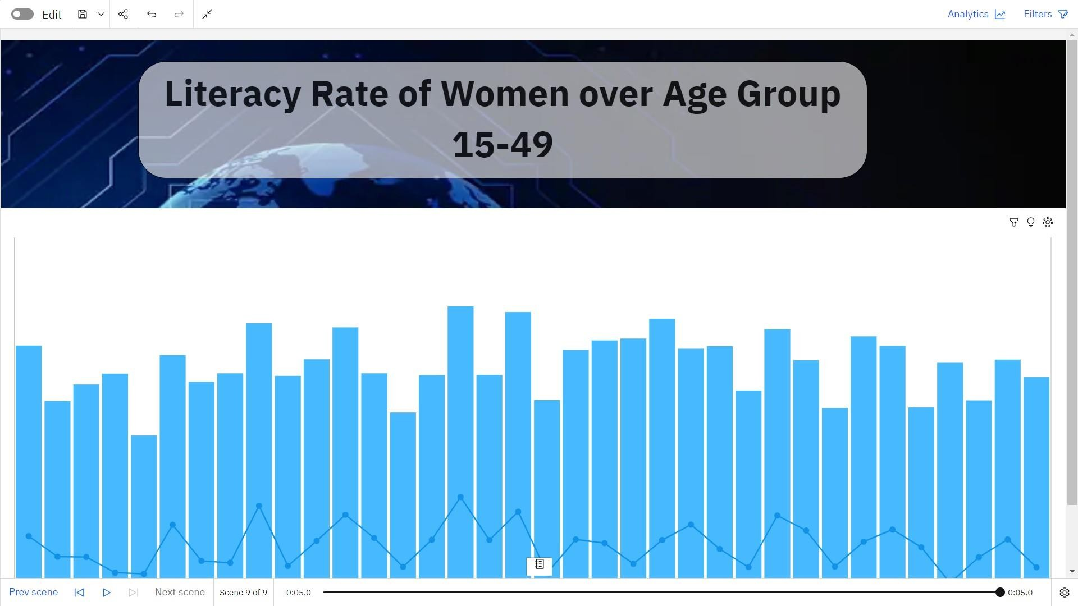

# REPORT

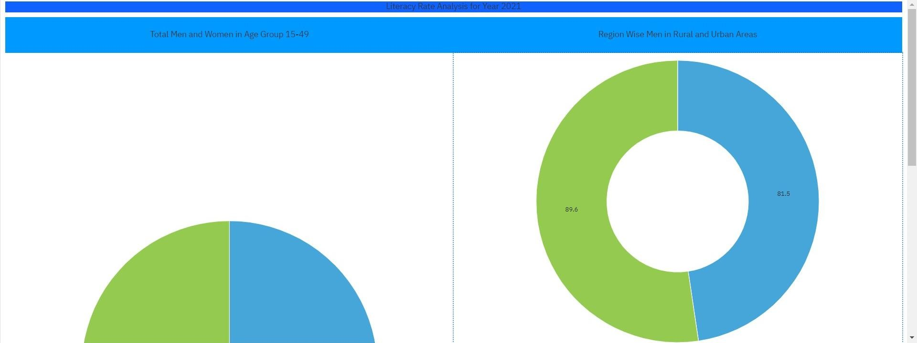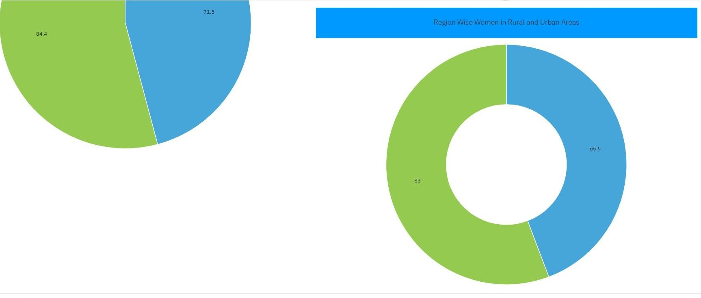

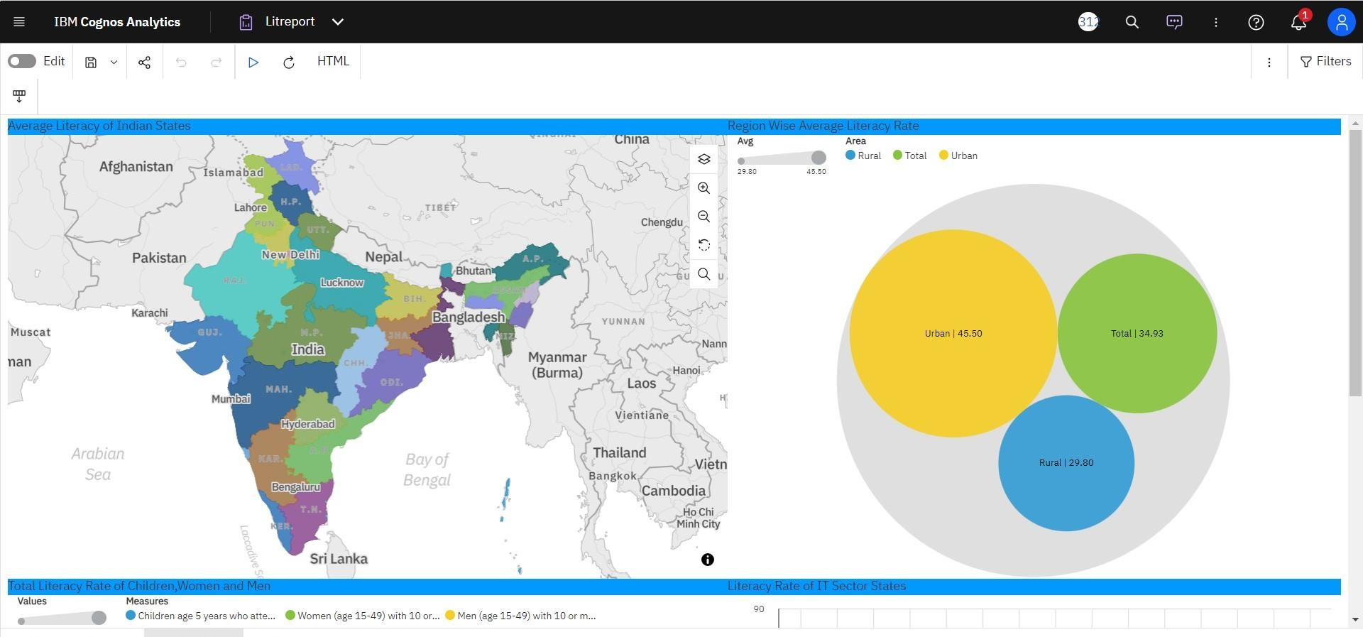

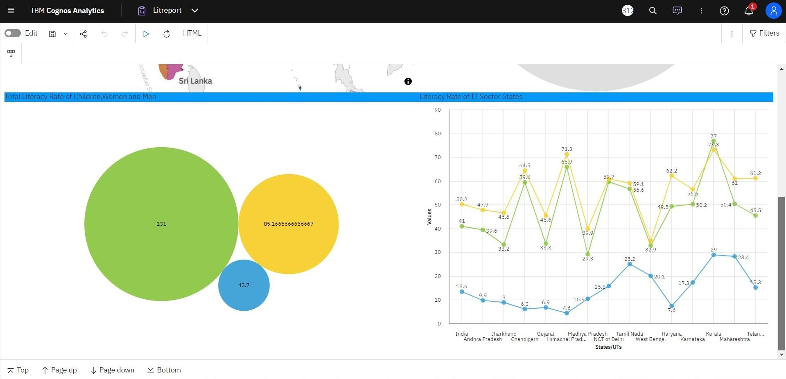

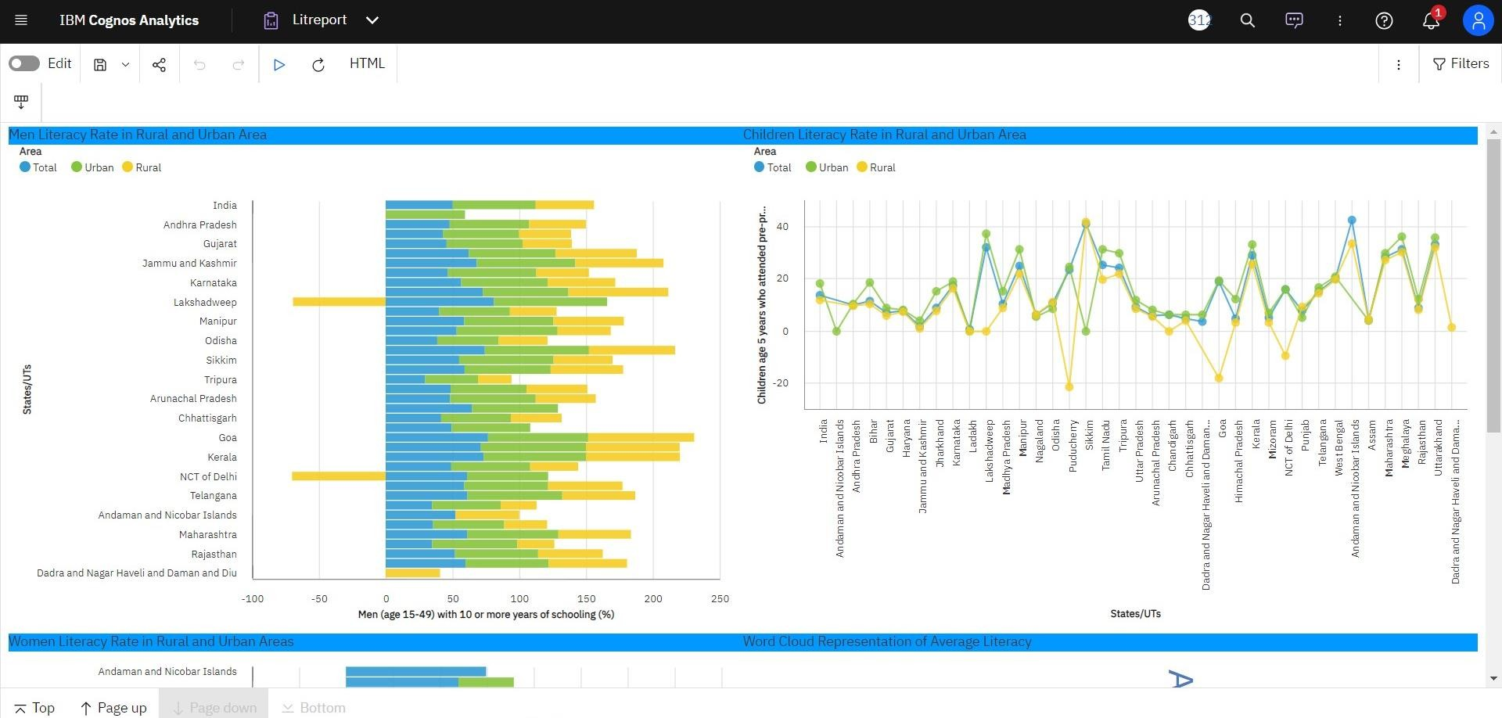

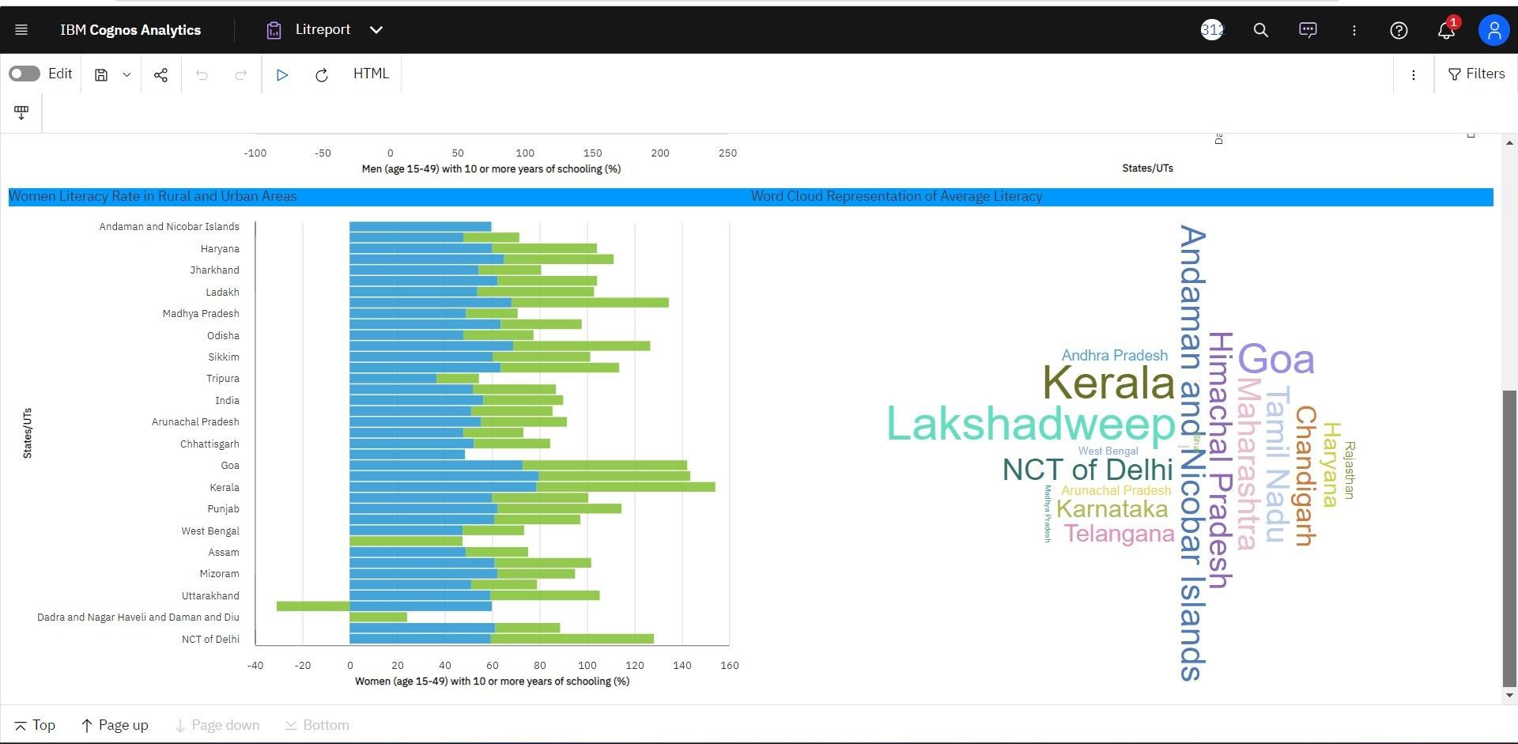



**WEB INTEGRATION**

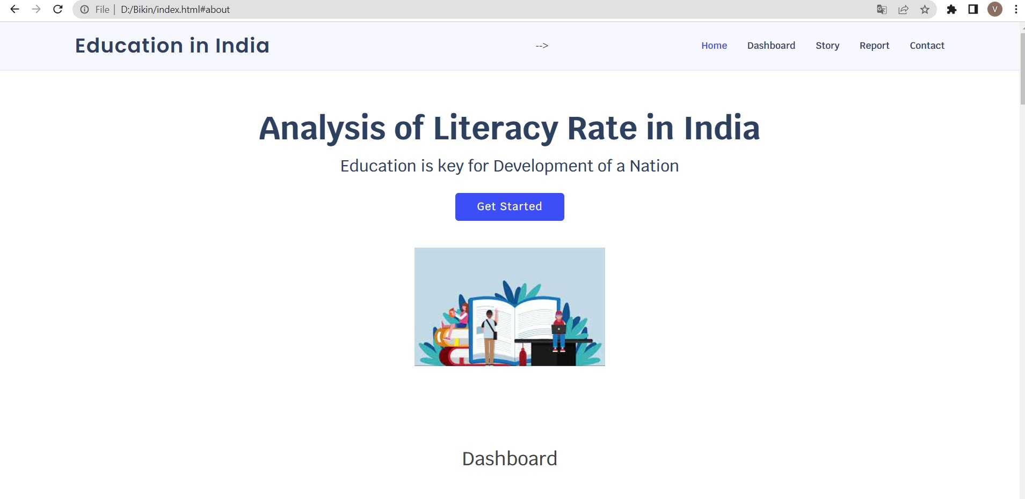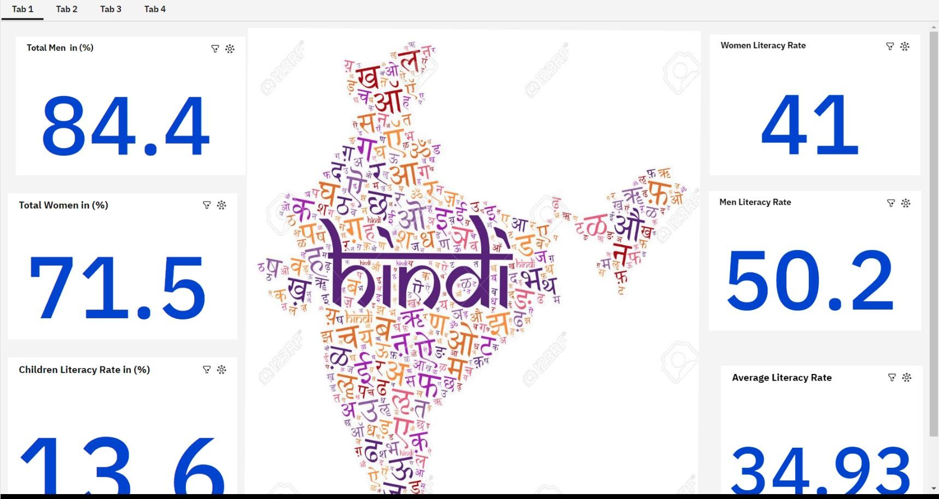

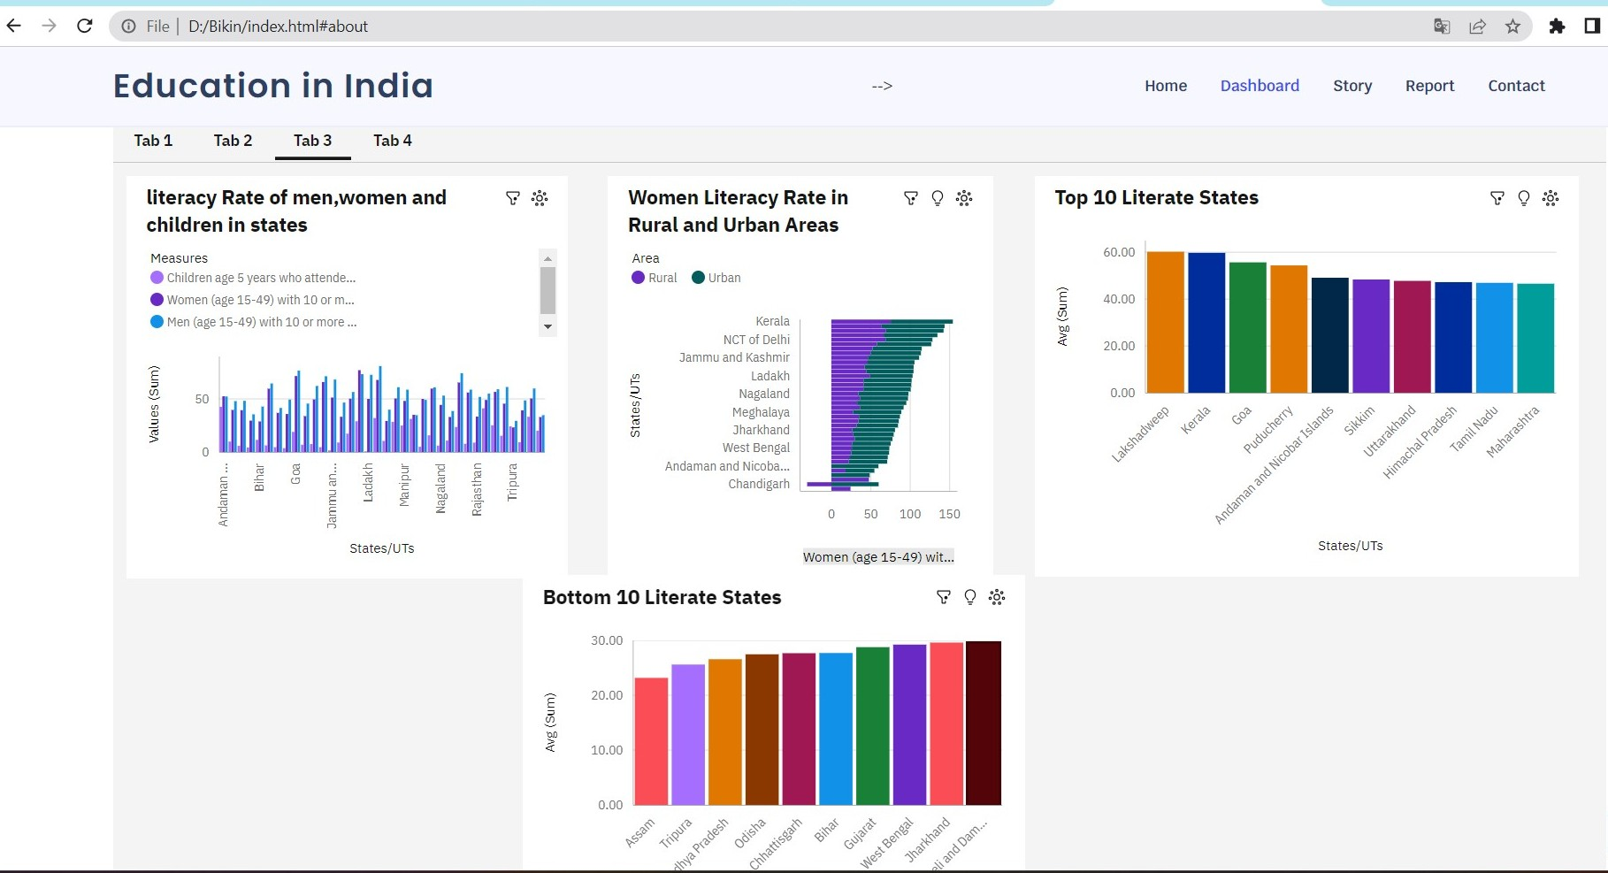

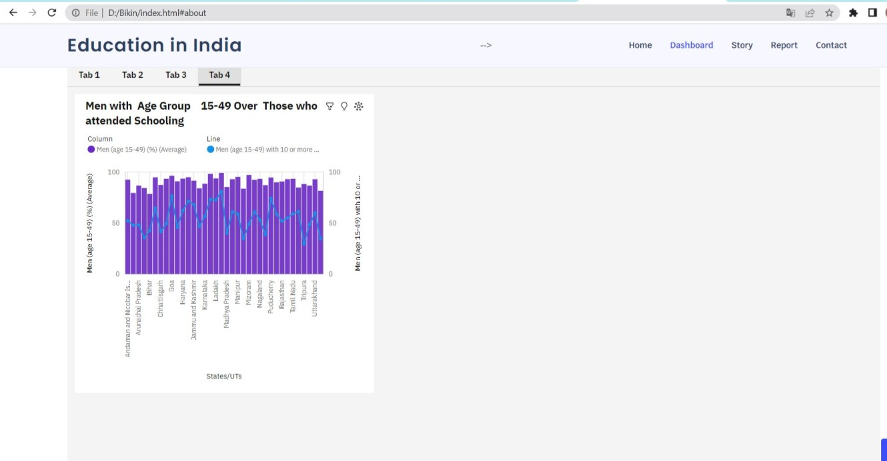

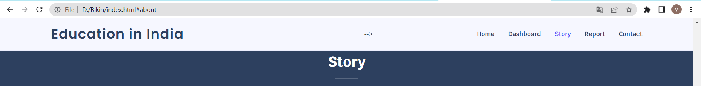













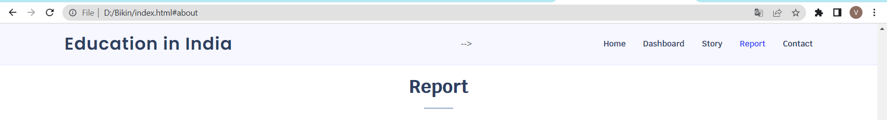



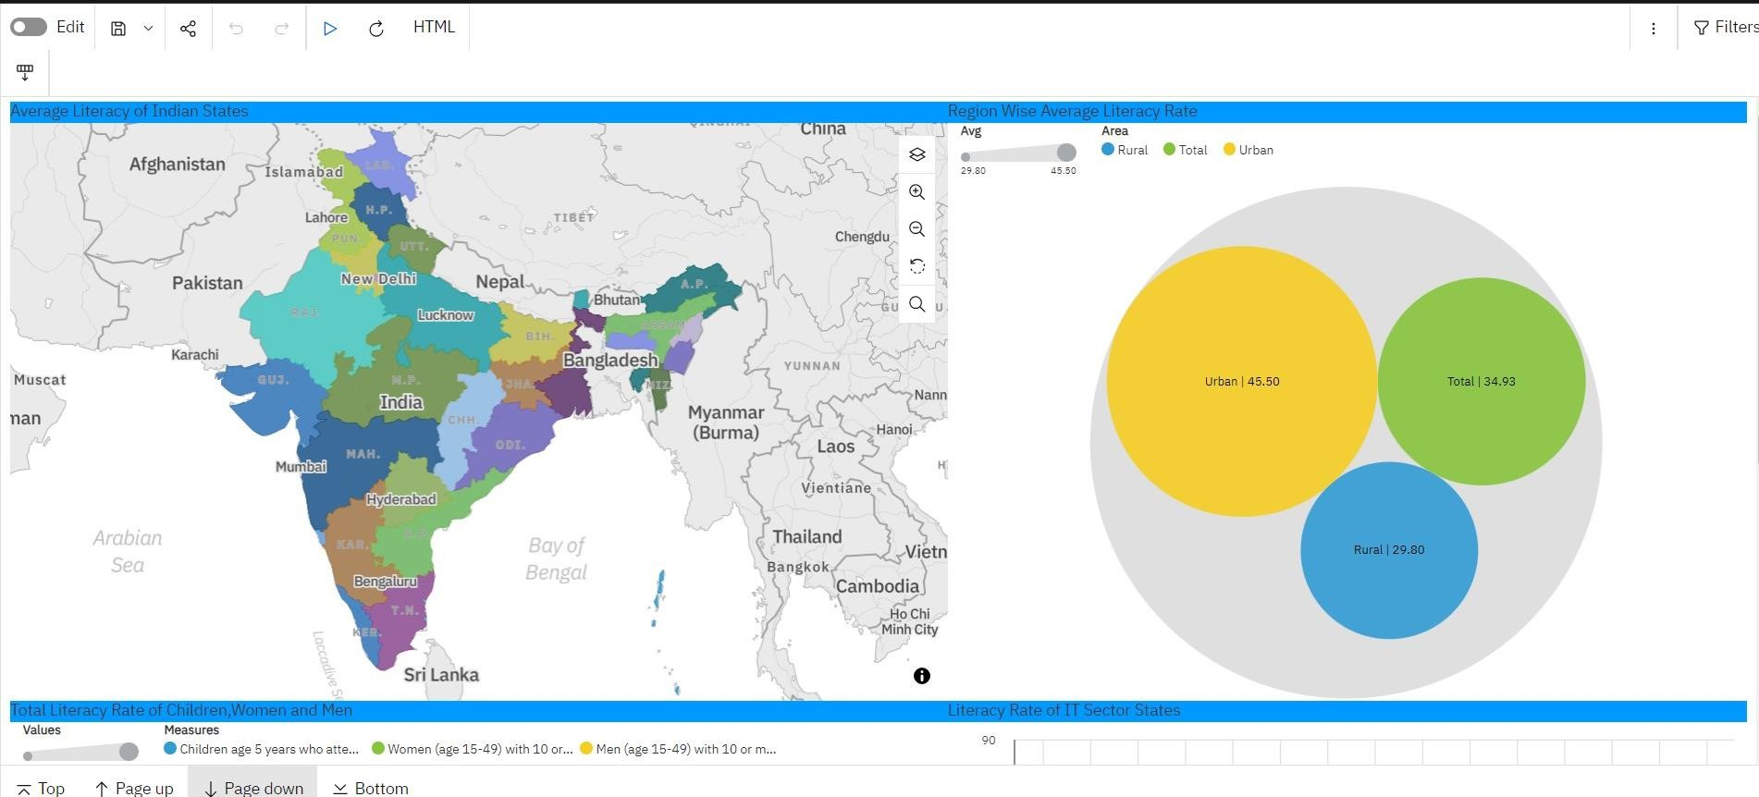

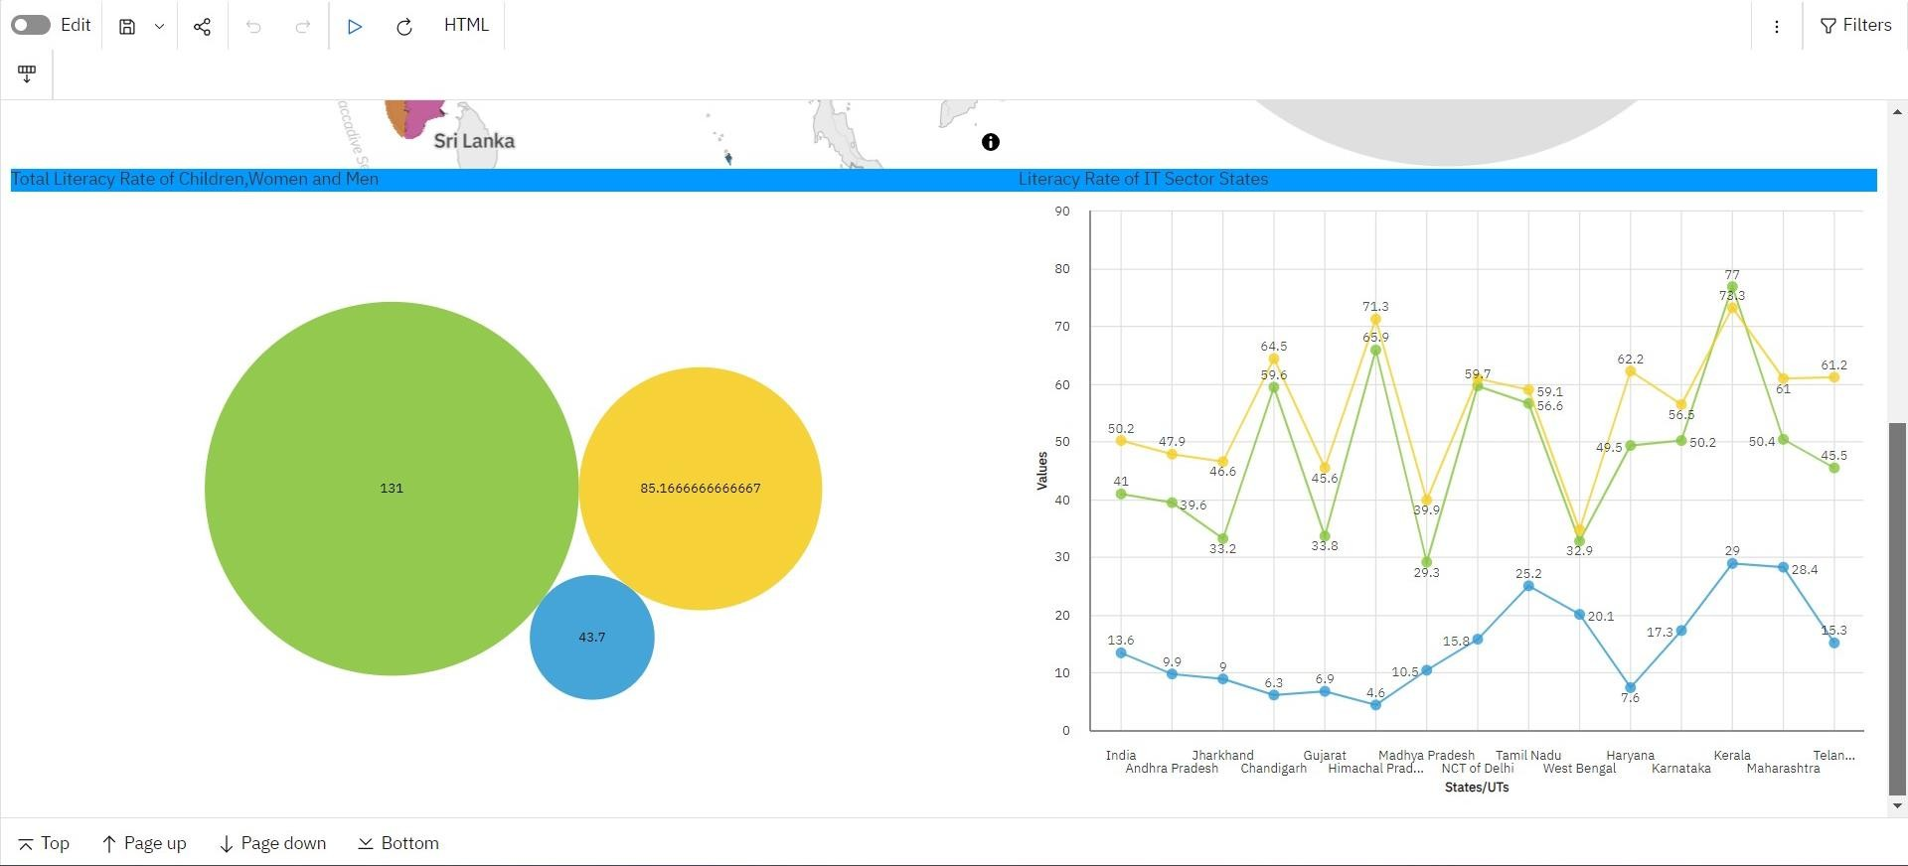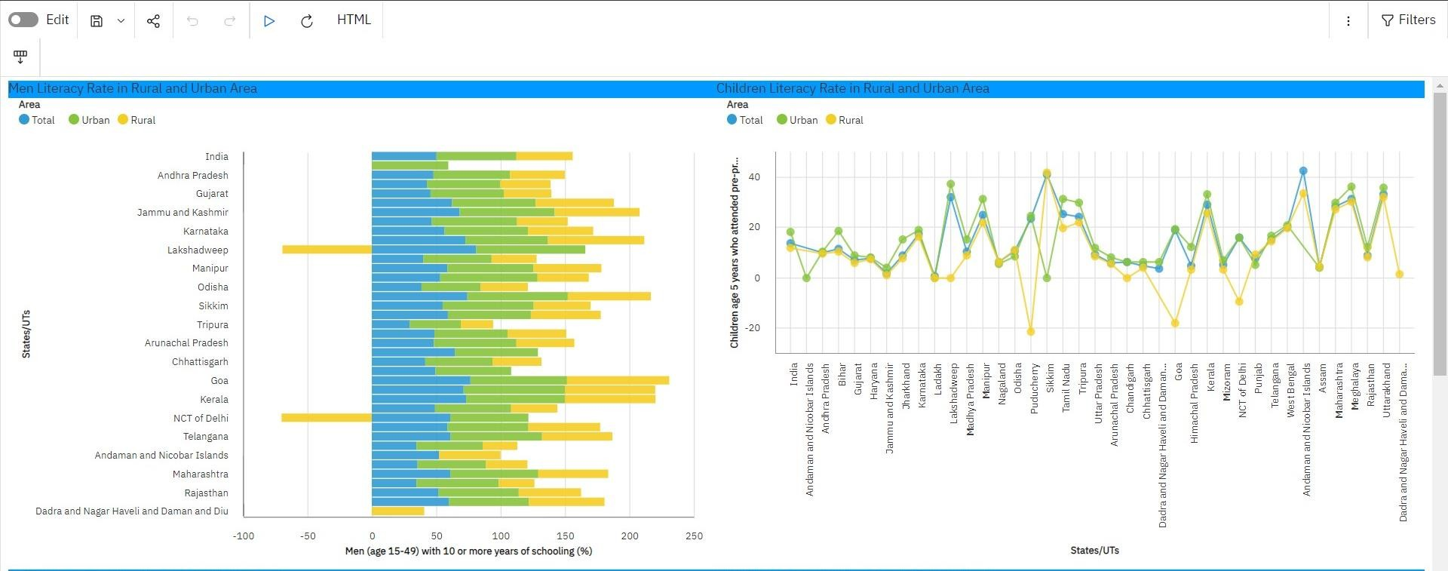

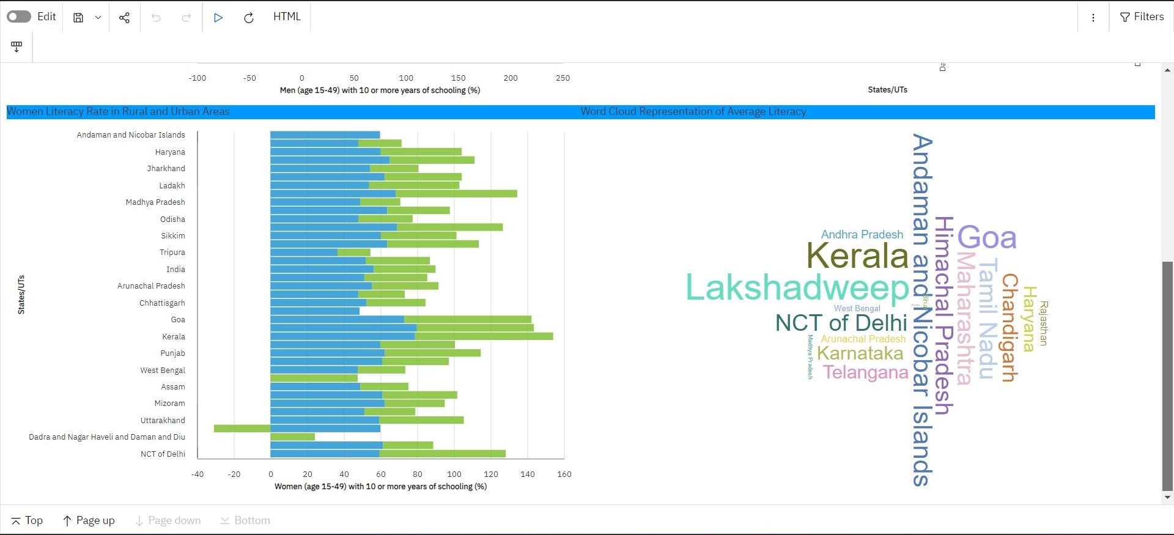

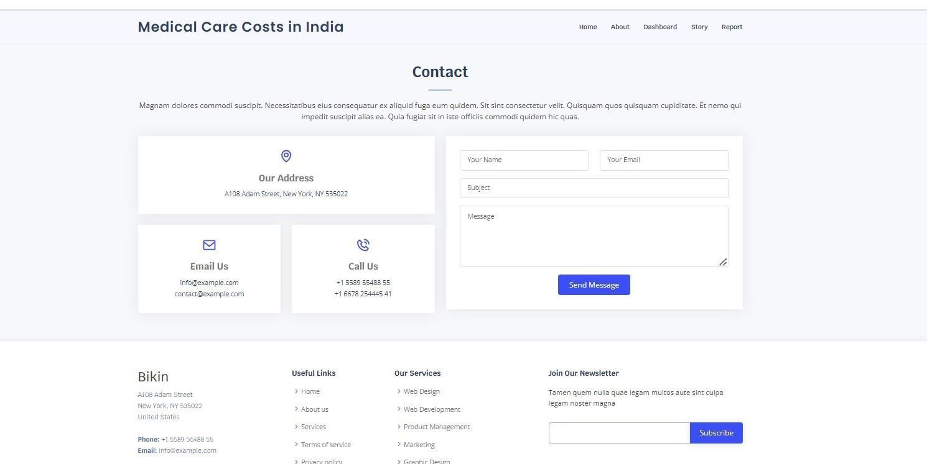

**5.ADVANTAGES & DISADVANTAGES**

### Advantages:

* Increased economic opportunities
* Lower crime rates
* Better health outcomes
* Greater civic engagement
* A more prosperous and just society

### Disadvantages:

* + Cultural barriers
  + Difficulties in reaching remote areas
  + Ethical Considerations



**6.APPLICATIONS**

The project literacy analysis has several valuable applications in the healthcare industry and beyond.

* **Planning and implementing education policies**
* **Monitoring progress**
* **Evaluating progress**
* **Raising awareness**
* **Treatment Decision Support**
* **Allocating resources**
* **Policy Development**
* **Benchmarking and Performance**
* **Research and Public awareness**



7.CONCLUSION:

In conclusion, Empowering the future: A Literacy Rate Analysis for better future project holds significant value and potential for the improvement of society. By leveraging data analytics, exploratory data analysis, the project aims to achieve several important outcomes.

Lastly, we have to create the web integration in the python folder. Downloadthe bixin file and run the index.html in visual studio code.

Overall, Empowering the Future: A Literacy Rate Analysis for Better Future project is a valuable initiative that has the potential to make a real difference in the world. By increasing literacy rates, we can create a more prosperous, just, and peaceful world for everyone.



8.FUTURE SCOPE:

The project, Empowering the future: A Literacy Rate Analysis for better future is vast. And holds great potential in transforming the society. Overall, the future scope of the Empowering the future: A literacy analysis for better future project is dynamic and

transformative. As technology continues to evolve and data-driven decision-making becomes

increasingly prevalent, the project's applications have the potential to revolutionize around the globe.