EXP.NO: 21

AIM: To design and implement the two bit half adder using Logisim simulator.

PROCEDURE:

1)      Pick and place the necessary gates.

2)      Insert 2 inputs into the canvas.

3)      Connect the inputs to the XOR gate and AND gate.

4)      Insert 2 outputs into the canvas.

5)      Make the connections using the connecting wires.

6)      Verify the truth table.

TRUTH TABLE:

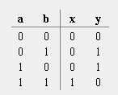

Y = A XOR B        X = A AND B

**Logical Diagram:**

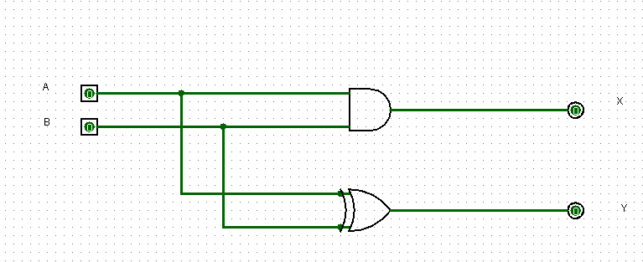

Half Adder using NAND Gates:

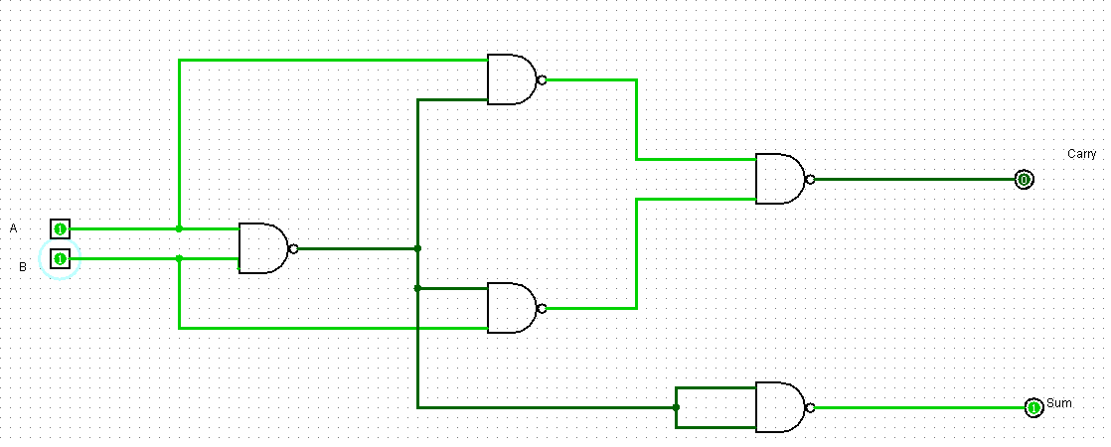

Half Adder using NOR Gates:

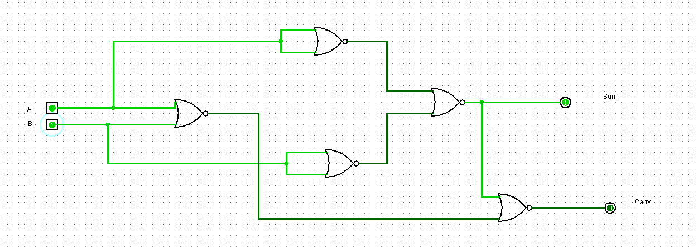

RESULT: Thus 2-bit half adder has been designed and implemented successfully using

Logisim simulator.