[ec2-user@ip-172-31-92-47 ~]$ sudo -i

[root@ip-172-31-92-47 ~]# hostnamectl set-hostname jenkinsmachine

[root@ip-172-31-92-47 ~]# exit

logout

[ec2-user@ip-172-31-92-47 ~]$ sudo -i

[root@jenkinsmachine ~]#

Install Java using the below command

[root@jenkinsmachine ~]# yum install java java-openjdk-devel –y

[root@jenkinsmachine ~]# yum install wget -y

Installing+Jenkins+on+Red+Hat+distributions

Installation

Add the Jenkins repository to the yum repos, and install Jenkins from here.

* sudo wget -O /etc/yum.repos.d/jenkins.repo <http://pkg.jenkins-ci.org/redhat/jenkins.repo>
* sudo rpm --import [https://jenkins-ci.org/redhat/jenkins-ci.org.key](http://pkg.jenkins-ci.org/redhat/jenkins-ci.org.key)
* sudo yum install jenkins –y

Start/Stop

* sudo service jenkins start/stop/restart
* sudo chkconfig jenkins on

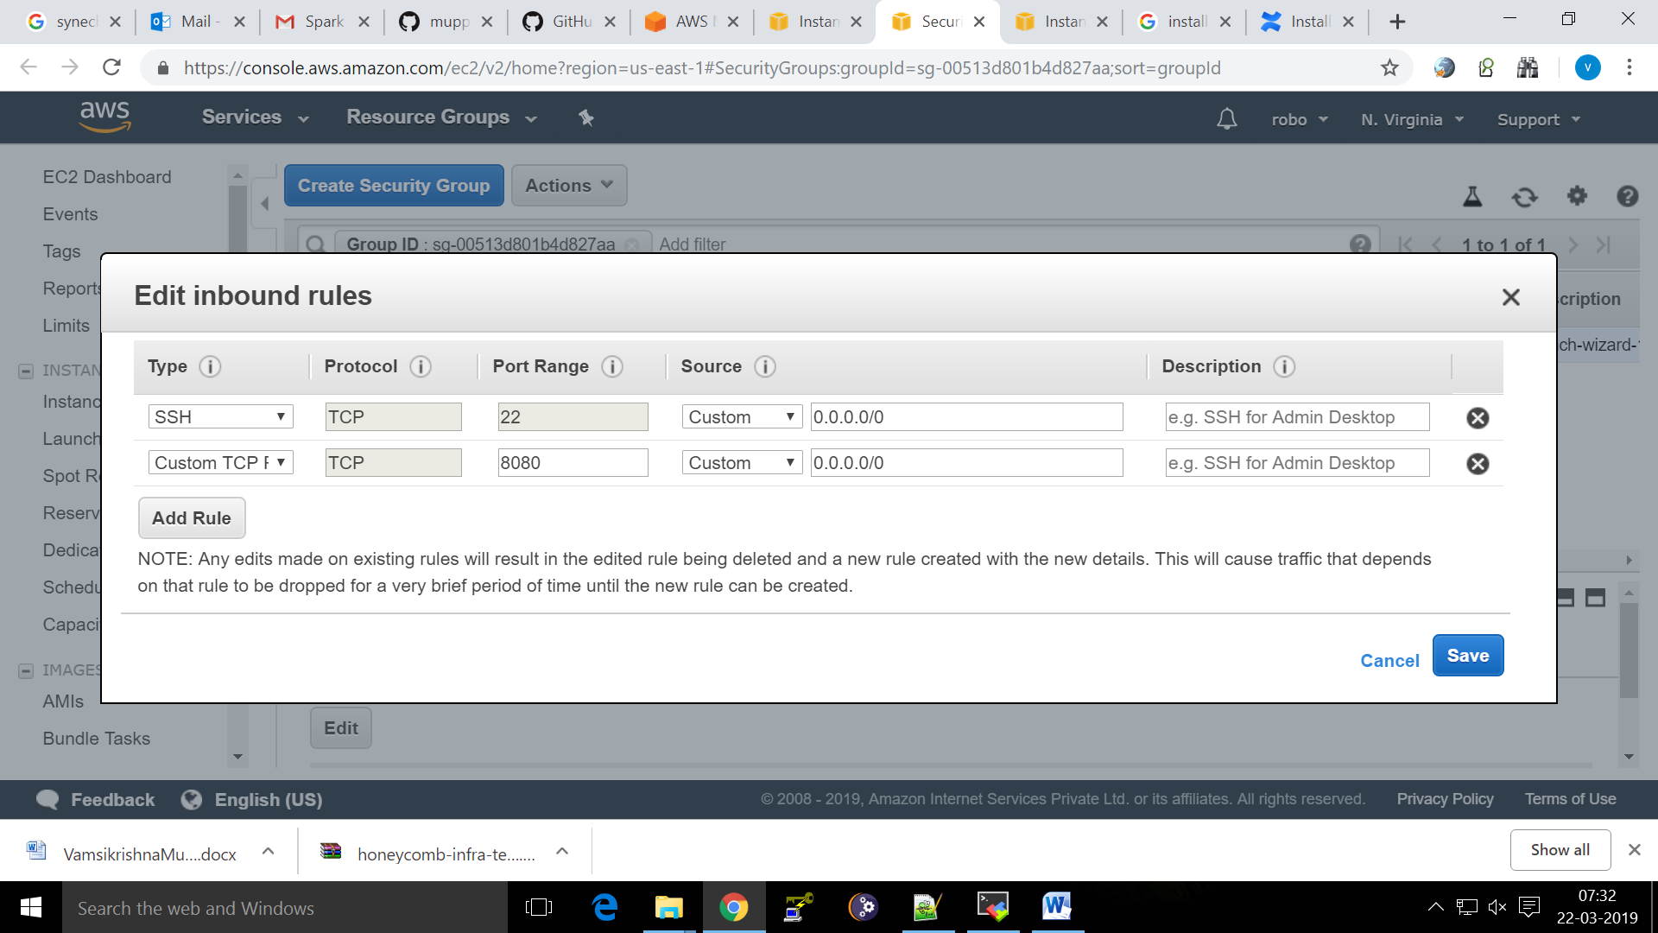

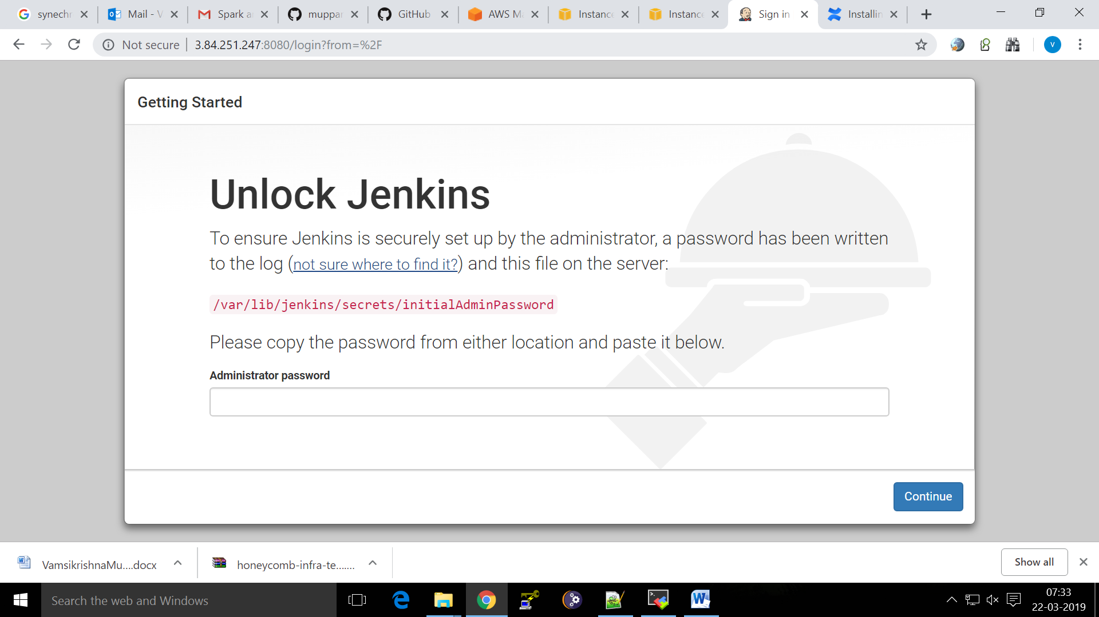

[root@jenkinsmachine ~]# service jenkins start

Starting jenkins (via systemctl): [ OK ]

[root@jenkinsmachine ~]# cat /var/lib/jenkins/secrets/initialAdminPassword

225a40b92f2046c4b1bbc0b93144e930

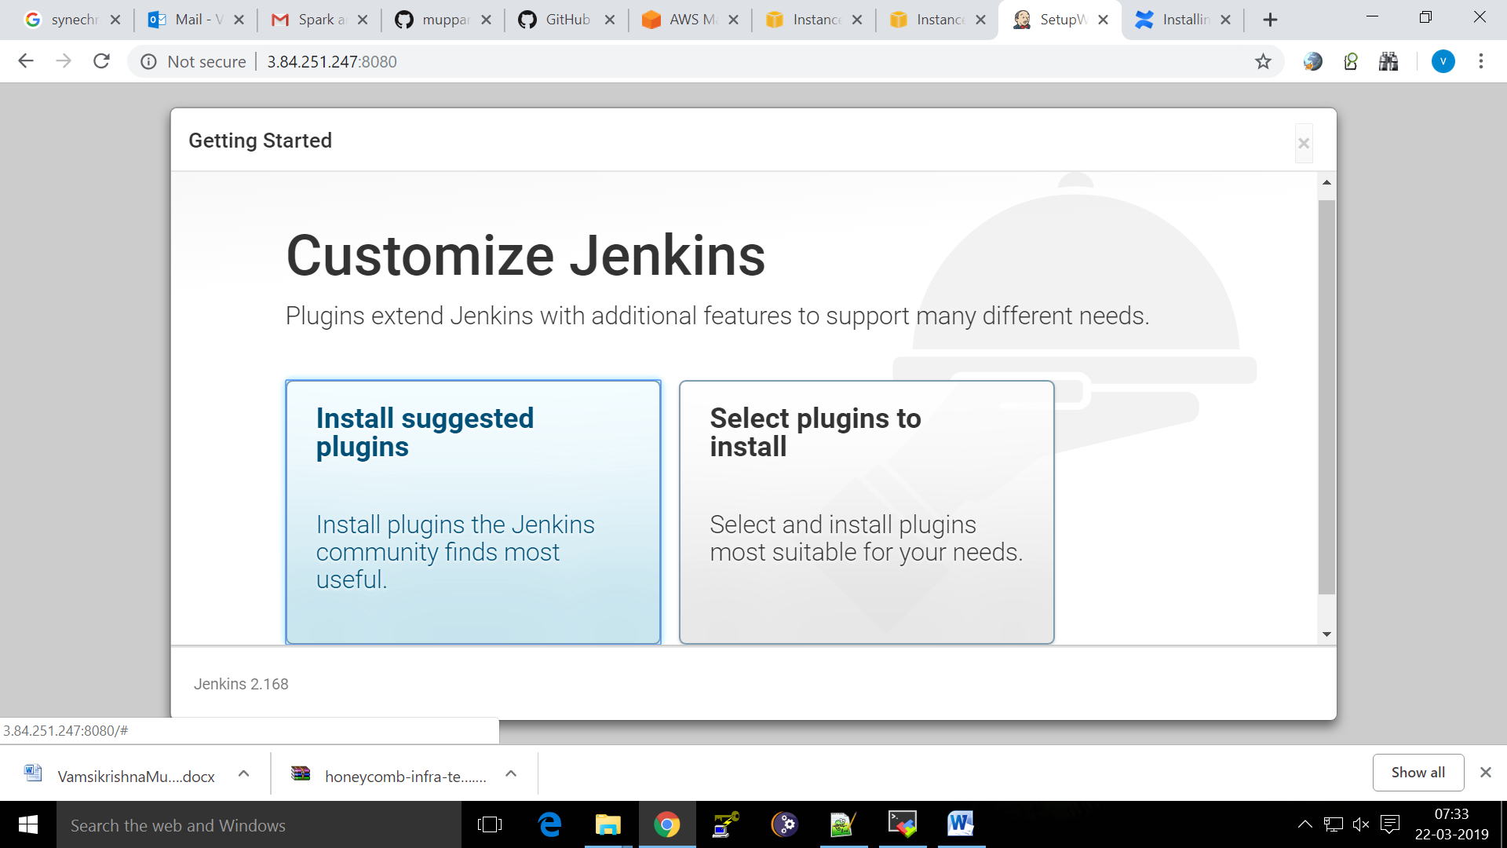

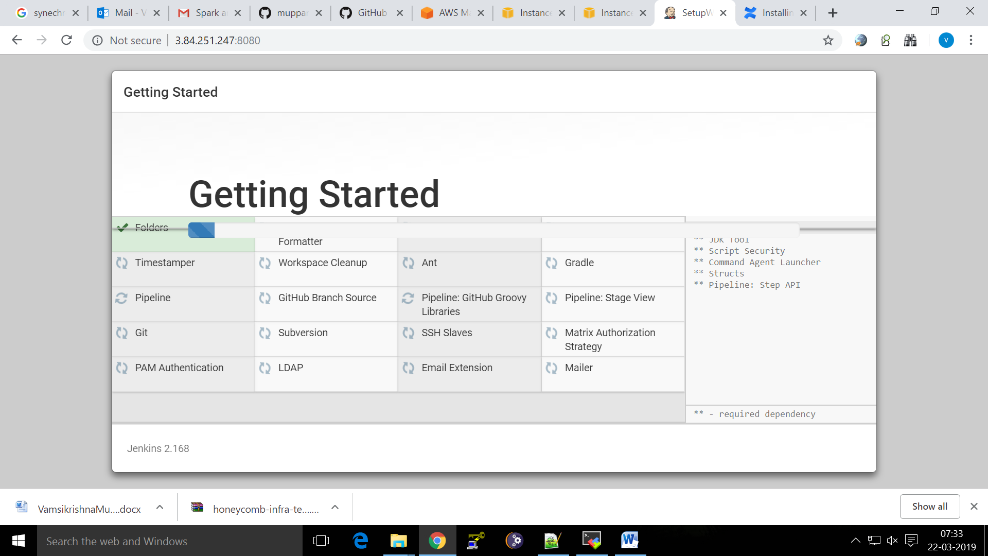

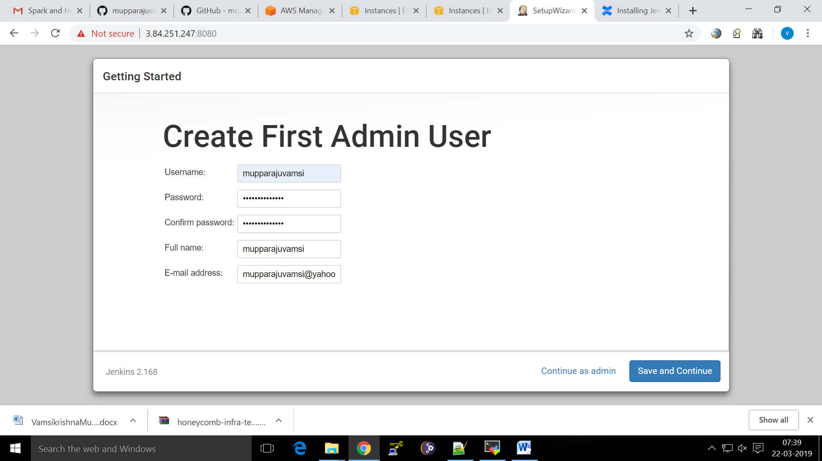

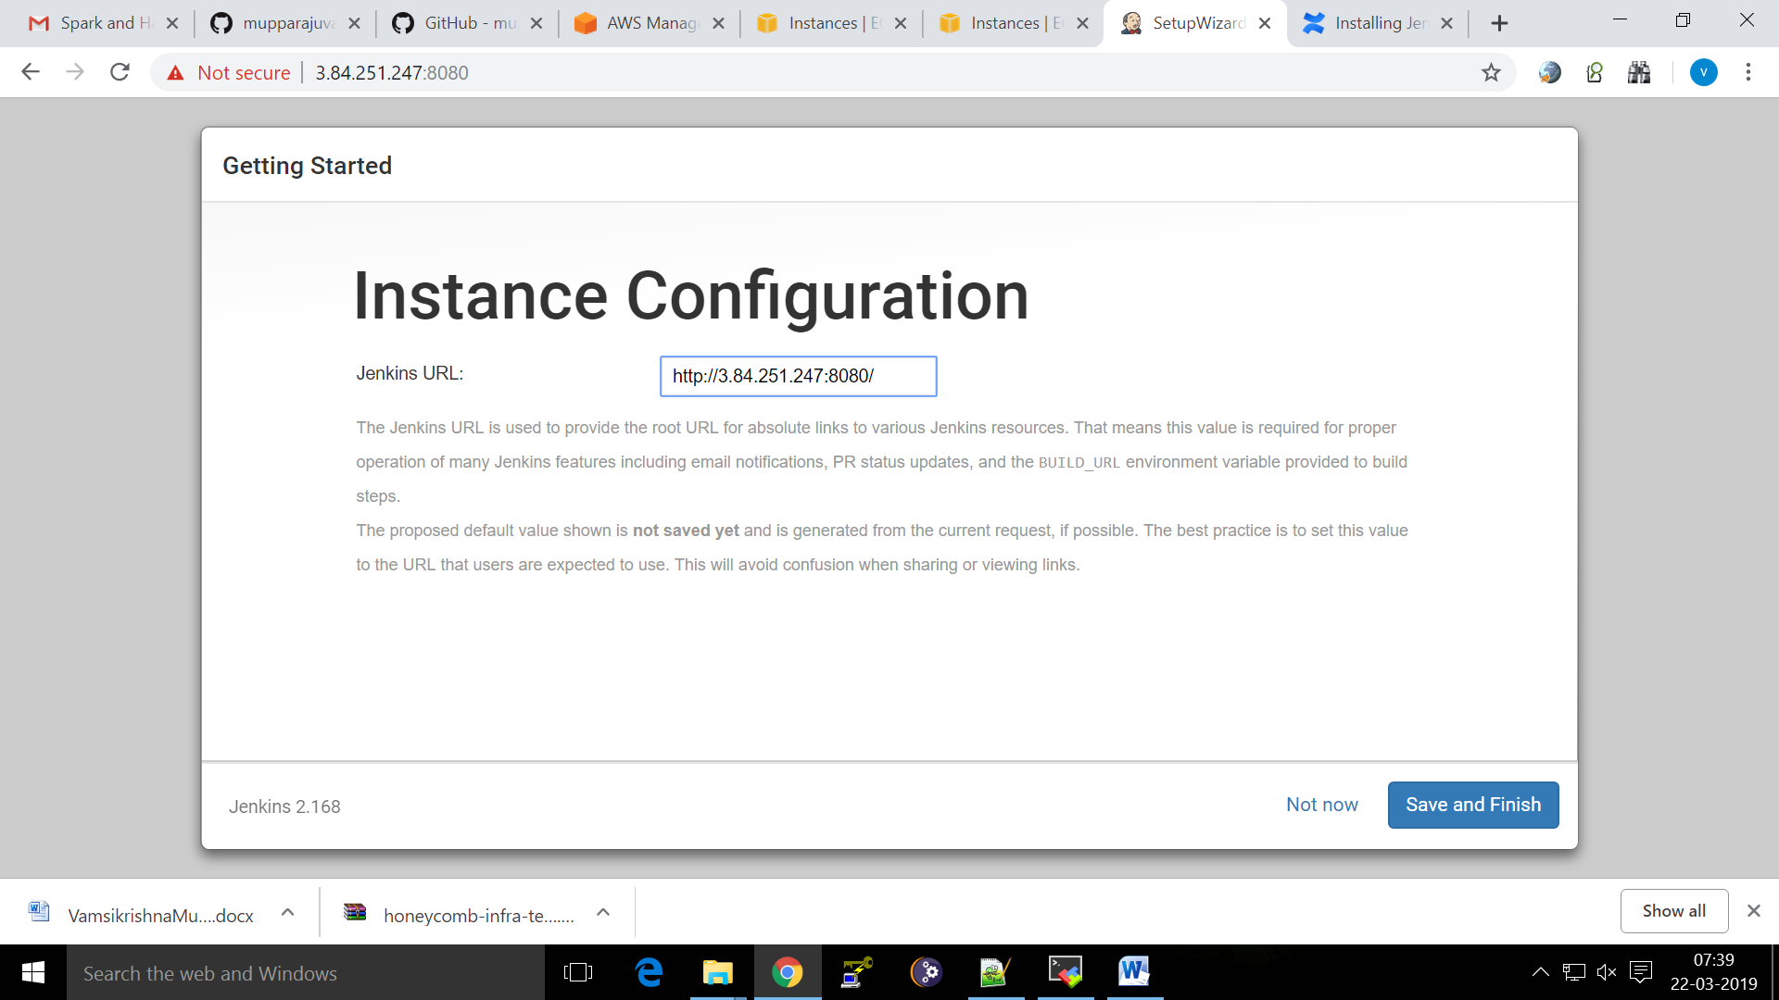

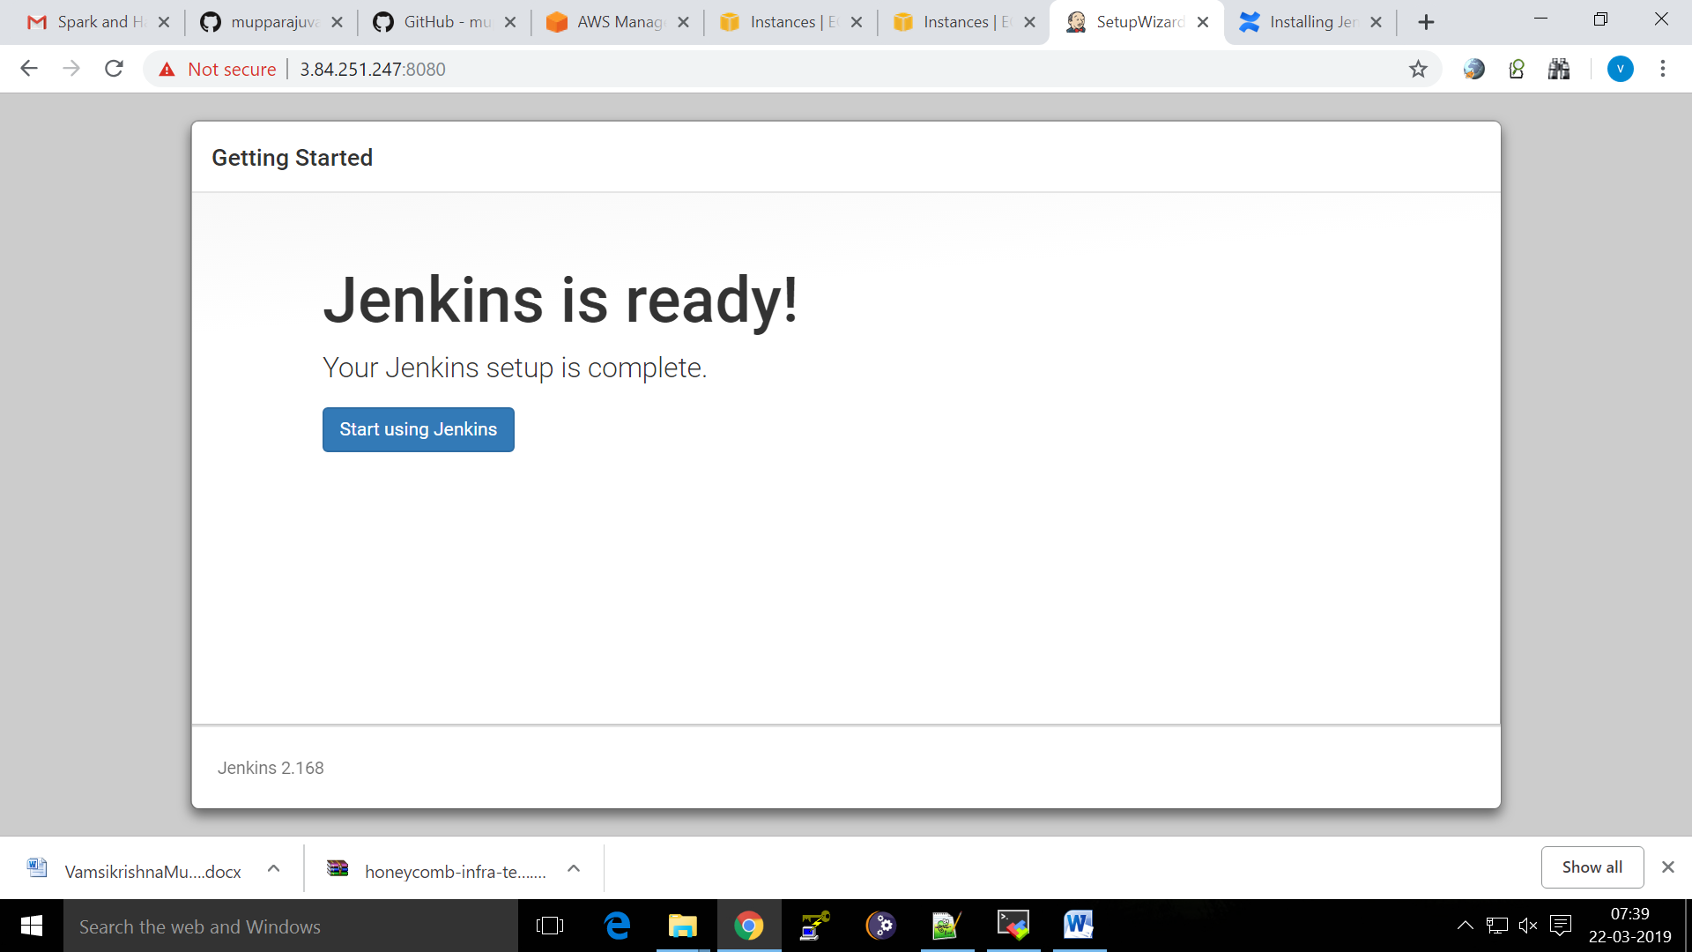

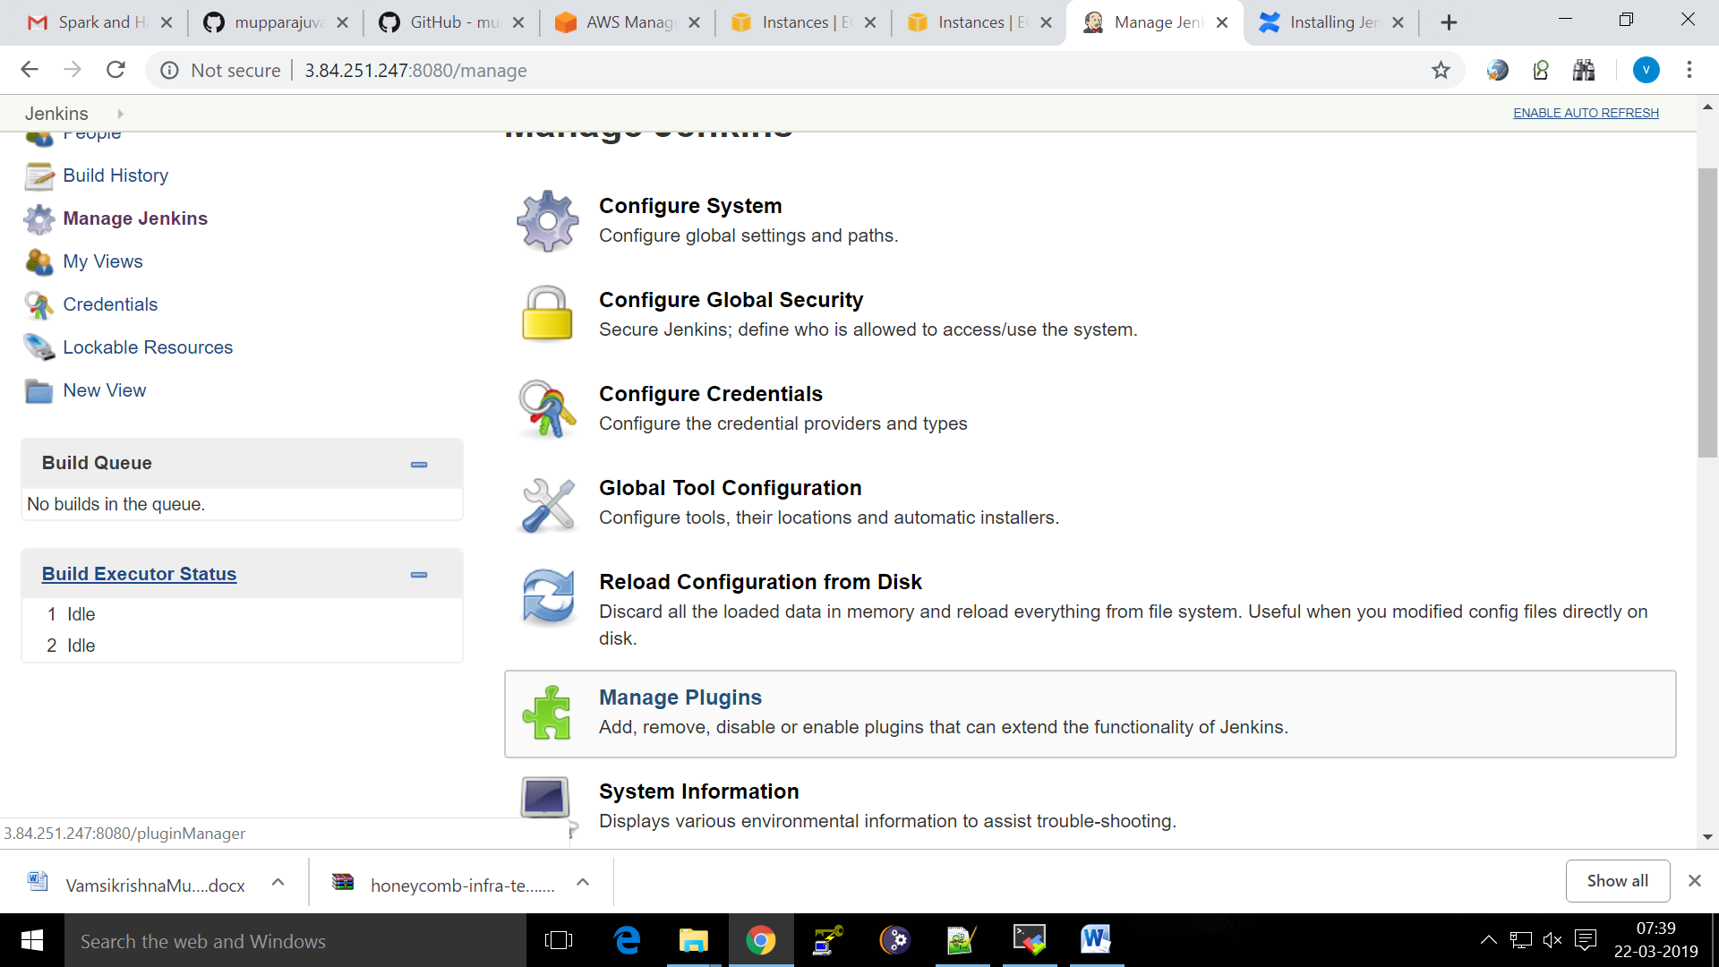

Install Maven Integration Plugin,  [Publish Over SSH](https://plugins.jenkins.io/publish-over-ssh) [Deploy to container](https://plugins.jenkins.io/deploy)

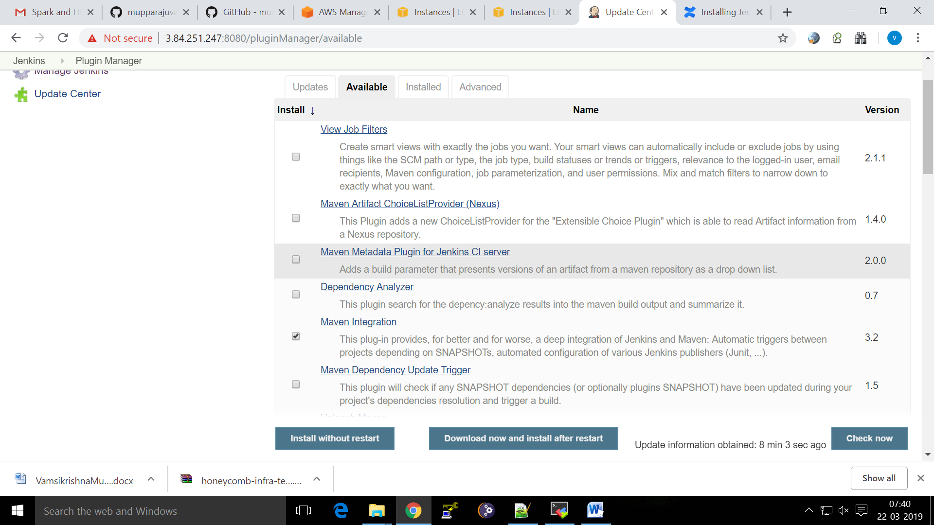

Install Apache Maven On RHEL7

[root@jenkinsmachine opt]# cd /opt

[root@jenkinsmachine opt]# wget <http://mirrors.estointernet.in/apache/maven/maven-3/3.6.0/binaries/apache-maven-3.6.0-bin.tar.gz>

[root@jenkinsmachine opt]# tar xvf apache-maven-3.6.0-bin.tar.gz

[root@jenkinsmachine opt]# vi /etc/profile.d/maven.sh

[root@jenkinsmachine opt]# source /etc/profile.d/maven.sh

[root@jenkinsmachine opt]# mvn -version

Apache Maven 3.6.0 (97c98ec64a1fdfee7767ce5ffb20918da4f719f3; 2018-10-24T18:41:47Z)

Maven home: /opt/apache-maven-3.6.0

Java version: 1.8.0_201, vendor: Oracle Corporation, runtime: /usr/lib/jvm/java-1.8.0-openjdk-1.8.0.201.b09-2.el7_6.x86_64/jre

Default locale: en_US, platform encoding: UTF-8

OS name: "linux", version: "3.10.0-957.el7.x86_64", arch: "amd64", family: "unix"

[root@jenkinsmachine opt]# cat /etc/profile.d/maven.sh

export MAVEN_HOME=/opt/apache-maven-3.6.0

export PATH=${PATH}:/opt/apache-maven-3.6.0/bin

Install git using

yum install git –y

